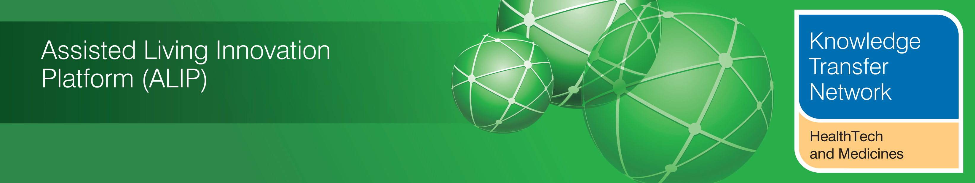
NEWSLETTER
September 2012

Welcome to the September 2012 newsletter from the Technology Strategy Board (TSB) Knowledge Transfer Network and the Telecare Learning and Improvement Network.

Our newsletter is now being distributed to 46,000 subscribers in the UK and worldwide. We hope that you find this newsletter useful. With around 1,000 news and events links over recent weeks, it is the most comprehensive newsletter available serving the telecare, telehealth, ehealth and assisted living communities.

This month we have seen the publication of a number of reports on telecare (Strategic Society Centre, Good Governance Institute, Carers UK) together with an excellent, highly recommended telehealth implementation toolkit from South Yorkshire CLAHRC. There is an update on Three Million Lives including a list of upcoming events where they are involved.

There are important conferences coming up in the Autumn covering telehealth and telecare including Health Service Journal/Nursing Times (Oct), Telecare Services Association (Nov) and Royal Society of Medicine (Nov) – booking is now open.

The links section is now available in a separate supplement rather than in the main newsletter (doc, pdf). A selection from this month’s listing is covered in the newsletter.
The newsletter contains a list of KTN/ALIP activities, conferences and workshops from the UK and Europe over the coming weeks as well as news from the UK and around the world. For weekly news updates and information, you can register with the Technology Strategy Board, ALIP group and the DALLAS sub-group. You can follow the dallas programme on Twitter at @dallas_connect. Also 3 Million Lives is now on Twitter at @3MillLives and now on LinkedIn. If you would like daily information on #telecare and #telehealth, then a Twitter stream is available at the TelecareLIN web site (you do not need to register on Twitter and it is accessible to organisations not able to connect directly to social media): http://www.telecarelin.org.uk/News/twitterStream/

Prepared by Mike Clark (Twitter: @clarkmike) for the ALIP Knowledge Transfer Network and Telecare Learning and Improvement Network

Contents
Item 1 – News from ALIP and the KTN – Page 2
Item 2 – Three Million Lives latest - Page 4
Item 3 – Report from Strategic Society Centre – ‘Who Uses Telecare’? – Page 5
Item 4 – Report from Good Governance Institute (GGI) - 'Care and support at home: an audit of telecare services in England' – Page 5
Item 5 – Report from Carers UK – ‘Carers and Telecare’ – Page 6
Item 6 – Housing LIN News – Page 7
Item 7 – Telehealth Implementation toolkit from South Yorkshire CLAHRC – ‘Ready, Steady, Go’ – Page 7
Item 8 – News Roundup – Page 8
Item 9 – Learning and Events – Page 12
Item 10 – Other useful links – Page 14
Supplement for September 2012
The links section is now available in a separate supplement rather than in the main newsletter (doc, pdf).

Item 1 – News from ALIP and the KTN
Ambient Assisted Living Forum, Eindhoven, Netherlands
The Healthtech and Medicines KTN (Assisted Living Innovation Platform) have been supporting 7 organisations to exhibit and attend the 2012 AAL Forum in Eindhoven, Netherlands (24-27 September 2012).
The organisations which were successful include a range from the assisted living innovation platform portfolio of projects:
- Docobo
- European Technology Business (ETB) Ltd
- University of Newcastle
- Health over Internet Protocol (HoIP)
- GUSTO
- Coventry University (HDTI)
- dallas
The Forum offers an opportunity to market their successes in assisted living technology and services and showcase the UK as leading in assistive living innovation.
6th Call for proposals of the AAL Joint Programme: “ICT based solutions for Supporting Occupation in Life”.
The topic of call 6 was discussed on 26 September 2012 during the AAL Forum 2012 in Eindhoven (Session B2, http://www.aalforum.eu/page/session-b2-2012). All members of the AAL community and all participants of the open consultation for call 6 were encouraged to attend.
In many cases, the active older adult is still confronted with a “deficit model of age” that – often unsubstantiated - assumes that occupational efficiency and general learning ability decline with age and implies that older people are less innovative, less productive and less able to work under pressure than their younger colleagues. Empirical evidence suggests that the biggest challenges for older workers are indeed physical strain, mental stress and smaller age-related limitations. This is accompanied by increased skills and competence based on work experience and changing values and attitudes towards work and career. Developments in technical and organisational means to retain the knowledge, expertise and abilities of older workers in the workforce – on a paid or voluntary basis - will help to lessen any potentially detrimental effects of demographic ageing on economic development.
Therefore, Call 6 of the AAL Joint Programme aims at funding the development of ICT-based solutions which enable older adults to continue managing their occupation – at work in an office or a factory (or any working environment), in a first or subsequent new second or third careers, in paid or voluntary occupation – while preserving health and motivation to remain active. The call will target the preservation of cognitive and physical capabilities of older persons when performing their paid or unpaid activity.
It is anticipated that the call will be launched at the end of January 2013, with a proposal submission deadline at the end April 2013. Please note that the call topic will be further developed after the Forum and changes to the focus are therefore still possible.
For more information on this event or any other ALIP project please visit the Assisted Living Innovation Platform on _ connect.
Item 2 – Three Million Lives latest
Update provided by the 3millionlives Communications Team
Business models to enable health, social care and housing to commission at scale are now being developed, to facilitate the transformation of these services so that telehealth and telecare become an intrinsic part of the care pathway – enabling choice for the individual and additional, effective, options for the care or health provider.
3millionlives will be represented at a number of forthcoming events, including:
- Liberal Democrat Party Conference, Brighton 22-26 September 2012
- Labour Party Conference, Manchester: 30 September - 4 October 2012
- PharmaTimes Telehealth and Telecare event, London: 02 October 2012
- Royal College of GPs, SCC Glasgow: 4-6 October 2012
- Conservative Party Conference, Birmingham: 8-11 October 2012
- Healthcare Efficiency Through Technology: 09 October 2012
- E4H, Leeds: 10 October 2012
- Healthcare at Home - Queens Nursing Institute: 15 October 2012
- E4H, Nottingham: 17 October 2012
- E4H, Bridgewater: 23 October 2012
- NCAS / ADASS, Eastbourne: 24-26 October 2012
- Primary Care Live, London: 17-18 October 2012
- HSJ Telehealth Conference 2012, London: 29-30 October 2012
- Scottish telehealth and telecare conference, Edinburgh: 1 November 2012
- International Telecare and Telehealth Conference, Birmingham: 12-14 November 2012
- eHealth & Telemedicine 2012 - 3million and rising: Integrating care, mainstreaming technology (Royal Society of Medicine) London: 26 - 27 November 2012
Stakeholder consultations include a forthcoming GP round table. Case studies have been added to the website, along with a series of partner resources.
For more information about 3millionlives, please see the website: www.3millionlives.co.uk. Also, follow us on Twitter @3MillLives, or join the discussion on LinkedIn
Item 3 – Report from Strategic Society Centre – ‘Who Uses Telecare’?

The Strategic Society Centre (Supported by Age UK) has published a new report entitled Who Uses Telecare? A further publication, The Future of Who Uses Telecare considers what the findings from the research mean for future policy.
The research analyses data from the English Longitudinal Study of Ageing (ELSA) for 2008 to explore the characteristics of personal alarm and alerting device users in the older population.
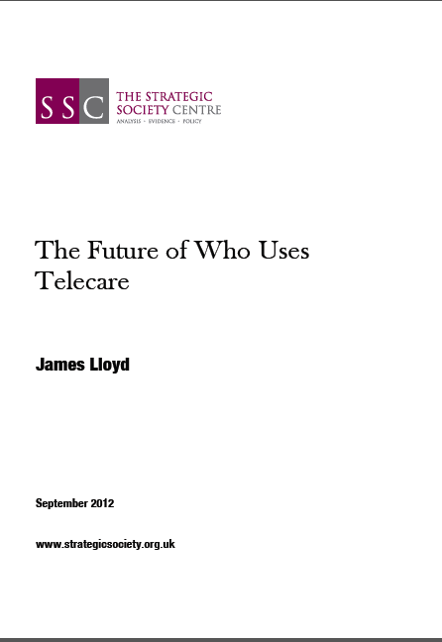
Various caveats are used in presenting the figures. The publication make various recommendations to policy makers. They include estimates of potential telecare users in the older population, concluding that as many four million people could be potential users of telecare.
See also:
Millions of people could benefit from telecare
'Four million could benefit from telecare'
Item 4 – Report from Good Governance Institute (GGI) - 'Care and support at home: an audit of telecare services in England'
GGI has published a new report (Summary) that brings together recent information from local authorities obtained through Freedom of Information Act requests. There was an 80% response rate. The full report is also available on request.
Again with this report, there are a number of caveats about the figures obtained from the local authorities that responded.
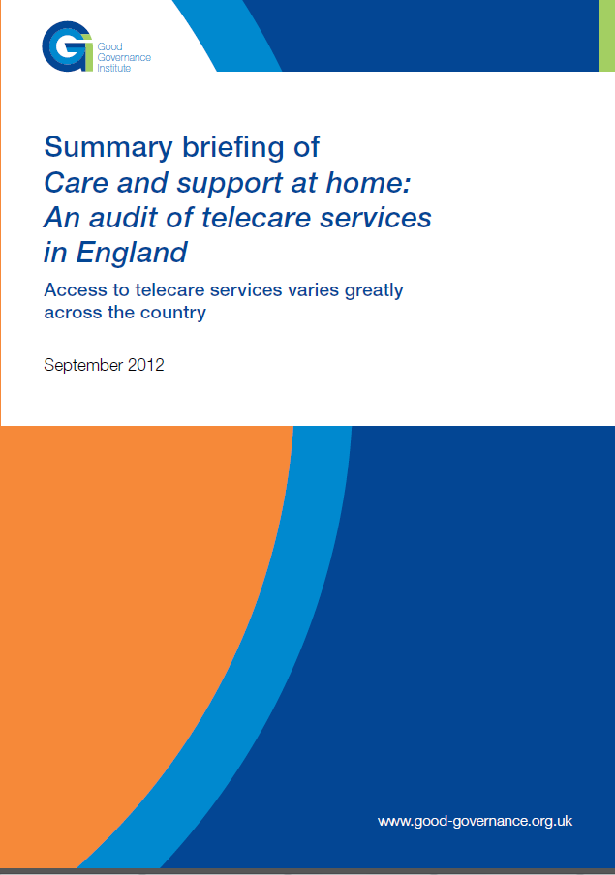
This GGI report provides a number of recommendations aimed at Government and local authority officials about how telecare services and user outcomes can be improved. These include telecare definitions, commissioning pack and plans, integration arrangements, prevention approaches, pooled budgets, telecare spending from NHS resources, awareness raising including Three Million lives.
See also:
Community Care: Postcode lottery in access to telecare revealed by national audit
Item 5 – Report from Carers UK – ‘Carers and Telecare’
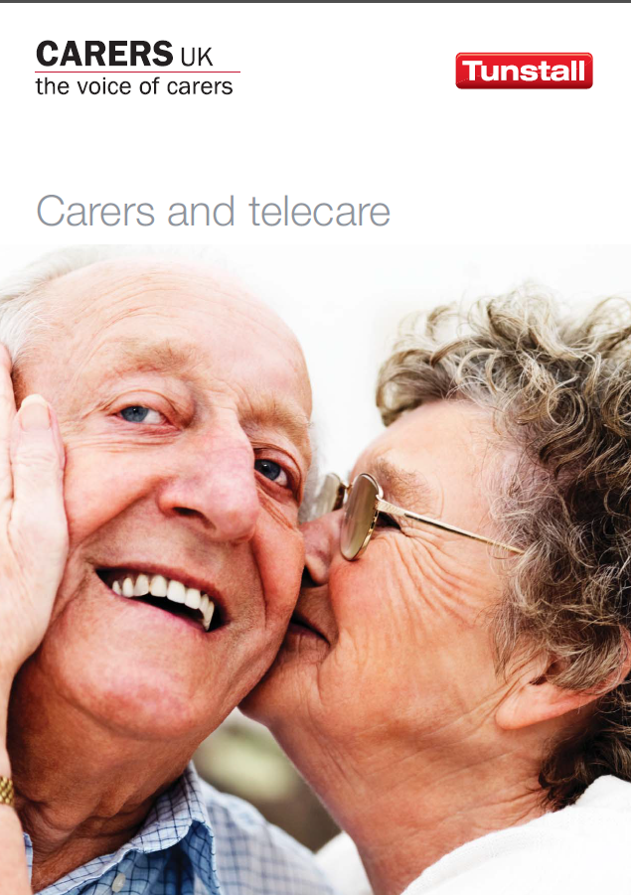
A new report on ‘Carers and Telecare’ is available from Carers UK. The report looks at the evidence and opportunities provided by telecare and telehealth and the barriers to greater take-up. The survey presents some useful findings for commissioners and service providers.
- Over 60% of carers surveyed said telecare/telehealth had given them peace of mind as a carer
- One in eight carers said telecare/telehealth had helped them stay in work or return to work alongside caring
- Almost two thirds of carers not using telecare/telehealth were unaware of the support available from technology
- Of carers not currently using telecare/telehealth one in four would like it but simply did not know where to find it
- Only 6% of carers said they would not want telecare/telehealth
Item 6 – Housing LIN News
Our sister organisation, Housing LIN is the leading national network for promoting innovative new ideas in enhancing the housing choices for older people and supporting change in the delivery of housing and related care and support services. Over the next five years, a £300m capital grant fund will operate to help develop specialised housing around the country. Extra funding will help more people stay independent for longer by creating extra housing tailored to individuals’ needs, keeping more people out of hospital and in their own home for longer. If you want to keep up to date and are not a Housing LIN member, you can register at http://www.housinglin.org.uk/useraccount/.

The Housing LIN also covers telecare and telehealth from time to time. A new viewpoint prepared by Ed Harding and Michelle Kane, entitled ‘Get with the programme? A look at health and wellbeing boards through the lens of telehealth and telecare’ is also now available along with two Board Assurance Prompts for specialist and general needs housing organisations.
Item 7 – Telehealth Implementation toolkit from South Yorkshire CLAHRC – ‘Ready, Steady, Go’
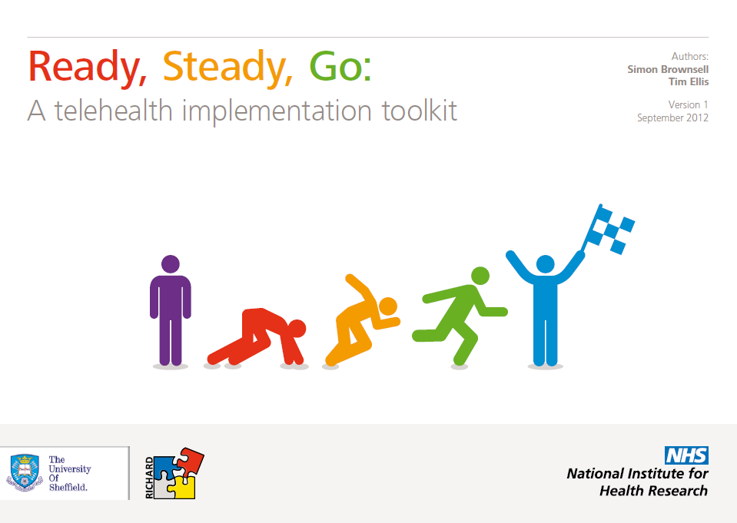
Based on experience, and validated by national and international experts, the ‘Ready Steady Go’ toolkit provides a framework that can be followed by organisations as they incorporate telehealth, and which should provide a supportive environment in which telehealth can flourish.

CLAHRC SY has collaborated with an EU-funded project called Regional Information and Communication Technology based Clusters for Health Care Applications and R&D integration (RICHARD) to produce the document.
This excellent toolkit prepared by Dr Simon Brownsell and Tim Ellis is a very useful document and comes highly recommended.
Item 8 – News Roundup
Here is a roundup of other news over the last month. A fuller listing is available in the supplement (doc, pdf).
a) Following the recent Cabinet reshuffle, there is a new Secretary of State for Health, Jeremy Hunt, and new Ministers at the Department of Health in England.
b) At a conference meeting on 24 September 2012, new social care minister, Norman Lamb called for innovation within the NHS, noting that more GP appointments could be conducted by email, saving time, which could then be freed-up for those with long term chronic conditions. He said freeing up the time of GPs would allow them to work with care teams and support patients with long-term conditions, ultimately enabling patients to "self-care”. "Telecare and Telehealth can be transformational in terms of enabling independent living much longer than would otherwise be the case,” he said.
c) Alistair Burns, DH National Clinical Director for Dementia writes in the Guardian - Primary care holds the key to raising quality of dementia patients' lives. Read more about the Department of Health’s dementia campaign or follow Dementia Challenge.

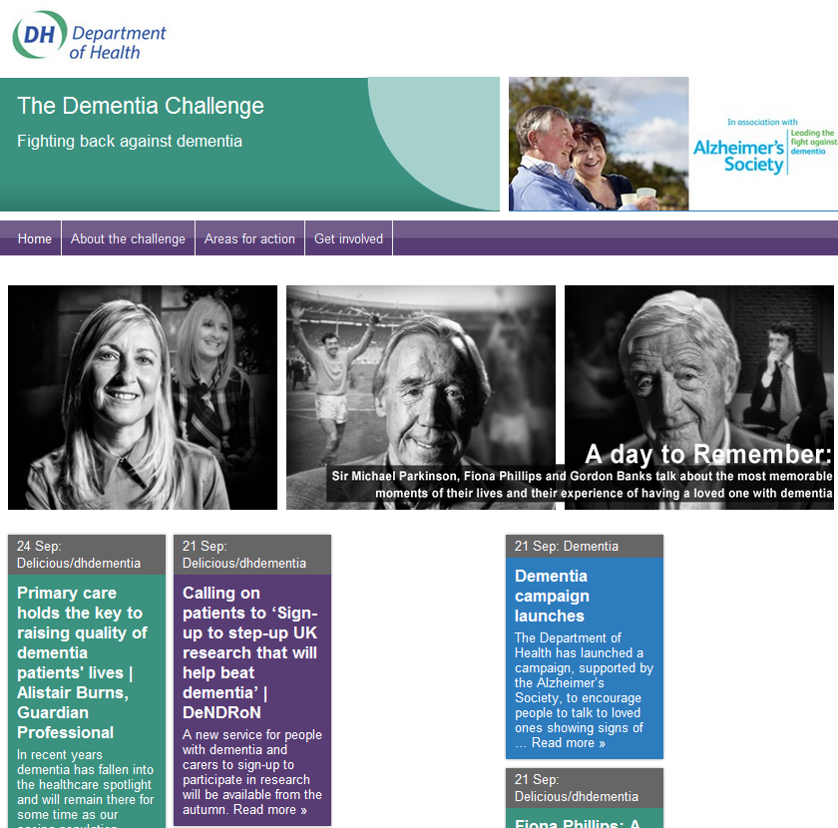
See also
Nice Guidance on Dementia – CG42
JIT/DSDC workbook on ‘Telecare and Dementia’
d) Liverpool has joined a network of "age-friendly" cities with new approaches to supporting older people which includes the use of assistive technology including telecare. The programme also includes a £7.7m dallas investment using 200 community champions to raise the profile of activities and services available to people in neighbourhoods, in order to address issues of loneliness and promote social inclusion.
e) Some early positive outcomes from a joint Berkshire Healthcare NHS Foundation Trust and Heatherwood and Wexham Park Hospitals NHS Foundation Trust telehealth study of 65 COPD patients have been published. NHS Gloucestershire has reported on the success of its telehealth service following a 12-month evaluation, which found that 88% of patients receiving telehealth in Gloucestershire would recommend the service to their friends and families, whilst another 85% rated the service as either excellent or good.
f) A recent TelecareAware article picks up the issue of reports from various sources about telehealth safety. Much of this reporting stems from a small Mayo Clinic trial. From the published paper, the mortality rate for the telemonitoring group (14.7%) was about what they expected from their knowledge of a group with complex comorbidities (13%) and the usual care mortality was lower than expected (3.9%) for the 12 months covered. It is important that anybody interested in telehealth looks at the paper in more detail to read what the researchers found. Articles referring to this paper seem to conveniently leave out the detailed discussion. If there had been any significant safety risks from the telehealth devices and service follow up then the trial organisers and researchers would have stopped the programme. Indeed on Page 775 of the Journal, the researchers say 'No direct harms or unanticipated problems involving risk to participants or others were reported'.
g) Recent tenders for telecare programmes have been published for Hampshire and Thurrock. GP commissioners in Cornwall and the Isles of Scilly are looking to procure a telehealth service to support up to 20,000 patients. An emergency alarm service to help people in Bath and North East Somerset to stay in their own homes for longer has been launched. The Birmingham Post are reporting that the Council’s £14m Telecare Programme is currently behind schedule with around 32 installations per week compared with 60.
h) Researchers from the University of Sheffield are appealing for volunteers to take part in a telecare study. The study will assess why some people choose not to use telecare support aids - such as pendant alarms, sensors and other devices which help people to live safely and independently in their home. "Many people decide not to use telecare, or might not be aware of the benefits of telecare, or how items could help them to continue living independently for longer," says the University. "We would like to speak to people who have never used telecare but who might benefit from the devices on offer." If you would like to take part in the study or if you want more information call Claire Bentley on 01142 222976 or email c.bentley@sheffield.ac.uk
i) From Pulse Today (may require registration) – ‘Telehealth needs a human face’ by Dr Ian Greaves (GP in Stafford), whose practice has used telemonitoring technology in a management scheme for patients with dementia, reports on progress including service improvements for patients and their families as well as potential savings. Ian Greaves said ‘Telehealth on its own doesn't work, but telehealth with a workforce that's going to support it can help people take responsibility for their own health’. Pulse Today also has a video interview with Adam Steventon from the Nuffield Trust covering telehealth and the WSD evaluation.
j) The Department of Health has identified a £1.5m budget for the potential roll out of personal health budgets. The evaluation of pilots is due this Autumn. People whose complex care needs are paid for by the NHS through the NHS Continuing Healthcare scheme, or those with a range of long-term conditions such as stroke, diabetes, neurological conditions, mental health needs and respiratory problems like chronic obstructive pulmonary disease (COPD), have been involved in the pilots.
k) In an update letter on Payment by Results and the national tariff in England for 2013/2014, the Department of Health has said that they plan to further expand the number of best practice tariffs aimed at ‘promoting better management of long term conditions to reduce the risk of avoidable hospital admissions’
l) A new NIHR report – ‘Understanding and improving transitions of older people: a user and carer centred approach’ has been published.
m) From EHealth Insider, A Newham University Hospital NHS Trust pilot of diabetes patients having outpatient appointments via Skype has reduced A&E attendances amongst participants. The one year pilot study replaced routine follow-up outpatient appointments for patients not requiring physical examination with web-based consultations.
n) i-focus has been working with the dallas communities. Find out more
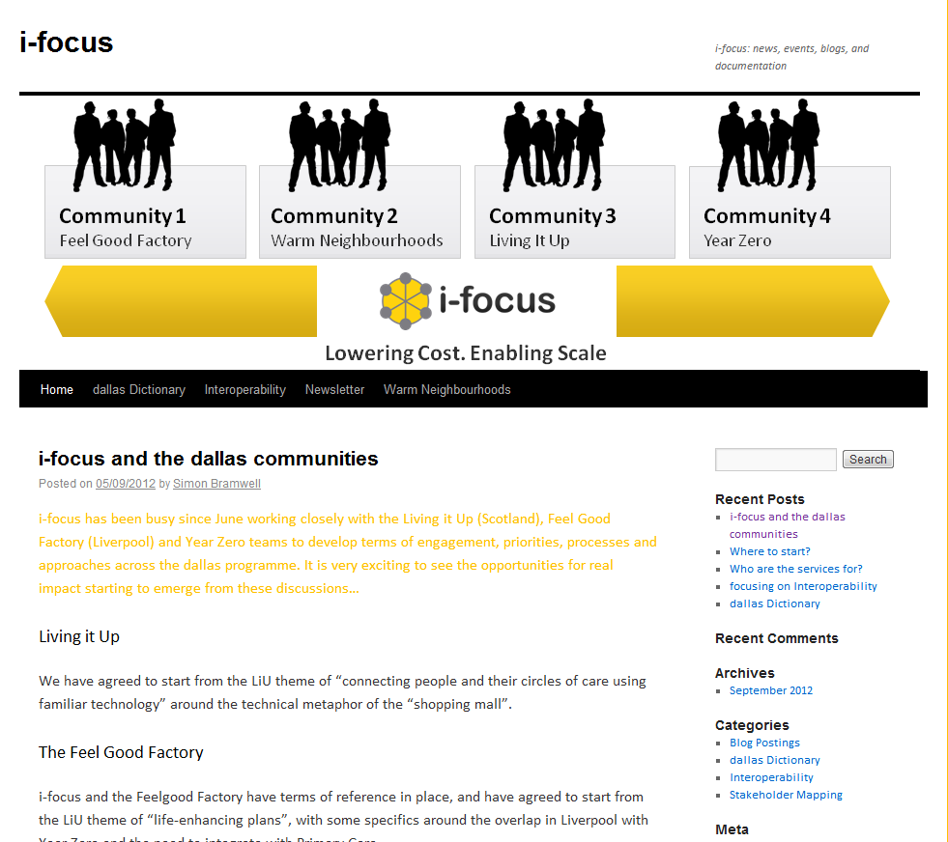

o) From the Telegraph, IP is to invest up to £500,000 in Oxehealth, creators of software that can be used with a webcam to track patients’ pulse, breathing rate, and oxygen saturation without the need for any other hardware.

p) Liverpool’s planned new specialist dementia care unit is expected to be used by up to 30 people per day and includes a 'Telecare' suite where staff will be able to fully assess people and identify the most suitable types of technology which can be fitted at home to help them stay safe such as sensors and warning alarms.

q) A UK telehealth text-based messaging system (Florence) developed in conjunction with NHS Stoke is extending low cost services whilst awaiting an evaluation from Warwick University.

r) In a Scottish Daily Record Report, People in Moray have become the first in Scotland to be equipped with wireless body patches which feed data back to GPs through broadband. It means they don’t have to visit the doctor or leave the comfort of their own homes. The ‘telehealth’ system logs patients’ blood pressure, oxygen levels, temperature and pulse and medics can intervene at the first sign of a problem.
s) From Healthcare Today, a report indicates that Edinburgh Council is working with housing, care and community services provider Bield to develop a system that allows people with dementia and other cognitive disorders to walk about safely, using global positioning satellite locating devices. Seven people are currently piloting the GPS Safe Walking project and are being monitored by researchers at Edinburgh University.
t) North Yorkshire County Council is the first local authority to take training in telecare use into private residential care and nursing homes. Following a pilot scheme in Scarborough, the council's health and adult services have provided training in the use of telecare to staff at more than 20 care homes. A second phase of training at a further 30 to 40 care homes is planned.
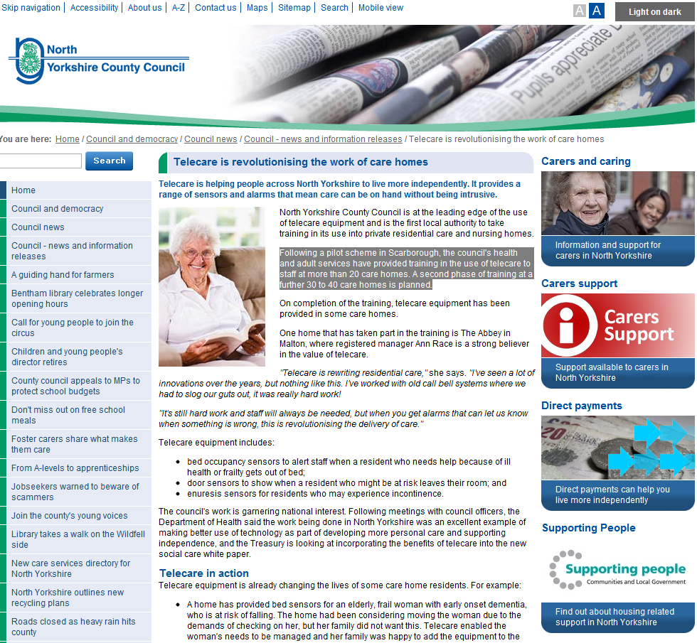
u) Northamptonshire Healthcare NHS Trust is among the first in the country to offer video consultations between doctors and some patients. People with attention deficit hyperactivity disorder (ADHD) or Aspergers will be able to speak to a clinic from their home from now on using the video calling website Skype and a webcam.
v) An article in the Irish Times covers how consultant Rheumatologist, Dr Ronan Kavanagh uses social media such as Facebook and Twitter.
w) The Journal of Assistive Technologies has an article on telecare fall detectors with mixed findings. The work was carried out to inform a service evaluation of the use of fall detectors across the West Midlands region and was funded by NHS West Midlands.
x) Age Scotland has requested a review of telecare services offered to elderly residents by phone line operators and local authorities after a 92 year old lay injured for more than 12 hours after the phone operator cut off his landline over a £90 bill. A panic alarm around his neck was rendered useless when his line was disconnected without his knowledge.
y) Healthcare IT News has an interview with VA’s Adam Darkins who also features in an excellent 30 minute Transform 2012 conference video. A new VA update shows the extent of their telehealth service. In 2011 over 380,000 veterans used the clinic-based telehealth services and 100,000 patients nationwide were enrolled in VA’s Home Telehealth program. Veterans can connect with VA specialists such as mental health, cardiology, dermatology, gastroenterology, rheumatology and urology.
Item 9 – Learning and Events
Loretta MacInnes (Telecare Services Association) provides an update on their upcoming conference
The International Telecare and Telehealth Conference 2012 will take place on 12 – 14 November 2012 at the Hilton Birmingham Metropole.
Come to conference to find out how telehealth and telecare can positively impact on the patient and service user journey, bringing real benefits to the individual, their family and carers, healthcare practitioners and the pharmaceutical industry.
Conference speakers include:
- Norman Lamb MP, Minister of State for Care & Support (invited)
- Rt. Hon Patricia Hewitt, former Secretary of State for Health; Senior Independent Director, BT and Chair, UK India Business Council
- Stephen Johnson, Deputy Director, Head of Long Term Conditions and Urgent & Emergency Care, Department of Health
- Dr Robert Stewart, Medical Director for Clinical Commissioning and Strategic Change, NHS Kent and Medway
- Fiona Philips, Broadcaster and author
- George Crooks, Medical Director/Chief Operating officer for NHS 24 and Director of the Scottish Centre for Telehealth & Telecare
- Mark VanderWerf, Chairman, American Telemedicine Association International SIG
Delegates can choose from 25 breakout sessions and case studies. View the largest specialist telehealth and telecare exhibition featuring new product launches and the latest innovations.
You can view the full conference programme and book online at: www.telecare.org.uk/conference or contact the TSA Conference Team on 01625 520320 and email: admin@telecare.org.uk
For further forthcoming learning opportunities and events that may be of interest, click on the links below:
AAL Forum - Eindhoven 24-27 September 2012 http://www.aalforum.eu/
PharmaTimes Special Meeting - New Patient Pathways – Telehealth and Telecare, 2 October, London
http://www.pharmatimes.com/Events/Telehealth_Telecare.aspx
RCGP Conference, Glasgow, 3-6 October 2012
http://www.rcgp.org.uk/annualconference
Healthcare Efficiency through Technology Expo - 9 October 2012, London
http://www.healthcareefficiencythroughtechnologyexpo.co.uk/event-at-a-glance/
E4H – Long Term Conditions – implementing self care, Leeds, 10 October 2012 (also other venues)
http://www.events4healthcare.com/LTC.html
The Queen's Nursing Institute Conference - Healthcare at Home, 15 October 2012, London http://www.neilstewartassociates.com/sh288/index.php?utm_source=Twitter&utm_medium=Tweet&utm_campaign=sh288%2BQNI
NCAS/ADASS, Eastbourn,e 24-26 October 2012
http://www.adass.org.uk/index.php?option=com_content&view=article&id=761&Itemid=454
Telehealth 2012 (Health Service Journal/Nursing Times) – London, 30-31 October 2012 http://www.hsj-telehealth.co.uk/
Telehealth and Telecare in Scotland: home and away, 1 November 2012, Edinburgh
http://bookings.shscevents.co.uk/all/2846

EHI Live 2012 6-7 November 2012, Birmingham, http://www.ehi.co.uk/events/ehi-live-2012/
Health 2.0 Europe, 6-7 November 2012, Berlin http://www.health2con.com/events/conferences/europe-fall-2012/
The International Telecare and Telehealth Conference (TSA), 12-14 November 2012, Birmingham http://www.telecare.org.uk/conference
Accelerating innovation in healthcare - 14 November 2012 London
http://www.westminsterforumprojects.co.uk/forums/event.php?eid=457
RAATE, 26 November 2012, Warwick http://www.raate.org.uk/
eHealth & Telemedicine 2012 - 3million and rising: Integrating care, mainstreaming technology (Royal Society of Medicine) Monday - Tuesday 26 - 27 November 2012 London http://www.rsm.ac.uk/academ/ted01.php
Healthcare Innovation Expo 2013 - Europe's largest, most exciting healthcare innovation event - 13th & 14th March 2013, London http://www.healthcareinnovationexpo.co.uk/

Item 10 – Other useful links
DALLAS _Connect Sub Group
Join the Sub Group at: https://ktn.innovateuk.org/web/dallas
Telecare Learning and Improvement Network www.telecarelin.org.uk

King’s Fund web site – telehealth and telecare
http://www.kingsfund.org.uk/topics/technology_and_telecare/index.html
Telecare Aware – daily news and comments www.telecareaware.com
Three Million lives
http://www.3millionlives.co.uk/
Twitter: @3MillLives and now on LinkedIn

Newsletter prepared by Mike Clark (@clarkmike) and brought to you by the Telecare LIN on behalf of the Technology Strategy Board
Disclaimer: “We provide this newsletter for information purposes only and neither the Technology Strategy Board nor the authors accept any liability whatsoever for inaccuracies, errors or omissions therein or for any consequences arising therefrom.”


