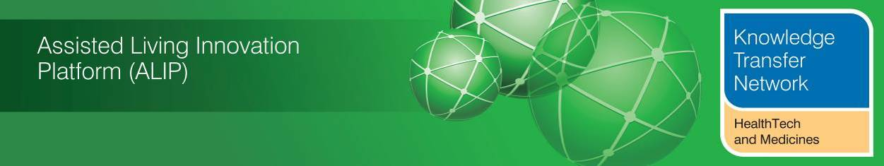
NEWSLETTER
November 2013
Welcome to the November 2013 newsletter from the Technology Strategy Board (TSB) Knowledge Transfer Network and the Telecare Learning and Improvement Network. We are grateful to the HealthTech & Medicines KTN and the TSB’s Assisted Living Innovation Platform for providing newsletter funding for another year enabling us to continue to provide the most comprehensive newsletter available serving the telecare, telehealth, mobile health, digital health and assisted living communities.

Launched October 2005, our free monthly newsletter is now distributed to 48,000 subscribers in the UK and worldwide via e-mail and archived at www.telecarelin.org.uk. You can also find highlights on Prezi (monthly) or Rebelmouse (daily) or by following Mike Clark on Twitter (@clarkmike). With over 800 news and events links over the last month, we hope that you find this newsletter useful.

November saw the announcement of the 14 integration pioneers in England (read more about the pioneers and the Integration Transformation Fund in an additional supplement this month - doc, pdf). Integration is clearly the way ahead in the UK. Commissioners and providers will need to consider how technology supported services can be at the heart of integration plans as there is less and less overall money together with limited skilled staff available to sustain existing configurations of health and care services. Innovative services like ‘Living it Up’ in Scotland will need to lead the way. A&E services are under serious pressures across the UK and further investment is being made to cope with winter – again the sector needs to demonstrate through personal and home sensors, apps, remote monitoring and schemes such as Warm Neighbourhoods that people can be supported at home. The December newsletter will have some conference updates, but to get us started, we have a report on the recent excellent conference in Scotland as part of a week of telehealth and telecare activities. There is a further update from NHS England on 3millionlives. Finally, with a continuing interest in innovation in health, housing and social care why not get involved in NHS Change Day – an opportunity to make a pledge to improve services.

The newsletter contains a list of KTN/ALIP activities, conferences and workshops from the UK and Europe over the coming weeks as well as news from the UK and around the world. For weekly news, updates and information, you can register with the Technology Strategy Board, ALIP group and the dallas sub-group. You can follow the dallas programme on Twitter at @dallas_connect. 3 Million Lives is on LinkedIn. You can also access a Twitter Stream via the TelecareLIN website.

Contents

Item 1 – News from ALIP (Assisted Living Innovation Platform), the Knowledge Transfer Network (HealthTech and Medicines KTN) and dallas – Page 3
Item 2 – 3millionlives - New technology can improve the health services delivered to millions of people – Page 6
Item 3 – NHS Change Day 2014 - Why social care should get involved – Page 9
Item 4 – Scottish Telehealth & Telecare Week – Page 10
Item 5 – Knowledge Tree Event – Page 12
Item 6 – UK policy announcements – Page 12
Item 7 – Other news – Page 21
Item 8 – Summary list of recent journal articles and evaluations – Page 26
Item 9 – Learning and Events – Page 27
Item 10 – Other useful links – Page 28
Additional:
links supplement (over 800 this month) - doc, pdf formats
Integration supplement – doc, pdf formats

The newsletter is
Prepared by Mike Clark (Twitter: @clarkmike and http://storify.com/clarkmike) for the ALIP Knowledge Transfer Network and Telecare Learning and Improvement Network.

Item 1 – News from ALIP (Assisted Living Innovation Platform), the Knowledge Transfer Network (HealthTech and Medicines KTN) and dallas
a) Formal launch of Living it Up
The formal launch of Living it Up (LiU), a £10m digital health, care and wellbeing project, took place this month (November 2013) with Scotland’s Cabinet Secretary for Health and Wellbeing, Alex Neil when he visited The Peak sports complex in Stirling.
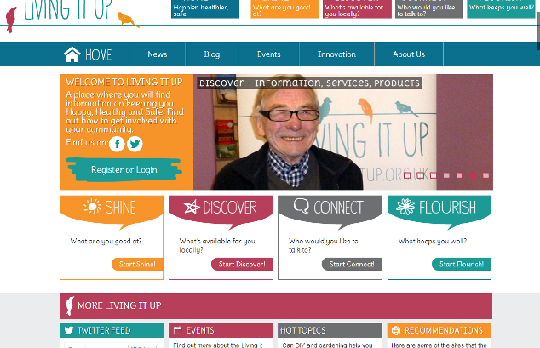
The project has enlisted local communities over a three year period to help in the design and development of ways in which local services can be delivered digitally. LiU will ultimately provide communities with better choice and control over their health, care and wellbeing. This will be delivered via innovative and integrated health, care and wellness services, information and products via familiar technology enabling people to care for themselves and others. These technologies will include mobile phones, tablets, computers, TV and games consoles.
The Minister (centre in picture) heard first hand from Forth Valley residents Bernard McGuckin, 61, who is currently on the lung transplant waiting list, and Betty McFarlane, 57, who has received a lung transplant, about how Living it Up will make a difference for local people, not only those with long term conditions but also for those who want to remain healthy and active.
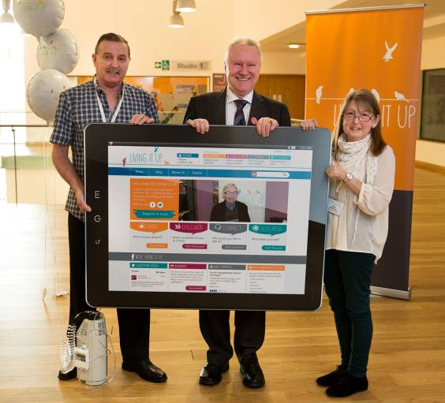
Health Secretary Alex Neil said: “I am determined that Scotland’s health service should lead the way in delivering care in new and innovative ways that really benefits patients”.
“Technology like this will help us do exactly that. Importantly it looks at care in a rounded way – not just treating people as patients but linking them into their local community and helping them to pursue interests that keep them healthy.
"That includes supporting people to live independently at home - one of our key priorities,. That it is generally better for people's health and will also help our health service cope with our ageing population.
“Over the last four years, Scotland has made significant progress on developing and expanding new technologies to help provide effective care and reassurance to many older people who want to stay at home.
"This project demonstrates our commitment to build on this progress and to expand even further the role technology plays in supporting twenty-first century healthcare.”
Living it Up is being developed at first in five areas – Forth Valley, Lothian, Moray, Highland/Argyll & Bute and the Western Isles. It is initially aimed at the over 50s but will also be of benefit to people living with long term conditions, care givers and those who just want to keep happy, healthy and safe.
Ultimately the project aims to build a community of 55,000 users in Scotland by May 2015 and to deliver both community and economic benefits to Scotland through innovation.
This phase of the project, which began in June 2102, saw an initial recruitment of 5000 people from the five pilot regions to help shape the project’s key service prototypes – Shine, Discover, Connect and Flourish. These services are as a result of extensive community engagement events and co-design workshops attended by members of the five communities, service providers, technology experts and innovators. It will provide an easily accessible menu of local services, information, products and social activities to support health, care, wellbeing and personal interests.
NHS 24 has been appointed by the Scottish Government to provide overall leadership for the project. Professor George Crooks, Medical Director, NHS 24, said: “Scotland is recognised worldwide as a leader in innovative telehealth and telecare services and products. Living it Up is an ambitious and unique programme which will assist in the integration and effective delivery of health and care services, while empowering users and carers to actively manage their own health, care and wellbeing and maintain their independence.”
For more information, visit www.livingitup.org.uk
b) eRedbook receives enthusiastic reception at CPHVA conference
The dallas _connect website (@dallas_connect) is a great way of keeping up to date with the overall programme as it rolls out. Year Zero have posted an article around the eRedbook on the _connect site. Don’t forget to join the dallas group so that you can keep up to date and network with others interested in this important initiative.
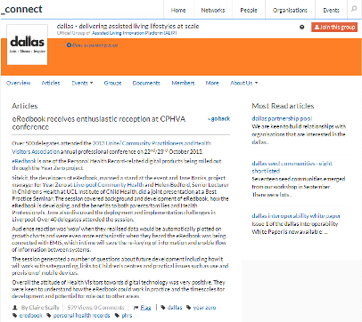
Over 500 delegates attended the 2013 Unite/ Community Practitioners and Health Visitors Association annual professional conference on 22nd/23rd October 2013.
eRedbook is one of the Personal Health Record-related digital products being rolled out through the Year Zero project.
Sitekit, the developers of eRedbook, manned a stand at the event and Jane Banks, project manager for Year Zero at Liverpool Community Health and Helen Bedford, Senior Lecturer in Children’s Health at UCL Institute of Child Health, did a joint presentation at a Best Practice Seminar. The session covered background and development of eRedbook, how the eRedbook is developing, and the benefits to both parents/families and Health Professionals. Jane also discussed the deployment and implementation challenges in Liverpool. Over 40 delegates attended the session.
Audience reaction was ‘wow’ when they realised data would be automatically plotted on growth charts and were even more enthusiastic when they heard the eRedbook was being connected with EMIS, which in time will save the re-keying of information and enable flow of information between systems. The session generated a number of questions about future development including how it will work with safeguarding, links to Children’s centres and practical issues such as use and provision of mobile devices.
Overall the attitude of Health Visitors towards digital technology was very positive. They were keen to understand how the eRedbook could work in practice and the timescales for development and potential for role out to other areas.
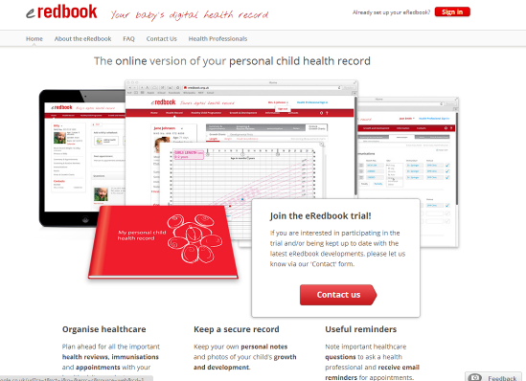
Item 2 - 3millionlives - New technology can improve the health services delivered to millions of people
 | Rachel Cashman, Head of Collaboration for Excellence, explains how NHS England will deliver the 3millionlives programme. | 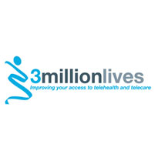
Also available from NHS England - New technology can improve the health services delivered to millions of people.
“As we all know, we have a growing elderly population, a growing number of people with Long Term Conditions (LTCs), and growing numbers of people with multiple LTCs. That is putting an increasing strain on already stretched NHS resources.
One in three people are living with at least one chronic condition, such as asthma, heart and lung disease, arthritis, hypertension and diabetes – and half of people over the age of 60 have one.
One in three of the population in England amounts to just over 15 million people with an LTC – and it’s estimated that by 2025 this will rise to 18 million.
People with LTCs are the biggest users of the NHS, accounting for around 50 per cent of GP appointments, 64 per cent of inpatient appointments and 70 per cent of inpatient hospital beds – meaning 30 per cent of the population accounts for 70 per cent of the spend.
If we continue to manage care in the same way as we do now, we can expect to see an estimated £4bn of additional cost on the NHS in five years.
In the new NHS and social care landscape, we need to find new approaches and service delivery models that will deliver more efficient and effective care.
We need better health outcomes and innovations that support people to live more independently, and we know that technology enabled care services can transform peoples’ lives.
The challenge we face now is integrating these technologies into the NHS and wider health and social care services, so they become a mainstream service, not a side-line proposition. And this is where the 3millionlives programme, delivered in the right way, can really make a significant difference.
So, what has NHS England done since taking over delivery of the programme on April 1?
Our first action was to conduct a rapid review of 3millionlives implementation to date, as there was a significant risk the programme as previously delivered would not hit the interim ambition of 100,000 new users in 2013. The review resulted in a need for a significant shift in strategic direction for the 3millionlives programme, including a redefined vision, mission and objectives for delivery, and bringing on board strong clinical and technological advocacy and a reframed partnership with Industry.
An early outcome from the review was an agreed change in governance arrangements, so that 3millionlives will be delivered going forward through a matrix approach of clinical advocacy, service improvement and technology strategy – making it a true partnership and synergy within NHS England. This is articulated in the vision statement for 3millionlives, which NHS England published over the summer.
There is now tri-partite accountability for the successful delivery of the programme at Director level, with co-ordination for delivery and implementation of the programme residing with my team, the Collaboration for Excellence Team.
Another early action from the review was the recognition that we needed to ensure that we are working together with industry as a true strategic partner in the delivery of 3millionlives, rather than simply as a transactional supplier.
Given the significant changes in the NHS since it was introduced, we felt that it was timely to look at the concordat and the membership of the Industry Group to ensure it was still fit for purpose under the new NHS England vision for delivery of 3millionlives.
Under our redefined vision for the programme, we intend to engage with, work with, and enable the 3millionlives brand to be associated with a much broader range of technology solutions and organisations. We therefore needed to ensure that industry is working with NHS England as a true strategic partner in the delivery of 3millionlives. We agreed with the Industry Group that it would cease to operate in its current form, and that members would adopt new ways of working with the NHS, social care and third sector moving forward.
NHS England has now convened a much wider ‘Integrated Care for 3millionlives’ Stakeholder Forum, bringing together Industry – including all of the original members of the Industry Group – commissioners, providers, colleagues from Social Care, the Third sector, and Local Government and housing, to form a collaborative group to collectively debate and resolve key system-wide issues around the delivery and implementation of the programme.
This is the first time all of the different stakeholder groups with an interest in delivery of 3millionlives have been brought together to look at issues collaboratively. The Forum met for the first time in October.
The programme will also now look much more widely across the system, to harness where the energy lies locally for delivery of 3millionlives. It will also now include a much broader range of assistive technologies – telehealth, telecare, telemedicine and telecoaching. The previous delivery model only focused on the first two of these.
The programme is now much more closely aligned with both the integrated care and technology strategy agendas, and the programme has been repositioned as ‘Integrated Care for 3millionlives’. It will be delivered as a unique collaboration between the NHS, Social Care and Industry to support integrated care, management of Long Term Conditions, and the enablement of 7 day services; an announcement about which is imminent.
So what’s next?
Working collaboratively with our stakeholders, we have identified four key areas where we need to either demonstrate progress, or have in place a clear plan for delivery by the end of this financial year. These are:
- Improving information governance
- Developing commissioning skills and capability
- Improving procurement levers and frameworks
- Developing measurement and metrics
We have established four rapid Task and Finish Groups, one to progress each priority area, and have appointed co-chairs for each.
We propose the findings and recommendations of these Task and Finish Groups inform the publication of a 3millionlives NHS England Delivery Plan for 2014-17, which we plan to publish by the end of March 2014.
I’m delighted that we have such a range of experts with such a breadth of experience driving the progress of these groups forward.
Already in the last 6 months, we have come a long way in moving delivery of the 3millionlives programmes in the direction we all want. For the first time, this truly feels like a collaborative effort to make 3millionlives a success”.
Since publication of the blog, there has been extensive coverage at EHI, Pulse and GP Online. In response to the articles, the following clarification has been provided.
“The intention to see 100,000 patients benefiting from telehealth in 2013 was an interim ambition in the commitment made by the Secretary of State for Health in 2012, to improve the lives of 3million people by 2017 through the use of technology into redesigned pathways. The overall 2017 commitment remains, and is in the NHS Mandate (Section 2.7).
The expectation of 100,000 patients benefitting from telehealth by the end of 2013 was intended as an ambition rather than a target, and was based on the old ‘Pathfinder’ delivery model introduced under DH in 2012. Following the recent period of NHS transition, and in taking on the leadership of the 3millionlives programme, NHS England has recognised and acknowledged that focusing solely on the 7 originally identified ‘Pathfinder’ sites is no longer the right model for delivery – a view shared unanimously by our stakeholders. We have therefore, with their help, radically overhauled the delivery model, moving to a model where we focus on where energy already exists locally for delivery of 3millionlives, so that we can harness it and build upon it.
In light of this, this we are identifying a new and rigorous set of metrics for 3millionlives, which will form an integral part of the 3millionlives Delivery Plan for 2014-17, as referred to in Rachel’s blog.
The ‘rapid review’ Rachel referred to in her speech was an internal review within NHS England of progress to date with the 3millionlives programme, undertaken in consultation with key stakeholders, and culminating in a series of recommendations to the NHS Executive Team. No formal report of the review has been produced.
The rapid review was unanimous in seeking a new operating model and seeking a less silo approach bringing all those interested from health, social care, clinicians, commissioners and industry together to identify system wide issues and solutions. We have done this by the creation of the Stakeholder Forum and it has recommended to us the priorities that would best help them deliver 3 million lives endeavour. We have listened, responded and are acting”.
Item 3 - NHS Change Day 2014 - Why social care should get involved
Thanks to Iris Steen, Head of Communications, Social Care Institute for Excellence
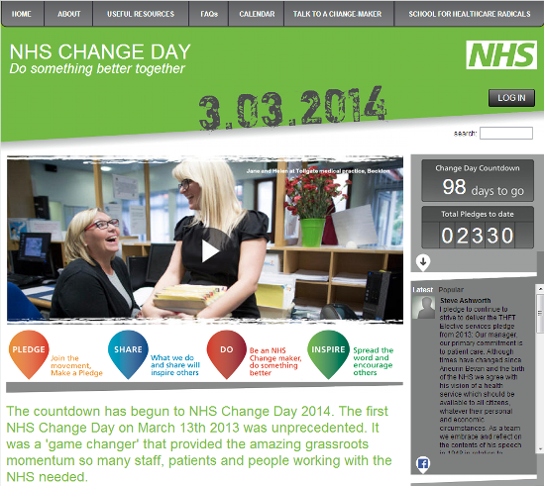
NHS Change Day started with a single tweet in 2012. A small group of healthcare staff decided they wanted to do something better together. In 2013, over 189,000 people made their own personal pledge to do something different to improve care.
So what’s this got to do with social care? Well, everything. We know that you cannot really have effective healthcare without good social care. The next NHS Change Day will be on 3 March 2014, and we have a real opportunity to show how our sector can help to improve the experiences of people who use both health and social care services.
The mission is to inspire and mobilise people everywhere to take action through making a personal public pledge to make a difference no matter how big or small. Everyone counts and every pledge matters.
All you need is an idea of what you could do to make a positive difference. Then you make a pledge - a simple promise to yourself and others that you will act on that idea and become a 'changemaker'.
You can make your personal or organisational pledge now and make sure that the role of social care is prominent throughout the campaign.
Lord Michael Bichard, chair of the Social Care Institute for Excellence, has already made his pledge:
"I pledge that SCIE will make supporting integrated care and health a priority. We will provide practical support and resources to tackle the barriers to effective integration, ensure our work focuses on the outcomes that individuals want, and work in partnership with our NHS colleagues."
And care providers out there are also making their pledges, like George Coxon from Classic Care Homes in Devon:
“We have developed a lot of positive action with health and social care partners sharing best practice and ideas on how we can do better to prevent avoidable admissions to acute hospitals for older frail elderly people. My pledge is that we redouble our efforts to explore more ways to address this through greater integration and steps to keep and get people out of hospital.”
But we need social care to have a stronger voice in this campaign. If you care, if you have an idea you think could help make health or social care a little bit better, please make a pledge. It is a way of taking collective responsibility to get on and do what we know needs to be done to improve care services.
Visit www.changeday.nhs.uk Twitter hashtag: #nhschangeday
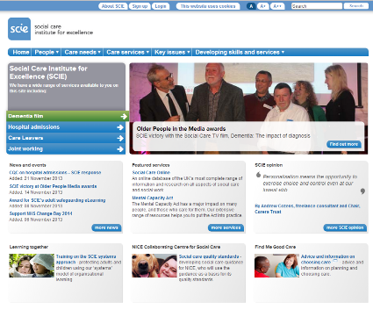
For information about SCIE visit www.scie.org.uk
Item 4 - Scottish Telehealth & Telecare Week
Thanks to Lisa Morton from the Scottish Centre for Telehealth and Telecare
A week of events showcasing the innovative and valuable work of telehealth and telecare took place across Scotland in October 2013.
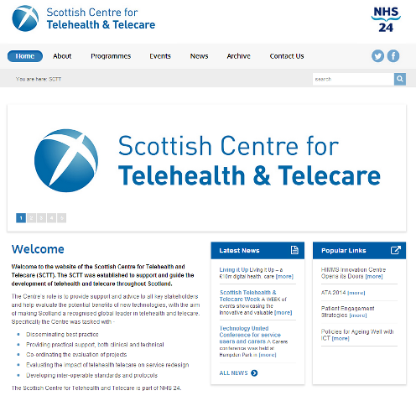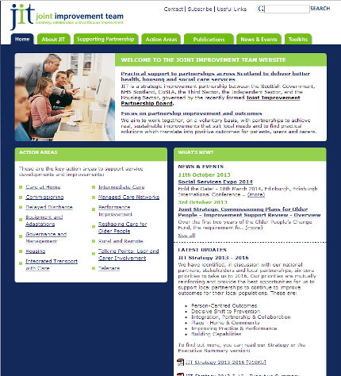
The Scottish Telehealth and Telecare Week, which ran at the end of October, was organised by the Scottish Centre for Telehealth and Telecare and the Scottish Government’s Joint Improvement Team (JIT) with involvement from telehealth and telecare organisations from around the world.
The week saw the formal launch of Scotland’s new innovation centre for digital health, the Digital Health Institute, followed by the inaugural European Telemedicine Conference. The two day event focused on all aspects of telemedicine – telehealth, telecare, e-health and m-health and featured experts from the USA, Spain, Norway, Israel as well as the UK.

Day Two of the conference featured a European Innovation Showcase with live demonstrations of emerging health, care and mobile technologies, a series of panel debates on innovation as well as ‘Dragon’s Den’ style sessions which offer SMEs and start-ups the opportunity to pitch their new ideas to a panel of industry leaders including IBM, Samsung, Deutche Telekom and Atos.
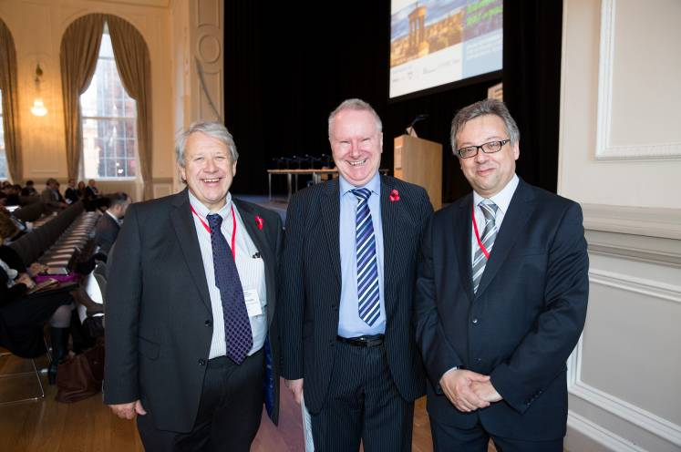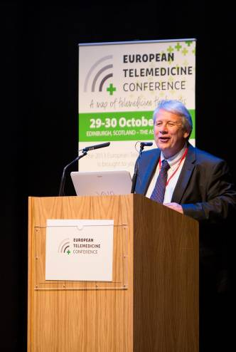
Professor George Crooks (NHS24), Alex Neil MSP and Martin Seychell (Deputy Director General, DG Sanco, European Commission)
Professor George Crooks said: “We should be very proud of the progress we have made in Scotland in implementing at-scale telehealth and telecare services supported by a strong strategic commitment from the Scottish Government, NHS Boards and Local Authorities. We were therefore delighted to be the host country and partner for the first European Telemedicine Conference. The conference also provided an opportunity to showcase best practice in telehealth and telecare from across Europe.”
A Carers conference was held at Hampden Park in Glasgow as part of two SCTT European projects SmartCare and United4Health. It provided opportunities for carers, service users and patients to learn how technology can support health, care and wellbeing. NHS Dumfries and Galloway organised a virtual Telehealthcare conference.
The week ended on November 1st with JIT’s Integrated Care Learning Event - Improvement, Innovation and Transformation at Heriot-Watt University, Edinburgh.
Item 5 – European Knowledge Tree Group – 24/25 March 2014
A range of speakers are being lined up and sponsorship is being sought for the next European Knowledge Tree Group (EKTG) event at the London School of Economics in March 2014. The EKTG is a high level group drawn from across technology, finance, service, policy and innovation sectors that has been looking at:
- Accelerating uptake of ICT & Ageing Solutions
- Determining impact indicators and methodologies for real goals
- Health and care market reforms
- Procurement and contract implications
- The impact of research
- The EU dimension – Horizon 2020
The next meeting in London on 24, 25 March 2013 will be considering:
- Pilots, demonstrators and scaling of initiatives – why aren’t services in the mainstream
- How do we educate people who would benefit from technology-supported solutions
- How do we pay for what is needed?
- What can technology do for mental health, mobility, deafness, diabetes, heart disease?
- How can we exploit technology from field to field?
- How are politicians persuaded of benefits or are they just too short-term?
If you are interested in presenting a paper, exhibiting or sponsoring at this event then send an abstract (no more than 800 words) by 7 January 2014 to Maggie Ellis (ELLISM1@LSE.ac.uk) or Nigel Rix (nigel.rix@espktn.org)
Item 6 – UK policy announcements
Here is a roundup of UK policy news over the last month. A fuller listing is available in the supplement (doc, pdf)
(i) The government has announced that it has published a full response to the 290 recommendations made by Robert Francis, following the public inquiry into the failings at Mid Staffordshire NHS Foundation Trust. This follows the government’s initial response in February 2013.
Actions on safety and openness include:
- transparent, monthly reporting of ward-by-ward staffing levels and other safety measures
- quarterly reporting of complaints data and lessons learned by trusts along with better reporting of safety incidents
- a statutory duty of candour on providers, and professional duty of candour on individuals, through changes to professional codes
- a new national patient safety programme across England to spread best practice and build safety skills across the country and 5,000 patient safety fellows will be trained and appointed in 5 years
- trusts to be liable if they have not been open with a patient
- a dedicated hospital safety website to be developed for the public

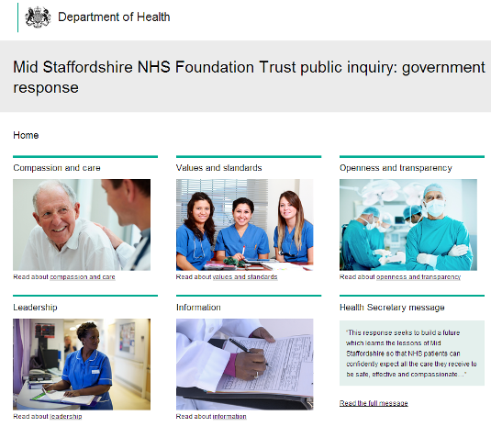
Other actions include:
- a new criminal offence for wilful neglect, with a government intention to legislate so that those responsible for the worst failures in care are held accountable
- a new fit and proper person test, to act as a barring scheme for senior managers
- every hospital patient to have the names of a responsible consultant and nurse above their bed
- a named accountable clinician for out-of-hospital care for all vulnerable older people.
- more time to care as all arm’s length bodies and the Department of Health have signed a protocol in order to minimise bureaucratic burdens on trusts
- a new care certificate to ensure that healthcare assistants and social care support workers have the right fundamental training and skills
- a new fast-track leadership programme to recruit clinicians and external talent to the top jobs in the NHS in England
Further links:
DH Announcement
Secretary of State: foreword to Mid Staffordshire inquiry response
Mid Staffordshire NHS FT public inquiry: government response
http://francisresponse.dh.gov.uk/
Jeremy Hunt’s personal message to all NHS staff following the government's final response to the Francis report.
Making the NHS the safest healthcare system in the world Mike Durkin gives his views on Francis.
NHS England promises new and far reaching drive to improve patient safety.

(ii) Sir Bruce Keogh has proposed a new blueprint for urgent and emergency care across England that proposes a fundamental shift in provision of urgent care, with more extensive services outside hospital and patients with more serious or life threatening conditions receiving treatment in centres with the best clinical teams, expertise and equipment.
Sir Bruce Keogh is publishing a report on the first stage of his review of urgent and emergency care in England. (more about the review on NHS Choices).

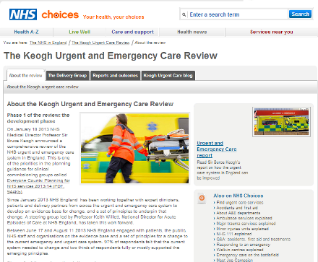

Sir Bruce says: “Our vision is simple. Firstly, for those people with urgent but non-life threatening needs we must provide highly responsive, effective and personalised services outside of hospital. These services should deliver care in or as close to people’s homes as possible, minimising disruption and inconvenience for patients and their families. Secondly, for those people with more serious or life threatening emergency needs we should ensure they are treated in centres with the very best expertise and facilities in order to maximise their chances of survival and a good recovery.”
Highlighting opportunities to shift care closer to home, he says 40 per cent of A&E patients are discharged requiring no treatment; up to one million emergency admissions were avoidable last year; and up to 50 per cent of 999 calls could be managed at the scene.
The report makes proposals in five key areas:
- Providing better support for people to self-care
- Helping people with urgent care needs to get the right advice in the right place, first time
- Providing highly responsive urgent care services outside of hospital so people no longer choose to queue in A&E
- Ensuring that those people with more serious or life threatening emergency needs receive treatment in centres with the right facilities and expertise in order to maximise chances of survival and a good recovery.
- Connecting urgent and emergency care services so the overall system becomes more than just the sum of its parts.
(iii) The Department of Health in England has issued a revised NHS Mandate for 2014 to 2015. Sir Malcolm Grant, Chair of NHS England has welcomed the refreshed Mandate from the Government on behalf of the organisation.
(iv) The Department of Health in England has issued the ‘Public Health Outcomes Framework 2013 to 2016’ along with some technical updates.
(v) This year’s State of Care report from the Care Quality Commission (see also) looks at the pressures on accident and emergency (A&E) services due to an increase of admissions for ‘avoidable’ conditions. The report also brings together the findings of more than 35,000 inspections covering the quality of health and social care services in 2012/13. Findings include:
- More than half a million people aged 65 and over were admitted as an emergency to hospital with potentially avoidable conditions in the last year
- There has been no overall improvement in the NHS around treating people with dignity and respect.
- One in five inspections of nursing homes revealed safety concerns, including failure to give out medicines safely or not carrying out risk assessments when starting to care for someone, and ongoing staffing pressures.
- There is a link between high staff turnover in residential homes and numbers of death notifications, which may suggest that too much staff churn results in gaps in care.
- More than 10 per cent of inspections of residential homes uncovered problems with either safeguarding and safety, staffing, or the care and support received by residents – for example, people not being helped to eat and drink enough.
- More than 10 per cent of home care agencies did not meet standards in staffing or monitoring quality.
- Common quality issues at home care agencies include late or missed calls and this is known to have a profound impact on people using services, leaving people feeling vulnerable and devalued.
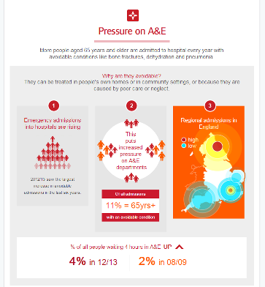
The Department of Health has issued a response to the CQC report.
(vi) The first UK Rare Diseases Strategy has been launched by Health Minister Lord Howe.
(vii) NHS reference costs 2012 to 2013 have been published that includes Information on how NHS providers used expenditure to provide healthcare to patients.
(viii) Adult Social Care Outcomes Framework (ASCOF) data is available as a map that allows people to find out more about care services.
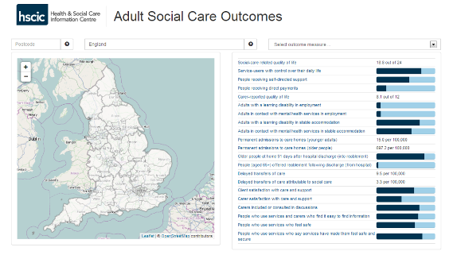
(ix) The Department of Health has published ‘Public health commissioning in the NHS 2014 to 2015’
(x) Updated guidance sets out the principles and processes of the National Framework for NHS continuing healthcare and NHS funded nursing care.
(xi) The Department of Health has issued a further statement on Winter pressures in A&E following a report from NHS England. With a million more people visiting A&E compared to three years ago, the system is under pressure. In response, work is being carried out on transforming out of hospital care by renegotiating the GP contract, agreeing a £3.8 billion integration fund to join up the health and social care system, and backing A&Es with £250 million to prepare for this winter.
A further £150 million will now be distributed around England to help hospitals maintain their A&E services over winter 2013-14 in addition to the £250 million targeted to the most at-risk areas in September 2013. The distribution of the extra £150 million will include those communities that are not deemed the most at-risk, to bolster and enhance their existing plans to maintain services and reduce the pressure on A&Es caused by cold weather.
(xii) ‘Personalised GP care will bring back old-fashioned family doctors’ according to the Department of Health as plans are announced for the new GP contract commencing in April 2014.
Under changes to their contract with the NHS, GPs will ensure the four million patients aged 75 or over will get all the treatment they need for physical and mental conditions.
GPs will oversee personalised care plans integrating all services, so the frail and elderly are better cared for in the community, reducing hospital admissions.
Out of five million emergency admissions last year, one third were people over 75, and more than one million could have been avoided.
GPs’ new responsibilities will include:
- offering patients same-day telephone consultations
- offering paramedics, A&E doctors and care homes a dedicated telephone line so they can advise on treatment
- coordinating care for elderly patients discharged from A&E
- regularly reviewing emergency admissions from care homes to avoid unnecessary call-outs in future
- monitoring and reporting on the quality of out-of-hours care
(xiii) Monitor has produced a preliminary review of walk-in centres (Department of Health statement.
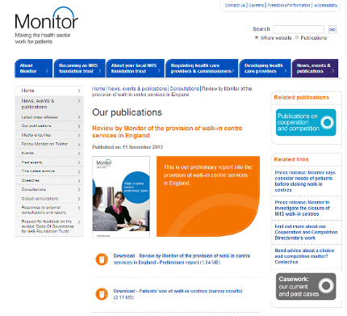
(xiv) Fourteen integration pioneers have been announced in England – you can read more in the November 2013 supplement (doc, pdf). The site are – Barnsley, Cheshire, Cornwall and Isles of Scilly, Greenwich, Islington, Leeds, Kent, North West London, North Staffordshire, South Devon and Torbay, Southend, South Tyneside, Waltham Forest and East London and City, Worcestershire.

(xv) A joint survey by Department of Health and Guardian Social Care Network has suggested new ideas for improving homecare. Jon Rouse, Director General for Social Care, will bring together leaders from the sector to shortlist ideas and to develop them into clear actions, working in partnership with relevant organisations and individuals.
Suggestions to improve homecare included:
- care providers having an online or telephone booking system like online groceries for people to book a care ‘slot’ linked to individual care workers
- using tablets to record care visits with access for the family doctor, local nurse and the person’s family
- creating local care teams so intimate care is never delivered by a stranger
People who took part in the survey said the most important factors in homecare are:
- friendly, respectful and capable care workers
- sufficient time for care
- choice about services

Further link:

Jon Rouse blog about the survey and homecare innovation.
(xvi) NHS England is inviting individuals and organisations to provide written submissions to help inform the development of its five-year strategy for specialised services. Deadline: 13 December 2013.
(xvii) A Regional Innovation Fund (RIF) of £5million is available this year (2013/14) to support and promote the adoption of innovation and the spread of best practice across the NHS. The fund is open to NHS England, as well as the NHS and Academic Health Science Networks (ASHNs). Allocations made through the fund will seek to deliver significant improvements in quality and efficiency in the NHS through innovation.
The categories under which RIF applications fall is two-fold. It can be:
a) aligned to supporting the spread and adoption of current innovations promoted within the NHS and NHS England, or
b) to support the development or adoption of new ideas.
Closing date: 6 December 2013.

(xviii) NHS England has responsed to the Sheffield University two year old study into 111.

(xix) CCG Bulletins now available from NHS England:

Bulletin for CCGs: Issue 45, 1 November 2013

Bulletin for CCGs: issue 46, 14 November 2013
(xx) ‘High Quality Care for All’ has the latest on accessible information.
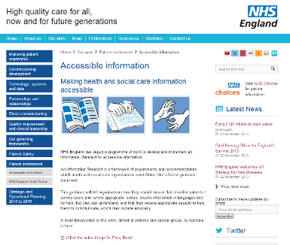
(xxi) Sir Bruce Keogh, NHS England’s medical director has explained the next steps in his plans to revamp A&E services across the country.
“There will be between 40 and 70 Major Emergency Centres but they will be connected as part of a network to smaller emergency centres who will still be receiving the majority of ambulances. By passing patients with acute conditions onto the specialist centres, we can decongest smaller A&E units so they have more capacity”.
“We also know that an enhanced 111 service can be at the hub of all we do: able to put patients in contact with a GP, a nurse, a pharmacist or the mental health team, for example, to get the proper, first-hand advice they need rather than just sending them to A&E. This service will also ensure they get a prompt appointment to see the person who is best placed to help them. It means people can book to see their GP the next day, or get in to A&E without a four hour wait. Of course, as part of this enhanced response service, people who need a 999 ambulance, will get just that”.
5 priority areas:
- Providing better support for people to self-care
- Helping people with urgent care needs to get the right advice in the right place, first time
- Providing highly responsive urgent care services outside of hospital so people no longer choose to queue in A&E
- Ensuring that those people with more serious or life threatening emergency needs receive treatment in centres with the right facilities and expertise in order to maximise chances of survival and a good recovery.
- Connecting urgent and emergency care services so the overall system becomes more than just the sum of its parts.
(xxii) NHS England has created a ‘Make, Share, Buy toolkit’ to enable CCGs to make informed decisions around what and from whom they access Commissioning Support.
(xxiii) In a blog, Tim Kelsey, NHS England’s National Director for Patients and Information, tells the EHI Live conference why transparency is the key to sustainable high quality services:
“Transparency saves lives and it is a basic human right yet transparency, unlike heart surgery, is not mainstream in our health and care services. Last year, I took a vision to the EHI Live conference (held this week in Birmingham) to make transparency the operating principle of the new NHS. Data sharing between professionals, patients and citizens is the precondition for a modern, sustainable public service: how can we put patient outcomes at the heart of healthcare, if we cannot measure them? How can we help clinicians maximise the effectiveness of their resources, if they do not know where they are spent? How can we ensure the NHS remains at the cutting edge of statistical and medical science if we do not allow researchers and entrepreneurs safe access to clinical data? Above all, how can we support patients to take more control of their own care if we do not give them access to their own data? Transparency, I have always argued, is key to public and patient participation and is the means by which we create high quality, sustainable health services. Events of the last twelve months have only emphasised why the data revolution is so urgent. We forecast a £30bn funding gap over the next few years in the NHS – a key response must be to do what every other large consumer industry has done and extract human and economic value from technology”.
Actions:
- transform the availability and quality of clinical data - Care.data/HSCIC
- Link GP and hospital data – From June 2014
- support health and care providers to make rapid progress on being able to share their data, safely, and in real time
- transform patient and public insight resources for local health and care communities. The Friends and family test (FFT) will be launched across all NHS services by March 2015
- CareConnect allows people to feedback on local services by phone, or text, or email, and is currently being tested in 17 Trusts in London and 3 in the north east
- enable every citizen to have online access to a variety of GP services, including booking appointments, ordering prescriptions and their medical records. Detailed guidance for GPs will be published by April 2014
- NHS Choices, a global success story, will over the next few months re-launch its offer to patients and the public and maximise their access to data
(xxiv) NHS England has welcomed the Royal Pharmaceutical Society’s “Future Models of Care” report, setting out the much wider role pharmacists can and should play in treating and advising patients.


(xxv) In a blog, Alistair Burns, NHS England’s National Clinical Director for Dementia, explains the importance of support for people, their families and carers once they have been diagnosed. The aim of high quality support is to ensure that people can live well with dementia and the importance of high quality support is recognised in the National Dementia Strategy (NDS) and the Prime Minister’s Dementia Challenge.
(xxvi) The National Audit Office has produced a report on emergency admissions (NHS England response).
“Many emergency admissions to hospital are avoidable and many patients stay in hospital longer than is necessary. This places additional financial pressure on the NHS as the costs of hospitalization are high. Growth in emergency admissions is a sign that the rest of the health system may not be working properly. Making sure patients are treated in the most appropriate setting and in a timely manner is essential to taking the pressure off emergency hospital admissions.”
Amyas Morse, head of the National Audit Office, 31 October 2013

(xxvii) NHS England has announced new commitments for increased openness and transparency. The new commitments were made as part of the UK’s national action plan at the Open Government Partnership’s annual summit in London.
They include:
- Publishing more clinician level data .
- Publishing more overarching clinical indicators
- Extending the Friends and Family Test
- Linking clinical data from GPs
(See also: ‘Drive for transparency on NHS treatment to be extended’ – article in The Guardian newspaper).
(xxviii) Working with Public Health England and NHS Right Care, NHS England has provided every CCG with a comprehensive data pack to support effective ‘commissioning for value’.

(xxix) A new legal ‘right to have’ a Personal Health Budget has been announced.
(You can follow the Department of Health in England, Jeremy Hunt and Norman Lamb on Twitter at @dhgovuk, @jeremy_hunt and @normanlamb. In Scotland, you can follow the Scottish Government’s Health Department on Twitter @scotgovhealth and Alex Neil @AlexNeilSNP (also @NHS24). In Wales follow @WelshGovernment)
Item 7 - Other news
Here is a roundup of other news over the last month. A fuller listing is available in the supplement (doc, pdf).

(i) Telecare map UK

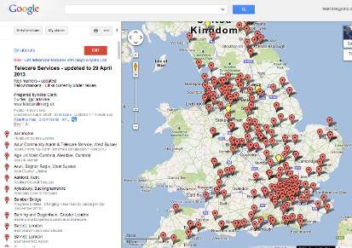
Currently running across multiple Google maps in alphabetical order by home nation – here is an updated map for UK telecare services.
(ii) The NHS European Office has a recent publication on ‘New EU Directive on public procurement - Implications for NHS commissioners and providers’.
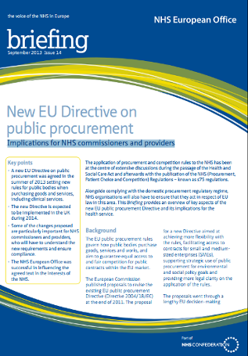

(iii) EHI reports on concerns about the lateness of a decision on the 'Safer Wards, Safer Hospitals: Technology Fund' - Of the total £260m, £90m must be spent in this financial year and £170m in the next and trusts must match any funding they receive.

(iv) According to EHI, GPs will have to update the Summary Care Record daily and give patients online access to their SCR information under the new General Medical Services contract for England.
(v) More coverage due in the December 2013 newsletter – the recent Telecare Services Association’s Annual Conference in Birmingham. Breakout session presentations now available.
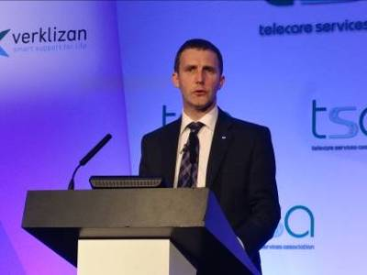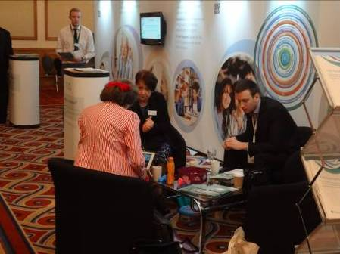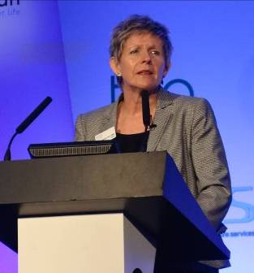
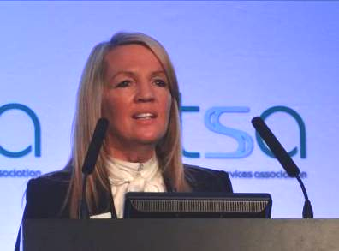
(vi) A report from eHeathInsider – ‘Mandate tells NHS England to push tech’ - The revised NHS Mandate contains a number of IT commitments, in line with policies and targets already announced by ministers (includes 3millionlives in Section 2.7).
(vii) NHS 111 will be enhanced to allow clinical staff to view patients' medical information under plans to overhaul urgent and emergency care provision. NHS England has put NHS 111 procurements on hold while it develops a new NHS 111 service specification, which will go live during 2015-2016. More than 90% of the population now has access to NHS 111 and 97% of calls are answered within 60 seconds. The service received nearly 600,000 calls in September.
(viii) Speaking at EHI Live 2013, Dr Maureen Baker said that the very fast development of apps in the health environment has created a need for better safety assurance, but applying medical device directives may not be the way forward.
(ix) Up to £20m of the 'Safer Hospitals, Safer Wards: Technology Fund' will go towards open source development. Speaking at EHI Live 2013, NHS England’s Beverley Bryant said 20 trusts want to pursue an open source electronic patient record system.

(x) EHI reports that the Health and Social Care Information Centre will extend its support for NHS organisations and providers using open source, open interfaces and cloud technology to increase integration across health and social care.
“By March 2015, we will develop and publish for consultation a 10-year strategic technology futures framework that majors on integration across social care into healthcare services, ensures that there is greater use of cloud technologies, open source, and other new developments, as well as increased use of standards for interoperability,” says the strategy.
(xi) The Journal of Assistive Technologies is planning a special issue in 2014 on research relating to the use of assistive technology for any life benefit by people living with dementia. First drafts are requested by 2 December 2013 and Publication is planned for June 2014.
(xii) If you are following the work of the U.S. Department of Veterans Affairs – here is a list of 15 apps they use.
(xiii) Here is the website for the recently launched CATCH (Centre for Assistive Technology and Connected Healthcare) in Sheffield. There are reports of the recent launch at TelecareAware and Tinder Foundation.
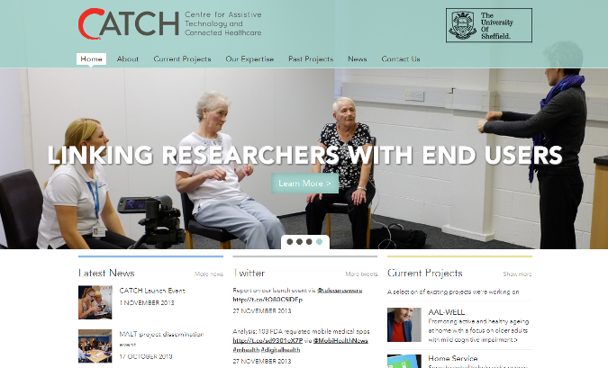
(xiv) There is a new database of telecare and telehealth projects and services in Scotland at the SCTT website.
(xv) Hospital admissions in England are on the increase – up to 15.1m in 2012/13 (13% increase). Every day 41,500 patients are admitted to hospitals across England, according to the latest HSCIC statistics (Guardian report).
(xvi) Widely reported but no evidenced breakdowns yet of the figures claimed – telehealth in the Basque Country of Spain.
(xvii) Telehealth examples are covered in Future ambitions for hospice care - our mission and our opportunity

Highland Hospice is using telemedicine to help it reach across a large rural area. It enables palliative care consultants to give advice from a distance without having to visit the patient. Dundee University is doing related research into this area and is considering how the working practices of the staff are affected by this development. Similarly Sue Ryder Manorlands Hospice started using telemedicine two years ago in partnership with the Telehealth Hub at Airedale Hospital. The hospice’s community team covers a large rural area, and the telemedicine service has proved to be an effective way of delivering support and advice to patients and health and social care professionals. Most recently the hospice has established a new plan to provide extra support to over 30 care homes across Airedale and Craven also using telemedicine.
(xviii) A new national survey by the Pew Research Center, supported by the California HealthCare Foundation, explores how adults with chronic conditions gather, share, and create health information, both online and offline.
(xix) Are there too many grey areas in the FDA final guidance on medical apps issued in September 2013 – HIMSS thinks there could be.
(xx) Reviewing 2013, Mobihealthnews has listed 51 digital health metrics.
(xxi) InformationWeek spoke with five experts scheduled to present at the mHealth Summit, Dec. 8 -11 in Washington, D.C., to discuss mhealth – what did they say?
(xxii) The NHS is to establish a patient feedback website, styled after the popular travel site TripAdvisor, to allow patients to post complaints online and show hospitals' responses to them in real time (Guardian interview with Tim Kelsey).
(xxiii) The recent ‘Transforming Primary Care in London’ report says that a large percentage of the population live with complex (often co-morbid conditions). Approximately 70 per cent of health and social care spend is attributed to the top 20 per cent of people with the highest levels of care need. People with long-term conditions account for more than 50 per cent of all general practice appointments, 65 per cent of all outpatient appointments and over 70 per cent of all inpatient bed days. There is a GP shortage. Nationally 16,000 more GPs will be needed than are currently available by 2021. Almost 16 per cent of London GPs are over 60 years old, compared with 10 per cent nationally. The percentage of GPs over 60 is typically higher in areas where there are many single handers – these also tend to be areas of greater deprivation. A thorough diagnostic of one London region found 30 per cent of practices to be operating from substandard premises – the proportion elsewhere is likely to be similar. Across London only a small percentage of practices are utilising their current digital capability - access to records (3% of practices), cancel or book appointments online (40% of practices) and order repeat prescriptions on line (40% of practices).
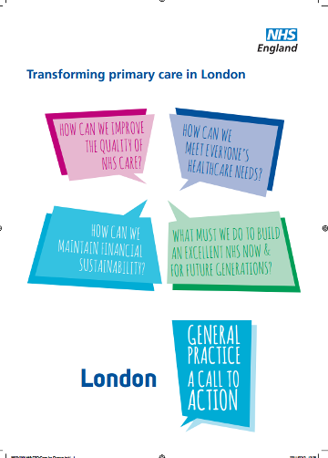
So what can be done? How can primary care services transform? How will the patients and users of services be involved? Would integrated services and more use of digital technology make a difference? What will be the involvement of health and wellbeing boards? How will the integration transformation fund be used? A Clinical Board for Primary Care Transformation, chaired by Dr Clare Gerada and a Civil Assembly will work in partnership with the Office of the London Clinical Commissioning Council and Londonwide LMCs to oversee the Call to Action for General Practice engagement process. Deadline for responses – 1 April 2014.
(xxv) If you have interesting new projects or innovations for our upcoming supplements in 2014 on dementia and long term conditions, send a tweet to @clarkmike.
(xxiv) Don’t forget to catch up with our sister publication ‘Housing with Care Matters’ at HousingLIN – you can also follow on twitter (@housinglin). The next newsletter is available in the week commencing 9 December 2013 – there will be details of the upcoming Housing LIN Annual Conference on 18 February 2014. Keynote speakers confirmed include Lord Filkin, Professor Anthea Tinker and Jeremy Hughes (CEO of Alzheimer's Society). Also, look out for a new briefing on extra care housing.
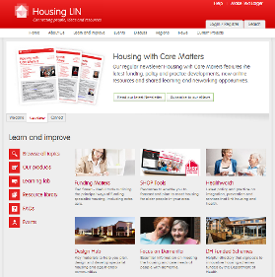
Recent highlights include:
(a) ‘Health begins at Home’ Family Mosaic research project being undertaken by the London School of Economics. It seeks to measure and test out the impact of their services, both as a social landlord and as a provider of housing-related care and support services, and ways in which they can improve the health and wellbeing of older residents whilst at the same time help reduce NHS costs.
(b) SHOP@ - Delivering the Detail - in the six months since the launch, SHOP@ has developed into a wide ranging product that offers housing, planning, adult social care and health professionals the detailed information required for understanding the market for older people's housing and care developments.
Item 8 – Summary list of recent journal articles and evaluations
Each month, our supplement (doc, pdf) provides a comprehensive list of recent journal articles. Here are a few links from this month’s list.

(i) The Journal of Assistive Technologies has a new article on ‘What influences withdrawal because of rejection of telehealth – the whole systems demonstrator evaluation’. In addition, from October there is a report on ‘Impact of telehealth on general practice contacts: findings from the whole systems demonstrator cluster randomised trial’.
(ii) Scottish researchers have a journal article on Advances in Telecare over the past ten years.

(iii) ATTILA (Assistive Technology and Telecare to maintain Independent Living At Home for People with Dementia) is a pragmatic, multi-centre, randomised controlled trial over 104 weeks that compares outcomes for people with dementia who receive ATT (assistive technology and telecare) and those who receive equivalent community services but not ATT. The study hypothesis is that fewer people in the ATT group will go into institutional care over the 4-year period for which the study is funded. The study aims to recruit 500 participants, living in community settings, with dementia or significant cognitive impairment, who have recently been referred to social services.

(iv) JMIR has a report on Systematic Reviews and Meta-Analyses of Home Telemonitoring Interventions for Patients With Chronic Diseases: A Critical Assessment of Their Methodological Quality

(v) Other recent reports:
A Content Analysis of Popular Smartphone Apps for Smoking Cessation
A pilot randomized controlled trial of a depression and disease management program delivered by phone
A videophone psychosocial intervention for dementia caregivers
Apps and online resources for young people with diabetes: The facts
Are doctors the structural weakness in the e-health building
Collaborative Practice Improvement for Childhood Obesity in Rural Clinics: The Healthy Eating Active Living Telehealth Community of Practice (HEALTH COP)
eHealth in Denmark: A Case Study
Electronic and Internet Health Tools May Decrease In-Person Physician Visits
Electronic Health Record Acceptance by Physicians: Testing an Integrated Theoretical Model
Evidence for the long term cost effectiveness of home care reablement programs
High-intensity telemedicine-enhanced acute care for older adults: an innovative healthcare delivery model
Integrated disease management interventions for patients with chronic obstructive pulmonary disease - The Cochrane Library - Kruis - Wiley Online Library
JAMA: Can Mobile Health Technologies Transform Health Care?
Longitudinal Differences in Cognitive Functioning Among Older Adults With and Without Heart Failure
Measuring the effects of online health information for patients: Item generation for an e-health impact questionnaire
Mobile health messages help sustain recent weight loss
Mobile Phone Health Apps for Diabetes Management: Current Evidence and Future Developments
Remote and web 2.0 interventions for promoting physical activity
Security Analysis of a Chaotic Map-based Authentication Scheme for Telecare Medicine Information Systems - Springer
Telecare for diabetes mellitus: case managers' experiences
Telephone-based health coaching for chronically ill patients: study protocol for a randomized controlled trial
Text messaging as adjunct to community-based weight management program
The Complexities of Technology-Based Care: Telecare as Perceived by Care Practitioners Eccles Issues in Social Science
The Effectiveness of Telemedicine for Weight Management in the MOVE! Program
The Long-Term Effects of Lifestyle Change on Blood Pressure: One-Year Follow-Up of the ENCORE Study

Item 9 – Learning and Events
Click on the following links for further conferences and learning events over the coming months.

EHTEL 2013 Symposium: Sustainable Partnerships for Well-being and eHealth, Brussels, 2-3 December 2013 http://www.ehealthnews.eu/events/3689-ehtel-2013-symposium-sustainable-partnerships-for-well-being-and-ehealth?utm_source=dlvr.it&utm_medium=twitter
2nd Annual Telemedicine Summit, Anaheim, 2-3 December 2013 http://www.worldcongress.com/events/HL13033/index.cfm?

Digital evolution: Making good things happen London 4 December 2013 http://www.communityhowto.com/news/digital-evolution-making-good-things-happen
ConnectedCare Camp, London, 7 December 2013 - Follow #psicare http://shirleyayres.wordpress.com/2013/10/25/welcome-to-the-connected-care-camp-on-7th-december-2013-psicare/
mHealth Summit Washington DC 8-11 December 2013 http://www.mhealthsummit.org/

4th International Conference on Wireless Mobile Communication and Healthcare Washington 11-13 December 2013 http://mobihealth.name/2013/show/home

Digital Health: How do we avoid 'Digital Exclusion' in health & social care? Health 2.0, London 22 January 2014
http://www.meetup.com/Health-2-0-London/events/141295512/

Digital Health in UK hospitals: Hope or Hype? Health 2.0, London 19 February 2013 http://www.meetup.com/Health-2-0-London/events/149275452/

Recent developments in digital health, London 27 February 2014 http://www.rsm.ac.uk/academ/tee02.php

The Internet of Things: Could this be the catalyst for innovation in the NHS? ? Health 2.0, London March 18, 2014 http://www.meetup.com/Health-2-0-London/events/149275672/
CUHTec telecare strategy course: Learning disability services Newcastle 20 March 2014 http://www.cuhtec.org.uk/wp-content/uploads/2013/04/20140320_LD.pdf
CUHTec telecare strategy course: moving to digital and mobile telecare Newcastle 21 March 2014 http://www.cuhtec.org.uk/wp-content/uploads/2013/04/20140321_mCare.pdf
eTELEMED 2014 - The Sixth International Conference on eHealth, Telemedicine and Social Medicine Barcelona 23-27 March 2014
http://www.iaria.org/conferences2014/eTELEMED14.html

Does giving patients more data actually increase engagement & improve outcomes? ? Health 2.0, London 16 April 2013

http://www.meetup.com/Health-2-0-London/events/149275892/

First European HIMSS mHealth Summit, Berlin, 6-8 May 2014 – Details to be added when available
Item 10 – Other useful links
HealthTech and Medicines KTN - https://connect.innovateuk.org/web/healthktn
Assisted Living Innovation Platform - https://connect.innovateuk.org/web/assisted-living-innovation-platform-alip
dallas_Connect Sub Group - Join the Sub Group at: https://ktn.innovateuk.org/web/dallas
Housing Learning and Improvement Network www.housinglin.org.uk Now on Twitter: @HousingLIN

Telecare Learning and Improvement Network www.telecarelin.org.uk

King’s Fund web site – http://www.kingsfund.org.uk/topics/technology_and_telecare/index.html
Telehealth and Telecare Aware – daily news and comments www.telecareaware.com
Three Million lives - http://www.3millionlives.co.uk/ LinkedIn

Newsletter prepared by Mike Clark (@clarkmike) and brought to you by the Telecare LIN on behalf of the Technology Strategy Board and Healthcare KTN.
Disclaimer: “We provide this newsletter for information purposes only and neither the Technology Strategy Board nor the authors accept any liability whatsoever for inaccuracies, errors or omissions therein or for any consequences arising therefrom.”



