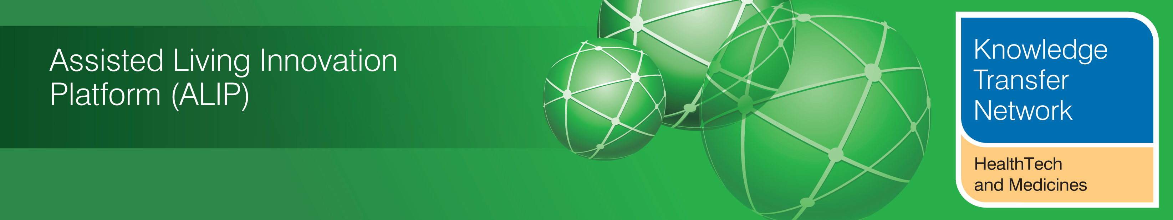
NEWSLETTER
November 2012

Welcome to the November 2012 newsletter from the Technology Strategy Board (TSB) Knowledge Transfer Network and the Telecare Learning and Improvement Network. Our free monthly newsletter is distributed to 46,000 subscribers in the UK and worldwide via e-mail and archived at www.telecarelin.org.uk

We hope that you find this newsletter useful. With around 500 news and events links over the last month, it is the most comprehensive newsletter available serving the telecare, telehealth, ehealth and assisted living communities.

November has been busy with a number of important conferences in England and Scotland. There has been the publication of the NHS Mandate in England with references to telecare and telehealth. The next phase of the 3millionlives initiative has been announced with plans for 100,000 users to benefit during 2013. Seven pathfinder sites have been identified to take the initiative forwards. New frameworks have been published for the NHS, adult social care and public health. The Care Quality Commission has published its state of care report for 2011/12.

The Knowledge Transfer Network has an excellent new important resource on assisted living UK capabilities.

The links section is now available in a separate supplement rather than in the main newsletter (doc, pdf). A selection from this month’s listing is covered in the newsletter.
The newsletter contains a list of KTN/ALIP activities, conferences and workshops from the UK and Europe over the coming weeks as well as news from the UK and around the world. For weekly news, updates and information, you can register with the Technology Strategy Board, ALIP group and the DALLAS sub-group. You can follow the dallas programme on Twitter at @dallas_connect. Also 3 Million Lives is now on Twitter at @3MillLives and also at LinkedIn. If you would like daily information on #telecare and #telehealth, then a Twitter stream is available (you do not need to register on Twitter and it is accessible to organisations not able to connect directly to social media).

Prepared by Mike Clark (Twitter: @clarkmike) for the ALIP Knowledge Transfer Network and Telecare Learning and Improvement Network

Contents
Item 1 - News from ALIP and the KTN (HealthTech and Medicines) – Page 2
Item 2 - The NHS Mandate – Page 3
Item 3 - Health technologies to improve the lives of people with long-term conditions – Page 5
Item 4 - Other UK policy announcements – Page 6
Item 5 - Recent Conferences – Page 8
Item 6 - Other News – Page 8
Item 7 - Summary of recent journal articles and evaluations – Page 11
Item 8 - Housing LIN News – Page 12
Item 9 - Learning and Events – Page 13
Item 10 – Other useful links – Page 14
Supplement for November 2012
The links section is now available in a separate supplement rather than in the main newsletter (doc, pdf).
Item 1 – News from ALIP and the KTN (HealthTech and Medicines)
Assisted Living UK Capabilities and Opportunity Report and Website
The Assisted Living UK Capabilities and Opportunities Report is now available to download from UK capability map website, click here to download your copy of the report (please note it is a large file).
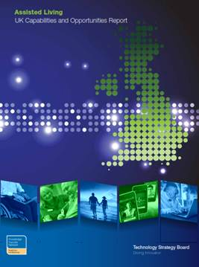
The report is an executive summary of the UK capabilities and opportunities in the sector, a ‘virtual catalogue’ that provides an overview of the products and services currently in existence. This report is also designed to stimulate and support the development and uptake of assisted living products and services by reporting on existing care needs and provision, identifying existing assisted living activity and suppliers and identifying sources of expertise. The analysis of the data then provides an initial guide for those in the public sector who are tasked with introducing assisted living services in their region and for organisations in the voluntary and private sectors who feel there is an opportunity to develop assisted living products and services. The virtual catalogue contains all the examples of assistive technology, telecare, telemedicine, telehealth, telehealthcare, e-health and m-health developed to date. This report and website has been commissioned by the Assisted Living Innovation Platform programme (ALIP).
Additional ALIP resources:
UK Capability Map
Assisted Living Directory
Assisted Living Demonstrator Map
Delivering Assisted Living Lifestyles at Scale (dallas) (Twitter: @dallas_connect)
For more information on events and ALIP projects please visit the Assisted Living Innovation Platform on _ connect.
Item 2 - The NHS Mandate
On 13 November 2012, the Department of Health in England published the NHS Mandate (also separate web site) covering the period from April 2013 to March 2015.
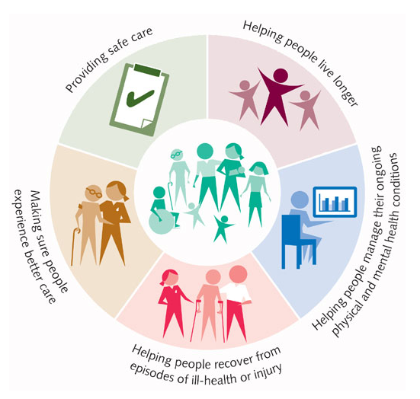
The NHS Mandate is structured around five key areas where the Government expects the NHS Commissioning Board (@NHSCB) to make improvements:
- preventing people from dying prematurely
- enhancing quality of life for people with long-term conditions
- helping people to recover from episodes of ill health or following injury
- ensuring that people have a positive experience of care
- treating and caring for people in a safe environment and protecting them from avoidable harm

Health Secretary, Jeremy Hunt (@jeremy_hunt) said:
“Never in its long history has the NHS faced such rapid change in our healthcare needs, from caring for an older population, to managing the cost of better treatments, to seizing the opportunities of new technology. This Mandate is about giving the NHS the right priorities to deal with those challenges. By focusing on what matters to patients, and giving doctors and other professionals the freedom to deliver, we will make sure the NHS stays relevant to our needs and continues providing the best possible care for us all.”
The NHS Commissioning Board will have a budget of £95.6bn of which around £61bn will be used by 211 Clinical commissioning Groups from April 2013.
In the NHS Mandate, improving the lives of people with Long Term Conditions is covered in Section Two. Key points include:
- Empower and support increasing numbers of people living with long term conditions (By 2018 nearly three million people, mainly older people, will have three or more conditions all at once (2.1)
- Make measurable progress towards making the NHS among the best in Europe at supporting people with ongoing health problems to live healthily and independently, with much better control over the care they receive (2.3)
- Implement 111 phoneline for non-emergency care in 2013 (2.4)
- involve patients and their carers, and empower them to manage and make decisions about their own care and treatment (including development of knowledge, skills, confidence to manage their own health as well as offering personalised care plans) (2.5)
- Develop options of holding a personal health budget (subject to evaluation of the pilot programme) (2.5)
- Provide access to information and advice about support available for five million carers (2.5)
- Provide online access to own health records held by their GP (Includes implementation of electronic records in all health and care settings, working with relevant organisations to set national information standards to support integration, arrangements for linking of records, plans for records to follow individuals with consent to any part of NHS or social care system) (2.6)
- Ensure ability to book GP appointments and order repeat prescriptions online (2.6)
- Secure electronic communication with their GP practice, with the option of e-consultations becoming much more widely available; (2.6)
- Significant progress towards three million people with long-term conditions being able to benefit from telehealth and telecare by 2017; supporting them to manage and monitor their condition at home, and reducing the need for avoidable visits to their GP practice and hospital (2.6)
- Provide care which feels more joined-up to the users of services, with the aim of maintaining their health and wellbeing and preventing their condition deteriorating, so far as is possible (2.8)
- Provide care which is coordinated around the needs, convenience and choices of patients, their carers and families – rather than the interests of organisations that provide care (2.8)
- Provide care that centres on the person as a whole, rather than on specific conditions (2.8)
- Provide care that ensures people experience smooth transitions between care settings and organisations, including between primary and secondary care, mental and physical health services, children’s and adult services, and health and social care – thereby helping to reduce health inequalities (2.8)
- Empower service users so that they are better equipped to manage their own care, as far as they want and are able to (2.8)
- Tackle practical barriers that stop services working together effectively, and for national organisations to provide help and expertise where this will be needed, rather than to design and impose a blueprint (2.9)
- Ensure better measurement of user experience of seamless care; better use of technology to share information; open and fair procurement practice; new models of contracting and pricing which reward value-based, integrated care that keeps people as healthy and independent as possible(2.9)
- Progress towards the Dementia Challenge – diagnosis, treatment and care of people with dementia in England should be among the best in Europe (2.10/2.11)
Other references to the NHS Mandate publication:
NHS Commissioning Board welcomes its mandate from the Government
Guardian, Telegraph, Independent, BBC, Pulse Today (requires registration), GP Online, HSJ (requires subscription)
Item 3 - Health technologies to improve the lives of people with long-term conditions
On 14 November 2012, Secretary of State for Health in England, Jeremy Hunt (@jeremy_hunt) announced that across the country 100,000 people are set to benefit from new health technologies.
Jeremy Hunt was speaking at an Age UK (@age_UK) conference where he kickstarted the roll out of telehealth, the use of electronic information and technology to help people manage their health independently, as a way of giving people with long-term conditions control over their own care. This followed publication of the NHS Mandate which said that ‘significant progress will be made towards 3 million people being able to benefit from telehealth by 2017’.

Jeremy Hunt said: “People with long-term conditions see doctors and nurses more than most of us – £7 out of every £10 spent on the health budget go towards supporting them. I want to free people with long-term conditions from the constant merry-go-round of doctors’ surgeries and hospitals. “Technology can help people manage their condition at home, free up a lot of time and save the NHS money. In a world where technology increasingly helps us manage our social and professional lives, it seems logical that it should also help people manage their health.”

Seven ‘pathfinders’ have been identified. These sites will agree contracts with suppliers to provide services for 100,000 people in 2013. The news release indicates that ‘leading technology companies will be supplying the NHS with the technologies and services at no upfront cost’. This opens up new managed service options for telehealth to answer previous questions about equipment costs, inventory management and data handling.
Seven pathfinders announced (14 November 2012):
- Worcestershire (3 CCGs and Worcestershire County Council)
- NHS Merseyside
- North Yorkshire & York and Humber PCT Cluster (will involve the CCGs as they develop)
- NHS South Yorkshire & Bassetlaw (Sheffield, Barnsley, Rotherhm, doncaster and Bassetlaw PCTs but will include CCGs as they develop)
- Kernow CCG and Cornwall & Isles of Scilly PCT
- NHS Kent and Medway (8 Kent CCGs, Kent County Council, Kent Community Health Trust and Medway Unitary Authority)
- Camden CCG (with UCL Partners)
References:
3millionlives press release
Response from 3millionlives industry working group - 3millonlives takes 100,000 steps closer to target
3millionlives key requirements document
For more information about 3millionlives, please see the website: www.3millionlives.co.uk. You can follow on Twitter @3MillLives, or join the discussion on LinkedIn

Item 4 - Other UK policy announcements
a) On 22 November 2012, the Department of Health (@dhgovuk) in England published ‘Improving health and care: the role of the outcomes frameworks. This sets out how the three outcomes frameworks, Adult Social Care, the NHS and Public Health work together to achieve the desired outcomes for the health and care system.
The overarching document explains the principles behind the three outcomes frameworks, including:
- how they support quality improvement for individuals
- demonstrates how the 3 frameworks are aligned
- the role of shared and complementary indicators
- sets out how they will work together in practice to help the system address the challenges facing the health and care system
The framework includes a new measure of social isolation (DH press release, Telegraph)

b) The Chief Medical Officer (Dame Sally Davies) has published her first annual report providing a comprehensive picture of England’s health.
c) The Department of Health in England has launched its Winterwatch arrangements that provides regular updates on how the NHS is coping with winter pressures.
d) The Department of Health in England has published a Dementia Challenge Progress Report and launched the Dementia Friends programme – a £2.4m programme to sign up one million people by 2015 (see also Dementia Friends website).
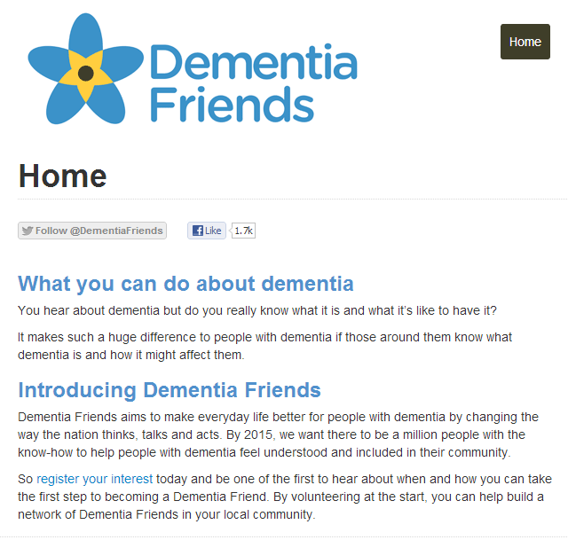
Other ‘next steps’ announcements include:
- £9.6 million for dementia research
- Extra support for GPs on dementia to spot and diagnose dementia (will include a dementia toolkit)
- Pilot with schools and youth projects
- £1 million prize fund for ways to increase diagnosis
- A £50 million fund for environments (eg care homes , hospitals) designed for people with dementia
- A commitment on information for people diagnosed with dementia Our Health online service directories to be rolled oout by March 2013
- 42 organisations signed up to the Dementia Care and Support Compact

e) The Department of Health has published a Simple guide to Payment by Results for the NHS in England.
f) A £1 million fund is being made available to nurses and healthcare professionals in Scotland working in community settings to enable them to access and update patient records using mobile technology.
g) The NHSScotland Chief Executive's Annual Report 2011/12 presents an assessment of the performance of NHS Scotland in 2011/12 and describes key achievements and challenges.
h) £4.7m million is being made available by Invest NI to attract innovation and technology to improve patient healthcare in Northern Ireland. The funding will be open to companies which choose the region to carry out research and development, health minister Edwin Poots has said.
i) Jeremy Hunt has ordered a review into a new rating system for NHS and social care.

(You can follow the Department of Health in England, Jeremy Hunt and Norman Lamb on Twitter at @dhgovuk, @jeremy_hunt and @normanlamb. In Scotland, you can follow the Scottish Government’s Health Department on Twitter @scotgovhealth and Alex Neil @AlexNeilSNP (also @NHS24). In Wales follow @WelshGovernment)

Item 5 - Recent Conferences
It has been a busy conference season. November started off with ‘Telehealth and Telecare in Scotland: home and away’ (Storify Twitter coverage is available). The Telecare Services Association’s Annual international Telecare and Telehealth Conference was held over 12-14 November 2012 (Programme, Twitter coverage, Break out presentations, Pics). The Technology and Strategy Board held a two day conference on interoperability on 21/22 November 2012 in Leeds and the Royal Society of Medicine’s two day eHealth and Telemedicine Conference took place at the end of the month. There will be more coverage of these recent conferences in the December newsletter with additional links.
Item 6 - Other News
Here is a roundup of other news over the last month. A fuller listing is available in the supplement (doc, pdf).
a) A program at Mayo Clinic using telemedicine technology is showing promise for patients with concussions in rural Arizona (Mayo Clinic Report, Video).
b) The Cabinet office has launched a red tape challenge for health and social care – ‘which regulations should be scrapped or improved to boost growth and jobs and give health professionals more time to care for patients, without weakening necessary public health safeguards?’
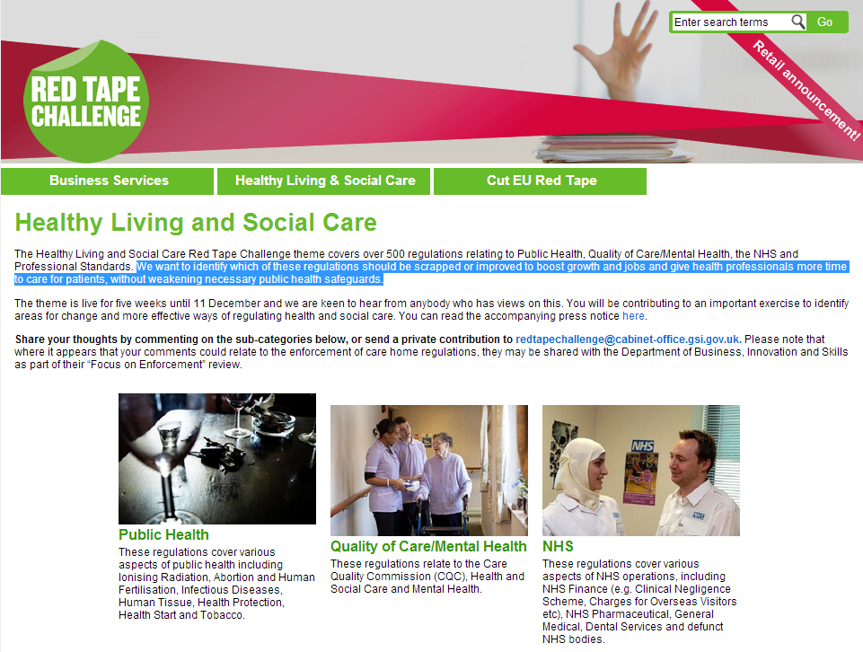
c) The Isles of Scilly has started trials allowing consultations between islanders and clinicians in Cornwall on a webcam began at St Mary’s hospital. Gastroenterology, ear, nose and throat, and dermatological conditions are the first areas of medicine covered in the trial.
d) Cold homes could be costing the NHS in England £1.36 billion every year in hospital and primary care due to the impact on older people’s health, according to new analysis by Age UK (Age UK Report – The Cost of Cold). The report says that even in relatively mild winters, there are around 8,000 extra deaths for every one degree drop in average temperature. The most common risk factor is cardiovascular diseases –strokes caused by blood-clotting or heart attacks – which account for 40% of excess winter deaths.
e) Age UK reports that ‘only three in every 10 people aged 75 or older have ever used the internet’. Among the estimated 7.63 million people who have never been online in their life, around two-fifths of them (43%) are over 75 years old, according to the Office for National Statistics.
f) The King’s Fund has a new website called ‘Time to Think Differently’ . A Blog covers the background to the new initiative which includes an opportunity to have your say. You can also join in via Twitter at #kfthink or use LinkedIn or Facebook
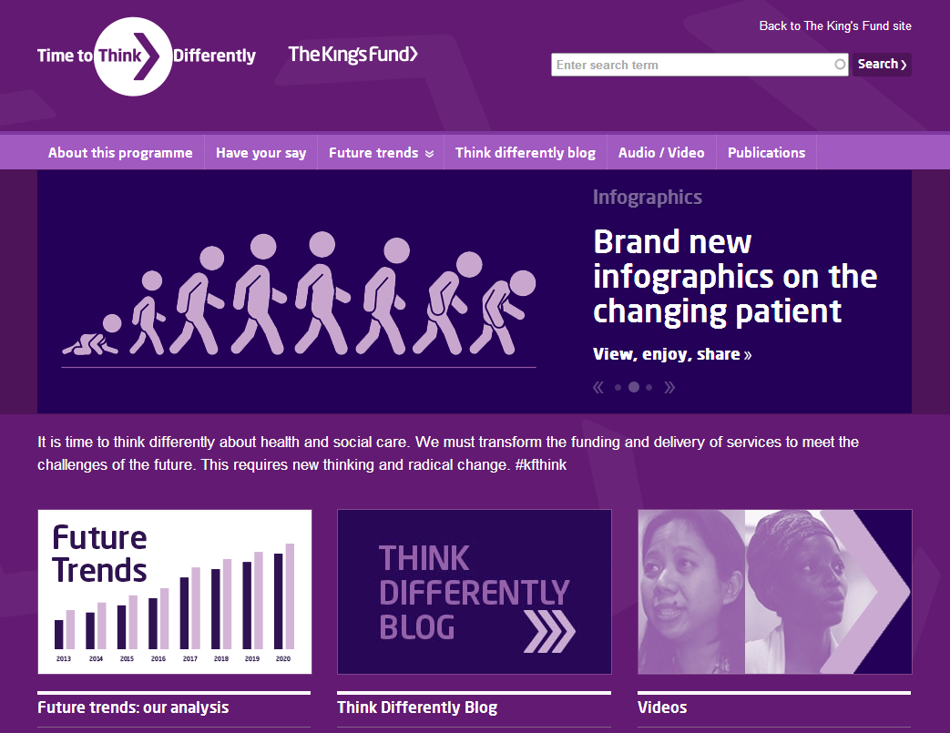

g) Some examples of wearable health tech devices and sensors embedded in clothing and skin patches are featured in this Information Week article.
h) Health Services in Western Australia are using telehealth technology over the Friday to Sunday period to guide emergency room staff through medical emergencies using high-definition cameras and computer monitors.
i) MHP Health Mandate has been looking at some of the priorities for the first wave of the 211 Clinical Commissioning Groups (CCGs). These include reducing unplanned admissions as well as improving dementia and mental health services. The article from MHP states that NHS East Riding of Yorkshire CCG has set specific local outcome targets to identify if they have been successful eg 600 more people are diagnosed early with dementia; 580 people living with a long-term condition are supported to avoid a non-elective admission. The expectation is that all 211 CCGs will be authorized by April 2013 and will receive around £60bn (60%) of total NHS budget in England.
j) Pulse Today reports that GPs saw 3.7% more people in appointments last year than the year before. The report also covers Jeremy Hunt’s presentation at the recent NHS Alliance conference and included references to whether the use of technology could help in responding to increased demand.

k) Telemedicine helps reduce stroke fatality in Ireland – a short article looks at the use of telemedicine remote consulting to rapidly assess whether clot-busting drugs would benefit the patient.
l) The Health and Social Care Alliance Scotland and the School of Design at Glasgow School of Art have been contracted to use their collective experience of community engagement and communication to support the development and delivery of the dallas Programme in Scotland (called ‘Living it Up’). The partnership recognised that the captured views of individuals, carers and communities would actively influence and shape the design and implementation of the programme throughout and beyond its lifespan. The latest report of the community engagement activities is called ‘A Little Birdie Told Us’
m) The Telegraph examines the latest ONS figures on dementia and covers a Policy Exchange report indicating that the number of hospital admissions has increased by 2.79 million since 2005. The report suggests that a lack of co-ordination between Primary Care Trusts, GP practices, and acute hospitals has led to an increase of hospital admissions for patients with long-term conditions such as diabetes and Alzheimer's who could be treated elsewhere.
n) As part of its involvement with the European INNOVAge project, the South East Health Technologies Alliance (SEHTA) has launched a UK Healthcare Innovation Hub – a centre of excellence where high tech entrepreneurs, academics, researchers and policymakers can meet, network and develop new and innovative healthcare concepts. T he UK hub is one of 14 ‘InnoHubs’ being launched across Europe.
o) NHS Direct maps out its future in an article for Government Computing - Chief executive Nick Chapman tells Gill Hitchcock about moving to NHS 111 and the barriers to telehealth.
p) The Social Care Institute for Excellence has a new publication ‘Using ICT in activities for people with dementia – A Short Guide for Social Care Providers’.
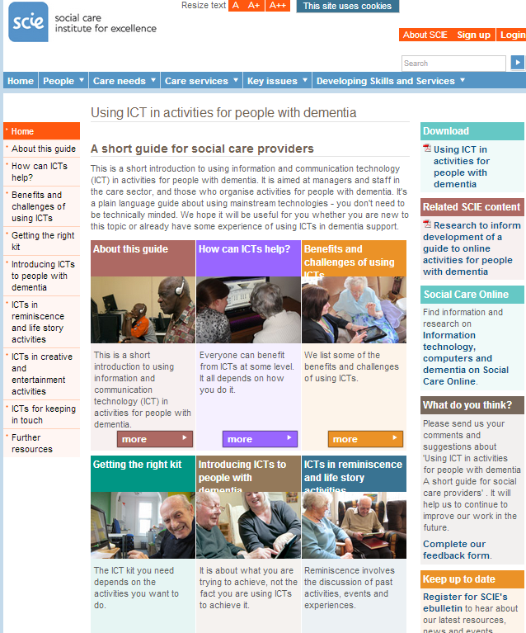
q) The US Department of Veterans Affairs is to double the number of telehealth consults to veterans according to this Government Health IT report. Adam Darkins, speaking at the Center for Connected Health's Symposium recently said that the VA is poised to boost its video consult program into the home and add more mHealth programs, e-consults and teleradiology programs to reach some 825,000 veterans by the end of 2013.
r) For those advocating raising the awareness of telehealth and telecare in the UK, you get the challenging as well as the good coverage. Some examples this month:
Guardian: GPs might remain unconvinced but telehealth is a no-brainer
Guardian: How telecare is transforming social care

Independent: Patients groups hit out at plan for online NHS services

Daily Mail: End of the doctors surgery? GP visits to be replaced by Skype consultations in bid to save NHS £3bn
Express: END OF THE DOCTOR'S SURGERY
Margaret McCartney Blog: Notes on the Whole System Demonstrator, Loneliness and Telehealth
s) The King’s Fund (@thekingsfund) has produced a new report ‘Health policy under the coalition government: A mid-term assessment’. There are several telehealth references including:
“Innovations in telehealth hold the promise of improving care for people with long-term conditions, but evidence suggests that without changes in how services are organised and delivered, the value of these technologies cannot be fully realised” (Page 26).
t) The Care Quality Commission (CQC - @CareQualityComm) has published its State of Care Report for 2011/2012. You can read comments in the Guardian and Telegraph.
u) The 5th call for awards under the NIHR invention for innovation (“i4i”) programme has been announced - Up to £6.25m to develop new devices & tech for patient care via BMJ (timetable)
Item 7 – Summary of recent journal articles and evaluations
Each month, our supplement (doc, pdf). provides a comprehensive list of recent journal articles. Here are just a few recent papers.
a) An article in the Journal of the American Medical Association (JAMA) looks at the impact on services of patients with online access to their medical records. Records between 2005 and 2010 from Kaiser Permanente patient portal users were examined by the researchers who calculated the numbers of office visits, telephone encounters, after-hours clinic visits, emergency department encounters and hospitalisations. More than 44,000 online users were matched with 44,000+ non-online users. The study found that there was an increase in clinical services by online record users but did not determine or examine the reasons behind the increase.
b) Five studies (including SMS text and video messaging) with at least six month cessation outcomes were included in an updated Cochrane Review paper. When all five studies were pooled, mobile phone interventions were shown to increase the long term quit rates compared with control programmes.
c) An Italian randomised controlled trial has looked at the value of exercise training in heart failure patients. Twice weekly exercise over ten years was found to improve quality of life with reduction in major cardiovascular events, including hospitalizations for CHF and cardiac mortality.

d) A Home Telemonitoring Program Reduced Exacerbation and Healthcare Utilization Rates in COPD Patients with Frequent Exacerbations – US Study.

e) A UK service evaluation in BMJ Open looks at the control of blood pressure using simple telehealth.
f) In the ‘EMPOWER-D’ randomised controlled trial, US researchers concluded that a nurse-led, multidisciplinary health team could manage a population of Type 2 diabetic patients in an online disease management program. Intervention patients (n=193) achieved greater decreases in A1C levels at 6 months compared to the usual care group (n=189), but the differences were not sustained at 12 months.

g) JTT has published ‘A systematic review of the mediating role of knowledge, self-efficacy and self-care behaviour in telehealth patients with heart failure’. Twelve studies met the inclusion criteria. The researchers concluded that failure to replicate previously established relationships emphasises the weakness of the telehealth literature, which impedes the ability to address questions such as how telehealth might achieve beneficial outcomes.

h) ‘Better Nights’ is an evaluation of a Choice Support/Southwark Council initiative to remove waking night staff from community-based supported living services for people with learning disabilities. The study assesses the impact of replacing waking night staff with sleep-in staff and assistive technology for 26 people.
i) A Cochrane Review update indicates that there is now good evidence that case management type interventions led by a heart failure specialist nurse reduces chronic heart failure related readmissions after 12 months follow up, all cause readmissions and all cause mortality. Telephone follow up by a nurse specialist and multidisciplinary interventions featured in the 25 styles studied.
j) In COPD, telehealthcare interventions can significantly reduce the risk of emergency department attendance and hospitalisation, but has little effect on the risk of death according to a Cochrane Review of ten RCTs.
Item 8 – Housing LIN News
The Housing LIN reports that a cross party group of MPs and peers has highlighted the benefits of improved housing options for older people.

The 2012 inquiry report, written by Jeremy Porteus - Secretary to the APPG Inquiry and director of the Housing LIN - is the result of a five month inquiry into the progress in implementing the recommendations and design criteria set out in the landmark HAPPI report.

The APPG inquiry found there were far reaching benefits from developing good quality housing for older people, including a reduction in health and social care costs, as well as the freeing up of family housing.
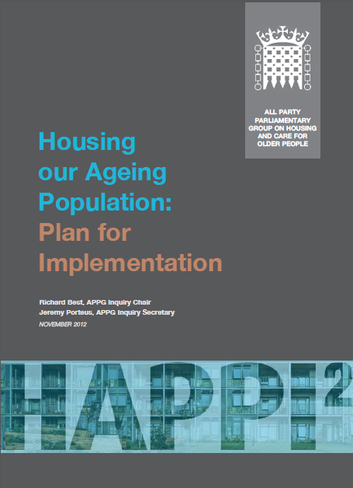

Housing LIN is the leading national network for promoting innovative new ideas in enhancing the housing choices for older people and supporting change in the delivery of housing and related care and support services.

Item 9 – Learning and Events
It is coming the end of the Autumn 2012 conference season. There will be a new listing in the next newsletter taking us into 2013.
2012
EHTEL 2012 Symposium "Fact not Fiction: The future of eHealth is already here" – 6-7 December 2012, Brussels http://www.ehtel.org/activities/ehtel-symposium/Facts-not-fiction-ehealth-future-is-here

2015 - How have we changed the business model? – 12 December 2012 Coventry https://connect.innovateuk.org/web/9697301
2013
ALIP Showcase Event 2013 – 5-6 March 2013, Liverpool https://connect.innovateuk.org/web/2013-assisted-living-showcase-event
Healthcare Innovation Expo 2013 - Europe's largest, most exciting healthcare innovation event - 13th & 14th March 2013, London http://www.healthcareinnovationexpo.co.uk/

Item 10 – Other useful links
DALLAS _Connect Sub Group
Join the Sub Group at: https://ktn.innovateuk.org/web/dallas
Housing Learning and Improvement Network www.housinglin.org.uk
Now on Twitter: @HousingLIN

Telecare Learning and Improvement Network www.telecarelin.org.uk

King’s Fund web site – telehealth and telecare
http://www.kingsfund.org.uk/topics/technology_and_telecare/index.html
Telecare Aware – daily news and comments www.telecareaware.com
Three Million lives
http://www.3millionlives.co.uk/
Twitter: @3MillLives and now on LinkedIn

Newsletter prepared by Mike Clark (@clarkmike) and brought to you by the Telecare LIN on behalf of the Technology Strategy Board
Disclaimer: “We provide this newsletter for information purposes only and neither the Technology Strategy Board nor the authors accept any liability whatsoever for inaccuracies, errors or omissions therein or for any consequences arising therefrom.”


