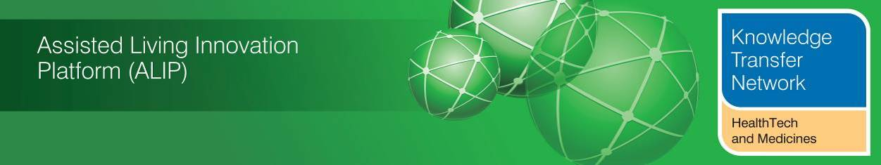
NEWSLETTER
July 2013
Welcome to the July 2013 newsletter from the Technology Strategy Board (TSB) Knowledge Transfer Network and the Telecare Learning and Improvement Network. We are grateful to the HealthTech & Medicines KTN and the TSB’s Assisted Living Innovation Platform for providing newsletter funding for another year enabling us to continue to provide the most comprehensive newsletter available serving the telecare, telehealth, mobile health, digital health and assisted living communities.

Our free monthly newsletter is distributed to 48,000 subscribers in the UK and worldwide via e-mail and archived at www.telecarelin.org.uk. You can also find highlights on Prezi (monthly) or Rebelmouse (daily) or by following Mike Clark on Twitter (@clarkmike). With over 800 news and events links over the last month, we hope that you find this newsletter useful.

The Government has published its Spending Review which includes a £3.8bn integration programme for health and social care in England. There are continuing NHS pressures with further hospital, 111 and A&E reports. NHS England has published a call to action to address these challenges and the Department of Health is making adjustments to the NHS Mandate (including services for older people) as well as consulting on the next one. There are publications and draft regulations on social care changes including eligibility criteria. There are new announcements on dementia-friendly environments as well as supported housing. There is a new assisted living framework and resources from Skills for Care and videos and presentations are available from the recent King’s Fund Congress on Telehealth and Telecare. There are a number of telehealth and telecare reports from around the UK as well as a summary of recent journal articles and upcoming events.

The links section (over 800 this month) is available in a separate supplement (pdf,doc).
The newsletter contains a list of KTN/ALIP activities, conferences and workshops from the UK and Europe over the coming weeks as well as news from the UK and around the world. For weekly news, updates and information, you can register with the Technology Strategy Board, ALIP group and the dallas sub-group. You can follow the dallas programme on Twitter at @dallas_connect. 3 Million Lives is on Twitter at @3MillLives and also at LinkedIn. If you would like daily information on #telecare and #telehealth, then a Twitter stream is available.

Contents

Item 1 – News from ALIP (Assisted Living Innovation Platform), the Knowledge Transfer Network (HealthTech and Medicines KTN) and dallas – Page 3
Item 2 – New assisted living technology framework and resources launched – Page 5
Item 3 – The King’s Fund Telehealth and Telecare Congress – Page 5
Item 4 – 3millionlives and NHS England Vision Statement – Page 6
Item 5 – UK policy announcements – Page 6
Item 6 - Other news – Page 10
Item 7 – Summary of recent journal articles and evaluations – Page 18
Item 8 – Learning and Events – Page 19
Item 9 – Other useful links – Page 20
Links supplement for June 2013 - doc and pdf versions are available - (pdf,doc)

The newsletter is
Prepared by Mike Clark (Twitter: @clarkmike and http://storify.com/clarkmike) for the ALIP Knowledge Transfer Network and Telecare Learning and Improvement Network.

Item 1 – News from ALIP (Assisted Living Innovation Platform), the Knowledge Transfer Network (HealthTech and Medicines KTN) and dallas
(i) Mi Programme - If you are visiting Liverpool, be sure to drop into the new Museum which currently is home to the Mi smart house and the ‘House of Memories’ dementia awareness training which uses the excellent museum exhibits and facilities.
 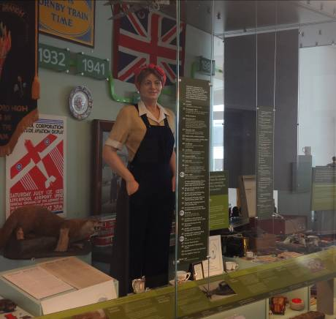
The Liverpool Museum (@MuseumLiverpool) features interactive displays on the history of the city.
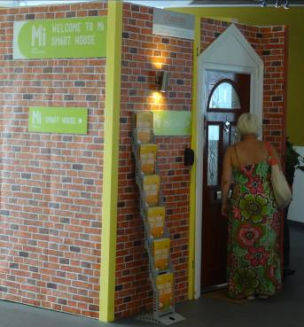
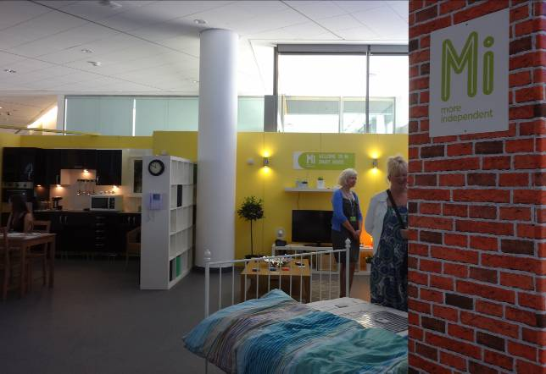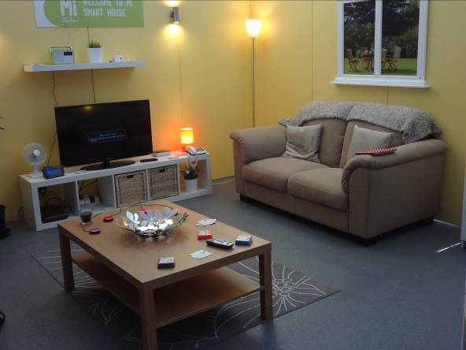
The Mi smart house (@liverpool_mi) features a number of technologies that can help with independent living.
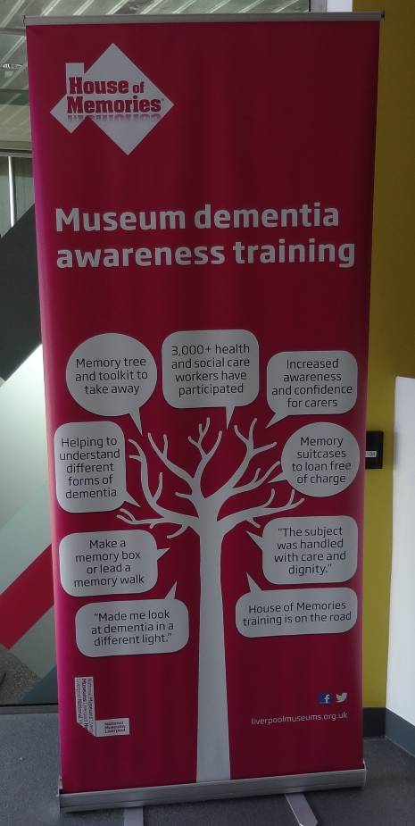 | Over 3000 health and care professionals have been involved in the House of Memories dementia awareness training (web site).  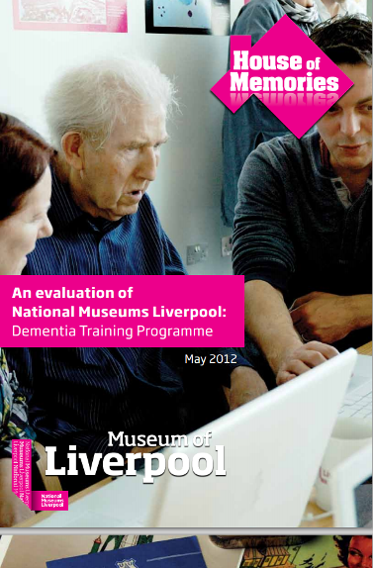  Evaluation Report
i) Horizon 2020 for Health – Funding and Collaboration, the opportunity for SMEs and UK Health sector (2nd October 2013, London)
The HealthTech and Medicines KTN (Health KTN) is pleased to announce the launch of the Horizon 2020 for Health event. This one day meeting will provide delegates with the opportunities to hear the latest developments in Horizon 2020 and complementary funding programmes which are most relevant for Healthcare businesses and SMEs, together with a landscape of the UK based support systems and networks for SMEs and industrial engagement. This event is being run in partnership with Knowledge Transfer Networks in the areas of ICT, Materials, Electronics, Sensors and Photonics, Nanotechnology.
This event is free to attend and registration is now open. Click here to register
(iii) Congratulations are due to Graham Worsley and Keren Down on their July Wedding and also to Jackie Marshall-Cyrus on her August Wedding. Graham, Keren and Jackie have all been extensively involved in the ALIP Programme since its inception. We wish them all well.

Item 2 – New assisted living technology framework and resources launched
As assisted living technology (ALT) becomes more common in social care and other fields, a new learning framework and resource hub have been launched to support those involved in commissioning, design or the delivery of workforce development in this field.
Skills for Care, the adult social care sector skills council in England, have created the new resources to equip the workforce with the confidence, skills and knowledge to fully engage with the technology on the market and apply it to enhance the lives of people who need care and support.
The framework is based on five guiding principles that an assisted living service can utilise – Readiness, Customer Flow Analysis, Workforce Analysis, Learning and Delivery and Checking. The framework is presented in easy to use chapters so organisations or individuals can pick or and choose the support they need.
The framework is backed up by an online ALT resource hub which includes guides to enable face-to face learning and eLearning modules giving organisations the option to choose the learning approach that best suits them and their workforce.
Item 3 – The King’s Fund Telehealth and Telecare Congress
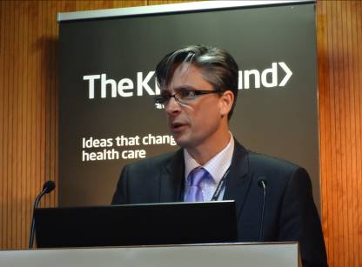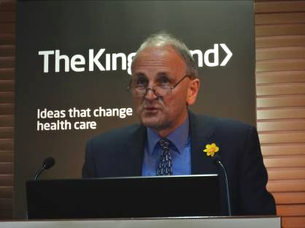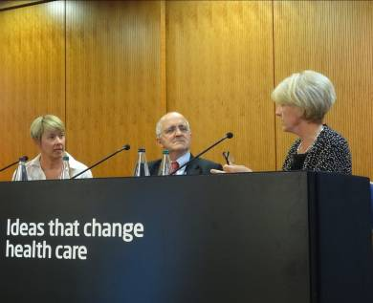
Dr Nick Goodwin (Left) from International Foundation for Integrated Care and Professor Chris Ham (Centre) from The King’s Fund introduce the proceedings. Beverly Bryant and Martin McShane from NHS England are questioned by Candice Imison from The King’s Fund.
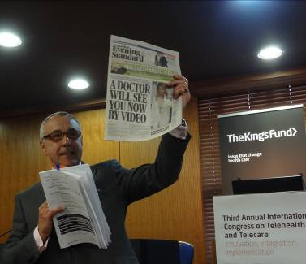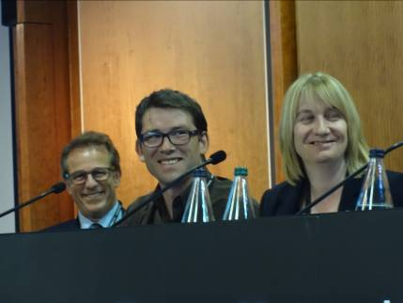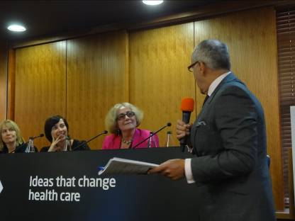
Roy Lilley (Health Writer and Broadcaster) is joined by Brian Rosenfeld (Philips Healthcare), Dr Jonathan Tomlinson (GP, The Lawson Practice), Helena Herklots (Carers UK), Alison Mlot (ALIP Lead, TSB) and Shirley Ayres (Digital strategy & Comms Consultant) for a panel session.
The King’s Fund held its third annual congress on telehealth and telecare in London in early July 2013. This newsletter will be providing more coverage of the Congress in the August edition. In the meantime, you can access videos, presentations and Storified tweets via the King’s Fund website or continue discussions via LinkedIn.
Building Better Healthcare has a summary of the Roy Lilley panel debate ('Digital divide' threatens future of telehealth and telecare).
EHI reports on one of the Whole System Demonstrator papers from the Congress.
The Standard covers London hospital to trial plan for doctors to watch patients via video link
Item 4 – 3millionlives and NHS England Vision Statement
Following the transfer of responsibilities from the Department of Health, NHS England has issued a vision statement for 3millionlives.
3millionlives is underpinned by the idea of service integration to improve patient care and outcomes.

When different services and sectors work together, towards shared goals, patients get far more flexible, better, and more appropriate care. To achieve true service integration, we recognise that 3millionlives needs to be delivered through a genuine partnership across NHS England – facilitating collaboration between clinicians, and empowering patients to better self-manage their conditions, with the use of technology. We also recognise that this cannot be achieved through technology alone – the key will be to deliver service transformation through realising the potential of that technology to support clinicians, patients and carers.

Under the overall leadership of NHS England Medical Directorate, 3millionlives will be delivered going forward by combining clinical advocacy, service improvement and technology strategy – making it a true partnership and synergy within NHS England. We are committed to the delivery and success of 3millionlives, and we are confident that this approach will put 3millionlives right at the heart of our ambition to deliver High Quality Care for All.
Item 5 – UK policy announcements
Here is a roundup of UK policy news over the last month. A fuller listing is available in the supplement (pdf,doc).
(i) In 2012 the government asked local authorities to bid for a share of £300m to boost the supported housing market to help older and disabled people to live independently. The Department of Health in England has now allocated £92m funding to build 3,544 new homes. Affordable supportive housing is designed to be accessible and aid independent living by having, for example:
- very few or no stairs
- cupboards that are at a reachable height for wheelchair users
- adapted bathrooms that are easy to access for older or disabled people
- handrails to reduce the chance of falls

The next Housing LIN Newsletter will be providing further information and updates.
(ii) From a Department of Health article, a Public Health England (PHE) review suggests that checking 40-74-year-olds’ blood pressure, cholesterol, weight and lifestyle could identify problems earlier and prevent deaths, heart attacks and cases of diabetes a year. PHE, which leads the NHS Health Check programme, has launched a ten-point plan to help councils roll them out to 20 per cent of their eligible local population a year.
(iii) From the Department of Health website - plans to help people better prepare for the cost of their future care needs have been published alongside details of how the new fairer funding system will protect homes and savings (Consultation closes on 25 October 2013). There is an additional blog from Jon Rouse, Director General for Social Care, Local Government and Care Partnerships.
(iv) The Department of Health in England has issued a statement based on Sir Bruce Keogh’s Review of 14 hospitals.
(v) The Government is to replace the Liverpool Care Pathway (LCP) and will ask senior clinicians to sign off all end of life care plans, as part of its response to the findings of an Independent Review, Care and Support Minister Norman Lamb has announced.

(vi) New proposals are under consideration for healthcare assistants and support workers to ensure care and compassion in the NHS and in social care (Cavendish Review).

(vii) Celebrating the 65th anniversary of the founding of the NHS, Health Secretary Jeremy Hunt has set out proposals to improve care for vulnerable older people and create a more personalised health service.
“Too often, the people the NHS fails are its heaviest users – older people with multiple long-term conditions – and there is frequently confusion and fragmentation over how care is provided”.
The proposals outlined by the Health Secretary include every vulnerable older person having a named clinician responsible for their care outside of hospital. This will mean that accountability is clear and care packages can be personalised and tailored around individual needs.
Details of the plan have been set out as part of the consultation to refresh the NHS Mandate – the Government’s ambitions for the NHS - for 2014/15.
As well as making sure that there is a named clinician responsible for care outside of hospital, other proposals for the Vulnerable Older People’s Plan include:
- Better early diagnosis and support to stay healthy – strengthening the role GPs play in supporting people to stay healthy and take an active role in managing the health of their local populations.
- Improved access – improving access to primary care through new types of services such as rapid walk-in access services; helping patients connect with their GP in different ways through new technology; making booking appointments easier and; building on existing services and opening hours.
- Consistent and safe out-of-hours services – People are often unable to access support or are confused at who to turn to for advice. The Government wants better access for patients across primary care and hospital services, including 111 and emergency services.
- Enhanced choice and control – including choice of GP practice; rolling out the friends and family test to general practice by December 2014; more choice about location and type of service such as seeing a preferred GP or nurse and the option of doing this face-to-face or via email and telephone.
- Better information sharing – making sure that information can be shared between services and people providing care in a coordinated and timely way, including all clinicians and carers having access to the same information about patients regardless of setting.
The Vulnerable Older People’s Plan will form a part of the integrated care plans that local authorities and clinical commissioning groups are putting together to access the three billion pound health and social care fund announced by the Chancellor in the spending review.
(viii) A new national eligibility criteria to be introduced in 2015 will set a minimum threshold that will allow local authorities to keep current levels of access to care and support services, Care and Support Minister Norman Lamb has announced. For the first time, this threshold will set out the individual needs and circumstances in which every council in England must offer care and support for adults.
Draft regulations describe the national threshold, which is at a level equivalent to ‘substantial’ in current guidance. This marks the start of a process to look at how best to deliver these changes to make the system fairer, without impacting on existing care users.
It will include exploring how councils can use their 2015/16 funding settlement, with £3.8 billion of pooled funding, including an additional £2 billion through the NHS, to maintain the same level of services when they move to the new care and support system.
(ix) ‘Helping people live better for longer’ – a new guide provides an overview of the Department of Health's new role from April 2013.
(x) Guidance is now available for health and wellbeing boards to meet local health and social care needs.
(xi) ‘Research and development work relating to assistive technology’ - The annual report prepared by FAST describes the wide range of government funded projects supporting the development, introduction and evaluation of assistive technology that might increase the range of activities and independence or wellbeing of disabled and older people.
(xii) The Department of Health has published its business plan for 2013 to 2015 and additional guidance on Payment by Results for 2013-14.
(xiii) The Department of Health has published a consultation document on ‘Refreshing the NHS Mandate’ (Closing date – 27 September 2013).

(xiv) Successful bids for the first round of dementia friendly environments have been announced with 116 amounts allocated to hospitals, care homes etc. There is one example of telecare from Nottingham.
(xv) LGC reports on the Government Spending Review announcement on £3.8bn integration for health and social care. The Department of Health website reports the comments of Jeremy Hunt and Norman Lamb on the Government’s Spending Review announcement. Here are the comments from Sir David Nicholson at NHS England:
“This is a very significant settlement for the NHS. It presents both opportunities and challenges. It is a potential ‘game changer’ as it gives us the opportunity to accelerate the development of integrated services. It means we can provide more joined-up care for care for patients with complex needs, enabling them to be supported at home.”
“Merging health and social care budgets to support integrated care at a time when resources are constrained will require us to rethink how we organise services around patients. We need to begin formulating plans as soon as possible so that we are ready to take full advantage of the opportunities offered by the 2015/16 settlement.”
(xvi) The first round of funding is now underway for NHS England’s ‘Safer hospitals, safer wards’ - Achieving an integrated digital care record’ (Report, application details).
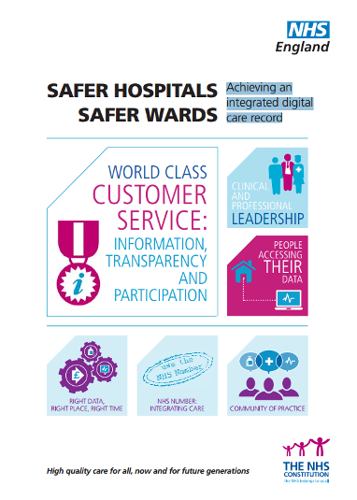
(xvii) The NHS England 6Cs Live! Communication hub (Care, Compassion, Competence, Communication, Courage and Commitment) will offer support and help to staff to deliver the six areas of action by signposting to evidence based tools and techniques as well as examples of how colleagues from across the country have delivered improvement in these areas.
(xviii) The NHS Services, Seven Days a Week Forum set up by NHS England earlier this year is gathering evidence into how the NHS could move towards offering patients better, safer and high quality health care every day of the week. Five work streams established by the Forum are investigating the benefits of providing 7 Day services across the country, as well as collating information on the challenges that such a transformation would inevitably throw up.
(xix) NHS England has called on the public, NHS staff and politicians to have an open and honest debate about the future shape of the NHS in order to meet rising demand, introduce new technology and meet the expectations of its patients. This is set against a backdrop of flat funding which, if services continue to be delivered in the same way as now, will result in a funding gap which could grow to £30bn between 2013/14 to 2020/21.
A new publication, ‘The NHS belongs to the people: a call to action’ sets out these challenges facing the NHS, including more people living longer with more complex conditions, increasing costs whilst funding remains flat and rising expectation of the quality of care. The document says clearly that the NHS must change to meet these demands and make the most of new medicines and technology and that it will not contemplate reducing or charging for core services.
(xx) Starting at the end of June 2013, NHS England has commenced a staged publication of mortality rates for individual hospital consultants in ten specialties. The data – covering around 3,500 consultants – will appear on the website NHS Choices and will cover a range of operations and procedures.
(You can follow the Department of Health in England, Jeremy Hunt and Norman Lamb on Twitter at @dhgovuk, @jeremy_hunt and @normanlamb. In Scotland, you can follow the Scottish Government’s Health Department on Twitter @scotgovhealth and Alex Neil @AlexNeilSNP (also @NHS24). In Wales follow @WelshGovernment)
Item 6 - Other news
Here is a roundup of other news over the last month. A fuller listing is available in the supplement (pdf,doc)
(i) O2 has withdrawn their UK telecare and telehealth products and services. There are more details about the arrangements on their website. Telehealth and Telecare Aware website has extensive discussions on the subject.
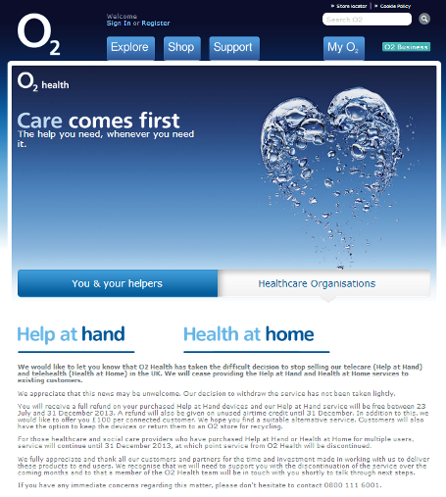

(ii) Worcestershire Telecare (19,000 service users) has been celebrating Platinum Member status of the Telecare Services Association.
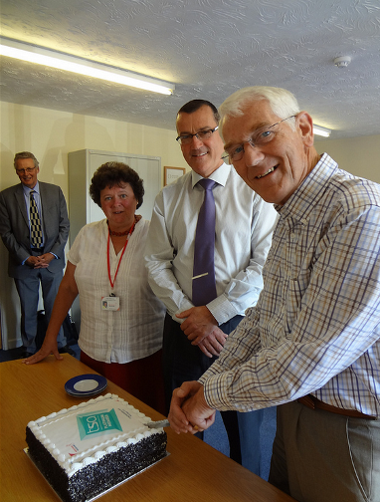

(iii) There is a new infographic from The King’s Fund as part of their Commission on the Future of Health and Social Care.
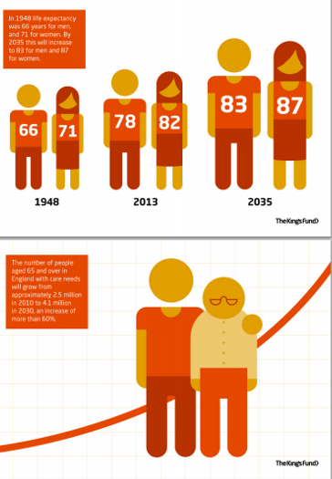
(iv) CSC has a new report on ‘Teleservices for Better Health’.
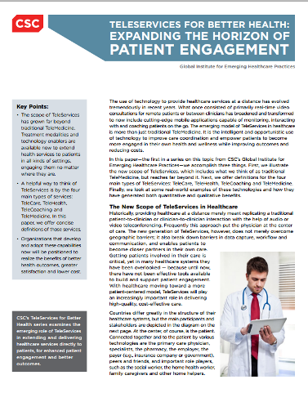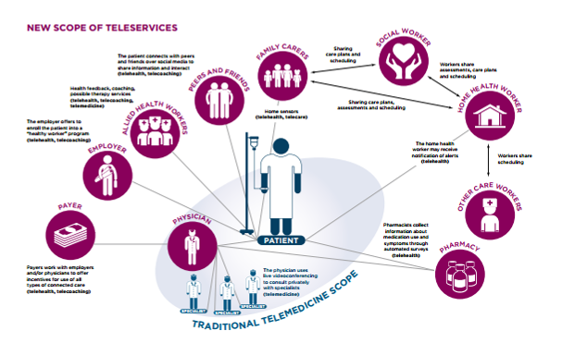

(v) Shaping our Age, supported by the Big Lottery Fund, is a joint project between the Centre for Citizen Participation at Brunel University, the Centre for Social Action at De Montfort University and older people’s charity the Royal Voluntary Service . The research challenges the common perceptions of ageing and seeks to question the portrayal of older people and the assumptions that those providing services for them often make.
(vi) The Royal Society of Medicine has published an overview of telehealth.
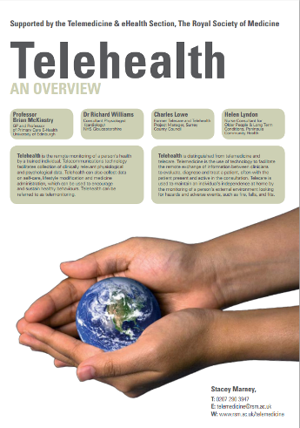
(vii) There is a new EU report on arrangements for the Active and Assisted Living Research and Development Programme.
(viii) The Audit Commission has a new report covering social care for older people.
(ix) There is a new Age UK report on direct payments for social care.
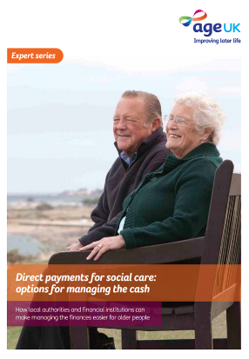
(x) Confused by social care jargon? – Think Local Act Personal (TLAP) has a helpful jargon buster.
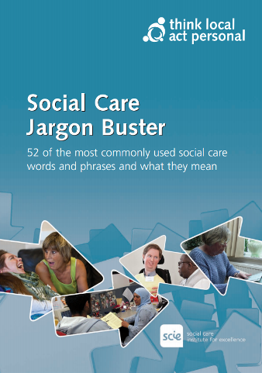
(xi) Angela Single, Clinical Director for Telehealth and Telecare at BT and Chair of the 3millionlives initiative looks at progress on telecare and telehealth adoption and BT plans in Cornwall.
(xii) Sheffield CCG has outlined a number of projects to help older people, disabled and minority groups at a cost of £6.5 million over the coming year. Funding will come from money saved by implementing a four per cent efficiency saving to contracts. The biggest investment will be £3.1 million to reduce the number of elderly and disabled people needing to spend time in hospital or travelling to outpatient departments.
(xiii) The National Audit Office has published a report on the financial sustainability of the NHS in England. There was a surplus of £2.1 billion across the NHS in 2012-13, matching that in 2011-12. However, there are signs of increasing pressure.
(xiv) Under proposals suggested by 2020health and launched by health minister Norman Lamb, GPs could be subcontracted by CCGs in certain cases to make ‘small discretionary payments’ to patients as part of the personal health budget scheme, with the practices taking responsibility for the administration of the budgets. In the pilot, the GP role was limited to making referrals and recommendations.
(xv) NHS Leicester City CCG’s telehealth and telecoaching for COPD patients programme is being expanded from around 47 current patients to 150 (including heart failure) as part of their integrated care approach following some early reported successes (EHI Report).
(xvi) After looking at VHA’s VistA system, NHS England has been considering an open source option for electronic patient records if trusts want it (EHI Report). EHI also reports on the NHS spending £285k on an exchange programme with the US Veteran’s Health Administration to investigate its use of open source software and telehealth.
(xvii) There is more from Airedale NHS Foundation Trust on the progress of their telemedicine service on their website. Airedale Hospital has a Telehealth Hub which connects to over 1,000 patients in 33 residential and nursing homes and their own homes via secure video links and allows them to have face-to-face consultations with nurses and doctors 24 hours a day, seven days a week. Patients can view consultants on either their own TV with a set top box or a mobile video system. The Trust has worked with technical partners Involve-Visual and Red Embedded to make the project a success. Manorlands Hospice for seriously ill patients is linked up along with six GP surgeries. Airedale provides 20 prisons throughout the country with clinical opinion and diagnosis using telemedicine. This covers a range of health problems including serious situations from skilled A&E consultants and second opinions on other medical conditions via scheduled appointments with consultants.
(xviii) You can find out more about Barnsley’s care navigation and telehealth service for people with long term conditions via their website.
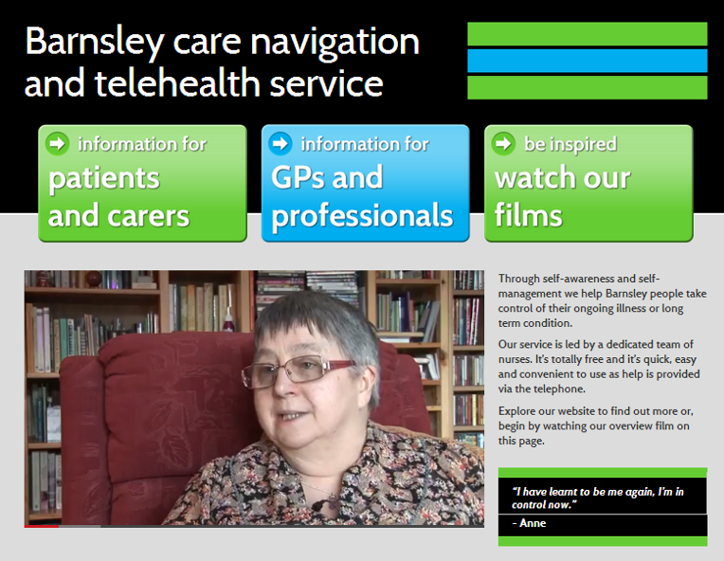
(xix) The Health Select Committee has questioned the preparedness of A& E services for next winter in response to rising attendances, variations in consultant cover and effective discharges (BBC Report).
(xx) The first two trained ‘dementia dogs’ have been working with their new owners. They have been taught to respond to alarms and bring medicine pouches, to nudge their owners to read a reminder and to encourage them to get out of bed in the morning (BBC News).
(xxi) BBC News reports that full rollout of the NHS non-emergency telephone service has been put back to 2014. The 111 service was due to be in place in April 2013, but five of the 46 services areas are still not live. In a later report, it appears that NHS Direct is looking to transfer its existing contracts because of financial sustainability.
(xxii) As part of an EU Project (Remodem), NHS Western Isles are testing a home mobile video call system to link people with dementia and their carers. The 1.5m ‘robot’ can show the face of the carer on its screen and move around the home to ensure everything looks OK (also reported at EHI).
(xxiii) An NAO report (BBC News) suggests that only nine of 44 rural areas would reach targets for high-speed internet by 2015, and four areas could also miss a revised 2017 target.
(xxiv) Bodmin in Cornwall could benefit from the ten year BT-Cornwall partnership which includes ICT support and telehealth.
(xxv) Mobihealthnews reports on an app that uses voice synthesis technology to provide verbal communication for people with conditions such as Autism, Cerebral Palsy, Aphasia, Parkinson’s disease. The app is designed with big buttons and high-contrast text for people of all ages to use easily. A user’s personalized text can be added, and other phrases can be deleted from the app to create the vocabulary that best expresses his or her personality.
(xxvi) Telecare and telehealth service provider, CarelineUK with over 110,000 UK service users and 120 staff in the New Forest has celebrated its 25th anniversary.
(xxvii) Read about the latest workshop on the COBALT Project – Challenging Obstacles and Barriers to Assisted Living Technologies.
(xxviii) The King’s Fund has an excellent video on ‘An alternative guide to the new NHS in England’.
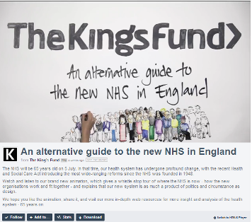
(xxix) In 2012, VA offered seriously injured post-9/11 Veterans and their Caregivers already enrolled in the Department’s Program of Comprehensive Assistance for Family Caregivers the opportunity to sign-up for a special pilot focused on mobile technologies.
VA selected more than 1,100 Caregivers to participate in the VA Mobile Health Family Caregiver Pilot. Starting in May 2013, Caregivers will begin receiving VA-loaned iPads loaded with a suite of apps to test over a 12-month period. The suite is comprised of nine apps that are designed to support Caregivers and the needs of the Veterans they assist. Through the mobile technology, Veterans and Caregivers will receive secure access to health care information, the ability to track personal health-related information, and functionality to share this personal health information with their VA health care teams.
(xxx) The EU funded REACTION project is bringing European projects together in the field of ambient intelligence advanced technologies in support of healthcare and assisted living to an event on Crete in September 2013.
(xxxi) NHS Western Isles is rolling out a free wi-fi network for staff and patients in an effort to increase mobile working and internet access (EHI Report).

(xxxii) BMJ has a report on England’s national programme for IT.

(xxxiii) A new Age UK Report (Later Life in rural England) looks at the challenges of older people living in the countryside.
(xxxiv) Figures from HSCIC on community care services show that the total number of people receiving services in 2012-13 was 1.3m (down 9 per cent from 2011-12 and down 25 per cent from 2007-08). Of these, 1.1m received community based services (a fall of 10 per cent from 2011-12), 209,000 received residential care (a fall of 2 per cent from 2011-12) and 87,000 received nursing care (which is less than a 1 per cent change from 2011-12). Feedback from councils suggests that the fall this year is again due to a number of reasons including an increase in the provision of reablement services outside of a formal assessment process, raised eligibility criteria for services and reduced funding/resources within Councils with Adult Social Services Responsibilities.
(xxxv) Fujitsu has announced the launch of the KIDUKU Project, a research initiative that aims to provide monitoring services and assisted independent living for senior citizens and patients who live in smart houses. The project will commence in July 2013 in Ireland, and will last for three years. It is being carried out in collaboration with three Irish research institutions—TRIL, CASALA, and CLARITY—each of which has pursued monitoring, diagnostic support and other advanced activities involving the use of ICT in a variety of scenarios, including medicine and daily life. The research aims to help older people and patients follow up with illnesses and support with appropriate treatment regimens. In addition, by streamlining the sharing of information among senior citizens and patients and their family members, primary physicians, and specialists, the project aims to leverage ICT to support the lives of people in an aging society.
(xxxvi) “The Government is failing to acknowledge we’re not ready for ageing” – Claire Turner from JRF looks at the Government’s formal response to the Ready for Ageing report published in March 2013 by the House of Lord’s Select Committee on Public Services and Demographic Change.
(xxxvii) The Health and Social Care Information Centre is looking at automating extractions of adult social care data from council IT systems and linking it with other healthcare data (EHI Report).
(xxxviii) EHI reports on telehealth services in Gloucestershire including impact on nurse caseloads, hospital admissions.
(xxxix) ‘Many health and wellbeing boards (HWBs) have already made substantial progress towards making real improvements in health outcomes, standing them in good stead for addressing major local issues like integration and health inequalities’, says a new report.
(xl) Hampshire County Council has signed a five-year deal with Argenti Telehealthcare Partnership to provide ‘telecare’ services. Devices used in the scheme can alert emergency services if a person has a fall, or remind people to take medication. If somebody requires help, a 24-hour monitoring centre is alerted and is able to respond quickly.
(xli) NHS managers in Co Durham and Darlington say the initial six-month pilot for warfarin patients inBishop Auckland and Darlington has been so successful it is to double in size. Blood checks and Warfarin monitoring was previously done in a clinic, but can now be done over the phone once the patient has been trained to provide their own results, which are then checked by hospital staff and the dosage changed if necessary.
(xlii) The Health Committee Second Report on urgent and emergency services has been published.
(xliii) ‘How an integrated health coaching and telehealth service saved my CCG £350,000’ - Dr Durairaj Jawahar from Leicester City CCG – reported at Inside Commissioning.
(xliv) NHS Calderdale Clinical Commissioning Group (CCG) and Calderdale & Huddersfield NHS Foundation Trust (CHFT) are working in partnership with Tunstall Healthcare to provide advanced telehealth solutions that will help to support people with long-term conditions. Telehealth will initially be offered to 24 COPD patients in their own home at any one time, with the initiative expected to develop and to benefit many more patients in the region. The objectives are to support early discharge and prevent hospital admissions, improve self-management, prevent future complications for those with COPD who haven’t yet started to access extensive healthcare, and support the COPD specialist nurses’ workload.

This new initiative is in the early stages of delivery, providing a service into people’s homes under the supervision and with the dedicated assistance of Calderdale and Huddersfield NHS Foundation Trust COPD specialist nurses. This new approach will help to avoid hospitalisation through early intervention, management of risks and improved medicine compliance.
NHS Calderdale CCG is also working alongside service providers to develop a new model of care as part of its “Quest for Quality in Care Homes” initiative, which will increase the level of support in care homes and improve outcomes for up to 1000 residents. The new model of care includes the development of a multi-disciplinary team, who will be available to support and advise staff in care homes on the prevention and proactive management of the needs of older people, including fall prevention and medication management.

A crucial part of the model focuses on the development of telehealth and telecare in 25 care homes, and will include the UK’s largest deployment into care homes. By supporting the analysis and treatment of people with care needs, this will improve their quality of life, and offer additional support for carers and family members.

This part of the programme is rolling out in two phases. Phase one is focusing on providing telecare solutions to 25 nursing and residential homes across the region. Phase two will enable a further 500 residents in care homes to benefit from telehealth solutions by early 2014.

(xlv) Dr Simon Fradd, a Southwark GP writes on telehealth in this Guardian article. In another article, Dr Jamie Wilson considers how to reduce social isolation in an age of declining social care budgets and as the NHS turns 65, John Gurnett looks at how we can use technology to deliver improved healthcare for the future.
(xlvi) In the United States, Humana is launching a nine-month telehealth pilot that will provide in-home monitoring to 450 Humana Medicare Advantage members in Ohio who have congestive heart failure (CHF).
(xlvii) According to a Guardian Report which looks at health statistics, there have been 600 deaths a month more than expected throughout the last year. The rise began at the end of 2011 and has only this month dropped back to the level that would normally be expected. Over the past 18 months, there have been 23,400 more deaths than expected, which is a 5% increase.
(xlviii) The Department of Health and NHS chiefs have rejected idea of fees for appointments after Pulse survey shows support among GPs (Guardian Report).
(xlix) PWC is looking at the future of the NHS at 75 years old (2023) – what will it look like?
(l) There is a new video from Medvivo on the benefits of telehealth from a GP’s perspective.
(li) Interested in integrated and community-based care? – Here is a Report from the Nuffield Trust.
(lii) The South Wales Argus reports concerns about the future of Newport’s telecare services.
(liii) The latest National Diabetes Inpatient Audit report includes concerns about the numbers of people ending up in hospital with life-threatening complications (Guardian Report).
(liv) The Eastern Shires Purchasing Organsiation (ESPO) has an EU tender for procurement of telecare and telehealth services.
(lv) A new report published by the Good Governance Institute (GGI) highlights how the successful integration of health, housing and social care services is crucial to the creation of sustainable care models for the future.
The report, ‘Rethinking the Integration Agenda’, examines the challenges that currently exist in delivering truly patient-centred care and, drawing on the experience of 16 leading experts from the housing, health and social care sectors, sets out three key pathways to address these challenges and overcome barriers to integration.
The report describes three key stages to overcoming these barriers:
- ‘Living Well’ pathways should inform attitudes towards care services. This demands that both housing and community-based assets are brought to the table and included in debate about care. If nationally mandated and delivered at a local level, this broader approach to integration will lead to better patient outcomes.
- Developing new cultures of care. Current cultures in organisations are limiting real-time integration, so care needs to be developed together with service users with organisations realigned around shared outcomes. Collaboration across boundaries by staff needs to be incentivised and prepared for, from basic training onwards.
- Investment in new enabling technologies. Decision-makers should benchmark service planning in line with new models of support, and focus on unlocking the potential of information technologies, engagement strategies and assistive technologies across care services.
Item 7 – Summary of recent journal articles and evaluations
Each month, our supplement (pdf,doc) provides a comprehensive list of recent journal articles. Here are summaries from just a few of the recent papers.

(i) The Veterans Affairs healthcare system has a comprehensive approach to treating heart failure including telehealth, clinical informatics, and disease management to support the care of patients.
(ii) Pulse covers a study of patients with cardiovascular disease who self-manage their own blood pressure medications and the opportunities for reductions in strokes.
(iii) A home-based blood pressure telemonitoring system, along with pharmacist assistance, contributed toward better short- and long-term BP control compared with usual care, researchers found.
(iv) Patients find ambulatory blood pressure monitoring (ABPM) less acceptable than home self-monitoring, Pulse reports.
(v) A journal article looks at the increasing interest in using video telehealth to deliver evidence-based psychotherapies (EBPs).

(vi) This Australian paper includes information and a case history on the cost-benefits for patients and practitioners using telehealth video consultations.
(vii) Two years after researchers gathered for an mHealth Evidence Workshop at the National Institutes of Health (NIH), an article has been published in the American Journal of Preventive Medicine concluding that "rigorous research" is needed to examine the potential and challenges of using mobile technologies to improve health outcomes.
(viii) A JMIR paper takes a critical look at methodological quality for home telemonitoring interventions for patients with chronic diseases.
(ix) Some further journal articles from this month’s listing:

Sensor technologies aiming at fall prevention in institutionalized old adults: A synthesis of current knowledge
A mHealth cardiac rehabilitation exercise intervention: findings from content development studies
Diabetes and risk of physical disability in adults: a systematic review and meta-analysis : The Lancet Diabetes & Endocrinology
Does telemonitoring in heart failure empower patients for self-care? A qualitative study
Each one-unit increase in BMI ups heart failure risk by 17%
Early Diabetes Signs Often Missed in Alzheimer's Patients
How QOF is shaping primary care review consultations: a longitudinal qualitative study
A Meta-Analysis of Web-Delivered Tailored Health Behavior Change Interventions
Effect of Home Blood Pressure Telemonitoring and Pharmacist Management on Blood Pressure Control: A Cluster Randomized Clinical Trial
Item 8 – Learning and Events
Click on the following links for further upcoming conferences and learning events.

Health 2.0 London: End of Life Care: Is there a role for data and technology? London, 1 August 2013 http://www.meetup.com/Health-2-0-London/events/121411752/
Mobile Healthcare: Innovations in Telemedicine, Washington DC, 14-16 August 2013 http://summer.gwu.edu/institutes/telemedicine

HSJ Telehealth 2013, London, 11 September 2013 http://www.hsj-telehealth.co.uk/home
Telemedicine Conference, Keele University 24 Sept 2013 http://bit.ly/14T8P34
Building Future Healthcare - Radical Approaches (HACIRIC) – London, 25-26 September 2013 http://www.haciric.org/events/2013/09/25/HaCIRIC-International-Conference-2013?
EDE Congress Let’s network our care! – Technology in care – opportunities and limits, Tallinn 26-28 September 2013 http://www.ede-congress.eu/en/program/programme/
CUHTec telecare strategy course: telecare in Mental Health, Newcastle University - 26 September 2013 http://www.cuhtec.org.uk/courses/

CUHTec telecare training course: Using Activity Monitoring, Newcastle University - 27 September 2013 http://www.cuhtec.org.uk/courses/

Horizon 2020 for Health – Funding and Collaboration, the opportunity for SMEs and UK Health sector, London, 2nd October 2013, London https://connect.innovateuk.org/web/healthktn/events-view/-/events/6885117?p_p_auth=LeZZK8bz
Health 2.0 London: Digital Health: How do we avoid 'Digital Exclusion' in society?, London 9 October 2013 http://www.meetup.com/Health-2-0-London/events/123909182/

EHI Live 5-6 November 2013 Birmingham http://www.ehilive.co.uk/

8th Annual UK Dementia Congress Nottingham 5-7 November 2013 http://www.careinfo.org/2013-events/uk-dementia-congress/
Sucesses and Failures in Telehealth – Brisbane, 11-12 November 2013 http://www.icebergevents.com/sft13/#.UcdN4jvuvWR
The International Telecare & Telehealth Conference 11-13 November 2013 Birmingham http://bit.ly/14T8FIO

Telemedicine & eHealth 2013: Ageing Well - how can technology help? London 25-26 November 2013 http://www.rsm.ac.uk/academ/tee01.php

Item 9 – Other useful links
dallas_Connect Sub Group - Join the Sub Group at: https://ktn.innovateuk.org/web/dallas
Housing Learning and Improvement Network www.housinglin.org.uk Now on Twitter: @HousingLIN

Telecare Learning and Improvement Network www.telecarelin.org.uk

King’s Fund web site – http://www.kingsfund.org.uk/topics/technology_and_telecare/index.html
Telecare Aware – daily news and comments www.telecareaware.com
Three Million lives - http://www.3millionlives.co.uk/ Twitter: @3MillLives and now on LinkedIn

Newsletter prepared by Mike Clark (@clarkmike) and brought to you by the Telecare LIN on behalf of the Technology Strategy Board and Healthcare KTN.
Disclaimer: “We provide this newsletter for information purposes only and neither the Technology Strategy Board nor the authors accept any liability whatsoever for inaccuracies, errors or omissions therein or for any consequences arising therefrom.”


