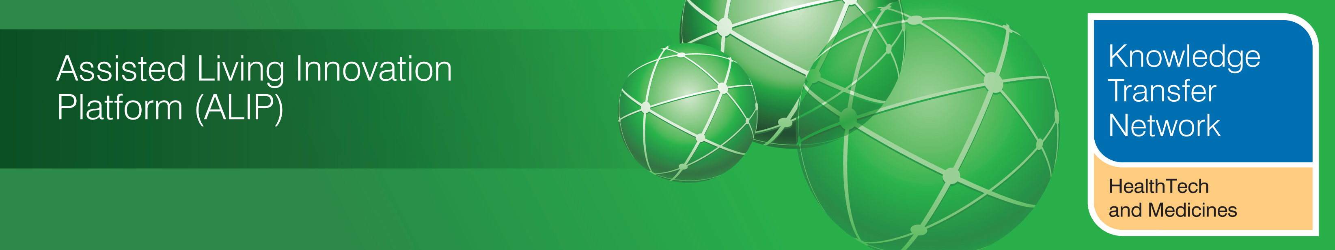
NEWSLETTER SUPPLEMENT
July 2012

Welcome to the July 2012 newsletter supplement from the Technology Strategy Board (TSB) Knowledge Transfer Network and the Telecare Learning and Improvement Network (LIN).

This Newsletter supplement provides a summary of the main sections of the Government’s recent Care and Support White Paper as well as the draft Social Care Bill.

If you would like daily information on #telecare and #telehealth, then a Twitter stream is now available at the TelecareLIN web site (you do not need to register on Twitter and it is accessible to organisations not able to connect directly to social media):
http://www.telecarelin.org.uk/News/twitterStream/
The monthly newsletter is available from http://www.telecarelin.org.uk
Prepared by Mike Clark (Twitter: @clarkmike) for the ALIP Knowledge Transfer Network and Telecare Learning and Improvement Network

The Care and Support White Paper (England only)
Introduction
The long awaited care and support White Paper has now been published (July 2012) alongside a draft bill and social care progress report. The ‘Caring for our Future’ website includes videos from Andrew Lansley, Paul Burstow and David Behan amongst others and looks at what the changes will mean for different groups (eg carers, care and support workers, care providers, local authorities).
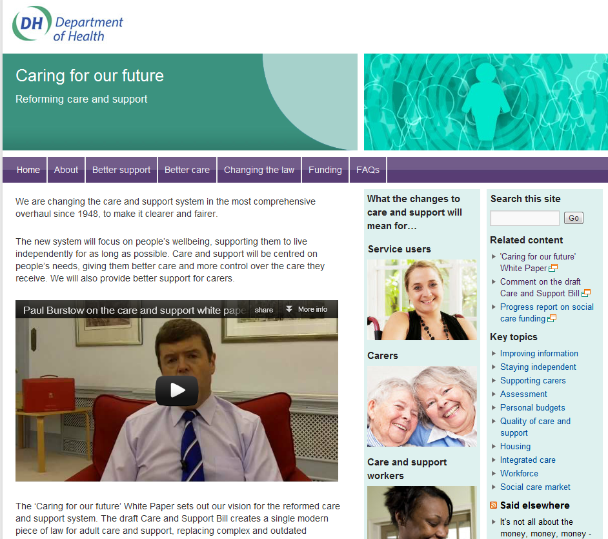
An infographic and flowchart on the website shows the current and future person-centred systems.
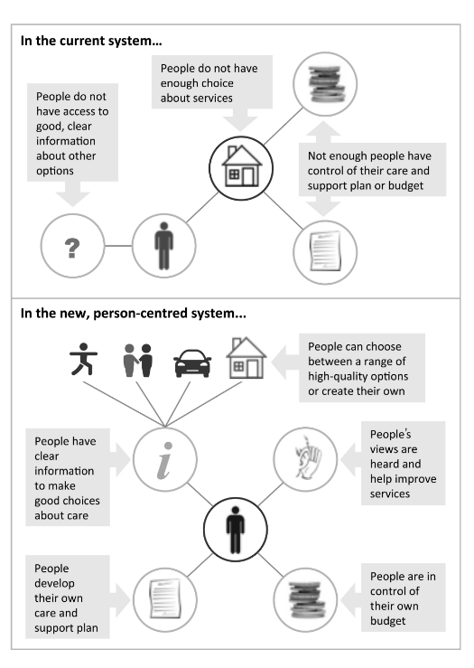
The Government has published a progress report on social care funding reform.
The draft Care and Support Bill is now available and it is possible to comment on the clauses online (by 19 October 2012). A set of factsheets is available which explain the sections of the Bill. A Department of Health Twitter stream is covering the Bill in 140 character tweets.
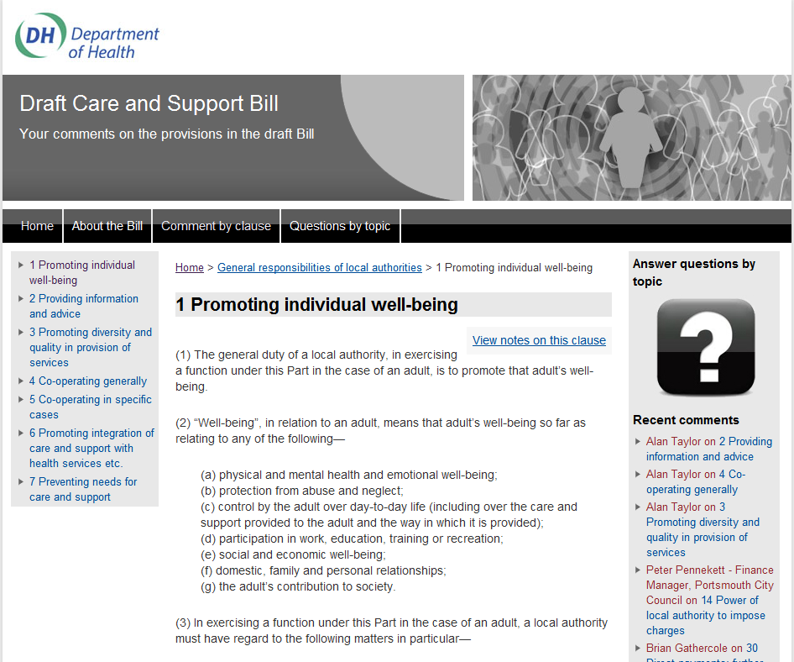

The Social Care Bill is based on recommendations from the Law Commission bringing together and updating social care legislation in one place. The Bill also gives the legal means to deliver the policy ambitions set out in the white paper.

Background facts

An ageing population will place extra demands on care and support services – here are some of the facts:

- 1.5 million people are aged 85 and over, the number over the age of 85 has risen by two thirds since 2004
- Age UK estimates that currently there are 800,000 older people who need care but do not receive it from the state, and that this will increase to 1 million by 2014
- An estimated 40,000 people each year sell their homes to pay for care
- A quarter of people can expect to pay nothing for social care, 50% can expect care costs of up to £20,000 and 20% can expect costs up to £100,000 or more
- The estimated cost of implementing the Dilnot recommendations on social care is £1.7bn a year

Areas covered by the White Paper and draft Bill

Many of the areas covered in the publications are familiar to health and social care organisations. The key decision on funding has been delayed until the Government spending review takes place – this has been the main area of comment and criticism following the publication of the White Paper. Here are some of the areas covered by the White Paper:

- A Chief Social Worker to be appointed by the end of 2012
- Local authorities to be required to apply a national minimum eligibility threshold to ensure greater national consistency in access to care and support, and ensuring that no-one’s care is interrupted if they move. Local authorities will have to continue to meet the assessed needs of people who have moved into their area until they carry out a new assessment of their own
- Dilnot proposals – capping the total cost of care to £35,000 and extending support for the elderly with assets of £100,000, up from the current limit of £23,250 is only supported "in principle" – future funding likely to depend on spending review decisions
- Dignity and respect will be at the heart of a new code of conduct together with minimum training standards and a code of conduct for care workers (due September 2012)
- Care assessments would be contracted out to provide clients with choice over who carries them out supported by the Department of Health's ‘right to provide’ initiative, which enables council staff to set up social enterprises to deliver functions they currently provide
- Appointment of principal social workers in every council, promote the deployment of social workers in community development roles and establish a statutory framework for safeguarding adults, including consulting on giving practitioners the power to enter homes where abuse is suspected.
- The development of "quality profiles" for all regulated care providers, including information on compliance with essential standards, performance against quality standards developed by the National Institute for Health and Clinical Excellence and families' views, drawn from "high-quality" consumer ratings sites
- The potential development of a personal assistants index to enable service users to compare PA services that are available locally
- Improving access to independent advice to help people eligible for financial support from their local authority to develop their care and support plan
- A new national information website to be set up to provide a clear and reliable source of information on care and support with £32.5 million for better local online services
- Time sharing/banking initiatives and social impact bonds to be investigated
- A duty on councils to develop and maintain a diverse range of providers in their areas
- A care and support housing fund will provide £200m of capital funding over five years from 2013-14 to encourage providers to develop new accommodation options for older people and disabled adults
- A commitment to accelerating the roll-out of assistive technology (telecare)
- Care market comparison websites, local area service information and independent quality ratings to be available
- A new care audit will be introduced in 2013 to highlight how well residential care providers are delivering dementia care
- A further £100 million in 2013/14 and £200 million in 2014/15 in joint funding to be available between the NHS and social care to support better integrated care and support
- Local authorities will be required to incorporate preventive practice and early intervention into care commissioning and planning
- Commitments are given to support approaches that combine community development with care and support locally
- The commitment to personal budgets remains (by April 2013 for people who want them)
- Action to stop councils contracting for home care by the minute in partnership with the Association of Directors of Adult Social Services
- Piloting the extension of direct payments to residential care to test the costs and benefits is planned
- From 2015 local authorities will be able to lend money to people for residential care etc which can be recouped after death (with interest)
- A commitment to supporting a better evidence base via a 'national library' from 2013
- A right to an assessment for carers who may need support and an entitlement to council support if they meet a new eligibility threshold for carers
- Pilots to test the idea of free social care for people who are dying and are registered on end-of-life care registers
- An ambition to double the number of care apprenticeships to 100,000 over the next five years
- A consultation in Autumn 2012 on whether there should be greater financial oversight of larger providers to ensure continuity of care in the event of their collapse
- Training more care workers to deliver high-quality care, including an ambition to double the number of care apprenticeships to 100,000 by 2017.

Assistive technology and telecare

Chapter 3 (Page 28) of the White Paper covers the roll-out of assistive technology. There is no specific funding for the rollout, however, local authorities have been recently able to use funding transferred from the NHS for winter pressures, early discharge etc. The White Paper identifies £300m for more integrated care and support.

“We know that assistive technology is not yet being used to its full potential to promote people’s independence. We will therefore take forward the Three Million Lives campaign, launched in December 2011, which will accelerate the roll-out of telehealth and telecare in the NHS and social care during a five-year programme to develop the market. This is being supported by an investment of up to £18 million over four years by the Technology Strategy Board, to demonstrate how assistive technology can be delivered at greater scale. We will set out the incentives and support for widespread adoption of assistive technology later this year. Assistive technology will also be considered in the integration framework”.

From Page 28 of the White Paper ‘Caring for our future: reforming care and support’ July 2012

LINKS

Department of Health

DH: Care and support White Paper published
Detailed news release about the goverment's plans

Care and Support White Paper

Draft Care and Support Bill

Short news release on progress report on social care funding

Progress report on social care funding
White Paper: Caring for our future reforming care and support (PDF, 1580K)
Easy Read version of the White Paper (PDF, 1281K)
Impact Assessments summary document (PDF, 440K)

IA Annex A Reform of adult social care legislation (PDF, 312K)

IA Annex B Independence, choice and control (PDF, 1458K)

IA Annex C assessment and eligibility (PDF, 1184K)

IA Annex D Quality providers & workforce ((PDF, 547K)

Caring for our future reforming care and support – Equality Analysis (PDF, 314K)

Government response to the House of Commons Health Committee Report on Social Care (Fourteenth Report of Session 2010-12) (PDF, 382K)

Reforming the law for adult care and support:the Government’s response to Law Commission report 326 on adult social care (PDF, 821K)

Caring for our future engagement: Summary of responses (PDF, 728K)

Ipsos MORI Caring For Our Future Engagement: Analysis of Responses (PDF, 1271K)

Bringing Clarity to Quality in Care and Support (PDF, 196K)

Factsheets

Factsheets explaining the proposals in the bill

Assessments and eligibility (PDF, 168K)

Charging and financial assessments (PDF, 251K)

Who is entitled to care and support? (PDF, 270K)

Personalising care and support planning (PDF, 349K)

The law for carers (PDF, 116K)

Protecting adults from abuse or neglect (PDF, 400K)

Health Education England (PDF, 128K)

Health Research Authority (PDF, 128K)

Andrew Lansley Statement to Parliament on care and support – 11 July 2012
Speech: Paul Burstow, King’s Fund, 18 July 2012
Further Reading (press coverage and analysis)

Andrew Dilnot: Reform delays leave elderly "in fear"

Andrew Lansley: elderly will be able to opt in to social care insurance scheme

Age UK response to Social Care White Paper
Care assessments to be outsourced under White Paper plans - Community Care (UK)
Care costs to be capped for elderly - Telegraph (UK)

Elderly care cap could be £100,000, Lansley reveals - Telegraph (UK)
Elderly care cap could be set at £100,000 - UK Politics - UK - The Independent (UK)
Elderly care cuts are dangerous and short-sighted, says charity | guardian.co.uk (UK)
Elderly care reform may be delayed | Society | The Guardian (UK)
Evolution or revolution: the story behind the Health and Social Care Act 2012 | Anna Dixon - The King's Fund (UK)
Financial vacuum at heart of social care proposals undermines ambitious vision for reformed system
Loans for elderly “paid back after death“ will pay for residential care | The Guardian (UK)
Lord Warner: Treasury must reconsider 'death tax' to meet soaring cost of elderly care - Telegraph (UK)
National minimum standard for elderly care to be introduced - The Guardian (UK)
Never Again? The story of the Health and Social Care Act 2012 by Nicholas Timmins | The Institute for Government (UK)
Nuffield Trust responds to the publication of the social care White Paper | The Nuffield Trust (UK)
SCIE media release: White Paper: Draft Care and Support Bill - Progress report on social care funding (UK)
Sector slams lack of funding solution in care White Paper - 7/11/2012 - Community Care (UK)
Social Care White Paper 'takes important steps towards a better future but stumbles over finance'
Social care funding clarity urged
Social care: what could have been
Social Care White Paper | Joseph Rowntree Foundation (UK)

Social care white paper: a policy disaster, but a political victory?

Social care white paper: what has the government agreed to?
Social care white paper is a wasted opportunity | Guardian Professional (UK)
Social Care White Paper: ADASS (UK)
Social care: your questions answered | guardian.co.uk (UK)

There's no long-term vision in Dilnot's dismissal

What the social care White Paper means for social workers

Newsletter supplement prepared by Mike Clark and brought to you by the Telecare LIN on behalf of the Technology Strategy Board


Disclaimer: “We provide this newsletter supplement for information purposes only and neither the Technology Strategy Board nor the authors accept any liability whatsoever for inaccuracies, errors or omissions therein or for any consequences arising therefrom.”


