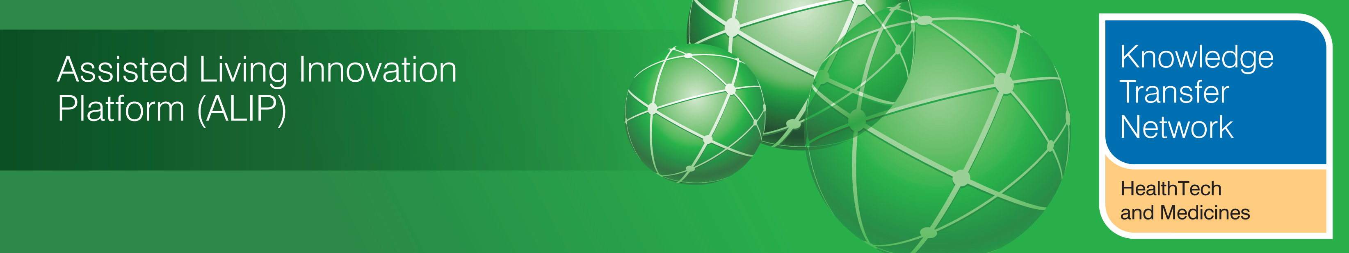
NEWSLETTER
July 2012

Welcome to the July 2012 newsletter from the Technology Strategy Board (TSB) Knowledge Transfer Network and the Telecare Learning and Improvement Network.

Our newsletter is now being distributed to 46,000 subscribers in the UK and worldwide. We hope that you find this newsletter useful. With over 700 news and events links this month, it is the most comprehensive newsletter available serving the telecare, telehealth, ehealth and assisted living communities.

This month there has been some further discussion in the medical press around the first Whole System Demonstrator published paper, several new examples of telecare and telehealth programmes from around the country together with some important reports from CBI, PSSRU and Housing LIN. From the Department of Health, we have the long awaited social care white paper as well as the NHS Mandate for consultation.

A short supplement is available covering the care and support white paper, the draft bill and social care progress report (doc, pdf). The links section is also now available in a separate supplement rather than in the main newsletter (doc, pdf).

The newsletter contains a list of KTN/ALIP activities, conferences and workshops from the UK and Europe over the coming weeks as well as news from the UK and around the world.

For weekly news updates and information, you can register with the Technology Strategy Board, ALIP group and the DALLAS sub-group. You can follow the dallas programme on Twitter at @dallas_connect. Also 3 Million Lives are now on Twitter at @3MillLives.

If you would like daily information on #telecare and #telehealth, then a Twitter stream is available at the TelecareLIN web site (you do not need to register on Twitter and it is accessible to organisations not able to connect directly to social media):
http://www.telecarelin.org.uk/News/twitterStream/

Prepared by Mike Clark (Twitter: @clarkmike) for the ALIP Knowledge Transfer Network and Telecare Learning and Improvement Network



Contents
Item 1 – News from ALIP and the KTN – Page 3
Item 2 - Whole System Demonstrator (WSD) latest – Page 3
Item 3 - Skills for Care online Survey of staff who are involved in delivering or working with Assisted Living Technology (ALT) – Page 4
Item 4 - Role of Assisted Living Technology for Specialised Housing Addressed in new report from Housing LIN – Page 5
Item 5 – Disruptive Social Care Podcast – Page 5
Item 6 – BHTA Report Building a business case for investing in adaptive technologies in England – Page 6
Item 7 - Department of Health – Research and development work relating to assistive technology 2011/2012 – Page 6
Item 8 - PSSRU Report-Building a business case for investing in adaptive technologies in England – Page 7
Item 9 – CBI Report - care closer to home could improve outcomes for patients and save the NHS £3.4 billion a year – Page 7
Item 10 - Developing our NHS care objectives: A consultation on the draft mandate to the NHS Commissioning Board – Page 8
Item 11-Tackling Health Deprivation with Telehealth in Wirral – Page 8
Item 12 Housing LIN Paper: Assistive technology as a means of supporting people with dementia: A Review – Page 10
Item 13 - Further UK News – Page 11
Item 14 – Learning and events – Page 13
Item 15 - Other useful links – Page 13
Supplements for July 2012
Social Care White Paper supplement (doc, pdf)
Links supplement (doc, pdf)

Item 1 – News from ALIP and the KTN
Technology Strategy Board Future Health Mission
The Future Health Mission 2012 is an entrepreneur-led trade mission to Boston, Massachusetts for twenty of the UK's most promising early stage and high growth potential healthcare technology businesses.
Run by entrepreneurs for entrepreneurs in partnership with the Technology Strategy Board, UKTI and private sector sponsors, The Future Health Mission provides winning companies with unparalleled insights, connections and opportunities to accelerate their business in the USA.
It is open to early stage companies with transformative technologies in regenerative medicine, stratified medicine, assisted living and diagnostics

NESTA - Ageing Well Challenge Prize
NESTA are offering a prize for the innovation that can reduce the isolation and/or increase the mobility of vulnerable older people by providing new opportunities for communities to come together to give time, skills and resources.

2012 AAL Forum
The KTN, with support from the Technology Strategy Board will be launching a competition to attend and exhibit at the 2012 AAL Forum in Eindhoven.
The competition will be open to all 5 funding calls under ALIP, and extends to the emerging dallas communities.
For more information on this competition please visit the ALIP pages on _connect where further details will be available soon, https://connect.innovateuk.org/web/2012-aal-forum

Telecare - Meet the Buyers Event 2012 - 14th September 2012
SEHTA's annual Meet the Buyers event will this year be held on the 14th of September at the Wolfson Conference Centre, Stoke Mandeville Stadium, Aylesbury, Buckinghamshire. This international event brings together the biggest telecare and telehealth procurers and the very best service and technology providers for partnering, networking and potential deal making.
The KTN will be exhibiting along with other ALIP organisations who will be using this opportunity to reach out to a commercially focused audience.

Glossary
AAL – Ambient Assisted Living
ALIP – Assisted Living Innovation Platform
KTN – Knowledge Transfer Network
UKTI – UK Trade and Industry
SEHTA – South East Health Technologies Alliance

Item 2 - Whole System Demonstrator (WSD) latest
The publication of the first Whole system Demonstrator Report in the BMJ recently continues to receive a lot of attention particularly from the medical press and academics. There are four further papers to be published before the full picture for telehealth can be seen. Telecare reports are likely to follow the five telehealth papers.

Although not yet available as a peer-reviewed paper, there has been some further reporting from a recent conference of the LSE analysis on cost-effectiveness and QALY for telehealth in the WSD programme. The indications from recent conferences are that the QALY for telehealth is high. Unfortunately, we do not have examples of QALYs from other telehealth programmes or even most other established health approaches outside of NICE Guidance for pharmaceutical interventions to make comparisons. Even at the high WSD equipment and service costs from 2008-2010, annual outlays look good against the cost of inpatient treatments for COPD, heart failure etc in the national tariff. It will be useful to look at the methodology in the cost-effectiveness paper when published.

With the changes in the NHS, the NHS Commissioning Board and 200+ Clinical Commissioning Groups will have an annual budget to commission services within the NHS mandate. This will mean that there will be no additional funding from Government for telehealth – Clinical Commissioning Groups (CCGs) will need to decide how local services are commissioned. The Three Million Lives Programme has been looking at new business models which involve lower cost solutions to support scaled programmes for CCGs and local providers.

Here is some of the most recent WSD coverage:

Nuffield: The impact of telehealth and telecare: evaluation of the Whole System Demonstrator project (UK)
Jim Easton: let’s get serious about telehealth (UK)
NHS boards see telehealth only as a means of saving money, warns expert | BMJ (UK)
Analysis: What’s the impact of telehealth on hospital use?
Pulse Debate: Were outcomes from the WSD trial positive? Yes - telehealth shows enormous potential for the NHS
Pulse Debate: Were outcomes from the WSD trial positive? No - the trial shows that telehealth risks lives
No new funds for telehealth, says DH - Pulse (UK)
Telehealth and telecare: why we're still waiting for the definitive report | guardian.co.uk (UK)
Telehealth 'three times over NICE cost limit' (UK)
BMJ: Impressive results for remote patient monitoring (UK)
Does telehealth reduce hospital costs? Six points to ponder - LSE (UK)

Item 3 - Skills for Care online Survey of staff who are involved in delivering or working with Assisted Living Technology (ALT)
CIRCLE (Centre for International Research on Care, Labour and Equalities) at the University of Leeds has been commissioned by Skills for Care to conduct a national online survey of staff who are involved in delivering or working with Assisted Living Technology (ALT).

The survey will enable researchers to gain an insight into the:

- Extent of ALTs being delivered across different areas in England
- Range of tasks associated with referral, assessment, installation, monitoring and response, and review of these services
- Health conditions of service users which are supported through the use of ALT
- Workforce development, support and qualifications available for staff working with ALT, and any gaps in this provision
The researchers are interested in obtaining views from across the ALT workforce, from commissioners and technicians to call handlers and care workers.

For more information contact: Dr Katy Wright, Research Officer, CIRCLE Research Centre, University of Leeds. email: k.j.wright@leeds.ac.uk
Item 4 - Role of Assisted Living Technology for Specialised Housing Addressed in new report from Housing LIN
A new report from the Housing Learning and Improvement Network (Housing LIN), focusing on the role of assisted living technology as an integral part of specialised housing, was launched recently at the National Housing Federation’s Housing Care and Support Conference and Exhibition 2012.
The report, ‘specialised housing for older people: The application of assisted living technology to support independence’ looks at the role of technology within sheltered and supported housing schemes to assist older people. Housing LIN has developed the Board Assurance Prompt in partnership with Nigel Appleton of Contact Consulting and the GGI (Good Governance Institute),
The report aims to encourage decision makers to better understand the use of telehealthcare as a means of supporting independence. It also demonstrates the proven benefits of assisted living technology for residents, increasing confidence and ensuring safety and security, whilst providing high quality and cost effective management solutions for providers.
Jeremy Porteus, Director of Housing LIN said “We welcome the launch of this new paper which suggests six key assurance questions that Board Members and Senior Officers might ask of their organisation, taking into consideration the financial viability and potential risks that housing providers might encounter when developing accommodation for older people. At a practical level, the BAP also provides a Maturity Matrix to support the development and improvement in implementing assisted living technology from a basic level to exemplary, using technology to enhance support and care delivery at home.
Item 5 – Disruptive Social Care Podcast
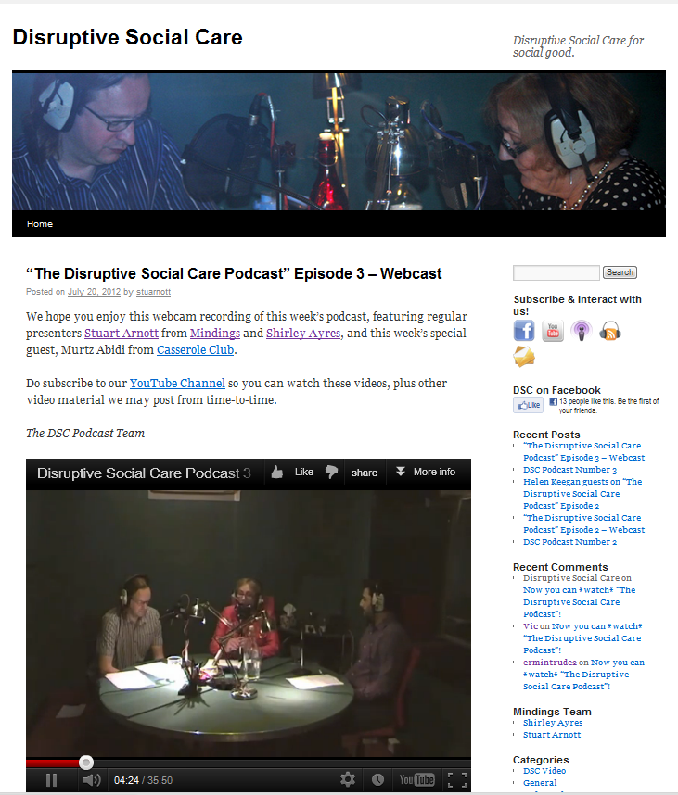
A new Disruptive Social Care video podcast commenced recently and is available via its own website, YouTube, iTunes and Facebook. Stuart Arnott from Mindings and Shirley Ayres are your hosts for a fortnightly 30+ minute review of thought-provoking social care innovation and news.
Item 6 – BHTA Report Building a business case for investing in adaptive technologies in England
A new report (Building a business case for investing in adaptive technologies in England) has concluded that savings could be made if more appropriate provision was made for people needing home adaptations. The report was produced by the LSE (London School of Economics) Personal Social Services Research Unit. It found that for every £1 spent on adaptive technologies there could be a net saving to the taxpayer of £1.10 – equating to an annual potential saving of £1,101 per person per year if the government puts aids and adaptations at the heart of its adult social care reforms.
The Government estimates that over half a million people (568,000) over sixty require an adaptation to their home. If the Government were to meet this need, it would deliver a saving of £625m.
The BHTA has made three core recommendations to government in light of the report's findings:
1. Prioritise the preventative role of aids and adaptations in forthcoming social care reform.
2. Increase investment in the Disabled Facilities Grant to enable longer term savings to be made to the public purse
3. Ensure local Health and Wellbeing Boards quantify unmet need for aids and adaptations in their area and have a clear plan to provide for it.
Item 7 - Department of Health – Research and development work relating to assistive technology 2011/2012
The latest annual report is now available.
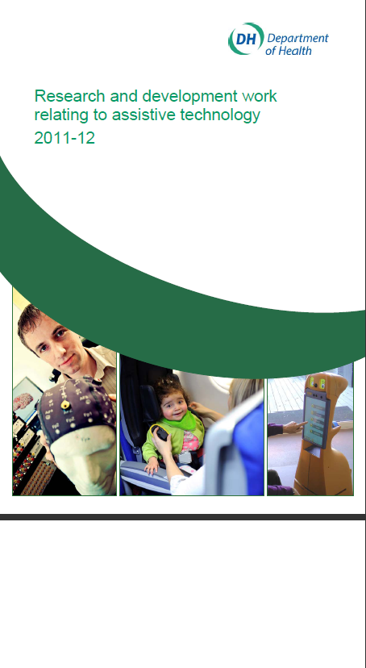
http://www.dh.gov.uk/health/files/2012/07/Research-and-development-work-relating-to-Assistive-Technology-2011-12.pdf
Item 8 - PSSRU Report-Building a business case for investing in adaptive technologies in England
The Personal Social Services Research Unit (PSSRU) has issued a report on ‘Building a business case for investing in adaptive technologies in England’ (PSSRU Discussion Paper 2831)
Using evidence from research literature and user surveys, they constructed a quantitative model to provide estimates of the average costs and benefits associated with use of equipment and adaptations within a dependent older population.
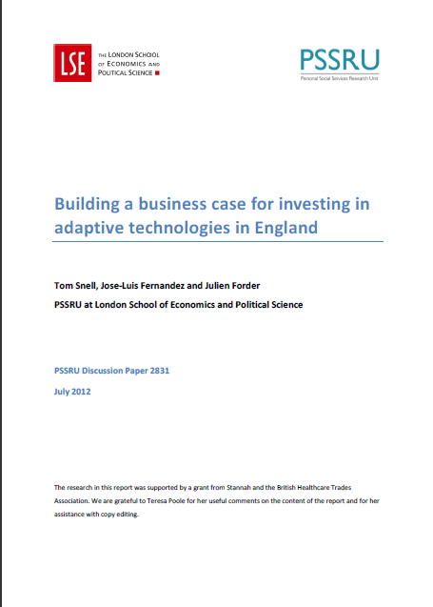
Using a conservative set of assumptions about the impact of aids and adaptations on quality of life and service utilisation, the results suggest that every pound invested in equipment and adaptations leads to reductions in the demand for other health and social care services worth 58 pence on average (including both state and private costs). In addition, the services lead to improvements in the quality of life of the dependent person worth £1.52 per pound invested. According to a more pessimistic scenario, reductions in the demand for health and social care equate to 26 pence per pound invested, with quality of life improvements valued at £1.38. According to the optimistic scenario of the model, reductions in the demand for health and social care are estimated at £1.08 per pound invested and quality of life gains at £1.72.
Item 9 – CBI Report - care closer to home could improve outcomes for patients and save the NHS £3.4 billion a year
Successfully delivering care closer to the home could provide better, healthier outcomes for patients and help ease NHS budgetary pressures by saving £3.4 billion a year, according to a CBI Public Services report published.
Katja Hall, CBI Chief Policy Director, said “The UK’s healthcare system is being squeezed by a combination of demographic, social and budgetary pressures that are likely to intensify, so business as usual is not an option. We urgently need to look at new ways to increase levels of home care which can deliver better outcomes for patients and savings for the NHS”.
The report suggests that remote working, including the effective use of smartphone technology, has the potential to save £1.9 billion pounds annually, by minimising the time that clinicians spend travelling, filling in forms and checking records, therefore maximising the time spent with patients. Wider adoption of homecare could save £1.3 billion annually by lowering unnecessary hospital admissions, facilitating early discharge from hospital and by preventing those with long-term medical conditions from suffering complications. This would also support the elderly to live independently in their own homes. Telecare and telehealth solutions could save £240 million annually.
The CBI report sets out eight recommendations to remove barriers in order to make the delivery of care close to the home more widespread.
Item 10 - Developing our NHS care objectives: A consultation on the draft mandate to the NHS Commissioning Board
The Department of Health in England has issued a new consultation document (Developing our NHS care objectives: A consultation on the draft mandate to the NHS Commissioning Board)
The document sets out Health Secretary Andrew Lansley’s expectations for the health service in England and marks the move to a more patient-centred, independent, transparent and outcomes focused NHS.
The mandate aims to:
- set care objectives that really matter to people
- ensure that patients continue to receive high quality care every time – care that is effective, safe and results in patients having as positive an experience as possible
- make sure that there is clear accountability and a transparent way to tell whether the Board is getting results
- set out a clear expectation for continual improvement across the health service

The consultation ends on 26 September 2012 - Respond to the consultation online

Item 11-Tackling Health Deprivation with Telehealth in Wirral
Dr Peter Naylor, Chairman of Wirral Health Commissioning Consortium, discusses how an integrated telehealth service could close the gap on health inequalities and reduce reliance on secondary care

How can you effectively meet the needs of your patients and tackle health deprivation, without overstretching the resources of existing health and social care services? This was the challenge facing Wirral Health Commissioning Consortium (WHCC) – a division within a federation Clinical Commissioning Group –consisting of 27 practices. Wirral has a population of more than 310,000 and a relatively high percentage of older people, with the number of over 85s set to increase from 7,900 to 17,600 by 2033. This is combined with pockets of high deprivation and significant health inequalities across the borough. WHCC wanted to undertake a complete system overhaul that could eradicate variations in health outcomes and improve mortality rates, whilst reducing dependence on secondary care services.
Tackling health inequalities
Health deprivation is a serious problem in Wirral, with a 15-year variation in mortality rates across the borders. There are approximately 13,000 patients with Heart Disease and a further 7,000 with COPD living in Wirral. These diseases require regular clinical intervention and are often associated with unnecessary hospital admissions and significant budgetary pressures on the local health and social care economy.
In order to reduce the burden of long-term conditions on both primary and secondary care services in Wirral, WHCC decided to implement telehealth in partnership with Tunstall Healthcare as part of a whole system change, putting patients’ needs at the forefront of decision-making. Using telehealth, to enable patients to manage their conditions in their own home reduces the need for repeat GP appointments and regular hospital admissions. The technology, which can work as part of a centralised or integrated service, provides additional support and reassurance for patients and their families/carers, whilst reducing mortality rates and emergency A&E visits through early intervention.
But systematic change requires more than just the technology. For us, telehealth is part of a wider service delivery that needs clinical advocates and strong systems in place to manage the information that comes from the telehealth devices. Simply relying on the technology as a lifeline is not enough; GPs and nurses need to realise that telehealth does not supply all the answers, but is a crucial element that requires acceptance and understanding from both the patients and the providers.
COPD patient pathways
COPD accounts for a high number of hospital admissions in Wirral. Last year alone, WHCC recorded 386 emergency COPD-related admissions at a cost of £660,861. As part of our system overhaul, we established a project dedicated to supporting patients with COPD to improve the quality of care and access to specialist services for patients.
We devised a patient pathway that ensured all clinicians were heavily involved in the referral stage for telehealth. Patients were selected based on well defined eligibility criteria and, taking their individual needs into consideration, a management plan was agreed as part of a partnership between GPs and specialist clinicians. The patients’ vital sign readings were sent to the monitoring centre on a regular basis, where they were monitored by specialist COPD clinicians and checked for abnormalities and trends if outside pre-determined levels.
We recently received an accolade at the North West Respiratory Awards 2012 for the community work we carry out using the telehealth service to support patients with COPD in the management of their own conditions. As a result of the project, community staff have been able to encourage patients to self-manage their conditions, whilst specialist COPD nurses have been commissioned to deliver dedicated sessions at GP practices, helping patients with a history of repeated hospital admissions.

One particular patient living alone with a confirmed diagnosis of COPD was given telehealth as part of a complete care package and, consequently, clinicians discovered other co-morbidities affecting her condition such as repeated drops in blood pressure. As a result of telehealth, the patient avoided unnecessary hospital admissions and felt positive and reassured by the additional support from the telehealth system.
Evaluation matters
Evaluation is a vital part of recognising measurable success to determine whether the investment is worthwhile. The British Medical Journal (BMJ) recently published a peer-reviewed study looking at the effects of telehealth on the use of secondary care. The results, which clearly validate findings from the Whole System Demonstrator (WSD), demonstrate that telehealth could reduce mortality rates and the need for emergency hospital admissions.
Before embarking on any new project, you should ensure you have a robust system in place to calculate QIPP savings and compile qualitative data from service users and providers, or run the risk of wasting time and effort. We are in the process of conducting a 12-month evaluation with patients and staff to gauge how they feel about the financial investment and we have already discovered early benefits from telehealth.
For us, it is vital that we utilise the knowledge of our patients to identify service development needs and gaps in service provision. We have to make changes in order to support the direction of community care and the growing elderly community at home, and it is important to engage with clinicians and nurses to build on the support from GP practices across Wirral.
Is it a bright future?
NHS Wirral has also supported a £1.6m joint venture with the local authority to implement a telecare service to support independent living for local residents, including those with long-term care needs. This has brought an additional form of support for patients who otherwise may be, or feel, at risk in their own home.
We believe telehealth will be one of the key elements in achieving our aim to eradicate our significant health inequalities and without it we could face rising costs and a potential decrease in quality over time. Telehealth delivers empowerment and can raise the bar on the possibilities to deliver improved quality of life and independence for people living with long-term conditions.
Contact details: Wirral Health Commissioning Consortium Lin Danher (Lin.Danher@wirral.nhs.uk)
Item 12 Housing LIN Paper: Assistive technology as a means of supporting people with dementia: A Review
To coincide with the Housing LIN’s involvement in the Prime Minister’s challenge on dementia, we have published this helpful review of how AT can support people with dementia. Co-authored by Tahir Idris and Steve Bonner, they indicate that awareness of the products, devices and solutions available is still sketchy and variable around the UK and there is almost a ‘postcode lottery’ relating to the quality of AT solutions available to people with dementia due to the varying approaches taken around the country. This paper captures examples of innovation and how AT can help to make a difference. For more information go to: www.housinglin.org.uk/pageFinder.cfm?cid=8563
Item 13 - Further UK News
Here is a roundup of some of the headlines from the last month (See supplement for more links doc, pdf). The care and support white paper is covered in a separate Telecare LIN supplement (doc, pdf).
- Hillingdon Council has reported on the success of its TeleCareLine and reablement services following an evaluation. The service is part of the council's efforts to reduce dependence on long-term residential care and enable people to remain living independently at home for as long as possible. A target of 750 new users in 2011/12 was exceeded with over 1120 additional people benefiting. It is expected this will rise to a total of 3000 additional people by 2015. An evaluation of 195 service users with enhanced packages of telecare support over the last twelve months, found that in 48% of cases telecare delayed the need for further services, a further 42% resulted in a smaller homecare package and in 10% of cases a delay in residential care placements has occurred. Admissions of older people to residential placements have halved and are at their lowest level since April 2008. Cost savings of £4.7m have been identified.
- Telecare financial modelling in Hampshire with a focus on older people with critical/substantial needs has indicated potential financial benefits of £3.4m over three years.

- An article on community matrons in Cambridgeshire covers their use of telehealth remote monitoring for people with long term conditions.
- Milton Keynes with Tunstall Healthcare have been developing services for people with COPD as part of the CommonWell Project. Results show that 79% of end users and 88% of carers have experienced major benefits from taking part in the programme, and 168 hospital admissions and 85 GP visits were avoided. Sandra Rankin, Head of Service at Milton Keynes said “We are starting to join up information from different systems in order to get a more holistic view of the person and tailor the support on offer. A health and Social Care system that talk to each other enables us to give a much better response to needs. It also means the district nurses and community matrons can prioritise their workloads more easily, because they have extra information about patients from the telecare equipment. The integrated system also avoids wasted home visits as health professionals can easily see on the system if, for example, a patient has been taken into hospital”.
- The Journal of Integrated Care has published abstracts from 2nd International Congress on Telehealth and Telecare held in March 2012 at The King’s Fund.
- An evaluation of cost savings from the Wakefield Telecare programme, which involved over 2,600 referrals for telecare, showed substantial average savings of over £12,600 per person, per year for older people and those with learning difficulties, calculated by the prevention of service users entering residential care. It also facilitated 12,200 hours of deferred residential admissions and supported 26% of hospital discharge referrals, helping the timely discharge of patients back home.
- Northern Devon Healthcare NHS Trust has launched an innovative service to support patients with Chronic Obstructive Pulmonary Disease (COPD). The trust has teamed up with local GPs and NHS Devon to set up Telehealth in North Devon.
- The Guardian reports that the Whittington hospital NHS trust in London is speeding its discharge rates using teleconferencing and saving about £150,000 a year based on a reduction in bed costs and penalty charges. Typically about 25 patients each day are reviewed during the teleconference.
- Phil O’Connell has an interesting article ‘Beneath the Hype of Telehealth’ at the Simple Teleheallth Community website - “The realisation of the illusive potential system wide benefits of telehealth at scale, requires that it must be low cost, quick and easy to use (for patients and their responsible clinicians) and be focussed on increasing independence, concordance and compliance i.e cost-effective”.
- Blackburn with Darwen Council and NHS Blackburn with Darwen have invested £500,000 in telehealth to promote self-management of Chronic Obstructive Pulmonary Disease (COPD) and Heart Failure.
- Tunstall Healthcare has been named Telehealth/Telecare provider of the year 2012 for the second consecutive year at this year's HealthInvestor Awards. The award recognises the success of Tunstall's 12-month telehealth project in partnership with NHS Halton and St Helens Division of Bridgewater Community Health Services. The project reduced unnecessary hospital admissions by 30% and enabled early discharge for people with long-term conditions, as well as revealing substantial cost savings and almost halving the average length of hospital stay for patients.
- The International Longevity Centre has issues a new report (‘Care home sweet home’) with the support of Barchester Healthcare. The report aims to understand and explain how care homes will need to develop to respond to a changing world. Trends have been identified that current stakeholders and partners feel will have an impact on the care home sector over the next 20 years. Issues relating to changes in the workforce, resident care, technology and the environment have been considered and potential responses to them are considered including the development of a ‘community hub’.
- The European Commission has launched an innovation partnership for Smart Cities and Communities. By launching a Smart Cities and Communities European Innovation Partnership (SCC) the European Commission aims to boost the development of smart technologies in cities – by pooling research resources from energy, transport and ICT and concentrating them on a small number of demonstration projects which will be implemented in partnership with cities. For 2013 alone, €365 million in EU funds have been earmarked for the demonstration of these types of urban technology solutions.
- Professor Trisha Greenhalgh and colleagues have a BMJ published paper on ‘The organising vision for telehealth and telecare: discourse analysis’ which analyses selected publications and conference events. The ATHENE (Assistive Technologies for Healthy Living in Elders: Needs Assessment by Ethnography) study has been funded by the Technology Strategy Board under its Assisted Living Innovation Platform (ALIP) call. The research questions were: ‘how do different stakeholders understand telehealth and telecare technologies and what do they envision will be achieved with them?’ and ‘what are the implications of these different understandings for the development and implementation of telehealth and telecare services?’ The paper covers many UK articles/events and concludes that ‘Introduction of telehealth and telecare is hampered because different stakeholders hold different assumptions, values and world views, ‘talk past’ each other and compete for recognition and resources. If investments in these technologies are to bear fruit, more effective inter-stakeholder dialogue must occur to establish an organising vision that better accommodates competing discourses’.
- The Health Foundation have completed a report on self management (Helping people help themselves). The report covers telephone-coaching and aspects of telehealth/telemonitoring.
- Each month a range of journal articles cover telehealth, telemedicine and telecare – a recent systematic review looked at the outcomes from 68 selected papers specifically covering older people. A range of journal articles are listed in the July supplement (doc, pdf).
- ‘Virtually all (88%) of the 305 patients receiving telehealth services in Gloucestershire would recommend the service to their friends and families, and 85% rate the service as either excellent or good’ according to a recent survey. The survey also revealed that patients find telehealth reassuring as it makes them less anxious about their condition and gives them peace of mind and confidence to manage their condition better, without having to make a trip to see their GP. Most of the county’s 85 GP practices are now referring patients they believe will benefit from telehealth, which can improve quality of life and result in fewer hospital admissions.
Item 14 - Learning and events
For forthcoming learning opportunities and events that may be of interest, click on the links below:
UKTI Advances in Assistive Medical Technologies day, 3 September 2012, London
https://connect.innovateuk.org/web/ukti-advances-in-assistive-medical-technologies-day
Broadband Britain - funding, 'killer apps' and digital engagement, 11 September 2012, London http://www.westminsterforumprojects.co.uk/forums/book_event.php?eid=416
SEHTA - Meet The Buyer Event, 14 Sept 2012, Aylesbury
http://www.sehta.co.uk/2012/07/03/sehta-announces-details-of-its-international-telecare-meet-the-buyers-event-2012/
Healthcare Efficiency through Technology Expo, 9 October 2012, London
http://www.healthcareefficiencythroughtechnologyexpo.co.uk/event-at-a-glance/
Health 2.0 Europe, 6-7 November 2012, Berlin http://www.health2con.com/events/conferences/europe-fall-2012/
The International Telecare and Telehealth Conference (TSA), 12-14 November 2012, Birmingham http://www.telecare.org.uk/conference
Accelerating innovation in healthcare 14 November 2012 London
http://www.westminsterforumprojects.co.uk/forums/event.php?eid=457
RAATE, 26 November 2012, Warwick http://www.raate.org.uk/
eHealth & Telemedicine 2012 - 3million and rising: Integrating care, mainstreaming technology Monday - Tuesday 26 - 27 November 2012 London http://www.rsm.ac.uk/academ/ted01.php
2013
Healthcare Innovation Expo 2013 - Europe's largest, most exciting healthcare innovation event 13th & 14th March 2013, London http://www.healthcareinnovationexpo.co.uk/

Item 15 - Other useful links
DALLAS _Connect Sub Group
Join the Sub Group at:
https://ktn.innovateuk.org/web/dallas
Telecare Learning and Improvement Network
www.telecarelin.org.uk

King’s Fund web site
http://www.kingsfund.org.uk/topics/technology_and_telecare/index.html
Telecare Aware – news and comments
www.telecareaware.com
Three Million lives
http://www.3millionlives.co.uk/

Newsletter prepared by Mike Clark (@clarkmike) and brought to you by the Telecare LIN on behalf of the Technology Strategy Board
Disclaimer: “We provide this newsletter for information purposes only and neither the Technology Strategy Board nor the authors accept any liability whatsoever for inaccuracies, errors or omissions therein or for any consequences arising therefrom.”


