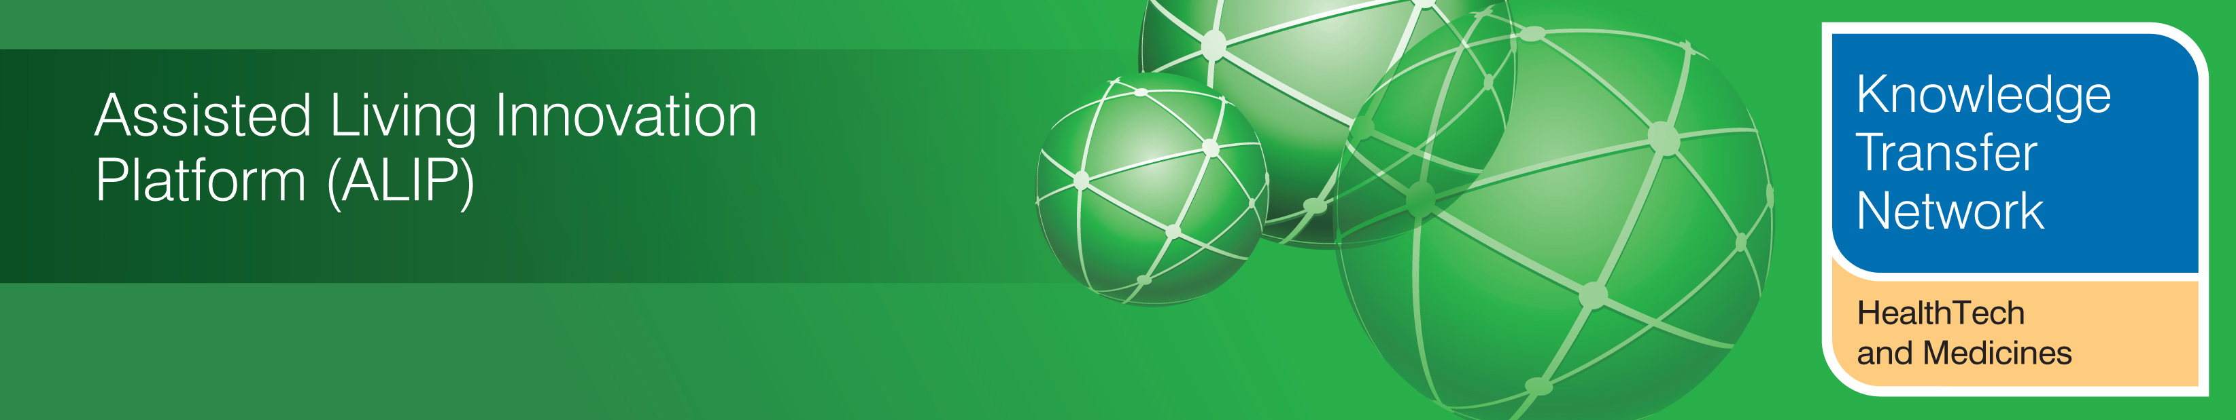
NEWSLETTER
January 2013

Welcome to the January 2013 newsletter from the Technology Strategy Board (TSB) Knowledge Transfer Network and the Telecare Learning and Improvement Network. Our free monthly newsletter is distributed to 46,000 subscribers in the UK and worldwide via e-mail and archived at www.telecarelin.org.uk. You can also find highlights on Prezi (monthly) or Rebelmouse (daily). We hope that you find this newsletter useful. With over 1200 news and events links over the last month, it is the most comprehensive newsletter available serving the telecare, telehealth, mobile health, digital health and assisted living communities.

This month there is news of a new telehealth and telecare strategy from Scotland and aspirations of a paperless NHS from English Health Secretary, Jeremy Hunt. There are new grant announcements as well as adult social care and public health funding programmes for local authorities. 101 clinical commissioning groups have now been authorised and there are a number of new publications from the NHS Commissioning Board ahead of the April NHS reforms commencement in England. There are a whole range of predictions about telehealth and mhealth for 2013 including some links to the recent Consumer Electronics Show which featured digital health. Don’t forget to book tickets for 5-6 March in Liverpool for the ALIP Showcase Conference organised by the HealthTech and Medicines KTN or for the Birmingham, Bristol or York seminars based on the recent assisted living capabilities regional reports.

The links section is now available in a separate supplement rather than in the main newsletter (doc, pdf). A selection from this month’s listing is covered in the newsletter.
The newsletter contains a list of KTN/ALIP activities, conferences and workshops from the UK and Europe over the coming weeks as well as news from the UK and around the world. For weekly news, updates and information, you can register with the Technology Strategy Board, ALIP group and the DALLAS sub-group. You can follow the dallas programme on Twitter at @dallas_connect. 3 Million Lives is now on Twitter at @3MillLives and also at LinkedIn. If you would like daily information on #telecare and #telehealth, then a Twitter stream is available (you do not need to register on Twitter and it is accessible to organisations not able to connect directly to social media).

Prepared by Mike Clark (Twitter: @clarkmike and http://storify.com/clarkmike) for the ALIP Knowledge Transfer Network and Telecare Learning and Improvement Network.

Contents
Item 1 - News from ALIP and the Knowledge Transfer Network (HealthTech and Medicines KTN) – Page 2
Item 2 - Latest news from the dallas programme – Page 3
Item 3 - 3millionlives update – Page 5
Item 4 - UK policy announcements – Page 6
Item 5 - Workforce implications of electronic assistive technology – Page 10
Item 6 - News from the Smart Homes & Buildings Association – Page 11
Item 7 - Other news – Page 13
Item 8 - Summary of recent journal articles and evaluations – Page 23
Item 9 - Learning and Events – Page 24
Item 10 - Other useful links – Page 26
Supplement for January 2013
The links section is now available in a separate supplement rather than in the main newsletter (doc, pdf).
Item 1 – News from ALIP and the Knowledge Transfer Network (HealthTech and Medicines KTN)
UK Capabilities and Opportunities Seminars
Commissioned by the HealthTech and Medicines KTN in 2011, MedilinkWM and SEHTA have produced 12 regional assisted living capability maps that provide industry with a high-level snapshot of each region’s demographic, economic and health statistics. This seminar will show you how to access and exploit this information!
Looking at the statistics for each region, together with an overview of the current assisted living activity in each region, delegates attending these seminars will have a unique opportunity to explore and discuss where opportunities may be found for increased sales, new business and product development. Click here to download your copy of the report.
Register here for the seminars:
Birmingham
Bristol
York
AAL Call 6 Information Day- Birmingham
The HealthTech and Medicines KTN will be holding a UK information day on 12th February 2013 about the next call topic of the AAL Joint Programme: “ICT solutions for supporting occupation in life of older adults.” Register here
Assisted Living Innovation Platform - 2013 Showcase - The Evolving Journey
5-6th March, Liverpool Football Club
The HealthTech and Medicines KTN are pleased to announce the launch of the 2013 ALIP Showcase Conference – The Evolving J This is the 5th Annual ALIP showcase conference and will provide the opportunity to hear presentations that demonstrate the outputs and achievements of the Assisted Living Innovation Platform.
During the lunch break delegates will be given an opportunity to join a Liverpool Football Club tour. The tour lasts for 20 minutes and will give delegates a chance to visit an executive box and view the stadium from the Centenary Stand.
Networking Drinks Reception
Delegates are invited to join the networking drinks reception at the Showcase Conference which will be held in the celebrated ‘Trophy Room’ which also is home to the European Cup. There will also be a short tour including the Hillsborough memorial and player’s dressing room. Register here
For more information on events and ALIP projects please visit the Assisted Living Innovation Platform on _ connect.
Item 2 – Latest news from the dallas programme
Contributed by Alison Mlot, dallas Programme Manager, https://connect.innovateuk.org/web/dallas Twitter @AlisonMlot
The Technology Strategy Board’s Assisted Living Innovation Platform (ALIP), is responding to the exciting and unprecedented phenomenon of population ageing. By 2021 half of the UK’s adult population will be over 50 years and by 2025 almost 1.5 million people will be living with a disability. The aims of ALIP are to foster technological, business and social innovation, ensuring people continue to live independent lives the way they choose in the future. ALIP is about making the future brighter for people in later life and for the wealth creation capability of the UK.
The dallas programme (delivering assisted living lifestyles at scale) is thinking beyond traditional health and social care to consider how new ideas and technology can be used to improve the way people live. By summer 2015, dallas aims to impact the lives of 169,000 people across the UK, benefiting from new and innovative products, systems and services redesign to transform their choices as they age.
Four dallas communities have attracted £37.3 million of funding (£19.6m from Technology Strategy Board, £5.4m from Scotland Government and £12.3m additional investment from the communities).
The communities will show how innovative technologies and services can be used to promote well-being and provide top quality health and care, enabling people to live independently and to expect a better future. Working with existing statutory health care provision the new schemes will encourage individuals to own the management of their health and lifestyles, but with support from the wider community, health professionals and their families.
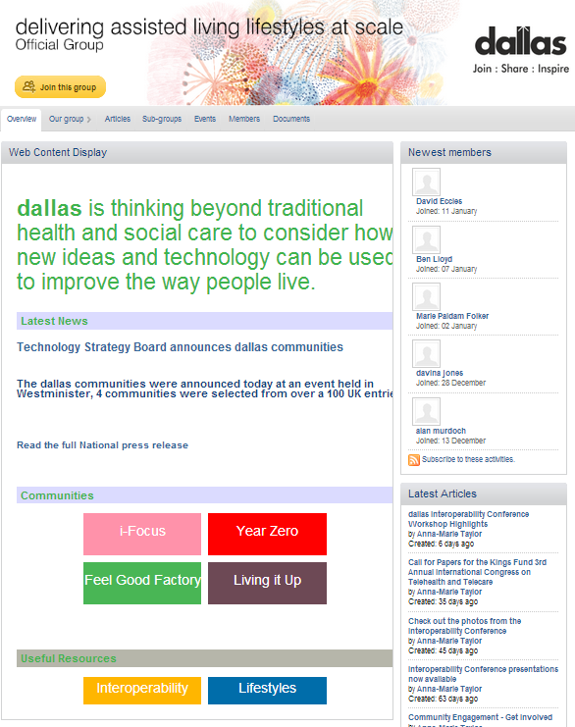

The four dallas communities are:

FeelGood Factory (dallas community in Liverpool)
FGF encourages individuals to take ownership of their own health and social care from an early age and to manage wellbeing in later life thus preventing long term hospital admission through better planning. The programme will work with communities to redesign and develop life enhancing technologies (their title for assisted living technologies) and services to empower individuals and support older adults to live the life they want.
i-Focus (www.ifocus-dallas.com) – aiming to enable anyone, anywhere in the UK, to access support, advice, and diagnosis securely and directly from trusted organisations using simple, consumer devices of their choosing e.g. a laptop, smart phone or TV. This includes the creation of a kite mark that will be applied to products and services that are compatible, giving consumers’ confidence that products and services will interoperate. The first service offered under the ‘Warm Neighbourhoods’ initiative aims to forge and strengthen informal care networks in the community and combat isolation through the use of mobile technologies. i-focus are working with the other communities to address the interoperability requirements which were embedded in the dallas programme.
Year Zero is an online application that empowers individuals to actively manage their health information from cradle to grave. The tools include eRedbook, a digital version of the paper-based Red Book that is given to all new parents to record their child’s health; RallyRound which will help family, friends and carers to cooperate around health, wellbeing and care, particularly to support older relatives; and Health Family Tree, to help people plot their family’s health genealogy.

Living It Up (LIU) is a digitally enabled, thriving community of opportunities to support better health, wellbeing and active lifestyles in Scotland. Innovative products and services will be developed through a trusted marketplace that is designed to fit the lifestyle of the user – in their homes, communities and organisations. Initiatives to be developed by LiU include ‘Hidden Talents’, which will support people to identify and use their hidden talents for the benefit of themselves and their communities. By encouraging individuals to share their skills, LIU aims to build confidence and community engagement.

The dallas programme strongly allies itself to the objectives of 3millionlives (@3MillLives). The Department of Health believes that at least three million people with long term conditions and/or social care needs could benefit from the use of telehealth and telecare services if implemented effectively as part of a whole system redesign. Technology Strategy Board is one of 3millionlives’ founder partners. dallas, with its wider wellness and lifestyles agenda will inform and connect with 3millionlives as it deploys over the next few years. This complements our dallas activity, which we see as action research for 3millionlives, particularly if it takes forward the substantial progress we have made on interoperability and lifestyles. Capitalising on the success of FeelGood Factory (FGF), DH has selected NHS Merseyside to lead a ‘pathfinder’ for 3millionlives. The Department of Health issued a press release about this on 14 November 2013.

Note: The Technology Strategy Board is a business-led executive non-departmental public body, established by the Government. Its mission is to promote and support research into, and development and exploitation of, technology and innovation for the benefit of UK business, in order to increase economic growth and improve the quality of life.
Item 3 – 3millionlives update
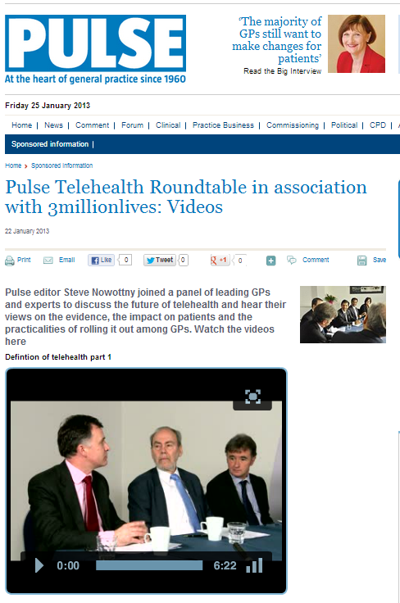
Videos are now available from the recent discussion of Pulse Telehealth Roundtable in association with 3millionlives – you will need to be registered at Pulse Today to access them.
The roundtable discussion is also covered in a Pulse Article and includes contributions from Steve Nowottny, Dr Will Haynes, Paul Hitchcock, Dr Atul Kumar-Beurg, Dr Margaret McCartney, Dr Chaand Nagpaul, Professor Stanton Newman
An update is available on the recent 3millionlives pathfinders. You can follow 3 Million Lives on Twitter (@3MillLives) and LinkedIn for the latest news and discussion.
Item 4 – UK policy announcements

(i) A National Telehealth and Telecare Delivery Plan for Scotland to 2015: Driving Improvement, Integration and Innovation has been published. The Plan from the Scottish Government, CoSLA and NHS Scotland sets out the vision and direction for a Scotland in which the use of technology will be integrated into service development and delivery, transforming access to and availability of services in our homes and communities and more acute settings. This Delivery Plan sets out six workstreams, each with specific actions to be delivered by 2015.
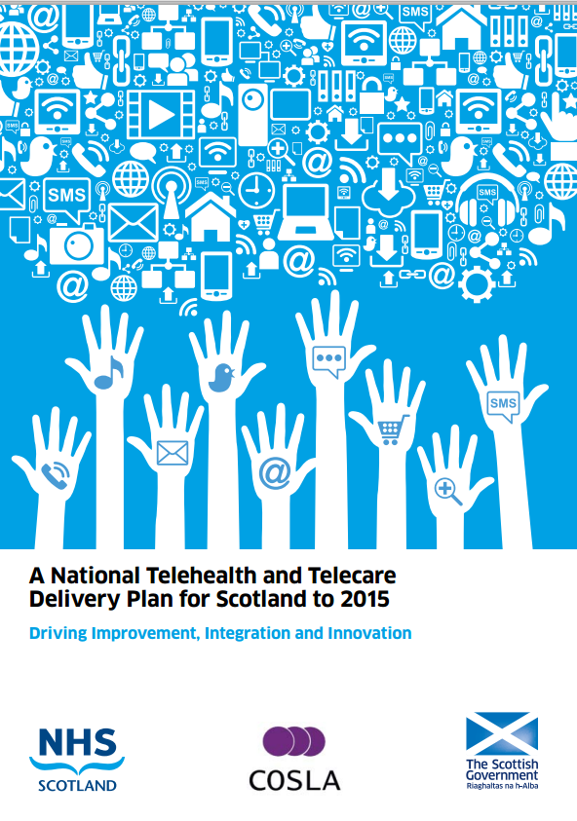
The strategy aims for a ‘Triple Win’ by 2020 - delivering the use of telehealth and telecare at scale in Scotland, will
- Enhance wellbeing and quality of life
- Improve sustainability of care
- Increase economic growth in Scotland
As a milestone towards 2020, the strategy’s ambitions for March 2015 are that:
- Telehealth and telecare will enable choice and control in health, care and wellbeing services for an additional 300,000 people
- People who use our health and care services, and the staff working within them, will proactively demand the use of Telehealth and Telecare as positive options
- There is a flourishing Innovation Centre where an interacting community of academics, care professionals, service providers and industry innovate to meet future challenges and provide benefits for Scotland’s health, wellbeing and wealth
- Scotland has an international reputation as a centre for the research, development, prototyping and delivering of innovative telehealth and telecare services and products at scale
Delivery will be supported by the Scottish Centre for Telehealth and Telecare, working in collaboration with the Joint Improvement Team. They will continue to engage with all key stakeholders and will provide improvement support and challenge in delivering the actions in the National Delivery Plan.
(ii) Some patients in Powys (Wales) will be able to speak to doctors via video and phone conferencing under the Digital Wales scheme (BBC Report , EHI Report) to use new technology to improve healthcare. Mobile phone apps will also be available to support certain patients under the Digital Powys scheme. A computer mapping system to help doctors plan treatments more efficiently is also being rolled out. Patients with conditions like Asperger's Syndrome who have smart phones will be able to use apps to alert a support team if they feel particularly agitated. Public health messages will be accessible via social media.
(iii) Jon Rouse has been confirmed as the new Director General for Social Care, Local Government and Care Partnerships at the Department of Health in England.
His responsibilities will include:
- policies on care and support for adults
- the department’s relationship with local government across all of health and care
- mental health
- disability
- health equalities
- health services for children

(iv) English Health Secretary, Jeremy Hunt has announced that he would like to see a paperless NHS by 2018. The announcement was accompanied by a report which suggests that improved use of IT could deliver significant annual savings.
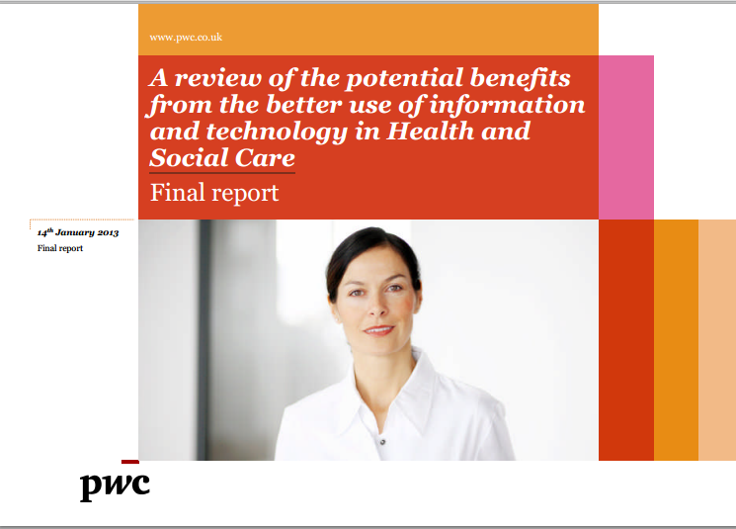
eHealth Insider also has an article on the subject by MHP’s Mike Birtwistle.
(v) The benefits of mobile technology for health staff and patients are covered in the final DH report of the mobile health worker project - a study on introducing mobile devices at 11 NHS pilot sites. The aims of the study were to understand the requirements of mobile working, and to demonstrate whether increased productivity and efficiency can be achieved by making changes to working processes.
(vi) The Department of Health (@dhgovuk) has announced funding of £120m for an open competition to research ways of improving NHS services. Each research project will involve collaborative partnerships between a university and surrounding NHS organisations and will be overseen by the National Institute of Health Research. The funding period for successful applications will run from January 2014 to December 2018 and there will be a maximum of £2 million per annum per CLAHRC over the five-year period.
(vii) A £5.45 billion two-year ring-fenced public health budget for local authorities has been announced by the Department of Health in England. From April 2013, public health budgets will be protected for the first time, with local authorities taking the lead for improving the health of their local communities. In 2013/14 the total budget for local public health services will be just under £2.7 billion. In 2014/15 the budget will be just under £2.8 billion.
(viii) Community Care has published a Care and Support Bill Reading List. You can follow Community Care on Twitter (@communitycare @mithransamuel).
(ix) The proposed strengthening of the NHS Constitution in England will be overseen by an expert group chaired by Minister of State for Care Services Norman Lamb.
(x) Care and Support Minister in England, Norman Lamb (@normanlamb) has announced that 6 local projects have begun work to help improve access to psychological therapies (IAPT) for those with severe mental illnesses. Funding of £1.2m will be used to help these trusts share information with other health organisations about how they deliver the best treatments that lead to improved patient choice and recovery.
(xi) In December, the Department of Health made £22 million of funding available to 21 pioneering research projects to boost dementia diagnosis rates and trial ground-breaking treatments. The funding was awarded by the National Institute of Health Research (NIHR) and was designed to cover all areas of scientific activity relevant to dementia, across the fields of care, cure and cause, including prevention. One of the projects awarded funding is the UK’s first ever trial to measure how much longer people with dementia can live safely and independently in their own homes, when they are provided with a specialised telecare technology package including motion sensors, GPS trackers, and personal alarms (ATILLA trial details 1 and 2).
(xii) GPs, district nursing and community hospitals should be subject to regular patient and staff satisfaction tests in the same way as has already been proposed for hospitals (with £50m incentives), David Cameron has announced. The Prime Minister is also promising every NHS ward will have a "dementia champion" and every NHS organisation a dementia nursing expert. A £50m incentive scheme will be available to improve dementia care in 2013-14. Hour-by-hour care rounds will be introduced in every hospital in England by the end of the year.
(xiii) The Department of Health in England has opened two new SBRI competitions with a total of £5million funding available to develop technological and innovative solutions that can:
- Improve experience for people with mental health illnesses; or
- Improve experience for people at the end of their life.
This funding is part of the Government’s commitment to help improve care for patients with long-term conditions and ensure high quality care and support offered to dying people in their final days and hours. The competition closes for entries on 28 February 2013.
(xiv) The Department of Health has set out the provisional adults’ personal social services (PSS) specific revenue and capital grant funding for local authorities for the periods 2013/14 and 2014/15. DH allocates the Community Capacity Grant to local authorities, providing capital funding to support development in three key areas: personalisation, reform and efficiency. Capital grant funding has been held constant in real terms for 2013/14 and 2014/15. This means that local authorities will receive DH capital grant funding of £129 million for 2013/14 and £132 million for 2014/15.
(xv) The NHS Commissioning Board (@nhscb) has publishing its planning guidance for 2013/14. The NHS CB aims to help local clinicians deliver more responsive health services, focused on improving outcomes for patients, addressing local priorities and meeting the rights people have under the NHS Constitution. Called Everyone Counts: Planning for Patients 2013/14, the document outlines the incentives and levers that will be used to improve services from April 2013, the first year of the new NHS where improvement is driven by clinical commissioners. It also addresses health inequalities, so that those most in need gain the most from the support provided. The guidance covers a clear set of outcomes against which to measure improvements and outlines five offers - moves toward seven-day a week working for routine NHS services; greater transparency and choice for patients; more patient participation; better data to support the drive to improve services; and higher standards and safer care. To assist those planning services locally, the NHS Commissioning Board has also published comparative information on outcomes for patients in all CCG and local authority areas. These outcomes benchmarking packs are intended to support the local planning of health and care.
Also published are the financial allocations for CCGs (£63.4bn) and for the NHS CB for 2013/14.
(xvi) A new vision and service model for district nursing was published on 4 January 2013 by the Department of Health in England (@dhgovuk) and the National Commissioning Board (@NHSCB).
The document sets out the strong foundations of district nursing services and also outlines the developments and innovations that ensure services can meet current and future needs including:
- making every contact count – providing opportunistic public health interventions and supporting the health and wellbeing of carers
- maximising efficiency – use of productive community services and innovation to enhance care
- integrated working with health and social care – developing strengthened ways of working with partners to maximise resources
- delivering complex care – supporting care in community settings e.g. administering chemotherapy at home, reducing avoidable hospital admissions and promotion of early discharge
- new technology to enhance care – the use of telehealth and mobile technology to support complex care in the home
- The district nursing service model outlines the district nurse-led team contribution to providing care and support in the community, including peoples’ homes
(xvii) The NHS Commissioning Board has authorised the second wave of clinical commissioning groups (CCGs), taking the total to 101, serving more than 28 million people. A total of 211 CCGs will, from 1 April 2013, be responsible for £65 billion of the £95 billion NHS commissioning budget. The remaining 110 CCGs are set for authorisation over the next two months. 74 of the CCGs have been authorised with conditions that will need to be addressed. CCGs, set up by the Health and Social Care Act 2012, will from April 2013 replace the 151 primary care trusts that currently commission healthcare services. They are independent statutory bodies, led by their members ie the GP practices in their area.
(xviii) The Cabinet Office has set out developments in the NHS and Social Care as part of its Mid-Term Review.
(xix) The Department of Health in England has confirmed the Date for receipt and publication of the Mid Staffs Public Inquiry report as 6 Feb 2013.
(You can follow the Department of Health in England, Jeremy Hunt and Norman Lamb on Twitter at @dhgovuk, @jeremy_hunt and @normanlamb. In Scotland, you can follow the Scottish Government’s Health Department on Twitter @scotgovhealth and Alex Neil @AlexNeilSNP (also @NHS24). In Wales follow @WelshGovernment)
Item 5 Workforce implications of electronic assistive technology
Article contributed by Dr Malcolm Fisk, University of Coventry
The Care Council for Wales, on behalf of all the UK skills councils, has commissioned work to develop draft new skills and knowledge sets for the social care workforce that arise specifically because of the advent of Electronic Assistive Technologies (EATs). These include telecare and telehealth. The work is being undertaken by Coventry University and is led by Malcolm Fisk.
The headings for the draft new skills sets for social care staff are:
- Basic IT and Technical Skills
- Knowledge of the Broad Range of EAT Available
- Knowledge of EAT Available for Access and Use in Relation to Particular Needs
- Assessments and Facilitating Self-Assessment in relation to EAT
- Specific Requirements around EAT Installations, Safety, etc.
- Specific Requirements around Telecare and Telehealth
The Coventry team are determining the range of EAT related tasks for which new knowledge, skills and competencies are required. They are inviting suggestions regarding these and the nature of the new, additional or enhanced skills and knowledge requirements.
Suggestions should be sent to gsands@cad.coventry.ac.uk by February 14th together with pointers to the type or range of social care staff to which these should apply. She should also be notified if you wish to be included in the formal consultation (later this year) regarding the detail of the draft skills sets and tasks to which they relate.
Item 6 News from the Smart Homes & Buildings Association
Contributed by Stephen Pattenden from http://www.shaba.eu/
Following on from the successful launch meeting of the Smart Homes & Buildings Association in November 2012, we are now pleased to announce that we shall be holding our first set of Panel Meetings in the second and third weeks of February 2013.
These meetings will be the first in a series of Panel meetings that will be held every two months throughout 2013.
We are holding meetings of the panels on the following dates and times:
Panel and Registration | Date/Venue | Time
Future Cities & Communities  Chair: Mike Perry – BRE | Thursday 14th February  Westminster City Council Archive Room 10 St Ann’s Street, London SW1P 2DE | 10.00 to 13.00
Energy  Chair: Ashley Pocock – EDF Energy | Thursday 14th February  Westminster City Council Archive Room 10 St Ann’s Street, London SW1P 2DE | 14.00 to 17.00
Technology  Chair: Dritan Kaleshi – University of Bristol | Friday 15th February  Coin Street Community Builders, 108 Stamford Street, London SE1 9NH | 10.00 to 13.00
Consumers  Chair: Zoe McLeod – Consumer Focus | Friday 15th February  Coin Street Community Builders, 108 Stamford Street, London SE1 9NH | 14.00 to 17.00
Health  Chair: Richard Foggie - ESPKTN | Wednesday 20th February  Westminster City Council Archive Room 10 St Ann’s Street, London SW1P 2DE | 14.00 to 17.00
Details of each Panel Event and Registration for them may be found at www.shaba.eu and then going to the relevant Panel page.
Each Panel will follow a similar agenda:
- Terms of Reference and objectives of the Panel
- Major areas of interest, Gaps and Panel policies
- Areas where we can deliver value and change
- Proposed programme for the year
- Actions and timescales for the above
The Panel meetings will output a series of valuable programmes that will make a difference to how the UK (and Europe) deliver services and products in the sectors and competences covered by the Panels. Most of all we are keen to ensure that SH&BA members gain market advantage for their products and services. Where there are opportunities for groups of SH&BA members to work together to fulfil a perceived market need, SH&BA will help create consortia.
We think it will be invaluable to attend these initial meetings. These initial meetings will be open to all, but will carry a small charge of £25 per meeting for non- SH&BA members (to cover the cost of organisation and the venues). Places are limited to 25 people per Panel, so we advise prompt registration. SH&BA members will receive a code for free Registration. Organisations that become members at the meetings or in the two weeks following the meetings will be eligible for a refund of their registration.
SH&BA has three main functions:
- To build understanding of the Smart Homes and Buildings market in the UK and Europe and from this identify opportunities for SH&BA members and their organizations.
- To identify issues which need to be resolved or areas requiring research to be undertaken in order to understand them.
- From the opportunities and issues identified, work as focused groups to help members create marketable products and services needed and where necessary set up R&D and other short term projects to resolve the issues and deliver better ways of fulfilling peoples' needs.
We have structured the way we will use the Panels and working groups to think and act according to the diagram below:
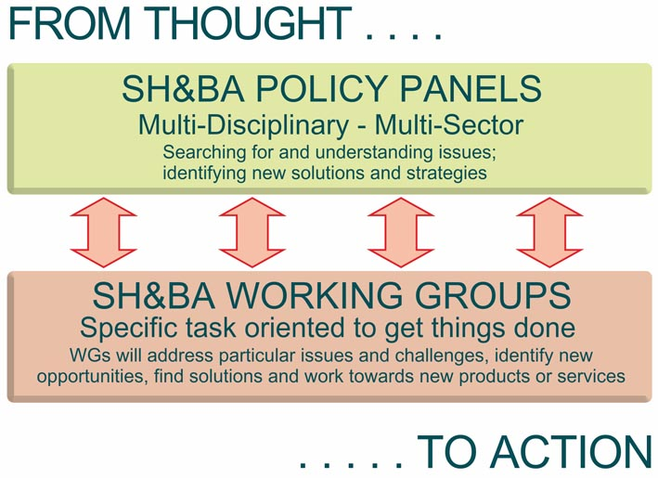
To take part in SH&BA Working Groups, Panels and bids which will in many cases lead to valuable industry knowledge, ideas for new services, products and projects for members, membership of SH&BA is necessary.
Future Panel Meetings will take place in April, June, September and November 2013 and the dates for them will be set at the first meetings in February: There will be a number of large scale events and as the Panels progress we will be launching Working Groups to address projects and issues of importance identified by the Panels.
We have now finalised our subscription structure and this can be found by clicking HERE, or download the membership application form from HERE. SH&BA’s online payment facility is now available - simply click on the “Join SH&BA” button from the membership page. An Introduction to SH&BA may be found HERE. For other information about SH&BA and to become a member please contact the SH&BA Secretariat - Telephone: +44 (0) 1379 890 442 or email: secretariat@shaba.eu or visit the website at www.shaba.eu.
Item 7 - Other news
Here is a roundup of other news over the last month. A fuller listing is available in the supplement (doc, pdf).
(i) 13 March 2013 – NHS Change Day - It could be something as simple as spending time with patients to ask for their feedback on the service, trying out a new approach with patients in waiting rooms or surgeries, or altering the way a routine task is carried out. The day is 13 March 2013. It will be the single largest improvement event in the NHS to date. Anyone can take part, not just those involved in healthcare. Follow on Twitter at #NHSChangeDay
(ii) The King’s Fund has announced a call for papers for the Third Annual International congress on Telehealth and Telecare (1-3 July 2013, London). The deadline for submissions is 15 February 2013. Follow the King’s Fund on Twitter (@thekingsfund @goodwin_nick)
(iii) £100,000 of additional funding has been allocated to Richmond Council’s Telecare Scheme. There are currently 1,600 residents and 250 residents will be able to benefit from the new funding.
(iv) The funding gap for providing adult social care in London could be as much as £907m within five years, according to a new report covered by the Guardian. The report, A Case for Sustainable Funding for Adult Social Care, estimates that London councils have the potential to make combined efficiency savings of between £240m and £735m but that leaves a funding gap.
(v) Integrating housing with health and social care can save hundreds of thousands of pounds per case for council services, according to the National Housing Federation (Article). The NHF report, aimed at local commissioners of health and social care, tells the stories of five people who receive integrated care, housing and support.
(vi) From the Telegraph, figures from the Office for National Statistics suggest that most people are living six years longer than current life expectancy projections - most men will live to 85 while the majority of women will survive until 89. And it is likely to increase for children born today.
(vii) From Pulse Today, “GPs are likely to take a pay cut rather than implement all the four directed enhanced services (DES) the Government is proposing from April 2013, as the workload involved will be‘very steep”, says GPC chair Dr Laurence Buckman. The new GP Contract (subject to consultation) will offer four DESs - worth £3,600 each - to GPs in England to incentivise dementia case-finding, developing access to online GP services, telehealth and case-managing patients at risk of hospital admission.
(viii) Sir David Nicholson, chief executive of the NHS in England, says he wants to see innovation as the "raison d'etre of every NHS employee". The Guardian Healthcare Professionals Network is launching a campaign to find and showcase the best examples of innovation in the health sector. Throughout 2013, the project will identify and celebrate the cutting edge developments in the sector, as well as examining the role of leadership in driving innovation and how best practice can be shared and communicated.
(ix) The Care Information Scotland website has a helpful page on telecare.
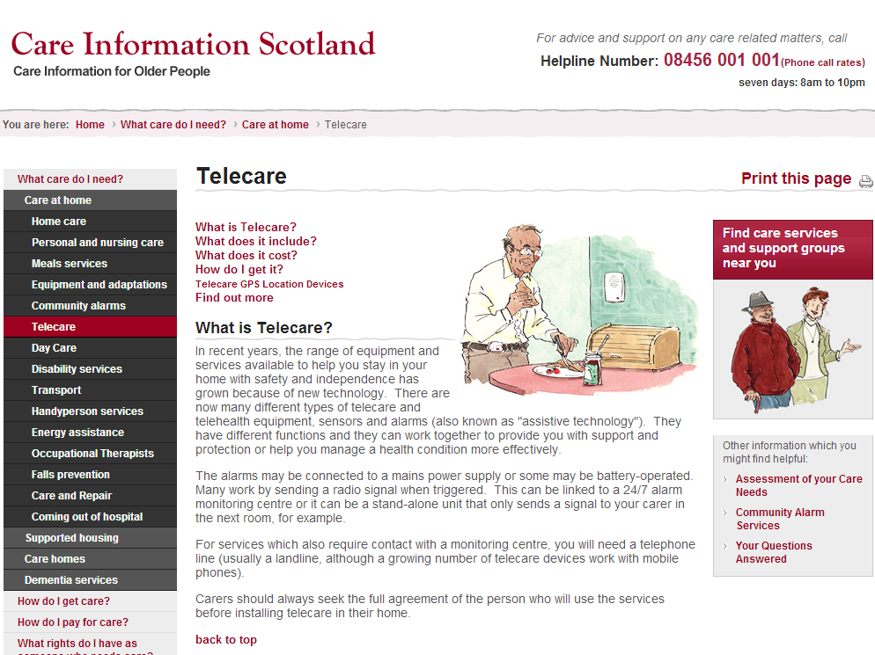
(x) People around the world are living longer but with higher levels of sickness, according to the largest ever study of the global burden of disease. The Lancet analysis shows high blood pressure, smoking and drinking alcohol have become the highest risk factors for ill health.
(xi) One of the most interesting news and discussion web sites launched in 2012 was the Disruptive Social Care Podcast developed and presented by Shirley Ayres (@shirleyayres) and Stuart Arnott (@MindingsStu). The podcast, available on a number of platforms including You Tube and iTunes over the last few months has presented a range of care innovators and policy experts in addition to important news updates during a period of intense discussion on the most cost-effective approaches to providing health and social care for the future. The programme is well-researched and professionally presented – the recent discussions with Richard Humphries from the King’s Fund and Paul Burstow MP have been particularly enlightening. The podcast needs funding support in 2013, so they have launched a crowdfunding and sponsorship scheme to maintain the high quality of the podcast for the future.
(xii) From Carers UK - Census data released in December 2012 reveals that the number of carers increased from 5.2 million to 5.8 million in England and Wales between 2001 and 2011. The greatest rise has been among those providing over 20 hours care – the point at which caring starts to significantly impact on the health and wellbeing of the carer, and their ability to hold down paid employment alongside their caring responsibilities. There are now 2.1 million people providing over 20 hours a week - a rise of almost half a million people in the last 10 years. Those providing the most number of hours of care – over 50 hours a week and very often caring round-the-clock - has in risen by 270,000 and is up from 1,088,000 to 1,360,000.
(xiii) New figures released by Alzheimer’s Society reveal wide variations in how many people are receiving a diagnosis of dementia in Britain. Diagnosis rates range from 31.6 per cent in East Riding of Yorkshire to 75.5 per cent in Belfast. There has been a 3 per cent increase in the number of people in the UK that have been diagnosed with dementia raising the number of people who now have a formal diagnosis to 46 per cent. However, there are thought to be another 428,000 in the UK (54 per cent people) who are living with the condition but who are not diagnosed. Alzheimer’s Society has produced an interactive map which highlights the number of people who have a diagnosis of dementia in different Primary Care Trusts in the UK. A survey of memory clinics showed the average waiting time for an appointment is 32.5 working days, which is over the 4-6 weeks (recommended by Memory Service National Accreditation Programme). Some memory clinics reported longer waiting times of up to 9 months.
(xiv) The UK is the fifth highest in the world for the rate of children diagnosed with type 1 diabetes. The UK rate is double that in France (12.2 per 100,000) and Italy (12.1 per 100,000).
(xv) From mHIMSS, a new bill, introduced in the U.S. House of Representatives, would increase federal support and payments for telehealth services. If passed into law, the Telehealth Promotion Act of 2012 would establish a federal reimbursement policy, wherein “no [medical] benefit covered shall be excluded solely because it is furnished via a telecommunications system.” Implementation would increase access to telemedicine within Medicare, Medicaid, the Children’s Health Insurance Program (CHIP), TRICARE, federal employee health plans and the Department of Veterans Affairs.
(xvi) In December 2012, eHealth Insider reported that Cornwall Council has voted in favour of outsourcing telehealth and telecare services to BT as a part of a shared service programme it hopes will generate additional jobs. Details are to still to be decided according to the report.
(xvii) An Independent Living Telecare show flat has been opened in York at Alex Lyon House in Tang Hall.
(xviii) A new telecare service in the UK has been launched by Geonovo (@telecarepro).
(xix) Deloitte has published a new report on ‘mHealth in an mWorld: How mobile technology is transforming health care’ which examines factors driving the adoption of mHealth and opportunities it presents to lower costs and improve patient outcomes.
(xx) The Danish government is the first to adopt national technical guidelines and standards to establish reference architectures for healthcare IT as part of their National Telemedicine Action Plan.
Continua Alliance guidelines have been chosen which cover the following areas:
- Secure collection, transmission and storage of personal health data from patients’ homes
- Sharing medical documents and images
- The management of health records, medical appointments, and other related information.
(xxi) The College of Social Work with Adults has published a report on ‘The Business Case for Social Work with Adults.

(xxii) In their latest report, ‘Health Online 2013’, Pew Internet report that 81% of U.S. adults use the internet and 59% say they have looked online for health information in the past year. 35% of U.S. adults say they have gone online specifically to try to figure out what medical condition they or someone else might have. When respondents were asked about the last time they had a serious health issue and to whom they turned for help, either online or offline:
- 70% of U.S. adults got information, care, or support from a doctor or other health care professional
- 60% got information or support from friends and family
- 24% got information or support from others who have the same health condition
(xxiii) In January at the International Consumer Electronics Show in Las Vegas, HealthSpot launched a walk-in telehealth station that will allow patients to take medical readings and communicate remotely with a doctor. A medical assistant helps patients by taking their blood pressure and setting up the telehealth session in the kiosk. The assistant can also determine if an in-person physician is necessary based on the patient's condition.
(xxiv) Leicestershire County Council has invested in a countywide telecare service from Tunstall, mainstreaming its delivery of assistive living technology to integrate fully with existing reablement services and provide additional support to people with health and care needs. Over the next twelve months, the council plans to support a significant number of people by using telecare, with funding from NHS transfer funding for Social Care.

(xxv) Thousands of elderly people are being kept in hospital needlessly after the number of district nurses fell by 18 per cent – is there a link? Article in the Telegraph.
(xxvi) The Telegraph and Argus in Yorkshire reports that telemedicine technology at Airedale Hospital is being used to help a woman with Parkinson’s Disease. Ruth Pickles will be the speech and language therapy team’s first patient to have Lee Silverman Voice Treatment (LSVT) using the hospital’s ‘telemedicine’ secure video link. The treatment is designed to help patients speak louder. Currently 1,000 patients across Airedale Hospital’s catchment area are linked to the Telehealth Hub, including those with chronic heart failure, chronic obstructive pulmonary disease and diabetes. Telemedicine is being used by 18 nursing homes across the Bradford district and three in Craven. Manorlands cancer-care hospice, at Oxenhope, near Keighley, is also linked up, as are six GP surgeries. A telemedicine community hub is available in Grassington where patients can have an outpatient consultation via a secure video link. The hospital also provides a telemedicine service to 21 prisons.
(xxvii) The National Diabetes Audit reports that people with diabetes are up to 65% more likely to have heart failure. The National Diabetes Audit looked at data on almost two million people and also found increased risk of other complications, and premature death. In 2010-11, 45,000 people had heart failure when the expected number would have been 27,300. People with diabetes were also at a significantly increased risk of need an amputation of the foot or leg.
(xxviii) As the healthcare sector in England gears up for April 2013, John Wilderspin, the former national Director of Health and Wellbeing Board Implementation explains how he envisages the boards working from April 2013 in this Guardian article.
(xxix) A report produced by end-of-life doctors and nurses (Association of Palliative Care, Marie Curie Cancer Care) – has said that many people were going without the help they needed such as specialist coordinated care from teams of professionals to help manage pain and disability in the final year of life and ensure patients are treated with dignity and compassion.
(xxx) Following Prof James Barlow’s (@jgbarlow2010) recent Haciric report ('Remote Care PLC’), there’s a follow up article (subscription required) in the Health Service Journal – it’s called ‘The remote care revolution needs a boost’.
(xxxi) BBC News reports on the progress of the NHS in England to find efficiencies of up to £20bn by 2015 to cope with rising demands. The National Audit Office found it had made a good start, achieving virtually all its forecast £5.9bn in 2011-12. But the report warned the push would get harder, as the easiest savings had been made first.
(xxxii) In a new report, The Royal College of Physicians said hospitals in particular had "poorly developed" systems in place for providing obesity support – services were often just dealing with the symptoms, such as heart disease or diabetes, rather than the cause. One in four adults are obese - a figure which is predicted to more than double by 2050.
(xxxiii) In a recent blog, David Lee Scher considers ‘Business Models of Digital Health Technologies: Implications for ROI (Return on Investment)’.
(xxxiv) From a press release, Moonray Healthcare has announced that it has made a substantial investment in Wiltshire Medical Services (WMS), a primary care services provider delivering care to more than 450,000 patients through a combination of GP urgent care services, a Single Point of Access, discharge planning support, telecare and telehealth programmes. As part of the deal WMS will acquire Telehealth Solutions Limited (THSL), a leading provider of telehealth technology. The press releases says ‘the combination will create an integrated, primary care focused organisation with market leading expertise across a broad range of remote patient management services’.
(xxxv) The U.S. Centre for Medicare and Medicaid Innovation is implementing a patient-centered ‘medical neighborhood’ pilot from a report in GovHealthIT. A group of vendors will help up to 15 health systems and provider groups in 15 states, use health IT to transform their practices, coordinate care, improve clinical performance and drive savings. The project will include about 157,000 Medicare and Medicaid beneficiaries. Aims over the 3 year project include:
- Decrease healthcare costs by $49.5 million within the 15 communities
- Improve the eligible patient population health by a 15 percent average in selected quality measures
- Achieve patient experience improvement by 25 percent
(xxxvi) An LGA-commissioned report examines progress made by the four ‘whole place’ pilots (Cheshire West and Chester Council, Essex CC, Greater Manchester and the west London tri-borough partnership), and assesses how the financial and service benefits could be applied across local government nationally. Financial analysis indicates that more than £4bn could be saved across local and central government each year.

(xxxvii) Are personal health budgets beneficial for older people? Here is a ‘For and against’ from www.homecare.co.uk. There is a new set of guidance on the subject from The Royal College of GPs and here is an example from Kent. There is a Personal health budgets update for Winter 2012 from the Department of Health in England.
(xxxviii) Do the thousands of health apps for smartphone and tablets launched each year have any real medical benefits? A recent Guardian article said that there are more than 1,000 health smartphone/tablet apps released every month. Most of the apps are not covered by regulatory provisions in the UK, USA or Europe.
(xxxix) The 2011 census has revealed there are more than 10 million people over the age of 65, the proportion aged 85-plus has grown rapidly and the trend will only continue. The Guardian is launching a major project looking at how society can support its ageing population. Bringing together key figures from the public, private and voluntary sectors, academia and central government, the project will include a series of quarterly events and a dedicated online ‘Ageing Population’ hub.
The awareness campaign, supported by the Joseph Rowntree Foundation, British Red Cross and Barchester Healthcare, will look at how service providers can plan and prepare for the growing older population. Issues to be explored during the course of the campaign will include:
• The future of social care funding
• Collaborative working to improve services for older people
• Supporting people to age well
• Pensions and welfare
• Encouraging older people into the workforce
• The role of telecare in services for older people
(xl) People want a broader choice in the public services available, and how they are delivered, from hospitals and schools to social care, according to an independent review conducted by David Boyle (press release).
(xli) Grandcare has been chosen by Saga to provide telecare and telehealth technology and systems to support their home care services. Here is coverage at the Grandcare and Saga websites.
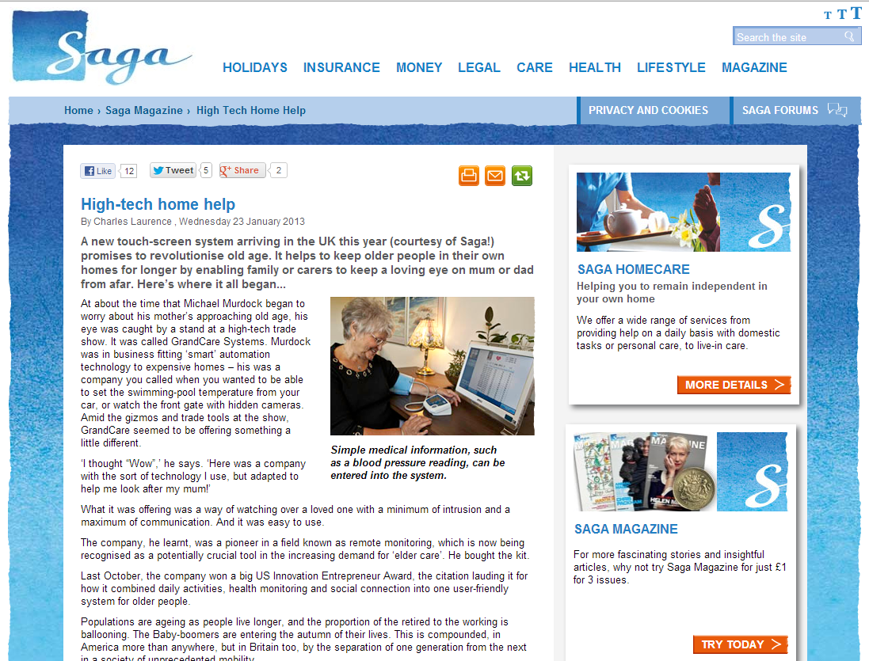
(xlii) In the United States, the Federal Communications Commission (FCC) has announced that it will make up to $400m available to healthcare providers to create and expand telemedicine networks nationwide, linking urban medical centres to rural clinics while providing greater access to medical specialists and instant access to electronic health records.
(xliii) A survey conducted by Diabetes UK found that NHS healthcare for most diabetic patients (85 per cent) either remained the same or worsened during 2012. Less people had an individualised care plan put together with their healthcare professional or were seen to by a member of a specialist diabetes care team when they were admitted to hospital. Just 11 per cent of those polled reported an improvement in their level of care.

(xliv) Hundreds of thousands of elderly people are left isolated because their grown-up children live too far away, warns WRVS in a new report. Also take a look at this Guardian article on ‘Britain’s Loneliness Epidemic’.
(xlv) Pulse Today covers the first round (2012) of ‘Any Qualified Providers’ (AQP) in the NHS in England. Almost 70% of the new approved providers are from the independent or third-sector.
(xlvi) The seventh annual GP Patient Survey (EHI Report) shows that 30% of respondents said that they would like to book their appointments online, up 1% from last year. However, the survey shows that fewer than 3 % of patients actually booked their appointments online.
(xlvii) The New York Times reports that the conversion to electronic health records has failed so far to produce the hoped-for savings in health care costs and has had mixed results, at best, in improving efficiency and patient care, according to a new analysis by the influential RAND Corporation.
(xlviii) In the U.S., federal authorities are providing $1.9 million in new funding for the nation's network of telehealth resource centers, paving the way for an additional five regional centers and one national center.
(xlix) From the Guardian - Councils in England will have their spending power cut by 1.7% from April 2013. Minister, Eric Pickles told the Commons a small number of local authorities would require larger savings to be made, but he said no council would face a loss of more than 8.8% of its total spending power thanks to a new efficiency support grant. The DCLG has also published 50 examples of where it believed councils could save money.
(l) There is a new report on technology in healthcare from the Digital Policy Alliance.
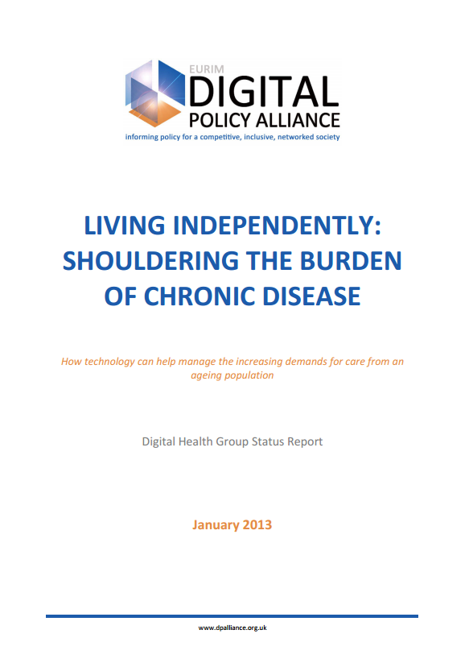
(li) There is a lot of talk about the ‘quantified self’ movement using various types of sensors, medical devices, monitors, computer programmes and apps. But beyond self-management and patient empowerment could it lead to obsessive behaviour, worry about unusual readings or trends and what will doctors do with the data if you present it to them? Here are some recent articles: Are we headed toward the over-quantified self?, Living the quantified self: the realities of self-tracking for health and Quantified Self and the Internet of Things: Everyone is collecting your data, so why shouldn’t you?
(lii) The Health and Social Care Information Centre (HSCIC) has published Clinical Commissioning Group (CCG) indicators for the first time covering Potential Years of Life Lost (PYLL), Mortality Emergency hospital admissions, Emergency re-admissions to hospital, Patient Reported Outcomes Measures (PROMS) and Patient Experience. It is anticipated that further CCG indicators will be released at the end of March 2013.
(liii) The latest e-bulletin is available from FAST (@FASTATUK) and here is their latest list of upcoming events.
(liv) Interested in mHealth? – here is a blog about the 10 Best mHealth Papers of 2012.
(lv) Here is a recent Telehealth video presentation on telehealth to allied health professionals covering 3millionlives.

(lvi) “What’s The Future Of Doctors When Sensors In Your Electronics Diagnose Disease?” Asks Bradley Kreit at FastCo looking at recent developments from companies such as AliveCor and Scanadu.

(lvii) New designs for medication packages and plans for labels that are easier to understand aim to help people stick to their drug regimens according to this Wall Street Journal article.

(lviii) The Scottish Centre for Telehealth and Telecare has started delivering health services via video link to police custody suites and prisons. The centre has set up video conferencing between health staff at major custody suites and some remote holding cells that do not have nurse support. (Also covered by eHealth Insider at ‘High road, remote care’).

(lix) Use of telehealth, telemedicine, apps are a consideration in the European COPD Coalition’s - ‘Call to action on COPD’


II. Care and Disease Management – Section 5
Fund and support the development and implementation of innovative tools, techniques and approaches to treating COPD, which include the promotion of home care and of telemedicine. The
use of modern technology (such as smart phones and applications) can improve patient access, information and disease monitoring, and will lead to cost savings.
(lx) The BBC covered telehealth in Kent on a recent TV programme which is unfortunately no longer available on the iPlayer. There is, however a short news item still available for viewing.
(lxi) The new clinical commissioning groups in North Yorkshire will need to make a decision on their future investment in telehealth. According to the Yorkshire Post, although 1200 patients have benefitted, current deployment of the telehealth units remains around a third of total units purchased.
(lxii) Andy Burnham MP (@andyburnhammp) has started a Labour Party consultation on the merger of NHS and social care (Speech, Video, Tweets Storified).
(lxiii) GPOnline (@GPOnlineNews) has an article on Florence telehealth (@nhssimple) based on the work initially carried out at NHS Stoke on Trent.

(lxiv) Jeremy Porteus from TelecareLIN and Housing LIN (@HousingLIN) features on the ever interesting King’s Fund ‘Think differently’ Blog with an article ‘When it comes to care, is there any place like home?’ The Next Housing LIN newsletter is published in Mid-February – make sure you are registered to get your copy.
(lxv) NICE guidance now supports a new blood pressure device that can detect atrial fibrillation.
(lxvi) Interested in 2013 Trends and roundups? Here is a list of recent links:
20 Tech Trends That Will Define 2013
10 Mobile Health Apps From Uncle Sam
100 trends that will change healthcare in 2013
115 Mind Blowing mHealth and Telehealth Statistics and Trends
Top 6 Telehealth Trends for 2013
Increased device adoption will make 2013 a banner year for mHealth
12 Expert Health IT Predictions For 2013
15 Predictions in Healthcare, Technology and Innovation for 2013
2013: The Year of Digital Health
2013: The Year of Patient Engagement Innovations
Future tech: Smart fabrics and other forecasts
Six steps to improve digital inclusion in 2013
Wearable technology could give you a New Year fitness boost
2013: The year of the mHealth user
Five innovations that will define tech in 2013, including an FDA battle over digital health
(lxvii) Interested in some of the technology and digital health at CES2013? Here is a list of recent of links:
2013 CES: Tom Paul of UnitedHealthcare
2013 CES: Unveiled - Withings is Coming Up with New Ways to Track Your health
5 Big Trends You'll See at CES 2013
A Closer Look at The Masimo iSpO2 Pulse Oximeter for iPhones/iPads (VIDEO)
The fork of the future: a gadget for greedy guzzlers
New Year’s Resolutions: A Physician’s overview of the best fitness trackers and what’s next
CES 2013: Health and safety technology booms
Beyond gadgets, telemedicine is about saving lives
CES 2013, GPS for the Soul and the Digital Health Revolution
CES 2013: the health and fitness gadgets coming your way
CES 2013: The Year of The Quantified Self?
CES telehealth panel: The tide is (slowly) turning
How technology is building a new old age
Item 8 – Summary of recent journal articles and evaluations
Each month, our supplement (doc, pdf)provides a comprehensive list of recent journal articles. Here are summaries from just a few of the recent papers.
(i) A study of clinicians in The Netherlands using Internet-based telemonitoring with heart failure patients found it didn't live up to their expectations. The JMIR study found that though telemonitoring is considered a breakthrough technology for treating heart failure patients, the clinics involved tended to lack a clear profile of the optimal patient and had begun working with the technology without guidelines, protocols and solid evidence of its usefulness.

(ii) Here is a Study from Ireland - Can individualized weight monitoring using the HeartPhone algorithm improve sensitivity for clinical deterioration of heart failure?
(iii) A US Study found that working-age adults with disabilities account for a disproportionately high amount of annual emergency department visitors. The study found that despite representing 17 percent of the working age U.S. population, adults with disabilities accounted for 39.2 percent of total emergency room visits. Those with a severely limiting disability visited an urgent care department more often than their peers and were more likely to visit the department more than four times per year. Emergency visits were also associated with poor access to primary medical care, which was more prevalent among adults with disabilities.
(iv) Does telemonitoring in heart failure empower patients for self-care? Researchers at Royal Brompton & Harefield NHS Foundation Trust interviewed fifteen patients at three and six months. They found that the majority of patients used telemonitoring daily and developed self-care skills in monitoring their heart failure over the six-month time-period of the study. A further study considered the ‘Effect of Patient Activation on Self-Management in Patients with Heart Failure’. The objective was to determine the efficacy of a patient activation intervention compared with usual care on activation, self-care management, hospitalizations, and emergency department visits in patients with HF.
(v) A new report on joint commissioning in health and social care has found the perceived benefits of collaborative working, such as efficiency savings and improvements to services, often lagged behind the reality. The study, carried out by researchers at the University of Birmingham for the National Institute of Health Research, warns that new financial pressures will make joint commissioning and joint working even harder in the future. “Our research finds no clear evidence that joint commissioning improves outcomes across the board. Even though we picked sites of ‘best practice’ for the study, most sites found it difficult to demonstrate what joint commissioning had achieved locally,” says Dr Helen Dickinson, one of the co-authors of the report.
(vi) A BMJ article covers work by Nuffield Trust on the period April 2001 and March 2011 which shows that the number of admissions for Ambulatory Care Sensitive (ACS) conditions increased by 40%. When ACS conditions were defined solely on primary diagnosis, the increase was less at 35% and similar to the increase in emergency admissions for non-ACS conditions. Age-standardised rates of emergency admission for ACS conditions had increased by 25%, and there were notable variations by age group and by individual condition. Overall, the greatest increases were for urinary tract infection, pyelonephritis, pneumonia, gastroenteritis and chronic obstructive pulmonary disease. There were significant reductions in emergency admission rates for angina, perforated ulcers and pelvic inflammatory diseases but the scale of these successes was relatively small. The researchers concluded that “increases in rates of emergency admissions suggest that efforts to improve the preventive management of certain clinical conditions have failed to reduce the demand for emergency care. Tackling the demand for hospital care needs more radical approaches than those adopted hitherto if reductions in emergency admission rates for ACS conditions overall are to be seen as a positive outcome of for NHS”. (Also covered at the Nuffield Trust website).
(vii) Patients in a telemonitoring study had a statistically lower rate of acute care hospitalization (ACH) and emergency department (ED) visit rates for a Medicare-certified home health agency.

(viii) There is some concern from the results from a recent study on smartphone applications for melanoma detection, according to researchers, “The performance of smartphone applications in assessing melanoma risk is highly variable, and 3 of 4 smartphone applications incorrectly classified 30% or more of melanomas as unconcerning. Reliance on these applications, which are not subject to regulatory oversight, in lieu of medical consultation can delay the diagnosis of melanoma and harm users”.

(ix) There is poor evidence and outcomes from two systematic reviews in PLOS Medicine on Mobile health technology:
The Effectiveness of Mobile-Health Technology-Based Health Behaviour Change or Disease Management Interventions for Health Care Consumers: A Systematic Review
The Effectiveness of Mobile-Health Technologies to Improve Health Care Service Delivery Processes: A Systematic Review and Meta-Analysis
There is some further discussion at www.mobihealthnews.com :

(x) Here is a Study from the VA: Mobile Applications and Internet-based Approaches for Supporting Non-professional Caregivers: A Systematic Review.
Item 9 – Learning and Events
Click on the links for upcoming conferences and learning events.
Preventing Falls in Kent - A participatory workshop – Maidstone 4 February 2013 (Follow #fallschat) https://www.eventbrite.co.uk/event/5089396522
Wearable Technologies Conference, Munich, 4 February 2013 http://www.wearable-technologies.com/wt-conference
Information day for AAL Call 6 - 12 February 2013, Birmingham https://connect.innovateuk.org/web/aal-call-6-information-day-birmingham
CUHTec: Preventing the need for long term care and re-hospitalisation using re-ablement strategies, University of York, 7 February 2013 http://www.cuhtec.org.uk/courses/

Northern Housing Consortium/Housing LIN: Meeting more than healthy and caring lifestyles: An Assisted Living Policy and Practice Day and Exhibition 7 February 2013 York http://www.northern-consortium.org.uk/ViewEvent?EventID=7
Mobile World Congress –Barcelona 25-28 February 2013 http://www.mobileworldcongress.com/conference/ (follow #MWC13)
Health Technology: Driving Innovation, Improving Patient Outcomes 26 February 2013, London http://www.insidegovernment.co.uk/event-details/health-technology/98
Telehealth, telemedicine and telecare: an introductory one-day seminar 28 February 2013 London http://www.rsm.ac.uk/academ/ted02.php
ALIP Showcase Event 2013 – 5-6 March 2013, Liverpool https://connect.innovateuk.org/web/2013-assisted-living-showcase-event
Improving Health Outcomes, The King’s Fund, London 6 March 2013 http://www.kingsfund.org.uk/events/improving-health-outcomes
Scotland meeting: Point of care testing- disruptive innovation on 7 March 2013 Glasgow http://www.rsm.ac.uk/academ/red08.php
SXSW – Austin, 8-17 March 2013 http://sxsw.com/
Innovate UK 2013 – London 11-13 March 2013 http://www.innovateuk2013.co.uk/
Healthcare Innovation Expo 2013 - Europe's largest, most exciting healthcare innovation event – 13 to 14 March 2013, London http://www.healthcareinnovationexpo.co.uk/
CUHTec:"Assistive technology and telecare for learning disability services", University of York 14 March 2013 http://www.cuhtec.org.uk/courses/

E-Mental Health - Harnessing the Power of Digital for Better Mental Health 18 March 2013, Horley http://ymhn3.eventbrite.com/

The International eHealth, Telemedicine and Health ICT Forum - Med-e-Tel 10-12 April 2013 Luxembourg http://www.medetel.lu/index.php

Tedmed – Washington 16-19 April 2013 http://www.tedmed.com/home

Using apps to transform healthcare delivery on 18 April 2013 London http://www.rsm.ac.uk/academ/ted03.php

Alzheimer’s Show 19-20 April 2013 London http://alzheimersshow.co.uk/
International Integrated Care Summit, The King’s Fund 8 May 2013, London http://www.kingsfund.org.uk/events/international-integrated-care-summit-2013
eHealth Week Dublin 13-15 May 2013 http://worldofhealthit.org/2013/

CUHTec:"Technology and innovation for managing people with dementia", Newcastle University, 19 June 2013 http://www.cuhtec.org.uk/courses/

CUHTec:"Prevention of falls and loss of independence in the frail elderly - including technology", Newcastle University, 20 June 2013 http://www.cuhtec.org.uk/courses/

The King’s Fund – International Telehealth and Telecare Congress 1-3 July 2013 London http://www.kingsfund.org.uk/events/third-annual-international-congress-telehealth-and-telecare

Item 10 – Other useful links
DALLAS _Connect Sub Group - Join the Sub Group at: https://ktn.innovateuk.org/web/dallas
Housing Learning and Improvement Network www.housinglin.org.uk Now on Twitter: @HousingLIN

Telecare Learning and Improvement Network www.telecarelin.org.uk

King’s Fund web site – telehealth and telecare
http://www.kingsfund.org.uk/topics/technology_and_telecare/index.html
Telecare Aware – daily news and comments www.telecareaware.com
Three Million lives
http://www.3millionlives.co.uk/ Twitter: @3MillLives and now on LinkedIn
Newsletter prepared by Mike Clark (@clarkmike) and brought to you by the Telecare LIN on behalf of the Technology Strategy Board
Disclaimer: “We provide this newsletter for information purposes only and neither the Technology Strategy Board nor the authors accept any liability whatsoever for inaccuracies, errors or omissions therein or for any consequences arising therefrom.”


