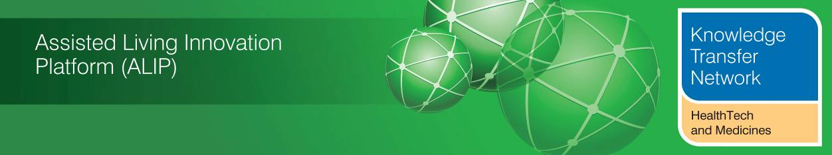
NEWSLETTER
February 2013
Welcome to the February 2013 newsletter from the Technology Strategy Board (TSB) Knowledge Transfer Network and the Telecare Learning and Improvement Network. Our free monthly newsletter is distributed to 48,000 subscribers in the UK and worldwide via e-mail and archived at www.telecarelin.org.uk. You can also find highlights on Prezi (monthly) or Rebelmouse (daily). We hope that you find this newsletter useful. With over 1200 news and events links over the last month, it is the most comprehensive newsletter available serving the telecare, telehealth, mobile health, digital health and assisted living communities.

If you have not registered for the ALIP showcase event in Liverpool on 5/6 March or the Healthcare Innovation Expo on 13/14 March you need to act quickly – the newsletter has more details. It is just a month now until the major NHS changes take place in England. 163 clinical commissioning groups have now been authorised - we have an additional supplement (doc, pdf) and signposting map to cover the changes. Over the last month we have seen the publication of the Francis Report and the announcement of a £75k social care cap – we can expect further legislative changes as policy makers prepare a response to the Mid-Staffs report and work out the detail of these future social care changes. We have a major update on the dallas programme from Alison Mlot and colleagues from the different communities. There are important reports from the Nominet Trust on social care innovation (paper by Shirley Ayres) and 2020Health (report by John Cruikshank and Jon Paxman) on the Yorks and Humber Telehealth Hub. There’s more on the digital challenge and the paperless NHS. If you work in the NHS, then 13 March is NHS Change Day – now around 70,000 pledges. We have a major article on health apps in the March newsletter, but there is plenty of app and mobile health news in this month’s edition too.

*Late news: First Whole System Demonstrator paper on telecare now published.

The links section is now available in a separate supplement rather than in the main newsletter (doc, pdf). A selection from this month’s listing is covered in the newsletter. The newsletter contains a list of KTN/ALIP activities, conferences and workshops from the UK and Europe over the coming weeks as well as news from the UK and around the world. For weekly news, updates and information, you can register with the Technology Strategy Board, ALIP group and the DALLAS sub-group. You can follow the dallas programme on Twitter at @dallas_connect. 3 Million Lives is on Twitter at @3MillLives and also at LinkedIn. If you would like daily information on #telecare and #telehealth, then a Twitter stream is available.

Prepared by Mike Clark (Twitter: @clarkmike and http://storify.com/clarkmike) for the ALIP Knowledge Transfer Network and Telecare Learning and Improvement Network.
Contents
Item 1 - News from ALIP and the Knowledge Transfer Network (HealthTech and Medicines KTN) – Page 2
Item 2 - See the reformed NHS in its entirety at Healthcare Innovation Expo 2013 – Page 3
Item 3 – 3millionlives update – Page 4
Item 4 - The dallas programme – Page 5
Item 5 - UK policy announcements – Page 13
Item 6 - Update on the NHS Reforms – Page 16
Item 7 - Other news – Page 17
Item 8 - Summary of recent journal articles and evaluations – Page 22
Item 9 - Learning and Events – Page 24
Item 10 - Other useful links – Page 25
Links supplement for February 2013 - (doc, pdf).
Item 1 – News from ALIP and the Knowledge Transfer Network (HealthTech and Medicines KTN)
Assisted Living Innovation Platform - 2013 Showcase - The Evolving Journey – last chance to register for 5-6th March, Liverpool Football Club
This is the 5th Annual ALIP showcase conference and will provide the opportunity to hear presentations that demonstrate the outputs and achievements of the Assisted Living Innovation Platform. The second day of the event features the dallas programme.
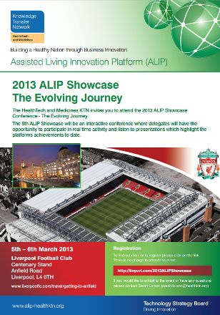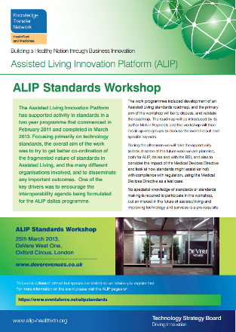
The final programme is now available. Register here.
On 25 March there will be an ALIP Standards Meeting. The ALIP work programme includes development of an Assisted Living standards roadmap, and the primary aim of the workshop will be to discuss, and validate the roadmap.
For more information on events and ALIP projects please visit the Assisted Living Innovation Platform on _ connect.
Item 2 – See the reformed NHS in its entirety at Healthcare Innovation Expo 2013
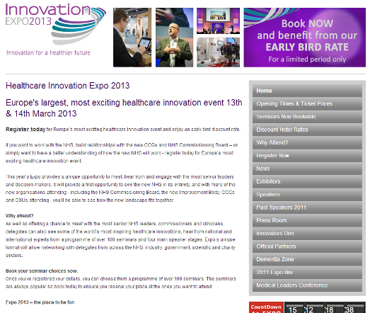
If you work as a provider of health-related services or if you’re a service user or commissioner, then ExCel in London on March 13 and 14 is the place to be.
Europe’s largest event of its kind is for people who want to work with the reformed NHS or to understand how it works. It’s also for anyone who needs to build relationships with the new Clinical Commissioning Groups (CCGs) and NHS Commissioning Board.
Expo 2013 will provide a unique opportunity to meet and engage with the senior leaders and decision makers from the new NHS as well as those from government, scientific and the third sectors.
10,000 delegates and scores of exhibitors are expected to attend over two days – and with many new organisations such as Clinical Commissioning Groups, Commissioning Support Units, Academic Health Science Networks and the new Improvement Body attending, you’ll be able to see just how the latest landscape all fits together.
If you only attend one event this year
Not only will you have the opportunity to meet and hear from senior leaders from the NHS, industry, scientific, government and charity sectors but some of the world’s most inspiring healthcare innovators will be showcasing their latest ideas.
There is an extensive programme of over 150 seminars and there are four main stages on which you can hear a variety of world-class speakers talking about a diverse range of subjects.
Special features
This year, in keeping with the focus on the Prime Minister Focusing on the Prime Minister's Challenge on Dementia, Expo will feature a dedicated dementia-friendly community complete with a life-sized high street, village green, home and garden, health and care services, school and cinema.
Speakers, exhibitors, carers and volunteers will give delegates the chance to understand how innovation and technology is improving the lives of people with dementia.
The Apps Zone is where you can get a hands-on experience with some of the latest health apps and the Innovators’ Den is where people with great ideas can pitch to a panel of experts who could arrange support and finance.
Register today
For more information, to register and to book your seminars, look at the website or follow updates on Twitter @NHSExpo and #NHSinnovationexpo2013
Item 3 – 3millionlives update
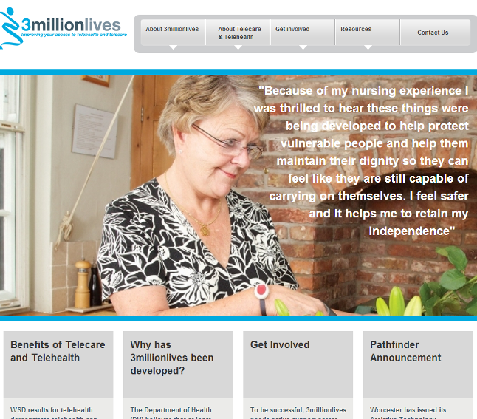
There is a new February 2013 newsletter available at the 3millionlives website. There is an update on the pathfinder programme. 3millionlives is an integral part of the Healthcare Innovation Expo, with a presence in both the exhibition floor and the Dementia Zone. This is an opportunity to see practical demonstrations and meet and hear from individuals and organisations who are leading the way in telehealth and telecare from the academic, voluntary, private, and public sectors. The newsletter has a promotional code for expo registration.
You can follow 3 Million Lives on Twitter (@3MillLives) and LinkedIn for the latest news and discussion.
Item 4 – The dallas programme
Contributed by Alison Mlot, dallas Programme Manager and the dallas communities https://connect.innovateuk.org/web/dallas Twitter @AlisonMlot
In last month’s newsletter, dallas Programme Manager, Alison Mlot, outlined the work of the dallas communities. This month the dallas communities provide more detail about their programmes. There is an excellent opportunity to find out more at the upcoming ALIP Showcase Event on 5-6 March in Liverpool - Follow (#ALIP2013 and @dallas_connect on Twitter).

The Year Zero project will design, develop and deploy a range of digital services and applications which will allow users to take control of their own health information and through the use of these services take a more active role in the self management of their health and wellbeing.
As these services are based on Personal Health Records (PHRs), users will be able to choose who to share this data with, from health or social care providers in the statutory sector to carers, third sector agencies or their friends and family.
These PHR based services are distinct from current moves to providing access to Medical Records held by the NHS in that they are entirely under the user’s control. Year Zero in that sense is citizen rather than provider focused. In addition, Year Zero believes that an added advantage of creating digital healthcare services centred on the user is that a whole series of the interoperability issues that have proven insoluble as regards providers can be removed if the citizen is put at the centre, allowing the redesign of services around them rather than configuring the user in terms of the services that are provided.
Year Zero intends to demonstrate the benefits of PHR’s across all age ranges. Our core products are:
- The eRedbook – a digital service emulating the current paper based Personal Child Health Record issued at the birth of every child, held by parents and unique in that the data is not owned by the Department of Health but by the citizen.
- A Personal Care Plan – an online, secure, shareable care plan created and owned by the citizen which can be shared with providers but also with carers, family, friends and other agencies to record, organise and coordinate care as well as become the basis for citizen recorded health information.
- Good Neighbours – a secure social networking application that allows the creation of a circle of support and the sharing and allocation of tasks and diaries within the circle.

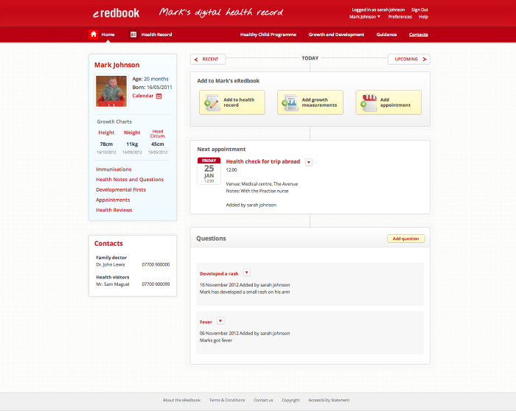
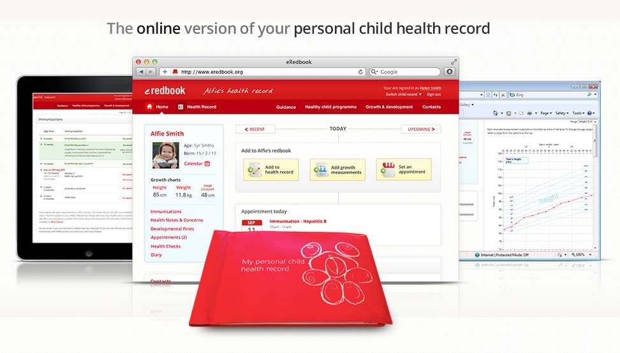
Each of these products will be rolled out through our NHS partners (Liverpool NHS Community Health Trust, Moray Health & Social Care Partnership/NHS Grampian, South Warwickshire NHS Foundation Trust and Rotherham NHS Foundation Trust) and developed in an iterative fashion using co-design principles and working toward connecting to statutory systems and services.
In addition we are working to offer these services direct to consumers in a free and sustainable fashion with brand and media partners. The project will also be integrating and developing digital applications to support behaviour change in connection to specific health and wellbeing needs.
At present a parental version of the eRedbook http://www.eredbook.org.uk/ is being deployed across our NHS partners to be followed in the summer by a version that can be used by health professionals. Our personal care planning app is in the advanced stages of development and has just completed a series of workshops with staff and clinicians from across all of our partners. A prototype will be rolled out to partners in the spring.

Living it Up (LiU), the Scottish element of the UK-wide dallas programme is funded by a consortium led by the Technology Strategy Board, the Scottish Government, Highlands and Islands Enterprise and Scottish Enterprise in partnership with other key stakeholders.
NHS 24 has been appointed by the Scottish Government to provide overall leadership, coordination, programme management and financial governance for the project.
LiU has entered its first recruitment phase of an initial 1500 people by Spring 2013. It is initially aimed at the over 50s but will also be of benefit to people living with long term conditions, care givers and those who just want to keep happy, healthy and safe. The programme aims to reach a community of 55,000 in Scotland by 2015 and to deliver economic benefit to Scotland through innovation.
The 3 year project will deliver innovative and integrated health, care and wellness services, information and products via familiar technology enabling them to care for themselves and others. These technologies will include TV, mobile phones, games consoles, computers and tablets
Each of the five LiU Project Areas – Lothian, Forth Valley, Highland/Argyll & Bute, Moray and the Western Isles – are running a series of community engagement and recruitment events throughout February and March as part of this process.
These events are an extension of previous community engagement activities, designed to actively engage the local communities to better understand their needs and how they would like to participate in the developing project.
The initial community engagement events, 'Hidden Talents', took place in Spring 2012 and reached approximately 250 people. At these ‘pop up’ events, in diverse locations such as shopping centres and hospital foyers, the community engagement team asked participants to reveal their ‘hidden talents’ and how they could share their skills with others. Finally participants were asked: “What, if anything, would make life better for them?”
The second wave of community engagement pop-up events, ‘A little birdie told us’, took place Summer/Autumn 2012 and asked around 500 participants to reveal the ‘assets’ in their communities and identified the services, support and people valued most locally. In addition 50 in depth interviews and focus groups with NHS staff and unpaid carers were conducted.

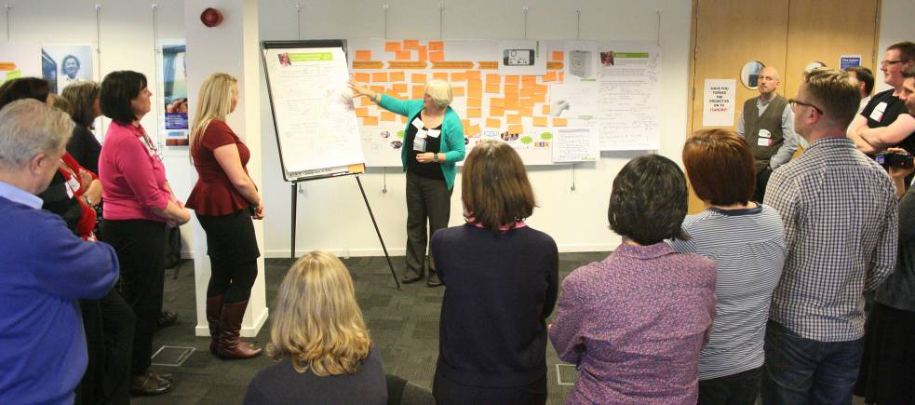
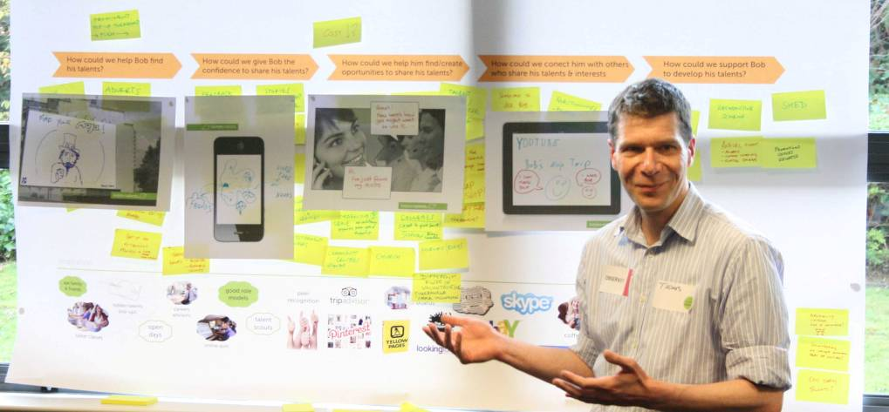
The key themes were then developed into service ideas through co-design workshops attended by members of the community, service providers, technology experts and innovators (illustrated in the above photos).
This process resulted in a set of service principles to guide LiU; brand and identity guidelines; and informed development of the key LiU services - Hidden Talents, Market Place, My Care and Keeping Connected through video conference.
LiU has now entered phase 2 (Jan – Dec 2013), which is focussed on developing working LiU service prototypes in partnership with the local communities. Community engagement work has been further refined to take into consideration the aims of this phase, and is developing new tools to assist in co-design, co-production and recruitment. Members of the 5 LiU communities will be encouraged to sign up on the Living it Up community engagement website as 'test users' during this phase, and will be invited to share their ideas, try the prototypes and feedback their views. http://livingitup.org.uk/

Like many other parts of the UK, Liverpool has a number of well-being challenges. Health & care interventions are as good if not better than other areas in the UK and we have moved forward at an equal pace to other areas in relation to the deployment of technology to the well-being challenges. Liverpool’s dallas community, Mi^{[1]} the consumer brand for the FeelGood Factory, has approached the challenge of achieving transformation within health and social care not from a technological perspective but from a people perspective.
Our starting point has not been “the technology doesn’t exist or work” – we believe it does but rather that:
- people do not have the information or confidence to use the technology and as a result retain traditional views of what to expect when they become vulnerable (a care home/home care/day centre) or ill (hospital/doctor). This insight is taken from Whole System Demonstrator.

- “practitioners” don’t fully understand the technology and/or fear it takes away employment opportunities and/or power (and therefore don’t maximise its potential)

Mi partners believe that individual demand for good health and consumer demand for technology to support well-being will drive the transformation of health and care (and remove any organisational or cultural inhibitors). So although Mi Liverpool is working across a spectrum of need we believe that real change will only occur at scale if we change the mindset of those people not in receipt of care and health services i.e. when they are fit, healthy, and able and in control.
Liverpool is asset rich and Mi is committed to taking an approach which builds upon those assets to achieve its aims. We are engaging with communities and individuals through the things they need and like to do, their lifestyles. To get Mi messages out to people at scale, we are working for instance, with Liverpool and Everton Football Clubs, National Museums Liverpool, Merseytravel and local retailers to piggy back upon their current successful engagement of 1,000s of local people.

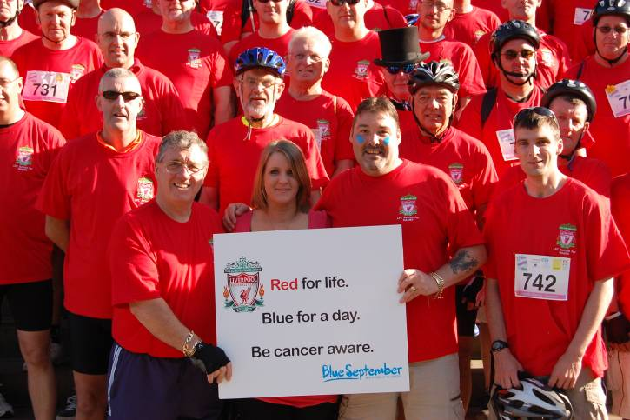
To engage with those people that are harder to reach, generally people who are less economically active, we are building upon existing volunteer assets to develop an army of Mi Champions able to:
- raise the profile of community activity, resources and assets
- encourage people to get involved to build local assets and resilience
- provide information, advice and signposting about things that are happening in the City

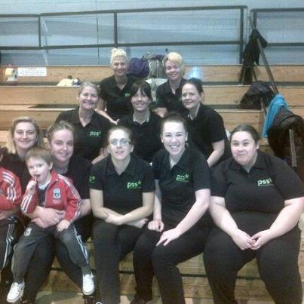
Mi Champion activity is community driven and covers a range of areas e.g. education, learning, employment and training, housing and health. Our messages about well-being, life planning and technology will be taken out to the community by Mi Champions.

The dallas Interoperability Conference in Leeds in November 2012 tackled some priority issues for i-focus and for dallas as a whole. Delegates with a wide range of expertise, across the health and wellbeing sector in the UK, gathered for a day to consider some key topics of interoperability in the emerging Assisted Living domain, including NHS, third sector and industrial partners.
i-focus http://ifocus-dallas.com/pub/has prioritised four areas of importance:
- Consumers’ Own Devices and the Medical Devices Directive
- Personal Health records and statutory Information Systems
- Identity and Consent
- Delivery of Services to Multiple platforms
Consumers’ Own Devices
To achieve Scale (the ‘S’ in dallas), Communities are expecting to be able to leverage the low cost and ease of use of mass-market products. David McGirr of the Year Zero project said: “Consumers’ Own Devices are key because it’s about health and well-being being part of your everyday life. It’s not about being ‘tech-savvy’; it’s about how people use communication and digital technology in their lives”. One of the perceived barriers to the use of “low-cost” or consumer-grade devices is that the Medical Devices Directive may restrict freedom to deploy. i-focus will be looking at this together with MHRA in some detail in the next quarter, and will publish their findings.
Personal Health Records
All the dallas projects are considering the use of Personal Health Records in some form, and there is perceived to be real value in making their data available to the statutory sector (and vice versa), so that people can be encouraged to take more responsibility for their own wellbeing. Understanding the human factors is essential before deploying technology in this area. Neil Tierney said: “so much of dallas is about trying to open up health records, we have to make absolutely sure that’s what people want”.
Information Governance
With regard to the sharing of information between systems, interoperability can be hampered by non-technical issues: “almost everything else is a technical issue. Information governance can knock dallas off the rails: all you need are enough jobs-worths to say that the walls between health care and social care can’t be breached,” adds Andrew Michaelson. This affects dallas firstly in the area of PHRs, where some of the i-focus scenarios involve moving personal health data between privately-held records and GP systems, for example.

Identity and Consent
When online services begin to emerge across the sector, people will begin to need to access systems deployed by a range of service organisations. The last thing they want is a vast array of diverse login methods with multiple passwords. Yet reliably identifying people is key to gaining confidence, and knowing for certain that only authorised people have access to data is crucial. This area looks at the deployment of new developments in federated identity schemes such as those being promoted by the Cabinet Office.
Multiplatform Service Delivery
As dallas is about scale, it must be possible to deliver services to devices that consumers already have available to them, or are prepared to purchase for themselves. Just as one consumer may be happy to use tablets and PCs, another may only be comfortable using their TV or a more traditional mobile phone. It must be possible to deliver services across this wide range of platforms, and this presents development challenges and architectural choices both in the organisation of the server-side or cloud-based services and also for the user-interface experience.
Warm Neighbourhoods® pilot proving popular!
The Warm Neighbourhoods® pilot service ‘AroundMe’ running over this winter is proving very popular. ‘Around Me’ service is a simple proposition combining ambient temperature, electrical usage, and activity monitoring sensors in the home to provide reassurance messages to an elderly or vulnerable end customer, and their informal care network.
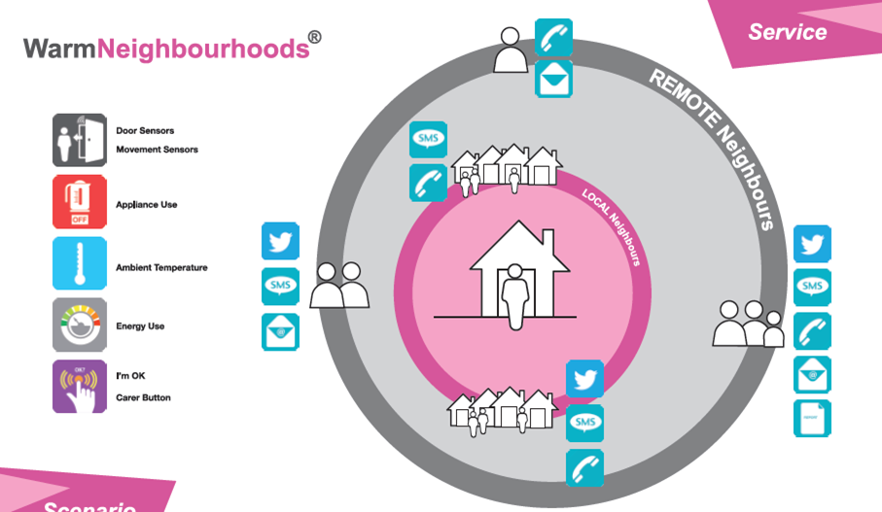
The pilot commenced in December 2012 with 12 end customers and their ‘neighbourhood’ of friends and family informal carers. The Health Design & Technology Institute (HDTI) at Coventry University has held mid-point interviews with the pilot participants and feedback has been very positive:
 | “I find it brilliant! It sends a positive message that I’m up and about, it also sends a message if I’m not, which is nice to know that he (responder) is keeping an eye on me”  “It’s comforting to know that somebody’s watching over me.”  “You do feel that there’s just a little assistance available or around the corner and that the family do know you’re alright.”  “You just get used to the [sensors] being where it is and you don’t notice it. I mean nobody said at my party, “What’s this?” that’s the main thing!”  “It is just something that’s there and we carry on as normal.”

Evaluating dallas – Benefits to the Individual, the System and UK Economy
In parallel with the work being undertaken by the communities, Databuild and the University of Glasgow have been conducting research to establish a baseline prior to considering the impact that the dallas programme has made to individuals, carers, systems and the wider economy in 2015.
Databuild are in the process of finalising a pioneering report which describes the current market for products, services and systems to support independent living. The report draws together existing evidence with findings from interviews with dallas community members, leading market experts and representatives from the wider industry, describing the current state of the independent living sector and barriers to growth, and summarising the data available to inform an estimate of the market size in 2011/12. The baseline estimates presented in the report will be reviewed and refined as the project progresses and will provide a basis for examining the economic impact of dallas activity in 2015 and beyond.
The University of Glasgow has developed a novel and pragmatic overarching evaluation framework which aims to provide methods and tools for evaluating both evidence based impact and outcomes relating to health, wellbeing and lifestyle and also implementation processes such as how technologies and services are co-designed and developed and ultimately integrated into peoples’ daily lives and working practices.
Item 5 – UK policy announcements
Here is a roundup of UK policy news over the last month. A fuller listing is available in the supplement (doc, pdf).

(i) The Department of Health in England has announced (subject to legislation) new funding reforms for care and support to ensure that the elderly and those with disabilities get the care they need without facing unlimited costs. The new measures are based on the recommendations made in 2011 by the Dilnot Commission. The new measures include, from April 2017:
- A cap on care costs (£61k in 2010/11 prices, equivalent to £75k in 2017/18)
- If someone is assessed by their local authority as having eligible care needs, they will be told how much it will cost the local authority to meet those needs with local services. These costs count towards their cap

From April 2015 people will not have to sell their home in their lifetime to pay for residential care. If people cannot afford their fees without selling their home, they will have the right to defer paying during their lifetime.
(ii) The Department of Health has a web page on the Mid Staffordshire NHS Foundation Trust Public Inquiry. Speaking in Parliament following the publication of the report, the Prime Minister apologised to the families of those who suffered for the way the system allowed horrific abuse to go unchecked. He said that that the report highlighted 3 core problems - a focus on finance and figures, no-one being accountable for patient care, and defensiveness & complacency. The Prime Minister announced that the Care Quality Commission will create a new Chief Inspector of Hospitals post to be responsible for new inspections regime from autumn.
(iii) The Care Quality Commission has published a review on home care services in England. The review covered inspections of 250 services providing care to 26,419 people. Community Care covers the story. http://bit.ly/YO5Noy

(iv) The Department of Health is seeking views on NICE standards to improve quality of social care (eg falls, meds management) – the consultation runs until 26 April 2013.

(v) The Department of Health has stressed the importance of finger prick tests in managing type 1 diabetes and ensuring that sufficient supplies of test strips are available.
(vi) Health Scotland has a new report on costing the burden of ill health related to physical inactivity in Scotland. For the first time, costs relating to prescriptions, consultations in General Practice and premature mortality associated with physical inactivity have been calculated.
(vii) The National Audit Office has said that councils are coping with the budget cuts but has highlighted care of the elderly and disabled as an area where councils are ‘reducing services’. (Telegraph).

(viii) Regulations on NHS procurement, patient choice and competition for England have been published. The regulations are designed to help ensure that commissioners’ decisions on buying clinical services are transparent and fair, and that they improve the quality and efficiency of health care services for patients. There is some concern, however, at the requirements for tendering for a range of health services.
(ix) The government has published a report providing an overview of responses to the consultation on strengthening the NHS Constitution.
(x) Final grant allocations for adults’ personal social services have been published by the Department of Health in England.
(xi) Guidance on the NHS Friends and Family Test has been published.
(xii) Seven patients, in the final year of the personal health budgets pilot programme, share their experiences, what the process is like, what they spend their money on and how they decided on this in a new DVD.
(xiii) Alzheimer’s Society has launched Dementia Friends information sessions (You Tube video).
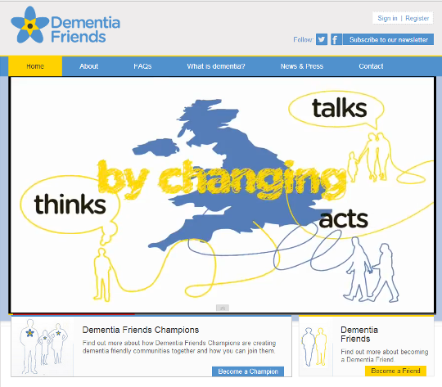
(xiv) The 2013/14 NHS Standard Contract has been published by the NHS Commissioning Board.
The contract is for use by commissioners when commissioning healthcare services (other than those commissioned under primary care contracts) and is adaptable for use for a broad range of services and delivery models.
(xv) 62 new Clinical Commissioning Groups (CCGs) have been authorised to take control of NHS budgets (56 of them with conditions). The total authorised now is 163 (of an expected 211). The final wave of CCG authorisations will be announced in March 2013.
(xvi) Secretary of State for Health in England, Jeremy Hunt, recently announced a move towards a paperless NHS over the next five years. There is a new ‘Digital Challenge’ website to keep up to date on the initiative and a short You Tube video.

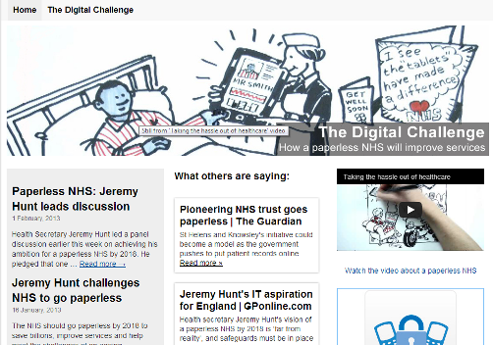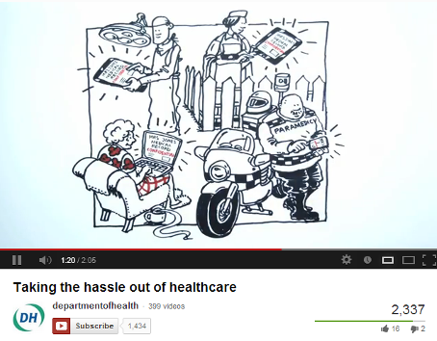
(xvii) Monitor has published its regulation arrangements for the healthcare sector. The licence, which will be issued to foundation trusts and will be effective from 1 April 2013, is a tool Monitor will use to regulate foundation trusts and other NHS-funded providers under the Health and Social Care Act 2012.
(xviii) The Department of Health has made available a short video on the use of ‘Any Qualified Provider’.
http://www.dh.gov.uk/health/2013/02/aqp-film/
(xix) Over five years from 2013/14, the Department of Health is making available £160m capital funding for specialist housing providers to bring forward proposals for development of specialist housing to meet the needs of older people and adults with disabilities outside of London. This funding may be supplemented by up to a further £80m capital funding in the first two years of the programme. The programme will be delivered and managed by the Homes and Communities Agency. There is also £40m (up to £60m) capital funding available for developments in London, to be delivered by the Greater London Authority. The Agency is now inviting responses to help inform development of the second phase of the funding which will aim to stimulate development in the wider private housing market. Providers are invited to submit their ideas for proposals using the phase two expressions of interest form (Word - 144KB) to Bids.CSDH@hca.gsi.gov.uk by 5pm on Friday 15 March 2013.
(xx) The DH website moves to GOV.UK in March 2013.
(You can follow the Department of Health in England, Jeremy Hunt and Norman Lamb on Twitter at @dhgovuk, @jeremy_hunt and @normanlamb. In Scotland, you can follow the Scottish Government’s Health Department on Twitter @scotgovhealth and Alex Neil @AlexNeilSNP (also @NHS24). In Wales follow @WelshGovernment)
Item 6 - Update on the NHS Reforms
With just a month to go until the major reforms of the NHS in England, we have an additional supplement (doc, pdf) this month showing a series of slides on the changes. There is also a signposting map to help link you to the web sources on the changes.

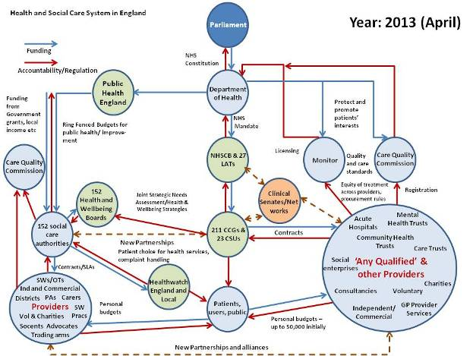
Item 7 - Other news
Here is a roundup of other news over the last month. A fuller listing is available in the supplement (doc, pdf).
(i) The Nominet Trust has published a provocation paper by Shirley Ayres (@shirleyayres) called ‘Can online innovations enhance social care?’
“The ageing population brings with it a rise in the concentration of assets that people in later life can bring to a community: wisdom, experience, perspective and a wide range of skill sets and capacities.
At Nominet Trust we are looking to understand where digital technology can best amplify these capabilities to strengthen communities and to enable meaningful participation in them by people in later life. Equally though, the ageing population brings a requirement to rethink our approach to social care as more of us require care; support in caring or become active as carers”.

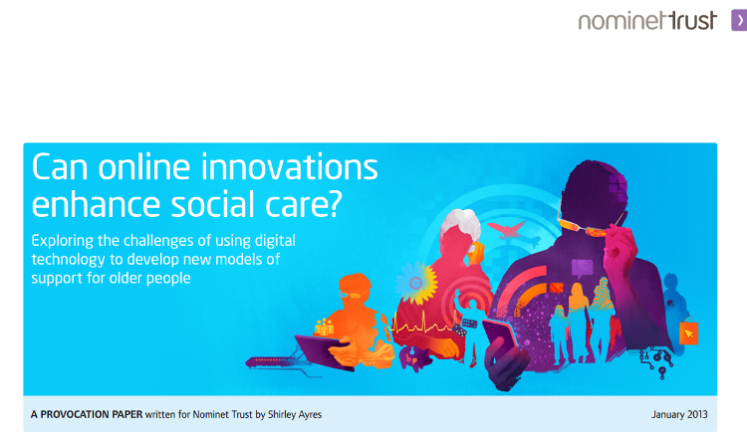

The paper identifies many new approaches to providing care that commissioners need to consider for the future in a variety of settings including integrated approaches with health and housing services. You can post comments and feedback at the Nominet Trust website.

In addition, Shirley Ayres has also published the ‘Click Guide to Digital Technology for Adult Care’ as a low cost eBook. This useful guide provides a wealth of detailed information in one place – links to over 100 resources, covering care, health and housing.

You can also find useful information on connected care and innovation in podcast format at the Disruptive Social Care website.

(ii) 2020Health (@2020health) has published an evaluation report on the Yorkshire and Humber Telehealth Hub.
Set up in 2010, the Telehealth Hub aimed to demonstrate the benefits from delivering telehealth at scale to people with long term conditions. The report by John Cruickshank and Jon Paxman examines the successes as well as the challenges of an ambitious programme. During this pilot scheme, services were provided from three sites - NHS Airedale Foundation Trust, South West Yorkshire Partnership Foundation Trust (SWYPFT) and Hull and East Yorkshire NHS Trust/University of Hull. A different telehealth service was provided by each sight.
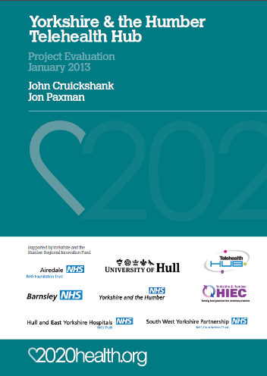
2020health also have additional reports available on telehealth, personal health records and other health issues at their website.
(iii) The Aston Medication Adherence Study (AMAS) looks at medication adherence in the UK based on three patient groups living in Birmingham. The researchers found that, overall, around a quarter to a third of the patients were non-adherent to their medication. Focus group discussions identified issues and barriers (eg presence or absence of symptoms, generic meds). If the findings were extended across the UK it could amount to a cost of £500m.
(iv) The Apple App Store now has a specific collection entitled, ‘Apps for healthcare professionals’ in the ‘Medical’ category. The collection is further subdivided into: Reference Apps, Medical Education Apps, EMR & Patient Monitoring Apps, Nursing Apps, Imaging Apps, Patient Education Apps and Personal Care Apps.
(v) A self-service revolution in healthcare? Walmart in the U.S. is installing 2500 kiosks in their stores for checking simple health metrics.
(vi) The Guardian has an article about One Housing Group and their decision to embrace telecare for their residents to help people continue living in their own homes and make it a core part of their service offering.
(vii) The Herald Scotland reports on a range of telecare and related technologies being developed as part of the ‘MultiMemoHome project’, a collaboration between researchers at the Glasgow University's School of Computing Science and the University of Edinburgh's School of Informatics. The programme involves using sound, vision, smell and touch to create interactive systems which they say can be easily understood and navigated by people with cognitive or sensory impairments.
(viii) The media continues to report on projections of future telehealth growth – here is information from a recent inMedica report (1.8m users by 2017).
(ix) The Telegraph reports that Seven out of ten adult social care directors surveyed expect either to scale back visits by carers this year or shift to remote services using alarms and phone links in the place of direct contact in an effort to cut costs. The study by The King’s Fund found that all but a handful of council social care departments are planning to make cuts, ‘efficiency savings’ or put up fees for service users.
(x) The Telegraph reports that ten thousand more GPs are needed for the NHS to cope with its increasing workload and ensure patients are properly cared for out of hours, Clare Gerada from the Royal College of GPs has said. At a recent BMJ roundtable event, Dr Gerada also called for greater integration and more use of modern technology to allow patients to consult their doctors remotely.
(xi) New data released from the 2011 Census covers the provision of unpaid care in England Wales.
- There were approximately 5.8 million people providing unpaid care in England and Wales in 2011, representing just over one tenth of the population
- The absolute number of unpaid carers has grown by 600,000 since 2001; the largest growth was in the highest unpaid care category, fifty or more hours per week
- Unpaid care has increased at a faster pace than population growth between 2001 and 2011 in England and Wales; the same is true in Wales and across all English regions other than London, where it decreased
(xii) An article at FierceMobileHealthcare looks at the state of the evidence base for mHealth and hopes to see improvements in 2013.
(xiii) Airedale Hospital is a pioneer in telehealth and telemedicine in the UK. Here is another update via eHealth Insider on their video consultations, remote monitoring, services for prisons and care homes. http://bit.ly/XuFDt1
(xiv) The NHS is producing more smartphone apps and a directory is promised at the Healthcare Innovation Expo – here are recent examples from Northumbria (GP app) and Birmingham Children’s Hospital (patient feedback). A nurse and her team from the Churchill Hospital in Oxford have developed an award-winning mobile phone application which could help prevent potentially fatal venous thromboembolisms (more commonly known as blood clots).
(xv) eHealth Insider (1,2) has been looking at GP support (via survey) for online access to health records and e-mail consultations by 2015.
(xvi) The British Medical Association has responded to the Department of Health’s consultation on the GP Contract – they have concerns about remote care monitoring and access to online health records.
(xvi) Totally Health is providing Leicester City’s selected COPD patients with a two-way health coaching service that supports the local care pathway and local primary and acute care providers. The health coaches are registered nurses who help patients manage their conditions by providing mentoring and support via phone calls and telehealth monitoring. Read more about early successes.
(xvii) NHS24 (Scotland) are piloting a BSL service for service users.
(xviii) Chubb has a new CareUnity telecare unit (press release, web site)
(xix) Pulse Today reports that Berkshire CCGs along with social care, community services and GPs have been looking at a number of options for reducing hospital admissions based on some retrospective analysis. As so many admissions had come via GPs, they decided to focus on giving them alternative options to a hospital referral including rapid response and re-ablement, mobile app covering admission alternatives, appointment of community geriatricians, service navigation team and home from hospital service.
(xx) The King’s Fund latest analysis of delayed transfers of care for England suggests that the numbers are going in the right direction, but it does not appear to match what NHS leads are saying in their latest survey.
(xxi) From the Guardian, Two social care experts have two very different opinions on personal budgets, which allow individuals to decide how to spend their social care money.
http://bit.ly/WZNeBb

(xxii) In a blog, David Lee Scher looks at the Five Pitfalls of Designing a Medical App:
- The motivation for the app development is misguided
- Lack of clinician involvement
- Poor attention to usability
- Not knowing the healthcare landscape
- Not building to regulatory specifications
Also from David Lee Scher:
Five Ways of Achieving Patient Engagement: Part 1: WITHOUT Technology The Digital Health Corner
Five Ways of Achieving Patient Engagement: Part 2: WITH Technology | The Digital Health Corner
(xxiii) From the American Geriatrics Society - Guiding Principles for the Care of Older Adults with Multimorbidity.

(xxiv) An interesting article from the Huffington Post - ‘From Dull Existence to a Life Worth Living - How Technology Can Transform Old People's Lives’ – can telecare, telehealth and other digital technology services help make a difference in the UK?
(xxv) In the U.S., Happtique is developing an App Certification Program for medical, health, and fitness apps. The company states that the “purpose of the program is to help users identify apps that meet high operability, privacy, and security standards and are based on reliable content.”
(xxvi) ‘The number of technical tools available to help patients live healthy lifestyles or control chronic health conditions has grown considerably during the past few years. But the percentage of patients who use some form of technology, such as mobile apps, to track health indicators has remained virtually unchanged for three years’. Amed News asks if ‘mobile health monitoring has hit a wall?’
(xxvii) Health and social care could account for half of all government spending in 50 years' time, a report from the King’s Fund warns.

(xxviii) IBM's Watson Could Be a ‘Healthcare Game Changer’ – Information Week looks at the first projects using Watson for decision support.

(xxix) Introducing telecare for 3,000 adults, with no disruption to their care – a short You Tube video from Wiltshire.
(xxx) Invicta Telecare has been selected by Viridian Housing to provide the emergency telephone call service for its 16,000 homes across the UK.
(xxxi) Richmond Council still has a free telecare offer running through till 31 March.
(xxxii) There will be more internet-connected mobile devices such as smartphones and 3G tablets than people in the world before the end of the year, according to new research. The milestone of 7bn is expected to be reached in the next few months.
(xxxiii) More and more U.S. states are introducing bills to breakdown barriers to telehealth implementation – 13 states, so far this year.

(xxxiv) Skype calls are now equivalent to one-third of global phone traffic – report.
http://ars.to/Ymo4u4
(xxxv) According to the CDC in the United States, falls are the number one cause of injury and death among older adults and the number one reason for hospital admissions for trauma. The CDC estimates the total medical cost of falls in 2010 was $30 billion. Mobihealthnews identifies seven technologies that could help prevent falls.

(xxxvi) The Health Service Journal (£) has an article on ‘Using technology to better manage long-term conditions’. Author, Clare Wexler, says ‘The current model of managing long-term conditions is unsustainable. The tipping point is fast approaching; it is time for the NHS and patients to think – and behave – differently. And technology will undoubtedly sit at the centre of the solution’.

(xxxvii) If you have access to Twitter, there are a number of online chats that may be of interest. #nurchat meets every fortnight. A recent topic was Apps, tablets and mobile devices in healthcare. Joining the chat counts towards CPD. The occupational therapists also meet up regularly using #Otalk. A recent subject for discussion was long term conditions – risk stratification. Finally, #fallschat covered a Kent conference on falls prevention and evening tweetchat.
(xxxviii) There is a new report on ‘Equity in the Digital Age: How Health Information Technology Can Reduce Disparities’.
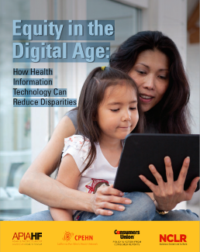

(xxxix) SSAIB, the UK’s leading certification body for organisations providing a variety of electronic security, manned guarding services, fire protection, intruder and other alarm systems, has an audit scheme for the social alarms sector. SSAIB has UKAS approval for its Telecare Services Scheme. The independent certification scheme allows providers to demonstrate third party compliance with a range of British and European standards, codes and practice, and best practice in terms of professionalism, competence and service quality. The scheme is also modular and flexible, enabling service providers to obtain certification for the specific areas of activity they undertake.
(xl) There is a new report from PWC and the GSMA which covers potential developments and savings from mHealth.

(xli) Housing LIN case study number 67 has recently been published – ‘Improving lives with Telecare: Making the right move’ by Martyn Durant, Services Director, Enterprise & Health, Wakefield and District Housing. Housing LIN newsletter for February 2013 is now available. Follow Housing LIN on Twitter - @HousingLIN
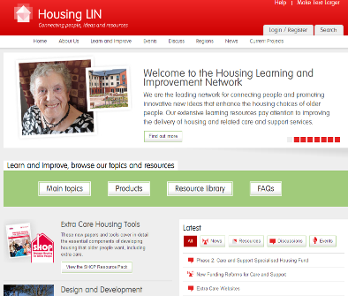

(xlii) Late news: First Whole System Demonstrator paper on telecare now published.

Item 8 – Summary of recent journal articles and evaluations
Each month, our supplement (doc, pdf) provides a comprehensive list of recent journal articles. Here are summaries from just a few of the recent papers.
(i) In this first study, researchers looked at the medical records of people living in senior living communities consider which episodes and interventions could be provided through telemedicine. The medical records of 646 patients were reviewed (1,535 unique episodes of acute care). 576 visits (38%) were identified as potentially appropriate for telemedicine-based acute care, with 38, 47, and 27% of phone, in-home, and ED visits being eligible, respectively. Potentially appropriate for telemedicine were falls and dermatologic, respiratory, and gastrointestinal illnesses.
(ii) The Commonwealth has published three case studies on the adoption of telehealth including Veteran’s Health Administration, Centaura and Partners Healthcare.
- Scaling telehealth programs: lessons from early adopters
- The Veterans Health Administration: taking home telehealth services to scale nationally
- Centura health at home: home telehealth as the standard of care
- Partners HealthCare: connecting heart failure patients to providers through remote monitoring
(iii) Spanish researchers conducted a small pilot study of the effectiveness of home telehealth for patients with advanced chronic obstructive pulmonary disease treated with long-term oxygen therapy. The mean number of hospital admissions was 0.38 in the telehealth group and 0.14 in the control group. During the study a total of 40 alerts were detected. The clinical triage process detected eight clinical exacerbations which were escalated by the case manager for a specialist consultation. There were clinically important differences in health-related quality of life in both groups.
(iv) A recent meta-analysis RCT study looked at the effectiveness of psychosocial interventions on heart failure patients' quality of life. A significant overall QoL improvement emerged after conducting psychosocial interventions with CHF patients. Interventions based on a face-to-face approach showed greater benefit for patients' QoL compared with telephone-based approaches. No significant advantage was found for interventions conducted by a multidisciplinary team compared with a physician and nurse approach, or for psychosocial interventions which included patients' caregivers compared with patient-only approaches.
(v) From JTT, Australian researchers have carried out a systematic review of the ‘Effects of type 2 diabetes behavioural telehealth interventions on glycaemic control and adherence’. The authors concluded that “13 studies met the eligibility criteria for inclusion. Four studies reported significant improvements in glycaemic control. Five of eight studies on dietary adherence reported significant treatment effects, as did five of eight on physical activity, four of nine on blood glucose self-monitoring, and three of eight on medication adherence. Overall, behavioural telehealth interventions show promise in improving the diabetes self-care and glycaemic control of people with type 2 diabetes”.

(vi) The Lancet has an article on ‘Frailty in elderly people’ which looks at various models and association with adverse health outcomes. A better understanding of the subject would be useful for primary care to enable a shift towards more appropriate goal-directed care.
(vii) A JAMA study looks at ‘The Relationship Between Hospital Readmission and Mortality Rates for Patients Hospitalized With Acute Myocardial Infarction, Heart Failure, or Pneumonia’. Researchers concluded that risk-standardised mortality rates and readmission rates were not associated for patients admitted with an acute myocardial infarction or pneumonia and were only weakly associated, within a certain range, for patients admitted with heart failure.
(viii) PLOS has an article on ‘Scaling Up mHealth: Where Is the Evidence?’ Researchers discuss what constitutes appropriate research evidence to inform scale up and consider that potential innovative research designs such as multi-factorial strategies, randomised controlled trials, and data farming may provide the evidence base. They make a number of recommendations about evidence, interoperability, and the role of governments, private enterprise, and researchers in relation to the scaling up of mHealth.
(ix) During a 5 year period (2005–2009) a total of 645 patients had home monitoring for heart failure in Ottawa. Researchers looked at impact and utilisation for under/over 75’s and found no difference.
Item 9 – Learning and Events
The RSM has a one day conference on ‘Point of care testing- disruptive innovation’ on 7 March 2013 in Scotland. This one day regional event in Glasgow is aimed at professionals, managers and policymakers considering using advances in medical technology to meet the challenges of delivering improved care with fewer resources. The conference will cover examples of point-of-care testing being used successfully in a wide range of circumstances to make step changes in care delivery that deliver improved patient outcomes, in many cases also at lower cost.
More information about the content of the day, as well as registration details, can be found at http://www.rsm.ac.uk/academ/red08.php
Click on the following links for upcoming conferences and learning events.
ALIP Showcase Event 2013 – 5-6 March 2013, Liverpool https://connect.innovateuk.org/web/2013-assisted-living-showcase-event
Scotland meeting: Point of care testing- disruptive innovation on 7 March 2013 Glasgow http://www.rsm.ac.uk/academ/red08.php
SXSW – Austin, 8-17 March 2013 http://sxsw.com/
Innovate UK 2013 – London 11-13 March 2013 http://www.innovateuk2013.co.uk/
Healthcare Innovation Expo 2013 - Europe's largest, most exciting healthcare innovation event – 13 to 14 March 2013, London http://www.healthcareinnovationexpo.co.uk/
CUHTec:"Assistive technology and telecare for learning disability services", University of York 14 March 2013 http://www.cuhtec.org.uk/courses/

E-Mental Health - Harnessing the Power of Digital for Better Mental Health 18 March 2013, Horley http://ymhn3.eventbrite.com/
ALIP Standards Workshop – 25 March 2013, London https://connect.innovateuk.org/web/alip-standards-workshop
The International eHealth, Telemedicine and Health ICT Forum - Med-e-Tel 10-12 April 2013 Luxembourg http://www.medetel.lu/index.php

Tedmed – Washington 16-19 April 2013 http://www.tedmed.com/home

Using apps to transform healthcare delivery on 18 April 2013 London http://www.rsm.ac.uk/academ/ted03.php

Alzheimer’s Show 19-20 April 2013 London http://alzheimersshow.co.uk/
International Integrated Care Summit, The King’s Fund 8 May 2013, London http://www.kingsfund.org.uk/events/international-integrated-care-summit-2013
eHealth Week Dublin 13-15 May 2013 http://worldofhealthit.org/2013/

CUHTec:"Technology and innovation for managing people with dementia", Newcastle University, 19 June 2013 http://www.cuhtec.org.uk/courses/

CUHTec:"Prevention of falls and loss of independence in the frail elderly - including technology", Newcastle University, 20 June 2013 http://www.cuhtec.org.uk/courses/

The King’s Fund – International Telehealth and Telecare Congress 1-3 July 2013 London http://www.kingsfund.org.uk/events/third-annual-international-congress-telehealth-and-telecare

Item 10 – Other useful links
DALLAS _Connect Sub Group - Join the Sub Group at: https://ktn.innovateuk.org/web/dallas
Housing Learning and Improvement Network www.housinglin.org.uk Now on Twitter: @HousingLIN

Telecare Learning and Improvement Network www.telecarelin.org.uk

King’s Fund web site – http://www.kingsfund.org.uk/topics/technology_and_telecare/index.html
Telecare Aware – daily news and comments www.telecareaware.com
Three Million lives - http://www.3millionlives.co.uk/ Twitter: @3MillLives and now on LinkedIn
Newsletter prepared by Mike Clark (@clarkmike) and brought to you by the Telecare LIN on behalf of the Technology Strategy Board.
Disclaimer: “We provide this newsletter for information purposes only and neither the Technology Strategy Board nor the authors accept any liability whatsoever for inaccuracies, errors or omissions therein or for any consequences arising therefrom.”


[1] Liverpool NHS, social housing provider, Riverside, Liverpool based charity, PSS, Hft, a national charity supporting people with learning disabilities, and technology partners Philips, Tunstall and Informatics Merseyside.

