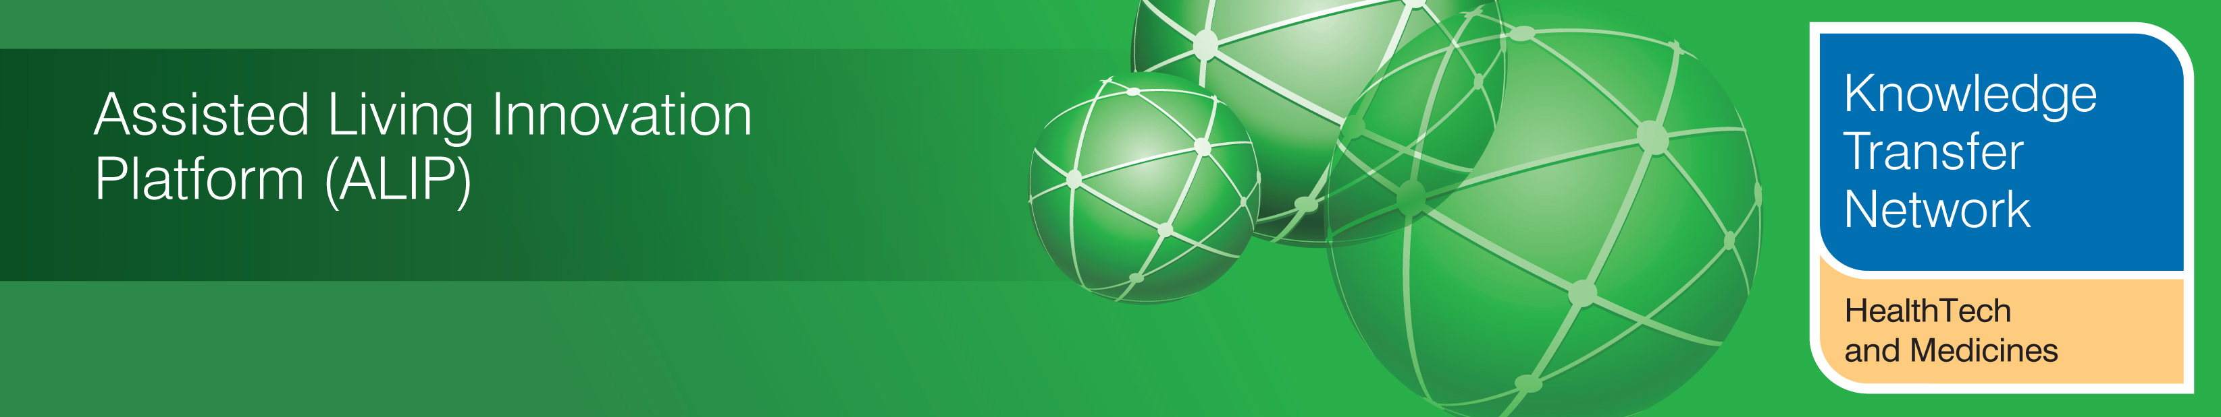
NEWSLETTER
August 2012

Welcome to the August 2012 newsletter from the Technology Strategy Board (TSB) Knowledge Transfer Network and the Telecare Learning and Improvement Network.

Our newsletter is now being distributed to 46,000 subscribers in the UK and worldwide. We hope that you find this newsletter useful. With around 700 news and events links this month, it is the most comprehensive newsletter available serving the telecare, telehealth, ehealth and assisted living communities.

This month we have seen the publication of the second journal article covering the Whole System Demonstrator (WSD) evaluation. With major NHS changes taking place in just over six months, further details are published about the transition arrangements together with DH consultations on how the new system will operate. There is a new DH commissioning toolkit on respiratory diseases and NICE are consulting on a dementia quality standard for social care. There are indications that the Dilnot recommendations on social care may be implemented from 2015. The Government’s procurement framework for telecare and telehealth has been extended until August 2013. There are important conferences coming up in the Autumn covering telehealth and telecare – AAL Forum (Sept), Health Service Journal/Nursing Times (Oct), Telecare Services Association (Nov) and Royal Society of Medicine (Nov) – booking is now open.

A short supplement is available covering evaluations, journal articles & surveys (January to June 2012) (doc, pdf). The links section is also now available in a separate supplement rather than in the main newsletter (doc, pdf). The newsletter contains a list of KTN/ALIP activities, conferences and workshops from the UK and Europe over the coming weeks as well as news from the UK and around the world. For weekly news updates and information, you can register with the Technology Strategy Board, ALIP group and the DALLAS sub-group. You can follow the dallas programme on Twitter at @dallas_connect. Also 3 Million Lives is now on Twitter at @3MillLives. If you would like daily information on #telecare and #telehealth, then a Twitter stream is available at the TelecareLIN web site (you do not need to register on Twitter and it is accessible to organisations not able to connect directly to social media): http://www.telecarelin.org.uk/News/twitterStream/

Prepared by Mike Clark (Twitter: @clarkmike) for the ALIP Knowledge Transfer Network and Telecare Learning and Improvement Network

Contents
Item 1 – News from ALIP and the KTN – Page 2
Item 2 - Whole System Demonstrator (WSD) and Three Million Lives latest – Page 3
Item 3 – Recent Government health and social care news – Page 4
Item 4 - Other News – Page 5
Item 5 - Round the clock news via the Telecare LIN Twitter Stream – Page 7
Item 6 - Telehealth map updated to 1 September 2012 – page 8
Item 7 - Learning and events – Page 8
Item 8 - Other useful links – Page 9
Supplements for August 2012
A short supplement is available covering evaluations, journal articles & surveys (January to June 2012)(doc, pdf). The links section is also now available in a separate supplement rather than in the main newsletter (doc, pdf).

Item 1 – News from ALIP and the KTN
NESTA - Ageing Well Challenge Prize
NESTA are offering a prize for the innovation that can reduce the isolation and/or increase the mobility of vulnerable older people by providing new opportunities for communities to come together to give time, skills and resources. The deadline for entries is noon on 12 September 2012.

Telecare - Meet the Buyers Event 2012 - 14th September 2012
SEHTA's annual Meet the Buyers event will this year be held on the 14th of September at the Wolfson Conference Centre, Stoke Mandeville Stadium, Aylesbury, Buckinghamshire. This international event brings together the biggest telecare and telehealth procurers and the very best service and technology providers for partnering, networking and potential deal making.
The KTN will be exhibiting along with other ALIP organisations who will be using this opportunity to reach out to a commercially focused audience.

Global Business Summit
The Global Business Summit on ICT was held on the 3 August 2012 and was great opportunity for technology leaders from across the world to hear first-hand about UK innovation and creativity, and to engage with UK industry leaders and businesses.
The Summit featured a number of panel-led seminars focusing on key ICT fields. The Summit also hosted a series of technology showcases; demonstrating some of the best in UK innovation, and offered numerous networking opportunities.
Under the ‘HealthTech and Medicines KTN’ banner we are able to offer you the chance to be included in the online expo which will be hosted for a further five months.
We can include;
- Videos up to 20MB
- PDF documents/pictures/links
- Remember- the information should be eye-catching and appeal to the on-line visitors
For more information please contact sarah.forson@healthktn.org
2012 AAL Forum - 24-27th September, Eindhoven
The KTN launched a competition for any ALIP project to apply for free exhibition space at the annual AAL Forum. We are pleased to announce that the following ALIP organisations were successful in securing space;
- Shropshire Council (GUSTO)
- HoIP CIC (CONNECT Business - Toolkits for Assisted Living)
- Newcastle University (SALT- Scalable Assistive Technologies and Services)
- Liverpool Primary Care Trust (Feelgoodfactory)
- European Technology for Business Ltd (Gait Trainer)
- Coventry University Health Design & technology Institute (CO-MODAL- Consumer Models for Assisted Living)
For more information on this event or any other ALIP project please visit the Assisted Living Innovation Platform on _ connect
Glossary
AAL – Ambient Assisted Living
ALIP – Assisted Living Innovation Platform
KTN – Knowledge Transfer Network
UKTI – UK Trade and Industry
SEHTA – South East Health Technologies Alliance

Item 2 - Whole System Demonstrator (WSD) and Three Million Lives latest
The second journal paper on the Whole System Demonstrator Programme has been published as a full free download. The paper is entitled ‘Exploring barriers to participation and adoption of telehealth and telecare within the Whole System Demonstrator trial: a qualitative study’. Barriers to the adoption of telehealth and telecare associated with non-participation and withdrawal from the trial were identified within the following themes:
- requirements for technical competence and operation of equipment
- threats to identity, independence and self-care
- expectations and experiences of disruption to services
In their conclusions, the authors consider that ‘insights gained from interviews have implications for health and social care staff indicating that more detailed information and time for discussion could be valuable especially on introduction of services. It seems especially important for potential recipients to have the opportunity to discuss their expectations and such views might usefully feed back into design and implementation’.
In a separate online article, Adam Steventon from the Nuffield Trust involved in the WSD evaluation considers ‘how useful are randomised controlled trials in evaluating new ways of delivering care?’
He looks at the length of time from inception to evaluation results (six years) for the WSD Trial as well as the amount of data to examine (over a billion rows of data from 250 health and social care organisations). He considers the advantages of RCTs as well as other approaches in bringing evidence together to improve healthcare.
In a recent press release, the Three Million Lives programme has announced the appointment of Olivia Eyers as the Industry Project manager. Olivia can be contacted at: olivia.eyers@3millionlives.co.uk. Further details about 3millionlives can be found on the website: www.3millionlives.co.uk
Item 3 – Recent Government health and social care news
The Department of Health in England has published a commissioning toolkit for respiratory services. It aims to make it easier to commission better outcomes for people with COPD by bringing together the clinical, financial and commercial aspects of commissioning in one place. The Department is also consulting on proposals for commissioners to deliver best value, Monitor licensing arrangements and joint strategic needs assessments and joint health and wellbeing strategy guidance. NHS Chief Executive, David Nicholson, has written to NHS leaders to set out the next stage in the transition to the new health and care system in England which commences in April 2013.

NICE has been asked by the Department of Health to pilot the development of a quality standard for social care on Dementia: supporting people to live well with dementia for use in England. The draft NICE quality standard on Dementia is now available for consultation. The consultation period will end at 5pm on the 16 October 2012.

A DH Personal health budgets easy read leaflet has been published.

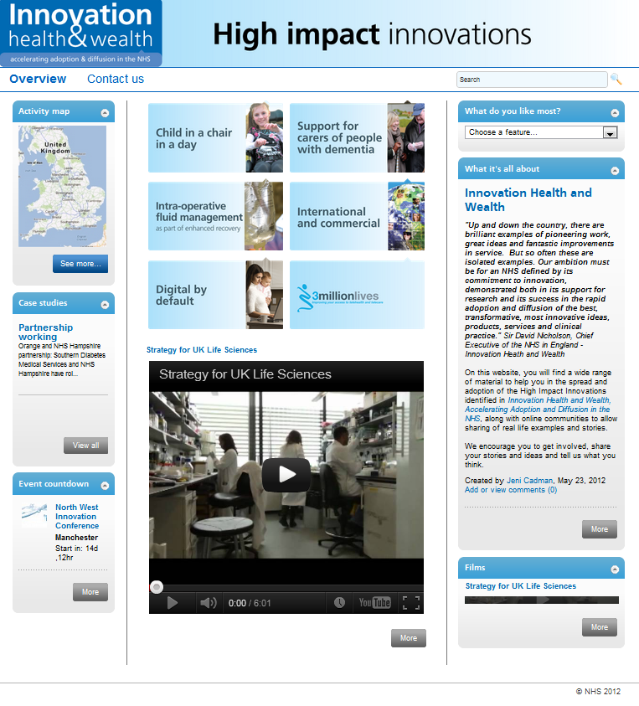

The NHS Institute for Innovation and Improvement dashboard provides material and links (eg 3 Million Lives) to promote high impact innovations identified in Innovation Health and Wealth, Accelerating Adoption and Diffusion in the NHS.
Item 4 - Other News
Here is a roundup of other news over the last month. A fuller listing is available in the supplement (doc, pdf).
- There have been numerous press reports (eg Independent) that the Dilnot social care recommendations for England may be implemented by around 2015.
- The Government Procurement Service’s Assistive Technologies - Telecare, Telehealth and Telecoaching framework has been extended to August 2013.
- Currently there are over 100 different models for vital signs monitoring in NHS hospitals. A joint group of senior doctors and nurses has said that moving to a national system (National Early Warning Score) could save thousands of lives a year.
- Early information from the 2011 census indicates that a total of 9.2million people across England and Wales are over the age of 65, an increase of more than 10 per cent in the past decade, with millions more due to retire in the next few years.
- The number of diabetes prescriptions rose by nearly 50% in six years, from 27.1m in 2005-06 to 40.6m in 2011-12, data from the Health and Social Care Information Centre (HSCIC) shows.
- Denmark's National Telemedicine Action Plan will be built on Continua Health Alliance design principles. The Action Plan for Telemedicine will establish reference architectures and national standards for health IT in Denmark, in areas including the secure collection, transmission and storage of personal health data from patients' homes, sharing medical documents and images, and the management of health records, medical appointments and other related information.
- Cancer research in the UK will get a boost under a £19m scheme funded by government and charitable organisations. The investment will see four 'e-Health research' Centres of Excellence established in London, Manchester, Dundee and Swansea. These virtual centres will be made up of researchers who will become experts at analysing UK health data and finding ways to use the data to improve patient care and public health. The Centres will focus on conditions including cancer, diabetes, obesity and cardiovascular disease. The Centres will link information in NHS health records with other forms of research and routinely-collected data, and are intended to keep the UK at the forefront of global medical research.
- In a new report, the Audit Commission has examined the variation in social care assessments and reviews across England.
- The Chartered Institute of Housing has published a new guide that takes a look at telecare, telehealth, and making the best use of these technologies. It also looks at building partnerships with care and health organisations to deliver services to residents.
- In a King’s Fund Blog, Chris Ham looks at integrated care North and South of the Border. Nick Goodwin blogs on ‘Jumping the gun in the telehealth steeplechase’. In a further blog, The King’s Fund looks at the variation in use of emergency hospital beds by patients over 65 and concludes ‘if all primary care trusts (PCTs) achieved the rate of admission and average length of stay of those with the lowest use, 5,700 fewer beds would be needed across England’.
- Telecare and other assistive technologies are included in plans for Liverpool’s first dementia centre.
- The EU ‘Commonwell’ project in Milton Keynes has provided telecare and telehealth equipment for COPD patients with joined up monitoring and support.
- A recent UK survey of more than 2,000 UK adults commissioned by Telehealth Forum found 91% had never heard of telehealth or telecare.
- A new US report, Emerging Technologies for Chronic Disease Care by Juliann Schaeffer
identified 11 tools based on a scan of emerging healthcare technologies. Nearly 50% of the US population has a chronic disease, and more than 75% of the nation’s total medical costs are spent on chronic disease. The 11 technologies to watch address various chronic diseases—from diabetes and asthma to heart disease and stroke—and breaks them down into four classes based on the available research and the number of adoption barriers.
- Each month, a list of relevant recent journal articles are brought together. These now appear in the links supplement (doc, pdf). Here is a small sample from this month’s listing.
- A Systematic Review of Healthcare Applications for Smartphones
- About 1,260 hospital admissions a day due to smoking, new figures show | The NHS Information Centre (UK)
- Adherence to Blood Pressure Telemonitoring in a Cluster-Randomized clinical trial
- Development of a predictive model to identify patients at risk of readmissions within 30 days of discharge (PARR-30)
- Methodologies for assessing telemedicine: A systematic review of reviews
- Remote Monitoring or Close Encounters? Ethical Considerations in Priority Setting Regarding Telecare.
- Telehealth and telecare service for COPD in Milton Keynes gives 28% return - BJHC (UK)
- The effect of telemedicine in critically ill patients: systematic review and meta-analysis.
- The organising vision for telehealth and telecare: discourse analysis
- Using preventive home monitoring to reduce hospital admission rates and reduce costs: a case study of telehealth among chronic obstructive pulmonary disease patients.
- The European Society of Cardiology have been considering the feasibility of telehealth for primary care at their annual congress (guidelines, slides).
- The QIPP digital initiatives register has been updated to 20 August 2012 – includes telehealth examples.
- Actively promoting telecare in London and beyond – London Telecare
Item 5 - Round the clock news via the Telecare LIN Twitter Stream
The TelecareLIN Twitter Stream uses hashtags (eg #telehealth) that pick up telecare, telehealth, telemedicine and other tweets – it gets updated around the clock from sources around the world.
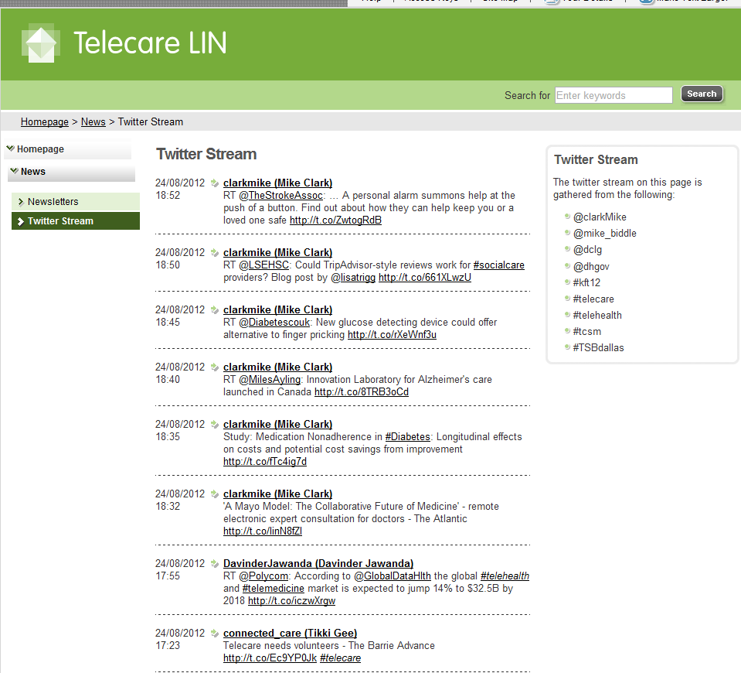
If you want to keep up with the daily news, then here are some recent examples from the Twitter Stream – you do not need to be registered with Twitter to use this facility. Don’t forget to refresh your web browser to see the updates.
- NHS Info Centre - Statistics on Smoking: England 2012: 'About 1,260 hospital admissions a day due to smoking' bit.ly/O0De6p
- BBC News: 'Diabetes rate in Scotland continues to increase' bbc.in/O0stRt
- BBC Click new video: 'Latest tech keeping the elderly safe' bbc.in/SMjv8O
- 'NI high dependency unit offers cutting edge patient care' - telepresence robot bit.ly/OWaaie andbit.ly/O2xKbo
- BBC news video: Daisy Hill Hosp (NI) recruits robots to aid care bbc.in/SkZx7H bit.ly/OWaaie bit.ly/O2xKbo
- BBC News Video: 'Webcams used for Nottingham stroke patients' bbc.in/O0xSpP
- 'Telehealth: the benefits of video conferencing' gu.com/p/39q7c/tw via @guardian #telehealth
- 'How to ... use housing staff to diagnose and manage dementia' gu.com/p/39d6d/tw via @guardian
- For and against med app regulation - forum discussion bit.ly/TVpACq
- RACGP (Australia) provide #telehealth support officers for video consults, implementation guidance, advice on Skype etc racgp.org.au/telehealth
- Tunstall Launches Next-Generation Home #TelecareSolution, Lifeline Vi via eHealthNews @tunstallhealth bit.ly/QuL8Ba
- 'Momentum for home monitoring of costly chronic diseases' - 75% healthcare spending in US - mobihealthnews shar.es/77qxw
- Self management of Diabetes in Scotland -bit.ly/MPj1Rg and bit.ly/MPj3Zx
- Telescot programme:Continuity, but at what cost? The impact of telemonitoring COPD on continuities of care 1.usa.gov/Sa7qwF
Item 6 - Telehealth map updated to 1 September 2012
The national telehealth map is currently being updated to 1 September 2012. Locations are colour-coded for long term conditions monitored.
The map covers projects, programmes and evaluation reports that are currently available in the public domain.
Clicking on the coloured marker provides links to websites and pdfs.
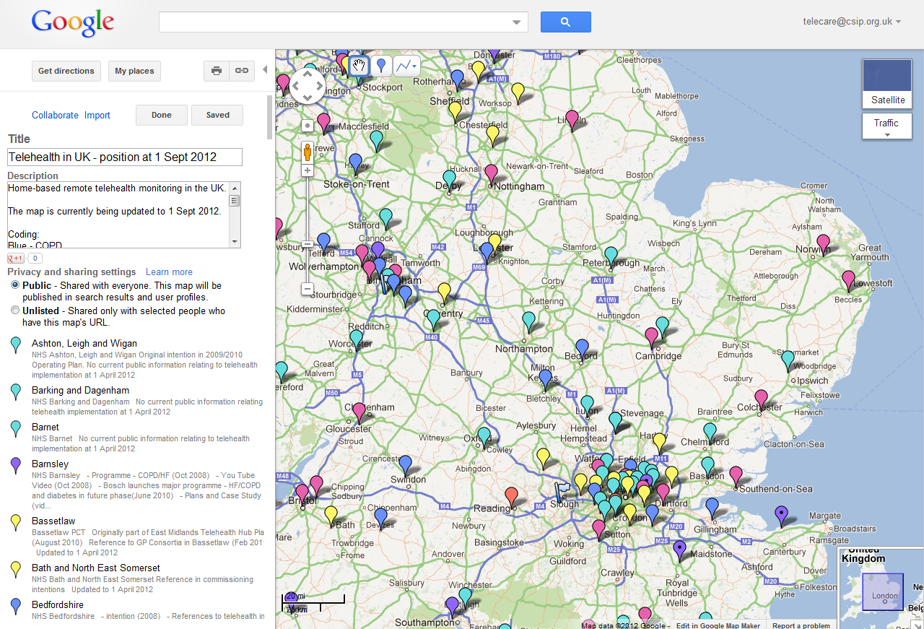
Item 7 - Learning and events
For forthcoming learning opportunities and events that may be of interest, click on the links below:
UKTI Advances in Assistive Medical Technologies day, 3 September 2012, London
https://connect.innovateuk.org/web/ukti-advances-in-assistive-medical-technologies-day
Broadband Britain - funding, 'killer apps' and digital engagement, 11 September 2012, London http://www.westminsterforumprojects.co.uk/forums/book_event.php?eid=416
SEHTA - Meet The Buyer Event, 14 Sept 2012, Aylesbury
http://www.sehta.co.uk/2012/07/03/sehta-announces-details-of-its-international-telecare-meet-the-buyers-event-2012/
AAL Forum - Eindhoven 24-27 September 2012 http://www.aalforum.eu/
Healthcare Efficiency through Technology Expo - 9 October 2012, London
http://www.healthcareefficiencythroughtechnologyexpo.co.uk/event-at-a-glance/
Telehealth 2012 (Health Service Journal/Nursing Times) – London, 30-31 October 2012 http://www.hsj-telehealth.co.uk/
Health 2.0 Europe, 6-7 November 2012, Berlin http://www.health2con.com/events/conferences/europe-fall-2012/
The International Telecare and Telehealth Conference (TSA), 12-14 November 2012, Birmingham http://www.telecare.org.uk/conference
Accelerating innovation in healthcare - 14 November 2012 London
http://www.westminsterforumprojects.co.uk/forums/event.php?eid=457
RAATE, 26 November 2012, Warwick http://www.raate.org.uk/
eHealth & Telemedicine 2012 - 3million and rising: Integrating care, mainstreaming technology (Royal Society of Medicine) Monday - Tuesday 26 - 27 November 2012 London http://www.rsm.ac.uk/academ/ted01.php
Healthcare Innovation Expo 2013 - Europe's largest, most exciting healthcare innovation event - 13th & 14th March 2013, London http://www.healthcareinnovationexpo.co.uk/

Item 8 - Other useful links
DALLAS _Connect Sub Group
Join the Sub Group at: https://ktn.innovateuk.org/web/dallas
Telecare Learning and Improvement Network www.telecarelin.org.uk

King’s Fund web site – telehealth and telecare
http://www.kingsfund.org.uk/topics/technology_and_telecare/index.html
Telecare Aware – news and comments www.telecareaware.com
Three Million lives
http://www.3millionlives.co.uk/
Newsletter prepared by Mike Clark (@clarkmike) and brought to you by the Telecare LIN on behalf of the Technology Strategy Board
Disclaimer: “We provide this newsletter for information purposes only and neither the Technology Strategy Board nor the authors accept any liability whatsoever for inaccuracies, errors or omissions therein or for any consequences arising therefrom.”


