Telecare LIN eNewsletter

April 2009

Booking is still available for 11 June event (Leeds) but reserve places are going quickly.

Welcome to the April 2009 newsletter. The Telecare Learning and Improvement Network (LIN) is responsible for providing general implementation support to organisations building their telecare and telehealth programmes.

If you are an organisation implementing telecare or telehealth in England and have an interesting local telecare or telehealth story for inclusion in a future newsletter then e-mail Mike Clark at telecare@dhcarenetworks.org.uk

Note: DH Care Networks is not responsible for the content of external links and does not endorse any suppliers or their products. Any claims made by organisations should be carefully evaluated as part of normal commissioning and procurement arrangements.

Contents
Headlines for April 2009 2
1 Pandemic Flu planning – Level 5 4
2 Whole System Demonstrator Action Network (WSDAN) - reserve places still available for Leeds on 11 June 2009 6
3 Adult social care workforce strategy 6
4 NHS Innovation Expo – 18/19 June 2009 7
5 Dementia strategy – demonstrator programme and journal articles 8
6 New pilots announced to bring health and social care together 8
7 Other Department of Health news 11
8 Ethical issues and telecare 12
9 News 12
10 Events 19

Headlines for April 2009

1 The Department of Health has provided information and guidance in recent months on pandemic flu planning. In the light of the current swine flu situation, it is important to review the effectiveness of local plans for business continuity to support current and future alert levels. A set of references are provided in the newsletter.

2 There are a few reserve places left for the next public Whole System Demonstrator event on 11 June in Leeds. As well as updates from the demonstrators, Leeds and Nottingham programmes, there will be presentations from Paul Trueman (YHEC: Scottish Telecare Evaluation), Professor John Cleland (Hull: telehealth and heart failure) and Professor Sue Yeandle (telecare research at Leeds University).

3 The Department of Health has published a workforce strategy. There are references to telecare including work being carried out by the Social Care Institute for Excellence on ethical issues.

4 There will be an NHS Innovation Expo on 18/19 June at the Excel Centre in London. The Expo includes telehealth exhibits.

5 The Department of Health has announced a demonstrator programme covering parts of the recently published Dementia Strategy. The Journal of Care Management Services has covered Housing and Dementia in its latest issue. The Housing Learning and Improvement Network has updated its web site pages on dementia.
6 Sixteen integrated care pilots have been announced by the Department of Health. These include social care as well as a range of health services.

7 The Mental Capacity Act Deprivation of Liberty Safeguards are now in force.
8 Cardiff University and the Nuffield Council on Bioethics are examining ethics issues for telecare and telehealth. Contact us if you have any views on this important area.

9 The news roundup includes the continuing development of mobile health applications, a telehealth project in Essex, a reminder about Care Quality Commission arrangements as well as new developments from around the world on telehealth.

10 A range of events are provided by DH Care Networks – don’t forget to register for the Leeds Whole System Demonstrator event on 11 June. The next event will be in September 2009.

1 Pandemic Flu planning – Level 5
NHS Choices and the Health Protection Agency web site are providing updated information on swine flu and the current level of alert. The Department of Health has issued guidance in recent months on pandemic flu planning for health, local authority social care services and businesses. A list of web links appears below. The social care guidance (“An operational and strategic framework: planning for pandemic influenza in adult social care”) makes reference to telecare services (see below).

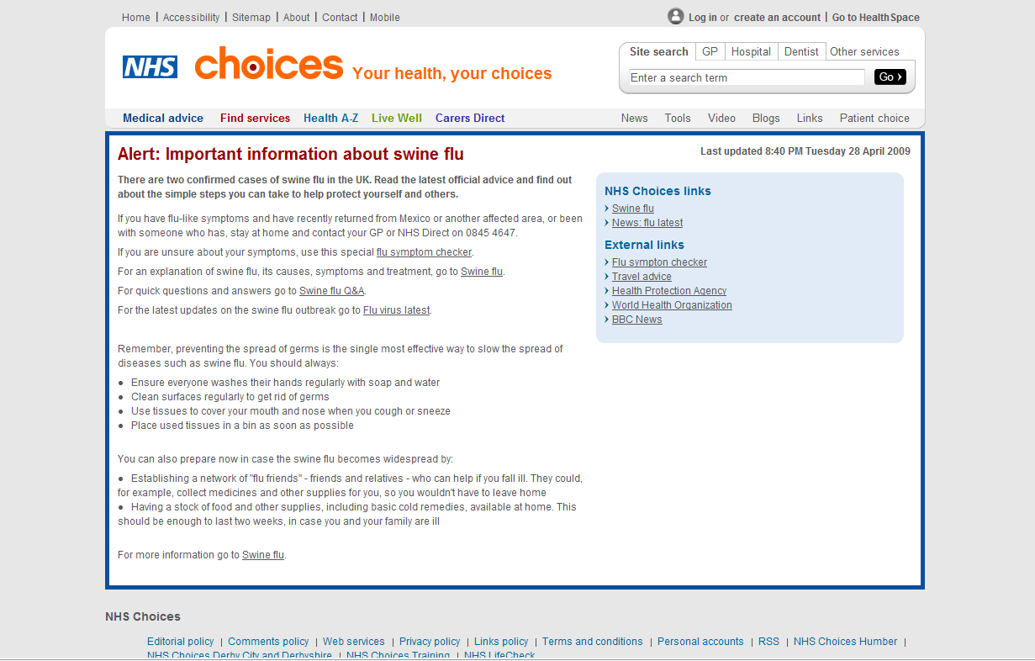

http://www.nhs.uk/AlertsEmergencies/Pages/Pandemicflualert.aspx

NHS Choices – will provide updated information on any changes:
http://www.nhs.uk/Pages/HomePage.aspx

Main DH Pandemic Flu site:
http://www.dh.gov.uk/en/Publichealth/Flu/PandemicFlu/DH_065006

Guidance for businesses:
http://www.dh.gov.uk/en/Publicationsandstatistics/Publications/PublicationsPolicyAndGuidance/DH_097137

Alert levels – we are currently at Level 5 (29 April 2009):
http://www.dh.gov.uk/en/Publichealth/Flu/PandemicFlu/DH_065157

Published guidance:
http://www.dh.gov.uk/en/Publichealth/Flu/PandemicFlu/DH_093202

Human resources guidance for the NHS:
http://www.dh.gov.uk/en/Publicationsandstatistics/Publications/PublicationsPolicyAndGuidance/DH_086833

Pandemic influenza: guidance for primary care trusts and primary care professionals on the provision of healthcare in a community setting in England
http://www.dh.gov.uk/en/Publicationsandstatistics/Publications/PublicationsPolicyAndGuidance/DH_091993

Planning for pandemic influenza in social care – some modules available (but not all)
http://www.dh.gov.uk/en/Publicationsandstatistics/Publications/PublicationsPolicyAndGuidance/DH_093380

An operational and strategic framework: planning for pandemic influenza in adult social care
Section 36
Key challenges in managing social care services include:
_ maintaining essential social care services in the community with reduced staff, including in all the services that are not about direct care but that form an essential lifeline for some people, eg meals on wheels, shopping schemes, transport services, provision of community equipment, community alarm services, telecare, etc
Section 117
specific training for telecare and community alarm call centre staff in helping to identify and support people isolated at home
Section 138
Some assistive technologies and community equipment, eg community alarms, telecare, grab rails etc, may help people to manage in the short term in their own homes.
Page 49 checklist
_ Start planning now to expand the use of telecare, etc.
http://www.dh.gov.uk/en/Publicationsandstatistics/Publications/PublicationsPolicyAndGuidance/DH_080755

DH Pandemic Flu FAQs
http://www.dh.gov.uk/en/Publichealth/Flu/PandemicFlu/FAQonly/DH_065088

UKHCA guidance for home care providers on Pandemic Flu
http://www.ukhca.co.uk/flu/

UK resilience (Cabinet office)
http://www.cabinetoffice.gov.uk/ukresilience/pandemicflu.aspx

UK Health Protection Agency (HPA)
http://www.hpa.org.uk/

US Centre for Disease Control
http://www.cdc.gov/swineflu/

DH web site for Statements from Secretary of State and Chief Medical Officer
http://www.dh.gov.uk/en/index.htm

2 Whole System Demonstrator Action Network (WSDAN) - reserve places still available for Leeds on 11 June 2009
Reserve places are available for the next WSDAN event on 11 June 2009. In addition to update information from the Whole system Demonstrator Programme, presenters will include:

- Paul Trueman, Director of York Health Economics Consortium on the recently published evaluation of the Scottish Telecare programme
- Professor John Cleland from Hull University on telehealth and heart failure
- Professor Sue Yeandle from Leeds University on telecare research

There will be updates on the NHS PASA timetable for the 2010 national framework, work being carried out by NHS Connecting for Health on capturing telehealth information in the summary health records and progress by the Assisted Living Innovation Platform. There will be presentations from Leeds and Nottingham.

http://www.dhcarenetworks.org.uk/Events/EventDetail/?eventID=462

3 Adult social care workforce strategy

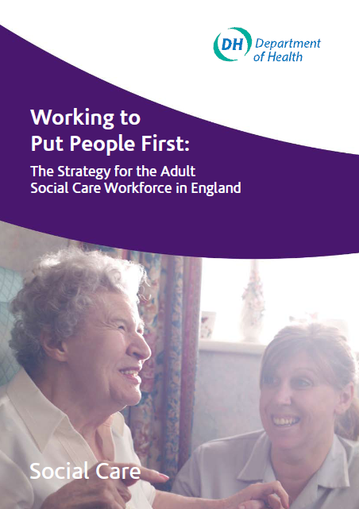

The Department of Health has recently published ‘Working to Put People First: The Strategy for the Adult Social Care Workforce in England’. There are several references to telecare in the document.

Page 35 …..”the Social Care Institute for Excellence has been asked by the sector to set up an advisory group to consider the production of an ethical code for use by all those involved in the provision, commissioning and manufacture of assistance technology and telecare. This will be published towards the end of this year”

Page 40 ……”The social care sector is now beginning to use technology and new products. These often come from organisations who have not previously supplied the social care market. The workforce has a role to be able to adapt to these new technologies and delivery mechanisms (alarm buzzers, digital television, internet, also assistive technology). There also needs to be a feedback loop from skilled social care practitioners to the suppliers of the technical equipment people are using (principally medical devices but increasingly now also assistive technology and telecare). This is crucial to drive the innovation of new products and services to meet the needs of individuals.
Alongside the need to understand how new technology can assist a person day-today, there is a need for the workforce to promote understanding that such technology can be enabling agents for people who use services to work. It is important that as a society we begin to recognise the importance of supporting people effectively to enable them to remain in or take up employment”.

http://www.dh.gov.uk/en/Publicationsandstatistics/Publications/PublicationsPolicyAndGuidance/DH_098481

4 NHS Innovation Expo – 18/19 June 2009
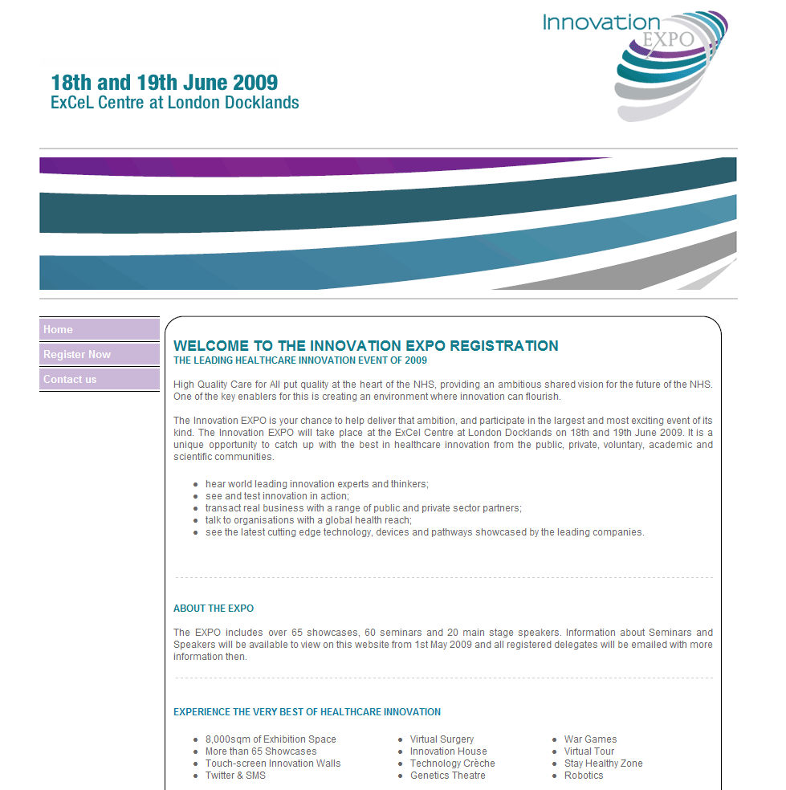

http://www.dh.gov.uk/en/Healthcare/Highqualitycareforall/Innovation/index.htm
http://www.healthcareinnovationexpo.com/

There will be an NHS Innovation Expo at the Excel Centre in London on 18 and 19 June 2009. This will include a range of technology and innovation including telehealth. A number of exhibitors have been confirmed together with prominent speakers (see Expo web site for latest information). There is a registration fee.

5 Dementia strategy – demonstrator programme and journal articles

Living well with dementia - a national dementia strategy: demonstrator site programme
The National Dementia Strategy requires an improved evidence base about the effectiveness of two service models proposed:
Objective 4 -enabling easy access to care, support and advice following diagnosis, and
Objective 5 - development of structured peer support and learning
DH we are inviting applications for demonstrator sites for these two areas. Completed applications should be returned, by email, by 12.00 on 21 May 2009.
http://www.dh.gov.uk/en/Publicationsandstatistics/Publications/PublicationsPolicyAndGuidance/DH_097629

Special journal issue on housing and dementia
The Journal of Care Services Management recently published a special issue on Housing and Dementia (Vol 3 Issue 3).

http://www.henrystewart.com/care_services_management/special.html

Housing LIN – web page updates on dementia
The Housing LIN has recently updated its web site on housing and dementia.

http://www.dhcarenetworks.org.uk/IndependentLivingChoices/Housing/Topics/browse/HousingandDementia/?

6 New pilots announced to bring health and social care together
1 April 2009
Patients in 16 pilot sites will benefit from a trial to see how health and social care services can join together to increase quality of care. The £4million scheme has been designed to look beyond traditional health and social care boundaries to explore how services for patients and service users can be improved. The scheme will then assess the benefits of different models of care and identify any best practice that could be used more widely.
Each site has developed new methods to help respond to particular local health needs. The health issues being tackled in each pilot include dementia, care for the elderly, substance misuse, chronic obstructive pulmonary disease and end of life care. The methods involved vary widely; they include partnerships, new systems and care pathways that span primary, community, secondary and social care.
The list below summarises each of the selected pilot organisations.
Integrated Care Pilots - pilot summaries
Bournemouth and Poole Teaching PCT
This pilot will be exploring a new model for delivering care for older people with dementia, involving collaboration between GPs, public sector organisations and third-sector services. It aims to provide a single point of access to an integrated community team.
Cambridge Assura LLP
This pilot will look at how different organisations across the health, social care and third sectors can better communicate and co-ordinate end-of-life care to enable people to be cared for and die in the place they choose. The pilot will also be improving public and patient engagement to ensure services are fully sensitive to user needs.
Church View Medical Practice, Sunderland
This pilot will improve quality of care and experience of services for the area's population of older people. The local acute trust and GP practice will work together as an integrated organisation, and will work in partnership with the PCT provider arm, social services and the patient practice group. The pilot will aim to provide an improved, personalised experience through active management of long-term conditions.
NHS Cumbria
This pilot will be exploring a new approach to helping patients with chronic diseases to manage their own care. It will be focusing on increasing the collaboration between GP and patient. It will aim to move care into a community setting and reduce hospital admissions.
Durham Dales Integrated Care Organisation
This pilot will involve seven partner organisations working together to meet the needs of a rural population, provide continuity of care and reduce health inequalities. It will explore a number of different care pathways aiming to improve planning information, move care into a community setting, increase patient/carer satisfaction and reduce hospital admissions.
Nene Commissioning CIC
This pilot will develop new models of long-term condition management to help patients remain independent for longer and have more choice in their end-of-life care. It will create personalised care plans for high-risk individuals and aim to reduce admissions to hospital.
Newcastle Hospitals NHS Foundation Trust
This pilot will provide an improved preventative service for over 60s at risk of falling by broadening the current falls and blackout (syncope) service provision. It will enhance provision and access to care and establish a network of community-centred training services led by clinicians, in partnership with the third sector and other agencies. By developing these community services the pilot aims to reduce the number of falls and admissions to hospital.
Cornwall & Isles of Scilly PCT
This pilot will unite primary, secondary, health and social care services by setting up a GP-led memory clinic supported by a team of practice-based case managers and dementia care advisers. It will seek to increase the number of people receiving an early diagnosis, reduce admissions to hospital and care homes and see people maintaining independent living for longer.
NHS Norfolk and Norfolk County Council
The focus of this pilot will be on integrating care services for the elderly. Joint working between the PCT and the County Council will identify people in need of support and then work with them to develop personalised care plans. It aims to help elderly people live fulfilling and independent lives and to form care plans that meet the needs of both patients and carers.
Northumbria Health Care NHS Foundation Trust
This pilot will be exploring a new approach to helping patients with Chronic Obstructive Pulmonary Disease (COPD) to manage their own care. The pilot will ensure providers work together to co-ordinate care, provide consistent information and education and help patients manage their own care (with assistance from their key worker).The pilot aims to increase patient satisfaction, reduce hospital admissions and reduce the length of stay in hospital when admission is required.
North Cornwall Practice-Based Commissioning Group
This pilot involves 10 GP practices in North Cornwall working together to integrate Mental Health community teams, based in a rural location, with a single point of access from GP practices. It will integrate Mental Health acute and social services.
The pilot will aim to dissolve boundaries so patients can more easily navigate through the system and ensure they 'only have to tell their story once'.
Principia - Partners in Health, Nottinghamshire
This pilot is designed to help create more informed and empowered COPD patients. It will involve partners working together through two projects to identify 'at risk' patients, and work with teams in community wards and with other partners involved in COPD treatment to integrate care along the clinical pathway. It is designed to improve co-ordination of care, increase patient satisfaction and reduce hospital admissions.
NHS Tameside & Glossop
This pilot will be seeking to change behaviour amongst people at risk of CardioVascular Disease (CVD). It will involve developing partnerships to identify 'at risk' residents, supporting them with diagnosis/treatment but also promoting self-care and behaviour change. The aim is to reduce the risk of CVD (and reduce mortality rates for patients who have contracted it), improve the patient experience and reduce visits to Outpatient clinics.
Torbay Care Trust
This pilot will be integrating care for the elderly so that it is personalised and tailored to individual needs, secures best possible outcomes and ensures best use of resources. It will involve partner organisations across primary, secondary, social care and mental health services focusing on the whole care pathway, seeking to deliver high-quality, safe, and reliable services for patients across the spectrum of care.
Tower Hamlets PCT
This pilot will be helping patients with long-term conditions to manage their own care. It will help patients make their own choices, with support from a range of diverse services and specialists locally. It will aim to improve health and well-being for patients with long-term conditions, increase uptake of services from targeted hard-to-reach groups and reduce the expected trends in long-term conditions.
Wakefield Integrated Substance Misuse Service
This pilot will integrate care in the context of a substance misuse and social reintegration service for vulnerable people. It will involve a partnership of NHS, third sector and wider stakeholders and aim to make measurable improvements in the "care experience" for substance misusers, creating integrated pathways that are both personalised and cost efficient.
http://nds.coi.gov.uk/environment/fullDetail.asp?ReleaseID=397405&NewsAreaID=2&NavigatedFromDepartment=False

7 Other Department of Health news

Third Sector Strategic Partnership programme
20 April 2009
The Department of Health has joined forces with 11 specialist organisations including Age Concern, the Men's Health Forum and the Race Equality Foundation in a bid to transform the way it works with third sector organisations.
The £5.5 million 'Third Sector Strategic Partner programme' will support third sector organisations to build on their skills and knowledge to improve health and social care services and act as advocates, as well as ensuring input from the sector in developing health and social care policy.
http://www.dh.gov.uk/en/News/Recentstories/DH_098388

New law comes into force to strengthen protection of vulnerable people – MCA Deprivation of Liberty Safeguards
2 April 2009
People who lack capacity in hospitals and care homes will now be protected by a new law known as the 'Mental Capacity Act Deprivation of Liberty Safeguards'.
The new law introduces new safeguards, so that, if a care home or hospital needs to deprive someone of their liberty for their own safety or wellbeing, they must now apply for permission. The law only applies to people in care home and hospital settings who are unable to make decisions on their own care or treatment and who need to be deprived of their liberty in their own best interests to protect them from harm.
http://nds.coi.gov.uk/environment/fullDetail.asp?ReleaseID=397403&NewsAreaID=2&NavigatedFromDepartment=False

8 Ethical issues and telecare
The Adult Social Care Workforce Strategy indicates that SCIE (Social Care Institute for Excellence) will be looking at the ethical issues associated with telecare. SCIE have commissioned Cardiff University to carry out a survey on the subject which is currently underway.

The Nuffield Council on Bioethics is also carrying out a wide consultation on ethical issues that includes telehealth.

Link:
http://www.nuffieldbioethics.org/go/ourwork/personalisedhealthcare/page_968.html

9 News

News from around the world covering telecare, telehealth and related areas of interest to commissioners, service providers, suppliers and other organisations

Calls for papers and funding bids
The East of England Strategic Health Authority is launching three new SBRI competitions in April
Managing Long Term Conditions:
Increasingly, more people are living with long term conditions and quite apart from the personal issues this creates; it poses a significant challenge to the local health service. We are looking for ideas and technologies that can be shown to make a difference in managing long term conditions. Specific areas that address the remote monitoring of patients combined with decision support to enable better care from home and innovative solutions to data and systems management with relation to patient care.

Patient Safety and improving health outcomes:
This competition is focused on the area of patient safety and areas where patient care can be improved, and errors eradicated. Specifically, we are looking for technologies that enable better patient monitoring, accurate transfer and interpretation of data to determine the correct treatment, designing best practice and eliminating calculation errors in medication.

Link: http://www.hee.org.uk/

Care Quality Commission
From 2010/11, the Care Quality Commission will register all providers of health and adult social care services against a single set of registration requirements that are focused on the safety and quality of care. Without registering with the Care Quality Commission, it will be illegal for health and adult social care organisations to provide services that are in the scope of the new framework. To maintain their registration, providers will need to demonstrate an ongoing ability to meet all the requirements.
http://nds.coi.gov.uk/environment/fullDetail.asp?ReleaseID=396974&NewsAreaID=2&NavigatedFromDepartment=True

eHealth – the wider adoption of technology

£4.9 for new health project in UK
http://www.medicalnewstoday.com/articles/145357.php

Ethics and ethical issues
The Nuffield Council on Bioethics is also carrying out a wide consultation on ethical issues that includes telehealth.

Link: http://www.nuffieldbioethics.org/go/ourwork/personalisedhealthcare/page_968.html

European issues
New partnership to boost e-health
The European Health Telematics Association has announced that it has signed an agreement with the International Society of Telemedicine and e-health to further their efforts in making telemedicine more widespread. http://www.ehealtheurope.net/news/4718/new_partnership_to_boost_e-health
EHTEL helps Swedish government review e-health
The Swedish government and healthcare authorities have called upon the European Health Telematics Association to discuss their national e-health strategy.
http://ehealtheurope.net/news/4730/ehtel_helps_swedish_government_review_e-health
Virtual Academy for Health Launched – EU

http://www.ehealthserver.com/research-and-development/182-virtual-academy-for-health-launched

Housing and telecare
Invicta Telecare shortlisted for the Housing Heroes Awards
http://www.24dash.com/news/Housing/2009-04-02-Invicta-Telecare-shortlisted-for-the-Housing-Heroes-Awards
Housing LIN – April 2009 newsletter (now available)
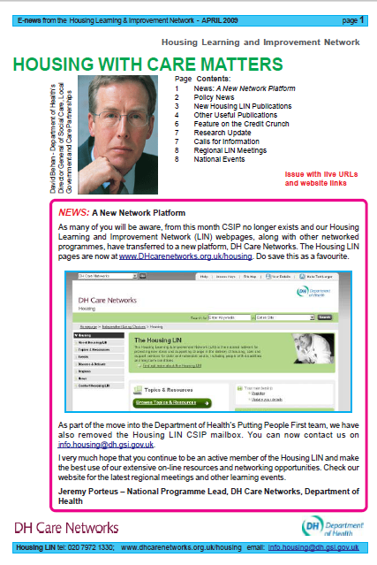
The latest newsletter includes policy updates and new Housing LIN publications. Of particular interest is the latest information on Supporting People and a study of housing and joint strategic needs assessments in South East England.
Supporting People and Area Based Grant
allocations 2009/2010
CLG has published details of how the £1.66 billion of Supporting People funding will be allocated amongst local authorities in 2009/2010. As reported in the previous Housing LIN enews, the Supporting People funding is un-ringfenced from 1 April 2009 and will become part of Area Based Grant from 2010. Click on the following link to download a pdf listing the grants allocated to each local authority,
Supporting People grant allocations 2009/201:
http://www.spkweb.org.uk/NR/rdonlyres/6E19E99CA20D-4752-93DE-D6C98A28BEC3/16428/

Joint Strategic Needs Assessment and Housing: Report of a study based on the
South East region
Link: http://www.dhcarenetworks.org.uk/IndependentLivingChoices/Housing/Topics/browse/Housing/HousingStrategy/?parent=3656&child=5448
Housing LIN newsletter (April 2009)
http://www.dhcarenetworks.org.uk/_library/Resources/Housing/Support_materials/Newsletter/Newsletter35.pdf

Journals
The April 2009 Journal of Telemedicine and Telecare is now available.
Examples of articles:
- An empirical analysis of the reduction in medical expenditure by e-health users
- Supervised training with wireless monitoring of ECG, blood pressure and oxygen-saturation in cardiac patients
- Evaluation of a mobile phone telemonitoring system for glycaemic control in patients with diabetes
- A review of the role of telemedicine in the accident and emergency department
- Pilot study of a virtual diabetes clinic: satisfaction and usability
Web-based management of diabetes through glucose uploads: has the time come for telemedicine?
http://www.ncbi.nlm.nih.gov/pubmed/19056140

Long term conditions

DoH launches long-term conditions guide for GPs
http://www.healthcarerepublic.com/news/PRACTICESTAFF/897516/DoH-launches-long-term-conditions-guide-GPs/
http://www.dh.gov.uk/en/Healthcare/Longtermconditions/yourhealth/index.htm

An overview of acute exacerbations of COPD – Nursing Times article
http://www.nursingtimes.net/nursing-practice-clinical-research/specialists/respiratory/an-overview-of-acute-exacerbations-of-copd/2007433.article

NHS Choices – Your health, your way

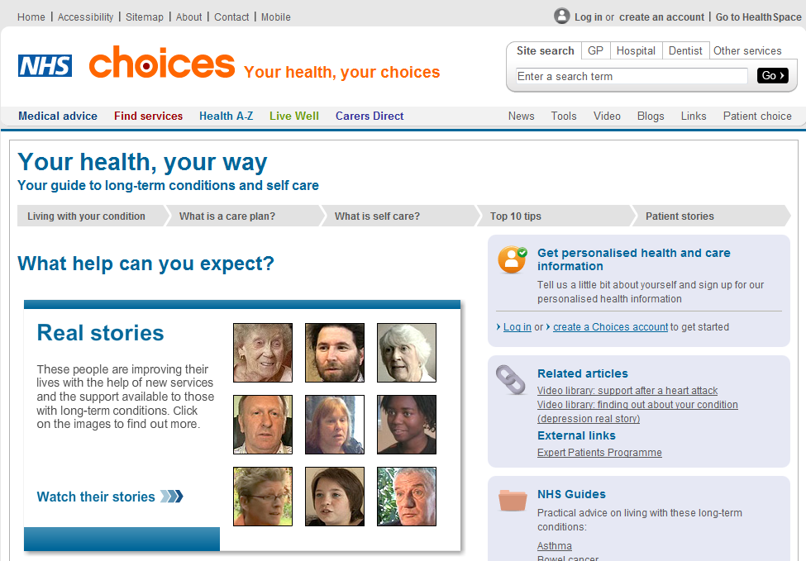

Your health, your way: http://www.nhs.uk/Yourhealth/Pages/Homepage.aspx

m-Health – the new generation of mobile healthcare
Mobile Tech In Health Care Gets Spotlight At Wireless Show
There is increasing interest in adopting wireless technology for help in administering medical care. Trials are underway for a number of devices, and funding could show up through a push by the Obama administration to make health- care providers "smarter."
http://money.cnn.com/news/newsfeeds/articles/djf500/200904021456DOWJONESDJONLINE000995_FORTUNE5.htm

Mobile revolutionizing healthcare: CTIA keynote speech
Wireless technologies are providing convergence, remote monitoring of patients and the means to provide individualized medicine, among a variety of other benefits. While the top five life-changers are currently the Internet, PCs and laptops, mobile phones, email, and DNA testing and sequencing, by 2015, it will be wireless medicine, according to the keynote.http://www.mobilemarketer.com/cms/news/software-technology/2971.html

Your health on the iPhone!
http://venturebeat.com/2009/04/21/your-health-on-the-iphone/

The mobile technology revolution
http://www.chestjournal.org/content/early/2009/02/06/chest.08-2425.short?rss=1

Mobile revolutionising healthcare – CTIA keynote speech
http://www.mobilemarketer.com/cms/news/software-technology/2971.html
Physicians have access to new obstetrics iPhone app
http://www.healthcareitnews.com/news/physicians-have-access-new-obstetrics-iphone-app

Self care
Self-care information packs launched for patients with long-term conditions
http://www.nursingtimes.net/whats-new-in-nursing/primary-care/self-care-information-packs-launched-for-patients-with-long-term-conditions/5000373.article
http://www.nhs.uk/yourhealth/Pages/Homepage.aspx

Telecare

“Telecare saves £11m and 80,000 bed days” – Scotland Report
http://www.healthcarerepublic.com/rss/news/article/900088/Telecare-saves-11m-80000-bed-days/

RCN builds telecare and telehealth resource

http://www.healthcarerepublic.com/news/PHARMACIST/890831/RCN-builds-telecare-telehealth-resource/

New service allows OAPs to live alone – Neath, South Wales

http://www.thisissouthwales.co.uk/news/New-service-allows-OAPs-live/article-944688-detail/article.html

Telehealth and telemedicine

ICN Telenursing Network launched
The International Council of Nurses (ICN) is pleased to announce the launch of the ICN Telenursing Network today during a keynote address at the Med-e-Tel Conference in Luxembourg.
Members of the new ICN Telenursing Network will collaborate with the International Society for Telemedicine and eHealth (ISfTeH) Telenursing Working Group, and other professional and industry organisations, to advance the use of telehealth technologies among nurses worldwide. An ICN Telenursing Network Advisory Group, composed of telenursing representatives from different parts of the world, will provide leadership and direction for the work of the network.
http://telehealthcanada.blogspot.com/2009/04/icn-telenursing-network-launched.html

Telemedicine, telepharmacies could preserve rural drugstores - Nebraska
http://www.kearneyhub.com/site/news.cfm?newsid=20293536&BRD=268&PAG=461&dept_id=577571&rfi=6

VivoMetrics and OBS Medical to create decision-assist software platform
http://it.pharmaceutical-business-review.com/news/vivometrics_and_obs_medical_to_create_decision_assist_software_platform_070409

Ventura firm's LifeShirt has 24-7 health monitoring

http://www.annals.org/cgi/content/abstract/150/7/485

Telemonitoring changes the working practice of cardiac nurses

http://www.news-medical.net/?id=48137

Advances in Online Care and Telehealth – comments from symposium in Hawaii

http://www.thehealthcareblog.com/the_health_care_blog/2009/04/advances-in-online-care-and-telehealth.html

RCN builds telecare and telehealth resource

http://www.healthcarerepublic.com/news/PHARMACIST/890831/RCN-builds-telecare-telehealth-resource/

NHS North East Essex announces home monitoring programme

NHS North East Essex is to install machines in the homes of patients for nurses to remotely monitor statistics such as blood pressure and pulse rate. The machine can also remind patients to take medication and eat healthily. The equipment is being installed over the next six months, with 40 units in operation by September. The one-year pilot will involve pulmonary disease patients, heart failure patients and others who have just been released from hospital and would benefit from regular checks.
http://news.bbc.co.uk/1/hi/england/essex/7983097.stm

Remote Monitoring of the Heart - Wearable wireless technology detects early signs of heart failure

A wearable patch measures temperature, heart and respiration rates, levels of physical activity, body position, and body-fluid levels using sensors that include an accelerometer and an impedance monitor.
http://www.technologyreview.com/biomedicine/22519/

Aging boomers face health care dilemma – New Hampshire

http://www.citizen.com/apps/pbcs.dll/article?AID=/20090426/GJNEWS02/704269924/-1/CITNEWS

A Doctor-Miles Away-Will See You Now
http://www.napsnet.com/articles/61280.html

Polycom Telepresence Helps Michigan Department of Corrections Procedures
http://hdvoice.tmcnet.com/topics/unified-communications/articles/54971-polycom-telepresence-helps-michigan-department-corrections-procedures.htm

IT to enhance healthcare across Europe
http://www.news-medical.net/?id=48869

ExpressMD(TM) Solutions' Remote Patient Health Monitoring Device Receives 510(K) Market Clearance Approval From FDA

http://www.bio-medicine.org/medicine-news-1/ExpressMD-28TM-29-Solutions-Remote-Patient-Health-Monitoring-Device-Receives-510-28K-29-Market-Clearance-Approval-From-FDA-42478-1/

Weekly phone advice helps diabetics cope
http://www.reuters.com/article/healthNews/idUSTRE5364LK20090407
Global Telemedicine Market to Exceed $18 Billion by 2015, According to New Report by Global Industry Analysts, Inc.
http://telemedicinetoday.blogspot.com/2009/04/global-telemedicine-market-to-exceed-18.html
Google Health expands deal with CVS pharamcies
http://news.cnet.com/8301-1001_3-10213205-92.html

10 Events
- CSIP Networks events planner

Forthcoming Networks Event List (27 April 2009)
Date | Event Title | Network | Places Remaining | Book
28/04/09 | Resource Allocation System - Holiday Inn Camden Lock - London | Personalisation | 10 of 50 | Book now
28/04/09 | Efficiency Solutions | Care Services Efficiency Delivery | 49 of 50 | Registration Closed
28/04/09 | Integrated Care and Support Pathway Planning | Care Services Efficiency Delivery | 50 of 50 | Registration Closed
30/04/09 | West Midlands Regional Housing LIN Meeting | Housing | 0 of 35 | Registration Closed
06/05/09 | Does integrated care really work? Moving the evidence base from process to outcomes and efficiencies. - London | Integrated Care Network | Reserve places available | Add me to the reserve list
07/05/09 to 08/05/09 | Transforming Community Equipment - Project Managers' Induction Course | Care Services Efficiency Delivery | - | N/A
20/05/09 | North East Midlands Regional Housing LIN Meeting | Housing | 38 of 40 | Book now
02/06/09 | Does integrated care really work? Moving the evidence base from process to outcomes and efficiencies.- Liverpool | Integrated Care Network | FULL | FULL
05/06/09 | Valuing People - Having your own home | Housing | - | N/A
10/06/09 | South West Regional Housing LIN Annual Conference - 'Tools for Change' | Housing | 68 of 160 | Book now
11/06/09 | Whole System Demonstrator Programme (WSDAN) - Integrated care using telecare and telehealth – Leeds | Telecare LIN | Reserve places available | Add me to the reserve list
17/06/09 | Carers and personalisation - Birmingham | Personalisation | 120 of 120 | Book now
23/06/09 | Resource Allocation System - Holiday Inn Camden Lock - London | Personalisation | 25 of 50 | Book now
25/06/09 | Carers and personalisation - Manchester | Personalisation | 120 of 120 | Book now
30/06/09 | Carers and personalisation - London | Personalisation | 120 of 120 | Book now
22/09/09 | Resource Allocation System - Holiday Inn Camden Lock - London | Personalisation | 26 of 50 | Book now

Latest events http://www.dhcarenetworks.org.uk/events/s/.

WSDAN Events:
11 June – Leeds (see events planner)

The Foundation for Assistive Technology (FAST) provides a full listing of forthcoming telecare events – see http://www.fastuk.org/services/events.php?pg=2. Suppliers also run telecare and telehealth events – check their web sites regularly for dates.

All previous telecare eNewsletters are available at: www.dhcarenetworks.org.uk/telecarenewsletters

Glossary:

ALIP – Assisted Living Innovation Platform
AT – Assistive Technology
BERR – Business Enterprise and Regulatory Reform
CSCI – Commission for Social Care Inspection
CQC – Care Quality Commission
DCLG – Department for Communities and Local Government
FACS – Fair Access to Care Services
IB- Individualised budgets
i4i – Invention for Innovation
LIN – Learning and Improvement Network
NHS CfH – NHS Connecting for Health
NHS PASA – NHS Purchasing and Supply Agency
POPP – Partnership for Older Peoples Projects
PT Grant or PTG – Preventative Technology Grant
SCIE – Social Care Institute for Excellence
TSA – Telecare Services Association
TSB – Technology Strategy Board
WSDAN – Whole System Demonstrator (Long Term Conditions) Action Network

