

CSIP Telecare eNewsletter

October 2008

Welcome to the October 2008 newsletter. The Care Services Improvement Partnership (CSIP Networks) is responsible for providing general implementation support to organisations building their telecare and telehealth programmes.

If you are an organisation implementing telecare and have an interesting local telecare or telehealth story for inclusion in a future newsletter then e-mail Mike Clark (newsletter editor, CSIP Networks) at telecare@csip.org.uk

Please note, some recent adjustments have been made to the CSIP Networks web site – the main URL is now www.networks.csip.org.uk

Telecare shortcuts:

www.networks.csip.org.uk/telecarefactsheets
www.networks.csip.org.uk/telecarenewsletters
www.networks.csip.org.uk/telecareservices
www.networks.csip.org.uk/telecareoutcomes

WSD Action Network:
http://www.wsdactionnetwork.org.uk/

Notes:

1 CSIP Networks is not responsible for the content of external links and does not endorse any suppliers or their products. Any claims made by organisations should be carefully evaluated as part of normal commissioning and procurement arrangements.

2 CSIP Networks has no connection with a UK organisation that has recently been identifying itself as ‘Csip Telecare’ on Google searches

3 If in doubt contact telecare@csip.org.uk to verify any claims being made of links to the Department of Health or CSIP Networks

Contents

Item | Page
1 Putting People First – one year on | 3
2 Putting People First – telecare charging | 7
3 Supplement – October 2008 | 10
4 CSCI Performance Assessment for 2008 | 10
5 DH and CSIP News | 12
6 Other news and links | 16
7 Events | 23

Item 1 looks at the position for telecare one year on from Putting People First. A link to telecare services on Google Maps is available together with a checklist for commissioners

Item 2 covers the latest position on charging and links to a recent charging survey for telecare

Item 3 Links to the supplement covering a number on suppliers with case studies and latest news

Item 4 reminds social care authorities that the CSCI performance figures will be published shortly

Item 5 lists recent DH and CSIP News including links to recent reports on POPP and Individualised Budgets

Item 6 Provides a monthly list of news and links

Item 7 lists CSIP events including an upcoming WSDAN telecare event on 22 January 2009.

Glossary:

ALIP – Assisted Living Innovation Platform
AT – Assistive Technology
BERR – Business Enterprise and Regulatory Reform
CSCI – Commission for Social Care Inspection
DCLG – Department for Communities and Local Government
FACS – Fair Access to Care Services
IB- Individualised budgets
i4i – Invention for Innovation
NHS CfH – NHS Connecting for Health
NHS PASA – NHS Purchasing and Supply Agency
POPP – Partnership for Older Peoples Projects
PT Grant or PTG – Preventative Technology Grant
TSA – Telecare Services Association
TSB – Technology Strategy Board
WSDAN – Whole System Demonstrator (Long Term Conditions) Action Network
1 Putting People First – one year on

Telecare LIN

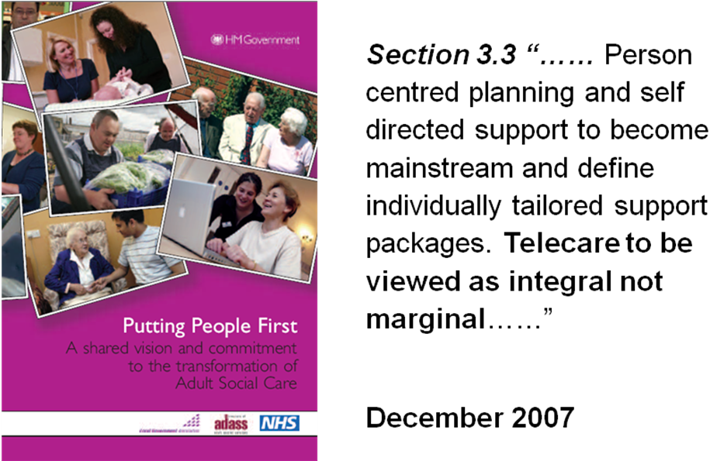

It’s coming up to a year from the publication of the landmark document ‘Putting People First’ (PPF) and most social care organisations are in the course of mainstreaming telecare services.

Over the last few weeks, the Department of Health has published reports on POPP and individualised budgets (see later in this newsletter for links to these documents).

The Department of Health has recently published a two page leaflet that summarises four important aspects of Putting People first:

- Universal Services
- Early Intervention and Prevention
- Choice and Control
- Social Capital

Link: http://www.dh.gov.uk/en/Publicationsandstatistics/Publications/PublicationsPolicyAndGuidance/DH_089665

Organisations will need to think about how telecare services are commissioned and provided in future as part of local social care transformation.

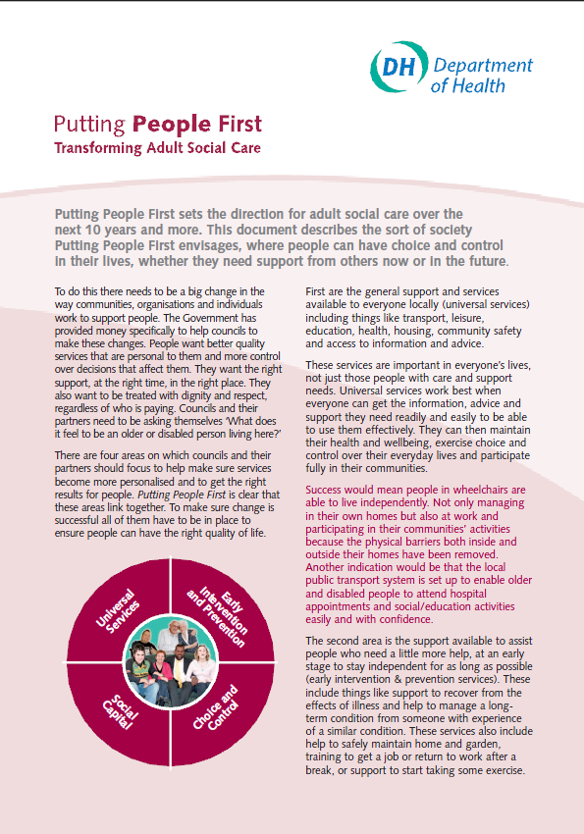  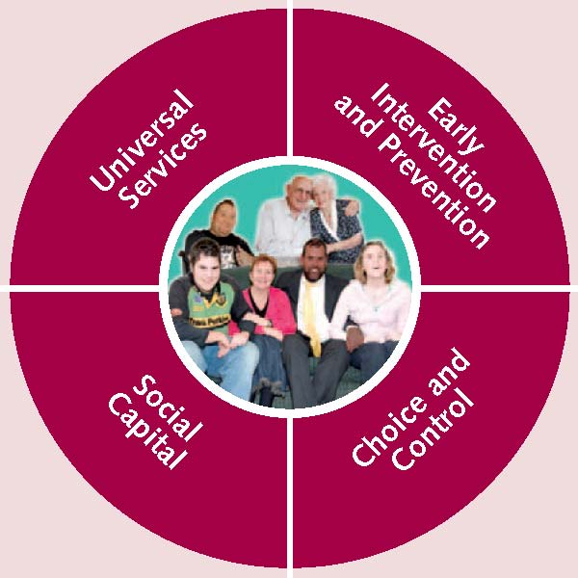 | “Putting People First sets the direction for adult social care over the next 10 years and more. This document describes the sort of society Putting People First envisages, where people can have choice and control in their lives, whether they need support from others now or in the future”.  “..There are four areas on which councils and their partners should focus to help make sure services become more personalised and to get the right results for people. Putting People First is clear that these areas link together. To make sure change is successful all of them have to be in place to ensure people can have the right quality of life”.  “..Universal services work best when everyone can get the information, advice and support they need readily and easily to be able to use them effectively. They can then maintain their health and wellbeing, exercise choice and control over their everyday lives and participate fully in their communities”.  “..The second area is the support available to assist people who need a little more help, at an early stage to stay independent for as long as possible (early intervention & prevention services).  “Not only do these early interventions make sure people can stay in their own homes for as long as they want, but are also the best way of keeping the costs down in the future. Success would mean people were supported to get the right exercise and equipment following a fall so they would not have to go into hospital, and could stay at home without significant risk of falling again. Alternatively, through effective use of telecare people with dementia are routinely able to stay at home with their families, who are able to continue their everyday lives”.  “..Self-directed support means having services available to meet people’s needs rather than people having to fit in with the things on offer. People who need support should be able to choose who provides that support, and control when and where the services are provided. The right information and advice needs to be available to help people decide”.

Link:
http://www.dh.gov.uk/en/Publicationsandstatistics/Publications/PublicationsPolicyAndGuidance/DH_089665

Some key challenges for commissioners include:

- What telecare services are currently being commissioned? Who provides them? How much do they cost?
- What current and future demand is there for services in your area? How do you build capacity?
- Do you have evidence of the effectiveness of local services? Do they provide good outcomes for users and their families? Are there more effective alternatives?
- Do you view telecare as integral to strategic planning, service commissioning and the provision of a wide range of care options for users, carers and their families?
- Do you use joint commissioning, pooled funds and integrated approaches with partners?
- What standards, specifications, contracts and service level agreements are in place? Do they align with Putting People First in terms of information, advice, choice, accessibility?
- Are there arrangements for brokerage and care coordination where people need further help?
- What costing and charging information is available when people choose to have direct payments and personal budgets?
- Do you look at regional and national as well as local options for telecare?
- Do you look at a broad range of assistive technologies and their availability not solely telecare? How do you promote innovation? How do you balance human contact and technology?
- Do you have performance and benchmarking information to review outcomes and cost-effectiveness?
- Are you providing services to support preventative approaches and social inclusion as well as providing emergency services?
- Are there arrangements for workforce training?
- Are you able to meet the needs of a wide range of users including black and minority ethic communities, people with sensory and cognitive impairments, people with learning and physical disabilities?

To assist commissioners and support service providers and users, CSIP Networks has now extended its list of telecare organisations.

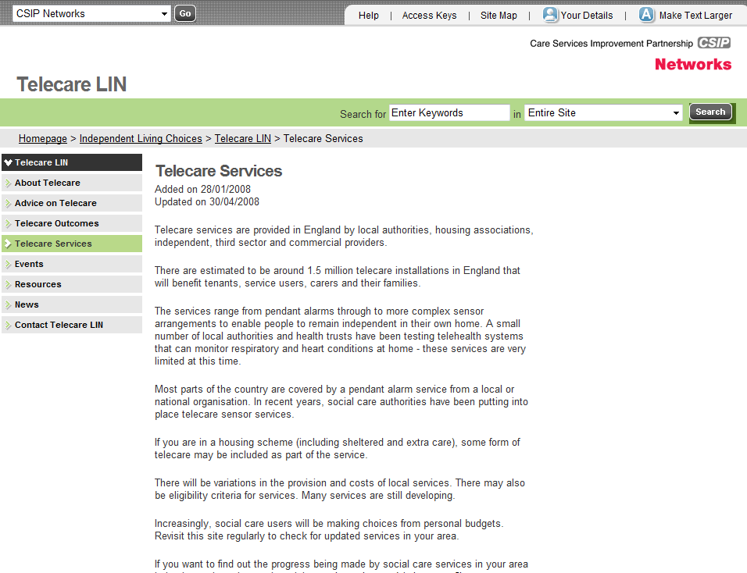

www.networks.csip.org.uk/telecareservices

This newsletter links to a Google Map of services. This has markers for services around the country.

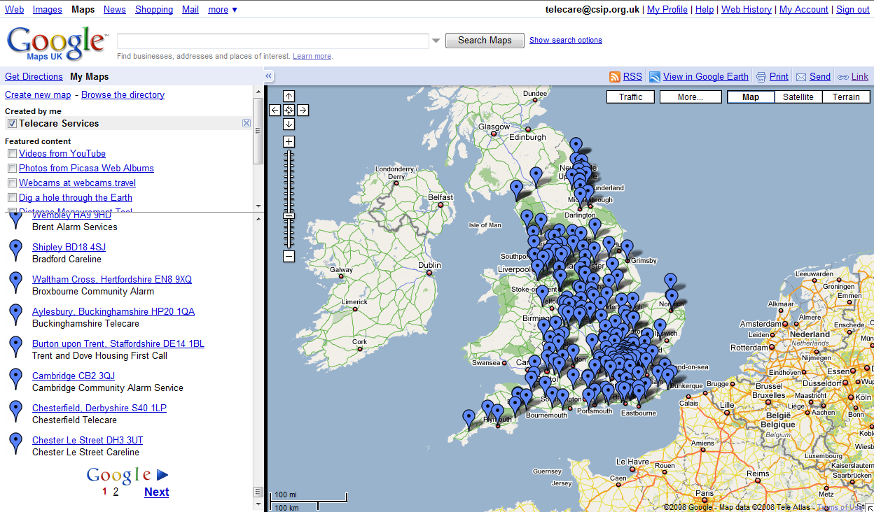

Go to the following link to access the map:
http://maps.google.co.uk/maps/ms?hl=en&ie=UTF8&msa=0&msid=100406857045032193451.0004540c223f16f2d1c9d&z=6
Note: 200 service links are on Page 1 and a further 114 on Page 2 (Click ‘Next’ at the bottom of the list to see sites on the second page)

Keeping track of these services is not an easy job because:

- There are over 300 entries
- Web sites are constantly changing without user redirection – there is no common site address such as www.yourorganisation.gov.uk/telecare except in a few examples
- Telecare can be found as ‘community alarm’, ‘Careline’, ‘Linkline’, ‘Helpline’ as well as a number of local variations eg MASCOT, BELL
- Many telecare services do not provide their addresses on their web pages, so we have used organisational headquarter addresses for the markers
- Some services have a head office and work across large areas, regions or in different localities so may have a presence elsewhere in the country
- Some web sites have not been updated for several years – one site had charging information from 2003

So please let us know if your entry needs updating or if we have missed your organisation.

It is possible to drag the map and change the magnification to look at a particular area. All links have been tested during October 2008 but may change. Remember, some entries may be on the second page.
More information will be provided when the CSCI 2008 returns are published.

CSIP Networks does not endorse any individual telecare organisations.

Note: CSIP Networks provides extensive support for commissioning and integrated care programmes at www.networks.csip.org.uk

2 Putting People First – telecare charging

Telecare LIN

Again with Putting People First in mind and to assist commissioners, service providers, users and carers, CSIP Networks has carried out a survey of telecare charging.

Putting People First  “For example, they can make their own plans for services with the money from the council. They can also get together with friends to make the plans together, or they can ask an agent or the council to arrange things for them. They must show that the money they have been given is making the difference it was supposed to make (the agreed outcomes)”. | “..Systems should be easy to follow and everyone involved should work together with the person at the centre of the plan. This is true whether the council is providing the support or people are buying the services themselves. To do this planning, people (or their advocates and supporters) need to understand what money is available to spend on their support. If it is their own money, they need to know what support there is locally, and that it is of a high quality and safe for them to choose. The same is true if some or all of this money comes from the council, people have a choice to spend part or all of the money in a way that they choose”.  “..Success would mean people in the community who need support and their families and carers feeling empowered to come up with flexible solutions to meet their needs, individually or collectively. They would understand what is available and be confident the services available to buy were suitable, safe and reliable. People feel they have a life rather than a set of services”.
Link:
http://www.dh.gov.uk/en/Publicationsandstatistics/Publications/PublicationsPolicyAndGuidance/DH_089665

The cost of service and how much users are currently charged can be complex. Commissioners and service providers need to carefully review their arrangements particularly if they are moving towards service mainstreaming for April 2009 and beyond.

For personal budgets, it is vital that people have sufficient in their budget to pay for existing and future telecare services. A failure to fully cost services or provide transparent charging information could lead to people stopping services or not taking up arrangements that could support their independence.

The first point is that telecare is provided by a number of different organisation types.

There are 150 social care authorities that have been using PT Grant fundng. There are 238 district councils in county areas who are involved in housing programmes in various ways in conjunction with housing associations, commercial and third sector providers. There are many types of housing scheme with different funding and eligibility arrangements as well as different monitoring and response.

There are third sector and voluntary organisations who provide direct services. Commercial providers are also involved.

There are 151 primary care trusts (PCTs) some of which are providing telehealth services. There is a fair amount of geographical boundary agreement with the social care authorities although there are still some differences eg Kent County Council has 2 PCTs in its boundary. To make things more complex, some local authorities are trialing telehealth, so is at least one housing association.

Up until 2005, most of the telecare in use was in the form of pendant alarms and pull cords and had been provided predominantly via housing routes.

If someone is in a housing scheme, the charge for the service is probably wrapped up in the service charge for maintenance etc. There may be warden or floating support during the day and routing to a control centre at night. Typically, smoke alarms have also been linked in many schemes. Extra care schemes will have 24/7 support. Some of the older schemes have pull cords only.

Supporting People has been used to support various people who may, for instance, be on full housing benefit.

For many years, some telecare providers have offered a service directly to the public. There may be some eligibility criteria. There is often a small weekly charge for these direct purchases. There are all sorts of charging combinations depending on the service provider and the service.

These charges can depend on whether the person buys or loans the equipment and the level of response. Home visit responses are normally charged at a higher weekly rate compared to alarm calls that go through the friends and family to provide the response.

Local social care authorities can make a charge for services ie residential care, home care, day care etc. They can make a charge for telecare using guidance on fairer charging.

Social care referrals generally go through an assessment of the user’s needs although some people may follow signposting routes into other low level and preventative services. The outcome will be a care plan and package of care. There is a financial assessment process unless the local authority has decided not to charge.

An Act of Parliament in 2003 restricted charging for daily living and home nursing equipment via an assessment. Building Telecare in England covers these arrangements in the Charging Section. Local social care services should not charge for the equipment but can charge for the service (monitoring, response, home visits etc). Organisations will need to decide which category installation and maintenance fall within. Particular care needs to be taken where different sensor configurations have different charges when the service is exactly the same or hiding equipment elements within a weekly service charge. CSIP Networks is not currently aware of any challenges to charging arrangements in England for telecare.

Because of the Preventative Technology Grant from 2006 to 2008, many authorities have delayed putting any charges into place until they have a better idea of how they will provide telecare as a mainstream service. You will see examples in the charging survey on this.

Where authorities have determined a charge under fairer charging, the user’s financial assessment may reach a monetary ceiling which means that there is, in fact, no charge for the telecare part of the care package. This occurs often when it is a large homecare package where carers are, for instance, going to someone’s home 20 hours or more a week to help with personal care, getting people out of bed etc.

One service (Tower Hamlets) has recently indicated that they have scrapped charges for telecare - http://www.towerhamlets.gov.uk/templates/news/detail.cfm?newsid=9827 .

It is understood that Newham also have not charged for telecare through their recent programme.

When benchmarking charges it would be necessary to ask if there was a telecare service charge for people in housing schemes.

Some authorities also define telecare in different ways eg pendant alarms are not included ass telecare.

Social care authorities can provide a direct payment, a cash equivalent, so that individuals can purchase their own service. Individualised or personal budgets are also now becoming available following Putting People First. This will transform the way care is provided.

There are limited examples of direct payments and individualised budgets for telecare but this is expected to change. People may seek out other solutions from the high street or top up their arrangements in future.

Here are some variations:

- Where the service is a ‘health’ service, there should not be a charge at all. This would include telehealth vital sign monitoring for heart conditions, respiratory conditions etc

- There must not be a charge for ‘intermediate care’ (http://www.dh.gov.uk/en/Publicationsandstatistics/Lettersandcirculars/LocalAuthorityCirculars/AllLocalAuthority/DH_4003698) – this could include a service provided for up to around 6 weeks following hospital discharge

- There is a grey area around telecare for medication dispensers – is it social care (chargeable) because it could replace a home care visit or is it health care (not chargeable) because it helps people comply with their medication – a local decision would need to be made

- There is a grey area where telecare is provided as part of a health-led falls prevention programme (http://www.nice.org.uk/CG21) – again, a local decision would need to be made

- Clearly, it is not fair to charge for the same service through social care and a housing charge

Where people are making their own purchase of disability equipment, there are special VAT rules that apply. In effect, people who meet the criteria do not pay the VAT element.

The CSIP Networks charging survey was carried out in October 2008 and can be found at
http://networks.csip.org.uk/nl/?l=336_1_1_1

3 Supplement – October 2008

Telecare LIN

From time to time CSIP Networks provide a supplier supplement. In July/August 2008 we again asked for submissions.

Contributors to this edition included:
- Buddi
- Connect for Care
- CELS
- Just Checking
- Home Telehealth Ltd
- Invicta
- Just Checking
- Pivotell Ltd
- Tunstall
- Halliday James Ltd
CSIP Networks would like to thank all of the organisations that contributed to this supplement.

Please note that CSIP does not endorse any individual supplier’s equipment and services.

Purchasing organisations should ensure that they make appropriate checks and carry out risk assessments prior to purchase.

The supplement can be accessed at http://networks.csip.org.uk/nl/?l=336_1_1_2

4 CSCI performance assessment for 2008

Telecare LIN

CSCI figures are now being finalised for publication at the end of November 2008. This will include all of the detailed local authority counts, spends and responses to questions on mainstreaming and outcomes.

We are currently following up with a small number of authorities to ensure that returns are consistent with the definitions in the CSCI guidance and there will probably be some final adjustments. If you think that there may be any issues (under or over count) of your 2008 figures, it would be helpful to know now. We can expect some scrutiny of the figures when they are published so it is important that they are accurate and consistent with submissions from previous years.

The text responses from the questions on mainstreaming and outcomes are as important as the counts of additional users and the year on year trends and will further help build the evidence base for telecare and telehealth.

The text responses will be set up in an Excel spreadsheet. By typing a keyword into Column A (see Excel screenshot below), an Excel formula searches each local authority response to the ‘outcomes’ question and shows a ‘Yes’ when the word is found it the entry. Column C gives the number of authorities that have used that keyword.

This will enable authorities to locate others looking at subject areas they may be interested in.

In the example below, you can see that 48 out of the 150 social care authorities have mentioned ‘dementia’ in their outcomes response. Some additional authorities may also have mentioned dementia in their mainstreaming response so it will be important to look at the two sets of responses.

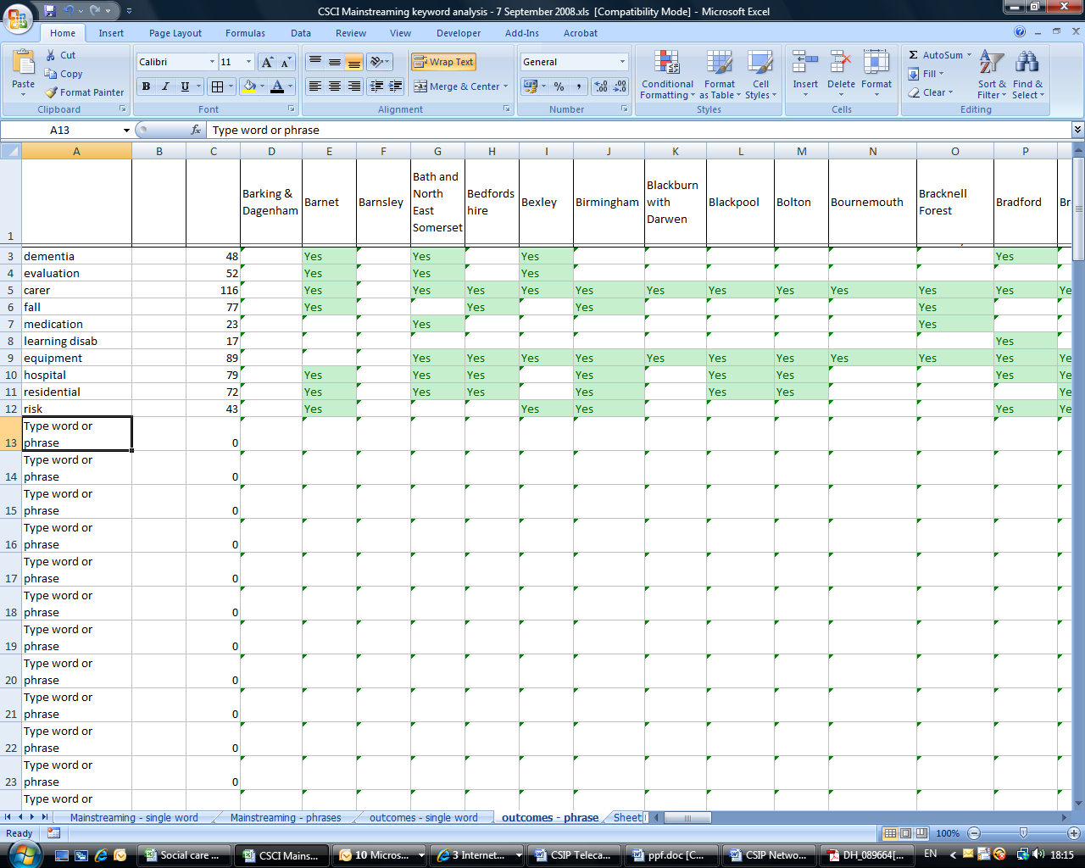
Every word from the text responses has been indexed and word counts will be available. This will give an indication of priority areas and achievements.

Various themes from the responses are also being analysed eg the most effective outcomes, stakeholder engagement, business case examples, integrated services, pooled funds, workforce issues etc.

If you would like a particular analysis, please contact Mike Clark at telecare@csip.org.uk so that this can be taken into account when publishing the information.
5 DH and CSIP News

Telecare LIN

A guide to patient and public involvement in urgent care (DH, October 2008)

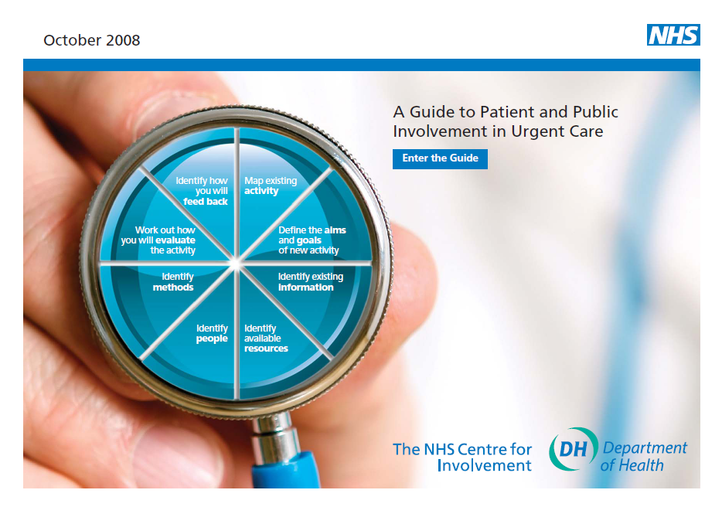

http://www.dh.gov.uk/en/Publicationsandstatistics/Publications/PublicationsPolicyAndGuidance/DH_089684

Putting People First - the whole story (DH, October 2008)

http://www.dh.gov.uk/en/Publicationsandstatistics/Publications/PublicationsPolicyAndGuidance/DH_089665

Government response to Cutting the cake fairly: CSCI review of eligibility criteria for social care (DH, October 2008) and CSIC Report (Cutting the care fairly)



http://www.dh.gov.uk/en/Publicationsandstatistics/Publications/PublicationsPolicyAndGuidance/DH_089618
http://www.csci.org.uk/about_us/publications/cutting_the_cake_fairly.aspx

Occupational therapy in adult social care in England: sustaining a high quality workforce for the future
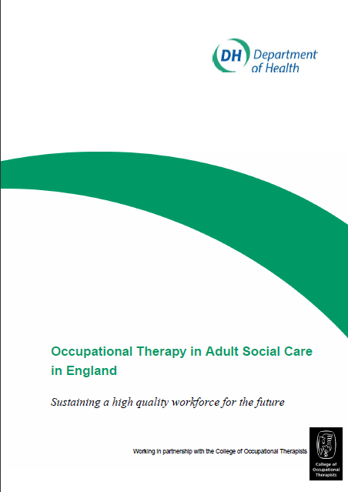

http://www.dh.gov.uk/en/Publicationsandstatistics/Publications/PublicationsPolicyAndGuidance/DH_089467

Safeguarding adults: a consultation on the review of the ‘No Secrets’ guidance (October 2008)
http://www.dh.gov.uk/en/Consultations/Liveconsultations/DH_089098

Integrated care pilot programme - prospectus for potential pilots (DH, October 2008)


Pilot site applications should be sent by 14 November 2008 to:
integratedcare@dh.gsi.gov.uk http://www.dh.gov.uk/en/Publicationsandstatistics/Publications/PublicationsPolicyAndGuidance/DH_089338

Health and Care Services for Older People: Overview report on research to support the National Service Framework for Older People (October 2008)
http://www.dh.gov.uk/en/Publicationsandstatistics/Publications/DH_088848

Evaluation of the Individual Budgets pilot programme: final report (October 2008)



http://www.dh.gov.uk/en/Publicationsandstatistics/Publications/PublicationsPolicyAndGuidance/DH_089505

Older people's quality of life improved through National scheme – POPP interim report (October 2008)

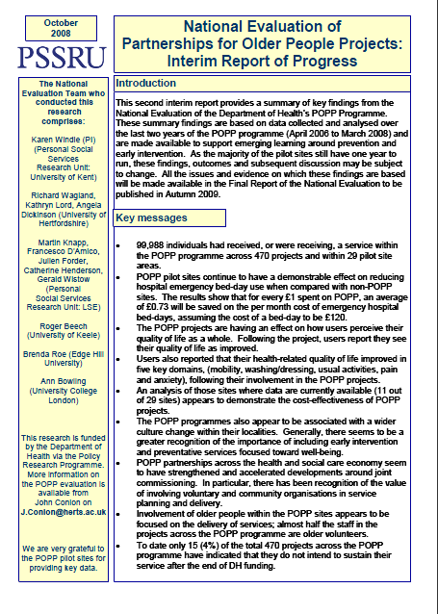
http://www.dh.gov.uk/en/SocialCare/Deliveringadultsocialcare/Olderpeople/PartnershipsforOlderPeopleProjects/index.htm

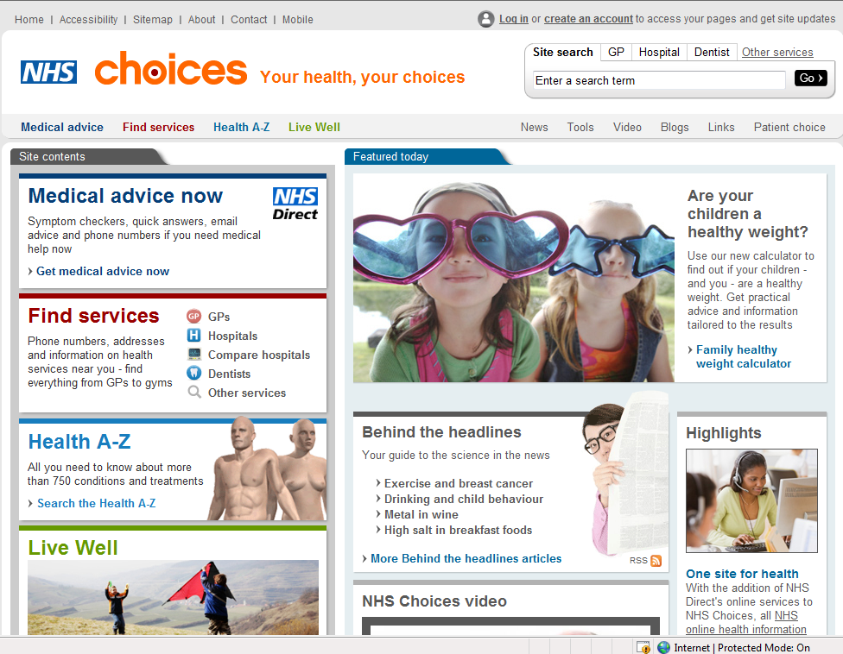
6 Other news and links

Telecare LIN

NHS Direct is joining forces with NHS Choices to provide health information on www.nhs.uk.
NHS Direct will continue to provide the telephone service on 0845 4647 supplying health advice and information 24/7
From early November, you'll be able to access all NHS online health information from one site. This includes the health encyclopaedia, common health questions and self-help guide.
By integrating the online services of NHS Direct and NHS Choices, the NHS will have the most comprehensive online health information service available anywhere.

Backing for physio self-referral
http://news.bbc.co.uk/1/hi/health/7680055.stm
http://www.independent.co.uk/life-style/health-and-wellbeing/health-news/patients-to-be-given-right-to-selfrefer-967681.html

Get well on a personal budget
http://www.timesonline.co.uk/tol/news/uk/health/article4968893.ece

COPD Exacerbations Linked with Depression and Anxiety
http://www.medpagetoday.com/Pulmonary/SmokingCOPD/11449
http://ajrccm.atsjournals.org/cgi/content/abstract/178/9/913
Health 2.0 conference promotes online solutions
http://www.healthcareitnews.com/story.cms?id=10244
Young people turn to Web for health care information
http://www.mediapost.com/publications/?fa=Articles.showArticleHomePage&art_aid=93143

Aetna, Microsoft create Internet storage for users
http://seattlepi.nwsource.com/business/384533_msftaetna23.html

iPhone For Telemedicine
http://www.wirelesshealthcare.co.uk/wh/news/wk43-08-0001.htm

WayPort Lands Medical WiFi Project
http://www.wirelesshealthcare.co.uk/wh/news/wk43-08-0003.htm

Weight Watchers Watch
http://www.wirelesshealthcare.co.uk/wh/news/wk43-08-0005.htm

Internet searches become "second opinions" for many patients
http://www.nytimes.com/2008/09/30/health/30online.html?_r=1&oref=slogin
Wall-Mart eHealth records
http://www.informationweek.com/news/software/database/showArticle.jhtml?articleID=210605059

Dossia Joins Continua Health Alliance, Highlights Open Standards for Healthcare Technology
http://www.marketwatch.com/news/story/dossia-joins-continua-health-alliance/story.aspx?guid={0F9AE15E-E6BF-4D08-BECE-B4FA26073FAC}&dist=hppr

Google joins Continua Alliance
http://www.e-health-insider.com/news/4261/google_joins_continua_e-health_alliance

European Commission consults on Web 3.0 – wearable devices
http://www.ehealtheurope.net/news/4193/european_commission_consults_on_web_3.0

Whitehead Institute to Offer MyCareTeam™ Diabetes Management Software to Employees & Family Members
http://www.prweb.com/releases/2008/09/prweb1336404.htm

Under-the-Skin Blood Sugar Monitor Boosts Diabetes Control
http://www.washingtonpost.com/wp-dyn/content/article/2008/09/08/AR2008090801015.html

Robots and sensors to help elderly stay independent
http://www.physorg.com/news143902315.html

Home telecare technologies for the elderly
http://jtt.rsmjournals.com/cgi/content/abstract/14/7/333
Association of Directors of Adult Social Services and Tunstall Sign Landmark Partnership to Extend Use of Telehealthcare
http://www.24dash.com/news/Health/2008-10-27-Association-of-Directors-of-Adult-Social-Services-and-Tunstall-Sign-Landmark-Partnership-to-Extend-Use-of-Telehealthcare
Digital champion to bridge the divide
http://www.publicservice.co.uk/news_story.asp?id=7493
Brent Telecare scheme reaches 250 service user milestone
http://www.brent.gov.uk/pressreleases.nsf/News/LBB-644
DigiTV wins EC funding to deliver health care services via Digital TV
http://www.citizensonline.org.uk/conline/news/display?contentId=5247
Telecare Success – York
http://yorklibdems.org.uk/news/000351/telecare_success.html
Telecare service in Tower Hamlets – no charge
http://www.towerhamlets.gov.uk/data/caring-for-you/data/older-people/data/alarm-services.cfm
Alarm link gives carer Joyce vital access to 24/7 home support
http://www.thisisderbyshire.co.uk/news/Alarm-link-gives-carer-Joyce-vital-access-24-7-home-support/article-409520-detail/article.html

Model-driven Service Engineering in Home Telecare
http://www.ejhi.net/ojs/index.php/ejhi/article/view/3%282%29%3Ae14
Carers Scotland guide to telecare
http://www.carerscotland.org/Information/Telecaresupportingcarers/Supportforcarers-aguidetotelecare.pdf
Counsel and Care calls for national fund to meet adult care costs
http://www.communitycare.co.uk/Articles/2008/10/16/109690/counsel-and-care-calls-for-national-fund-to-meet-adult-care-costs.html
Councillors mull shake-up plans for adult social care in Northamptonshire – telecare reference
http://www.caringbusiness.co.uk/c/portal/layout?p_l_id=259730&CMPI_SHARED_articleId=1399787&CMPI_SHARED_ImageArticleId=1399787&CMPI_SHARED_articleIdRelated=1399787&CMPI_SHARED_ToolsArticleId=1399787&CMPI_SHARED_CommentArticleId=1399787&articleTitle=Councillors%20mull%20shake-up%20plans%20for%20adult%20social%20care%20in%20Northamptonshire
Nottingham City Council Unveils Pioneering Approach to Improving Care for People with Dementia
http://www.24dash.com/news/Housing/2008-10-15-Nottingham-City-Council-Unveils-Pioneering-Approach-to-Improving-Care-for-People-with-Dementia
Help is at hand with alarm system – Gwynedd
http://news.bbc.co.uk/1/hi/wales/north_west/7666816.stm

John Knox Village joins forces with Tunstall to present Home for Life Solutions
http://www.aahsa.org/article.aspx?id=5374
A new telehealth age dawns
http://www.eetimes.com/news/latest/showArticle.jhtml?articleID=211100011

Report: Patient-monitoring tech could save $200B in health costs by 2033
http://www.govhealthit.com/online/news/350643-1.html?CMP=OTC-RSS
Continua Health Alliance Advances Mission to Create Connected Personal Health Ecosystem
http://br.sys-con.com/node/717700

Wireless solution for post-op care
http://www.marketwatch.com/news/story/jasper-wireless-helps-activ4life-launch/story.aspx?guid=%7B38EBA03E-B535-4C42-B2F3-D708F9A39AF5%7D&dist=hppr

Home monitors improve health, behavior
http://www.azcentral.com/arizonarepublic/business/articles/2008/10/14/20081014biz-homehealth1014.html

Integrated Medical Systems Receives FDA Clearance for World's First 'Suitcase' Intensive Care Unit
http://www.marketwatch.com/news/story/integrated-medical-systems-receives-fda/story.aspx?guid=%7BCAC2A9E0-0808-472F-B3C0-031D392EB6B0%7D&dist=hppr

Honeywell's Remote Monitoring Solutions Help Reduce Rehospitalizations and Duration of Hospital Stays for Patients

http://news.thomasnet.com/companystory/821142
KePRO partners with Health Hero Network
http://www.hospitaliteurope.com/default.asp?title=KePROpartnerswithHealthHeroNetwork&page=article.display&article.id=13912

UK Patient Monitoring Medical Investment Opportunities, Analysis and Forecasts to 2012 Report
http://www.marketwatch.com/news/story/uk-patient-monitoring-medical-investment/story.aspx?guid=%7B8EF3E403-0221-4EF1-8AF4-AAAB9400B239%7D&dist=hppr
Stroke Rehabilitation Through Modified Video Games
http://www.livingwithcerebralpalsy.com/blogger/2008/10/stroke-rehabilitation-through-modified.html
Smart Fabrics Make Clever (Medical) Clothing
http://tamisansnews.livejournal.com/176183.html
Health Care in the Hands of Machines
http://www.sdbj.com/industry_article.asp?aID=8944195.1818003.1696058.6039332.1201883.660&aID2=130457
Heart failure unit shows the way
http://www.irishhealth.com/?level=4&id=14412
Technology in 2033: 'Smart beds' will monitor patients' vital signs
http://www.democratandchronicle.com/article/20081005/OPINION02/810050346/1039/OPINION
A method of extracting the number of trial participants from abstracts describing randomized controlled trials
http://jtt.rsmjournals.com/cgi/content/abstract/14/7/354
Innovation Centres to promote 'Wellbeing' tech – Scotland
http://hi-techscotland.com/article/08-10-27__innovation-centres-to-promote-wellbeing-tech
New patient e-health sites launched
http://www.nelm.nhs.uk/en/NeLM-Area/News/2008---October/20/New-patient-e-health-sites-launched/
ER Patients Often Left Confused After Visits
http://www.nytimes.com/2008/09/16/health/16emer.html?_r=2&ref=science&oref=slogin&oref=slogin

eNeighbors For The Elderly
http://www.wirelesshealthcare.co.uk/wh/news/wk40-08-0001.htm

Monitors crucial to home care – Australia
http://www.australianit.news.com.au/story/0,24897,24348857-24169,00.html

Keep an electronic eye out
http://www.ft.com/cms/s/0/d4fb67b4-8b21-11dd-b634-0000779fd18c,dwp_uuid=02e16f4a-46f9-11da-b8e5-00000e2511c8.html?nclick_check=1
NHS to let patients self-refer for therapy
http://uk.reuters.com/article/domesticNews/idUKTRE49K1JQ20081021

New health care line helps seniors stay independent
http://www.georginaadvocate.com/News/Regional%20News/article/83018
DH wants ISO equivalent for health information
http://www.ehiprimarycare.com/news/4268/dh_wants_iso_equivalent_for_health_information

Individual Patient Budgets: Background and Frequently Asked Questions
http://www.hsmc.bham.ac.uk/publications/pdfs/individual_patient_budgets_13Oct08.pdf

NHS 'not making enough use of IT'
http://news.bbc.co.uk/1/hi/health/7687154.stm

Serious Games Redefining How Digital Media Is Used In Healthcare
http://seriousgamesportal.blogspot.com/2008/10/serious-games-redefining-how-digital.html

Evaluating use of telemedicine within a minor injury unit
http://www.nursingtimes.net/ntclinical/2008/10/evaluating_use_of_telemedicine_within_a_minor_injury_unit.html

Telemedicine's Rise Means More Doctors Are Phoning It Inhttp://www.switched.com/2008/10/20/telemedicines-rise-means-more-doctors-are-phoning-it-in/

Continuous Cardiac Monitoring Extending the Reach of Cardiovascular Care
http://www.marketwatch.com/news/story/continuous-cardiac-monitoring-extending-reach/story.aspx?guid=%7B59CBEE9F-A8FA-4154-B1C2-F12A51A7D3BC%7D&dist=hppr
Association of Directors of Adult Social Services and Tunstall Sign Landmark Partnership to Extend Use of Telehealthcare
http://www.24dash.com/news/Health/2008-10-27-Association-of-Directors-of-Adult-Social-Services-and-Tunstall-Sign-Landmark-Partnership-to-Extend-Use-of-Telehealthcare

Technology and Aging
http://usflibraries.typepad.com/fmhiloop/2008/10/new-book-techno.html

Gas crisis fuels telehealth
http://www.govhealthit.com/print/4_21/news/350573-1.html

Connected Personal Health in 2015: "Getting it Right!"
http://www.ehealthnews.eu/content/view/1340/65/

Telehealth program serves growing elderly population http://www.newsday.com/services/newspaper/printedition/sunday/lilife/ny-lfvital285857993sep28,0,1124268.story

Health IT behind bars
http://www.govhealthit.com/blogs/ghitnotebook/350609-1.html

Life-saving hi-tech help on hand at the touch of a switch
http://www.journallive.co.uk/north-east-news/news-archive/2008/10/02/life-saving-hi-tech-help-on-hand-at-the-touch-of-a-switch-61634-21943149/
Technology plays big role in changing health care landscape
http://www.startribune.com/lifestyle/health/30072544.html?elr=KArksi8cyaiUHK:uUiD3aPc:_Yyc:aUU

Texts tackle HIV in South Africa
http://news.bbc.co.uk/1/hi/technology/7688268.stm
Telehealth Solutions from American TeleCare, Inc. Support Heart Failure Management Study in Canada http://altmedblog.blogspot.com/2008/10/telehealth-solutions-from-american.html

Report: Patient-monitoring tech could save $200B in health costs by 2033
http://www.govhealthit.com/online/news/350643-1.html

Continuous Cardiac Monitoring Extending the Reach of Cardiovascular Care
http://www.marketwatch.com/news/story/continuous-cardiac-monitoring-extending-reach/story.aspx?guid=%7B59CBEE9F-A8FA-4154-B1C2-F12A51A7D3BC%7D&dist=hppr

Police in Argyll are being called out to help the elderly
http://www.pressandjournal.co.uk/Article.aspx/908373?UserKey=

NHS Barnsley Invest In Innovative Telehealth Technology To Monitor Patients With Long Term Conditions
http://www.medicalnewstoday.com/articles/127498.php

Health-Related On-Line Forums: What's the Big Attraction?
http://www.informaworld.com/smpp/content~content=a904870429~db=all~order=page

Tele-guidance of chronic heart failure patients enhances knowledge about the disease. A multi-centre, randomised controlled study
http://www.escardiocontent.org/periodicals/heafai/article/PIIS1388984208003681/abstract?rss=yes

Educational effectiveness of a personal digital assistant-based geriatric assessment tool
http://www.informaworld.com/smpp/content~content=a904503646~db=all~order=pubdate

User attitudes towards physical activity websites in a randomized controlled trial
http://www.sciencedirect.com/science?_ob=ArticleURL&_udi=B6WPG-4T77G23-1&_user=10&_coverDate=08%2F16%2F2008&_rdoc=13&_fmt=high&_orig=browse&_srch=doc-info(%23toc%236990%239999%23999999999%2399999%23FLA%23display%23Articles)&_cdi=6990&_sort=d&_docanchor=&_ct=31&_version=1&_urlVersion=0&_userid=10&md5=4530238803817bd09df165906a32cf27

eHealth as a challenge to ‘expert’ power: a focus group study of internet use for health information and management
http://jrsm.rsmjournals.com/cgi/content/abstract/101/10/501

NHS must rise to technology challenge and catch up with other industries, says The King’s Fund
http://www.kingsfund.org.uk/media/nhs_must_rise_to.html

Cornwall telehealth tender
https://tactica.belmin.com/app/rfq/publicpurchase_frameset.asp?PID=420&B=TACTICA&PS=1&PP=transactions.asp

7 Events

Telecare LIN

- CSIP Networks events planner

Latest events from CSIP Networks at http://www.networks.csip.org.uk/Events/ as at 31 October 2008.

Forthcoming Event List

Date | Event Title | Network | Places Remaining | Book
06/11/08 | Transforming Care and Support - Housing Matters - Manchester | Housing | FULL | FULL
11/11/08 to 20/11/08 | Survive and Thrive - Skilling up for changes in the Housing with Support sector | Housing | - | N/A
11/11/08 | London Personalisation leads network meeting | Personalisation | 5 of 50 | Book now
13/11/08 | Transforming Care and Support - Housing Matters - Bristol | Housing | FULL | FULL
19/11/08 | Eastern Regional Housing LIN Meeting | Housing | 6 of 35 | Book now
25/11/08 | Transforming Care and Support - Housing Matters - York | Housing | FULL | FULL
27/11/08 | Achieving World Class Commissioning - Supporting the transformation programme for adult social care | Integrated Care Network | - | N/A
02/12/08 | Transforming Care and Support - Housing Matters - London | Housing | FULL | FULL
03/12/08 | Alcohol Concern Annual Conference & AGM Localism: Friend or Foe? How does national alcohol policy translate at the local level? | Alcohol Learning Centre | - | N/A
08/12/08 | South West Programme manager's workshop 2 | Personalisation | 50 of 50 | Book now
09/12/08 | Transforming Care and Support - Housing Matters - Birmingham | Housing | FULL | FULL
22/01/09 | West Midlands Regional Housing LIN Meeting | Housing | 32 of 35 | Book now
27/01/09 to 28/01/09 | Self directed support - The future for supported housing? - 15th Annual Housing, Care and Support conference | Housing | - | N/A
29/01/09 | North East Regional Housing LIN Meeting | Housing | 35 of 35 | Book now
10/03/09 | Acquired Brain Injury - Current practice and vision for the future | Housing | - | N/A

- The first WSDAN public event will be held in London on 22 January 2009 at the Brit Oval – more details to follow in coming weeks

- Tim Ellis (Department of Health) will be covering the Whole system Demonstrators and Ed Harding from CSIP Networks will be speaking at the TSA Conference (3-5 November) Brighton

- CSIP Networks’ Mike Clark will be at the Worcestershire Telecare event (20 Nov), East Midlands Dignity Champions event (25 Nov), North West Telecare Group in Preston (27 Nov) and North East Telecare Group in York (4 Dec)

- The WSDAN site provides a list of national and international telecare and telehealth events

The Foundation for Assistive Technology (FAST) provides a full listing of forthcoming telecare events – see http://www.fastuk.org/services/events.php?pg=2. Suppliers also run telecare and telehealth events – check their web sites regularly for dates.

All previous telecare eNewsletters are available at: www.networks.csip.org.uk/telecarenewsletters

CSIP Telecare Services

You can send comments and questions about the CSIP Implementation Guide, factsheets or other resources or contact us via telecare@csip.org.uk. Also, use this mailbox to send in good practice examples. If you or a colleague would like to receive future copies of the newsletter then all you need to do is register at http://www.networks.csip.org.uk/useraccount/register/?

