

CSIP Telecare eNewsletter

March 2008

Contents
1 Telecare outcomes 3
2 Telecare services and personalisation 4
3 Extra Care Housing Fund 2008-2010 Announcement 7
4 News from Government Departments relevant to telecare 8
5 New CSIP Publications 10
6 Recent web links 11
7 Events 24

Item 1 covers the recent telecare conferences and the CSCI performance assessment arrangements

Item 2 covers personalisation, transforming social care and its impact on telecare

Item 3 provides information about the recent extra care announcement

Item 4 covers news from Government departments which could be relevant to telecare

Item 5 covers recent CSIP publications

Item 6 provides an extensive range of recent web links on telecare and telehealth

Item 7 lists upcoming events

A March 2008 supplier supplement is available

The April Newsletter will cover the updates to the NHS PASA national framework for telecare (http://www.pasa.nhs.uk/PASAWeb/Productsandservices/Telecare/)

The Care Services Improvement Partnership (CSIP Networks) is responsible for providing general implementation support to organisations building their telecare and telehealth programmes.

If you are an organisation implementing telecare and have an interesting local telecare story for inclusion in a future newsletter then e-mail Mike Clark (newsletter editor, CSIP Networks) at telecare@csip.org.uk

If you or a colleague would like to receive future copies of the newsletter then all you need to do is register at http://www.icn.csip.org.uk/index.cfm?pid=12

Glossary:

ALIP – Assisted Living Innovation Platform
AT – Assistive Technology
BERR – Business Enterprise and Regulatory Reform
CSCI – Commission for Social Care Inspection
DCLG – Department for Communities and Local Government
FACS – Fair Access to Care Services
NHS CfH – NHS Connecting for Health
NHS PASA – NHS Purchasing and Supply Agency
PT Grant or PTG – Preventative Technology Grant
TSA – Telecare Services Association
Update from Mike Clark, CSIP Networks
1 Telecare outcomes

Telecare LIN

A Total of 440 people attended the recent five CSIP telecare events in London, Leeds, Manchester, Birmingham and Taunton. The delegates came from a wide range of service areas across health, housing, social care, third sector, independent and commercial sectors. It was good to see the increasing amount of interest from health trusts and commissioners.

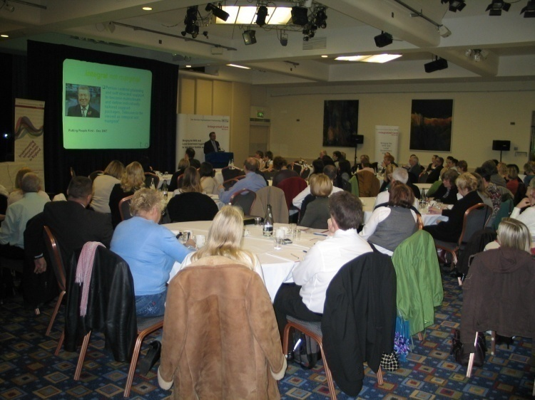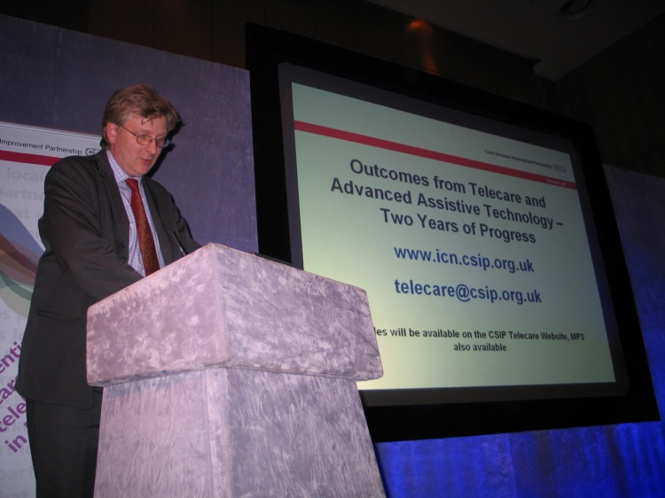

Birmingham Telecare event CSIP’s Jeremy Porteus at the Manchester event

The events covered a wide range of telecare progress, outcomes and achievements with over 50 presentations from 30 speakers. CSIP would like to thank all of the speakers, contributors and delegates for their interest and involvement.

Out of 84 feedback forms, 79 people found the event ‘useful’ or ‘particularly useful’. CSIP would like to thank people for this important feedback and will be covering some of the suggestions and constructive comments further.

Because it was important to provide venues around the country to enable as many people to contribute, we did not include workshops. The events were structured slightly differently but we thought it important to cover as many examples from around the country through the morning sessions as we could to further build up the evidence and recognise the important work that people had done. We also provided generous refreshment breaks so that people had the opportunity to network with colleagues.

Some people asked about delegate lists. It is very difficult to prepare full delegate lists in advance. If there is a particular area of interest that you wish to follow up, then send an e-mail to Mike Clark at telecare@csip.org.uk.

Slides for all of the presentations are available at www.icn.csip.org.uk/telecareoutcomes. This web page will continue to build up examples of local outcomes and links to evaluations.

Also, the CSCI performance assessment for social care authorities due shortly will include questions on outcomes, mainstreaming and sustainability alongside the additional users benefiting from telecare. This means that by Summer 2008, we will have outcome information from every social care authority based on 2-3 years of progress. You may wish to bookmark this CSIP web page to check for additional information and links as it is added.
2 Telecare services and personalisation

Telecare LIN

April 2008 sees the commencement across social care authorities of programmes to transform social care. This follows the Concordat (Putting People First) in December 2008 and the local authority circular (LAC (2008)1) in January 2008.

LAC (2008)1 – references to telecare
11…….Supported by the DH’s efficiency programme, councils have increasing shown how developing homecare re-ablement services can support independent living and deliver value for money. Assistive technology such as telecare and minor adaptations, like fitting a handrail, can also enable people with support needs to continue to live in their own homes……

17 ……To do this will require a common assessment of individual social care needs, emphasising the importance of self-assessment. The role of social workers will be focused on advocacy and brokerage, rather than assessment and gate keeping. This move is from the model of care, where an individual receives the care determined by a professional, to one that has person centred planning at its heart, with the individual firmly at the centre in identifying what is personally important to deliver his or her outcomes. With self-directed support, people are able to design the support or care arrangements that best suit their specific needs. It puts people in the centre of the planning process, and recognises that they are best placed to understand their own needs and how to meet them. They will be able to control or direct the flexible use of resources (where they wish to), building on the support of technology (eg telecare), family, friends and the wider community to enable them to enjoy their position as citizens within their communities……

10 …..Person centred planning and self-directed support to become mainstream, with individuals having choice and control over how best to meet their needs, including through routine access to telecare…..

See also:

19. In the future, all individuals eligible for publicly-funded adult social care will have a personal budget (other than in circumstances where people require emergency access to provision); a clear, upfront allocation of funding to enable them to make informed choices about how best to meet their needs, including their broader health and well-being. Having an understanding of what is available will enable people to use resources flexibly and innovatively, no longer simply choosing from an existing menu, but shaping their own menu of support. A person will be able to take all or part of their personal budget as a direct payment, to pay for their own support either by employing individuals themselves or for purchasing support through an agency. Others may wish, once they have decided on their preferred care package, to have the council continue to pay for this directly. The approach, which may be a combination of both, will depend on what works best for them. The term personal budget will describe this transparent allocation of resources.

Link: http://www.dh.gov.uk/en/Publicationsandstatistics/Lettersandcirculars/LocalAuthorityCirculars/DH_081934

This will have a significant impact on how telecare and telehealth is commissioned and provided in future. In the January 2008 issue we looked at the importance of ensuring that money actually moves into personal budgets to support existing and future telecare services.

Personal budgets only apply to social care at this time and not to health and differ from individualised budgets. Personal budgets only cover the adult social care element whereas the individualised budget pilots have looked at additional funding streams outside of adult social care.

Commissioners will need to consider the needs of the whole population (Joint Strategic Needs Assessment) and review local priority areas (Local Area Agreements). This means that commissioners will not only look at the current local service arrangements for telecare, they will be looking at:

- National and regional service options – this may differ for ECG monitoring compared to home sensor monitoring and responses
- Service standards and costs – what standards are expected from a range of services and how much do they cost? Is there any external auditing of standards, costs, performance activity?
- Retail providers and links with wider community equipment/assistive technology – what is happening in the high street or available over the internet that will meet user needs? is a telecare option needed when there are simpler devices available? Is telecare part of a wider home adaptation process?
- Enhanced packages for domiciliary care providers – these providers will be visiting homes on a regular basis, will be CSCI registered, will provide 2nd/3rd responder services, may have electronic care plan monitoring and could offer telecare/telehealth service enhancements using integrated support
- Support for self care, self management and self purchase – users and carers will be buying their own equipment and services with their own savings or money provided through statutory services – where can they go for independent advice? Where they can see equipment?
- Brokerage services – how will independent brokerage services be commissioned to support people with their purchasing decisions? How will people get information to help them?
- Impact on existing services and contracts - What impact will it have on existing block contracts for telecare/domiciliary care? How will health professionals respond to people taking their own blood pressure and vital signs measurements?

Services Providers will need to look at:

- Service standards – how does your performance compare with other services operating in the same area? Are services independently audited?
- Service costs – how much does it cost? Will users/carers be able to pay the actual costs from their personal budgets which could be much higher than their current charges – if it actually costs £15 per person per week to provide a monitoring and response service what happens when the user takes this money elsewhere to pay for another service?
- Service options – what equipment/service configurations are available?
- Partnerships – who will you partner with to provide enhanced services eg domiciliary care, long term condition monitoring etc

Service brokers and independent advisors will need to look at:

- Gathering independent information to support user/carer choice
- Making information accessible with opportunities for viewing, testing, trialling equipment and services
- Innovation and improvements to meet user/carer needs
- Optimising care plans for users/carers within their personal budget
- Income streams to support independent guidance

To assist with the programme to transform social care services and support personalisation, we are taking the first step to bring together basic information about the wide range of telecare service providers now available.

At this time it will include mainly housing and social care service providers within local authorities, third sector and independent/commercial sector organisations. Service offerings will continue to vary from one organisation to the next – it could be a simple pendant alarm through to a range of home sensors to the future possibilities of telehealth and integrated systems. There are various types of eligibility criteria in place and some care pathways are supported in different ways. This makes it difficult to build up comparative data but enables services to be individually customised.

As we gather further information, it will include retail and other options and link to sites that provide costs and more detailed information eg www.atdementia.org.uk

The web page for service details is www.icn.csip.org.uk/telecareservices . If you have a service link at this time, please let Mike Clark know via the mailbox – telecare@csip.org.uk.

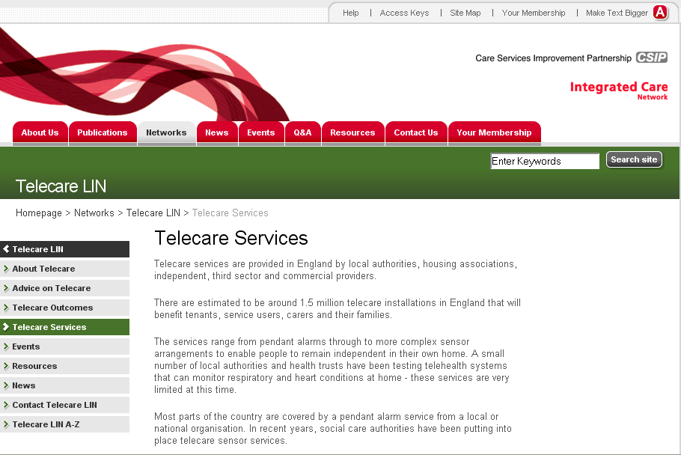

Notes:
Each social care authority has a telecare profile at www.icn.csip.org.uk/telecareprofiles which provides independent information from CSCI and other sources.

CSIP is not responsible for the content of external links and does not follow up complaints about service providers so it is important that details are confirmed with the organisation concerned.

The Department of Health has confirmed funding of £80m over two years (2008-2010) for the Extra Care Housing Fund. It follows Putting People First and the recent Local Authority Circular that set out the capital and revenue arrangements to transform the delivery of social care in England.
3 Extra Care Housing Fund 2008-2010 Announcement

Telecare LIN

The money will allow local authorities and their partners to build on previous innovation in providing greater housing with care choices for older people and/or other people with long-term conditions. Since the first grant arrangements were allocated in 2004, the Department of Health has now made £227m available to local authorities and their partners, through a bidding process.
The new developments should promote independence, well-being and good health and enable residents to remain in their own homes - where necessary with the support of appropriate care services. Ministers also expect that using the Fund will stimulate the wider development of a range of housing with care services within the boundaries of each successful local authority as part of a Local Area Agreement (LAA).
References are made to telecare.
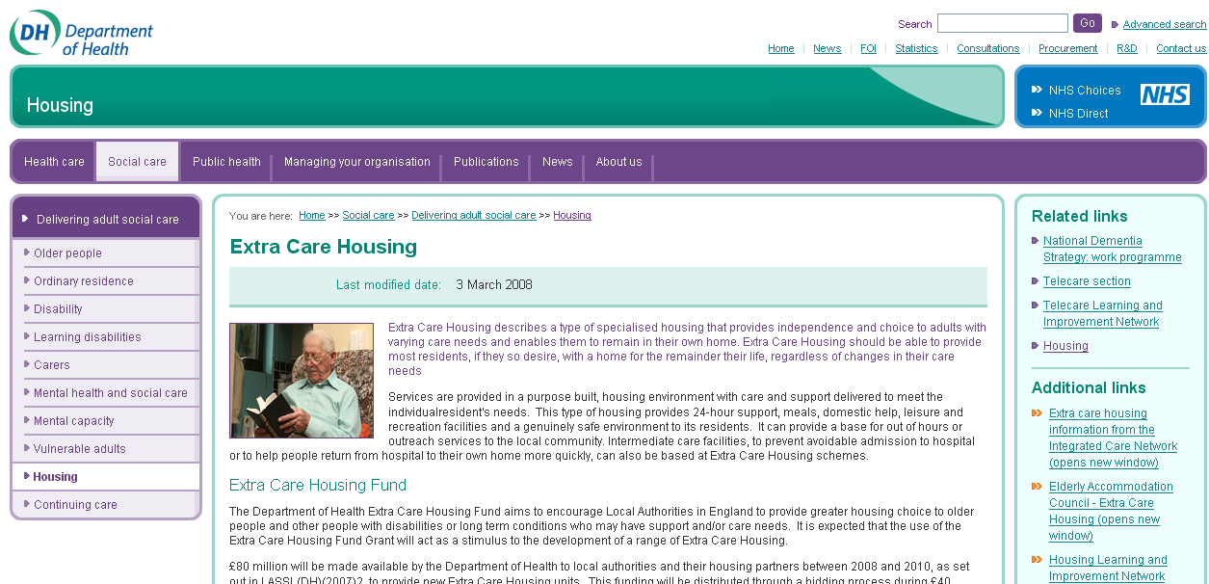
Department of Health site with full details:
http://www.dh.gov.uk/en/SocialCare/Deliveringadultsocialcare/Housing/DH_083199
http://www.dh.gov.uk/en/SocialCare/Socialcarereform/Userledorganisations/DH_083152
Additional CSIP information on the bidding process and other useful background information:
http://www.icn.csip.org.uk/housing/index.cfm?pid=761

Allied Health Professional (AHP) Bulletin, Issue 63, March 2008
4 News from Government Departments relevant to telecare

Telecare LIN

http://www.dh.gov.uk/en/Publicationsandstatistics/Bulletins/Alliedhealthprofessionalsbulletin/Browsable/DH_083428

- New web site section on national dementia strategy

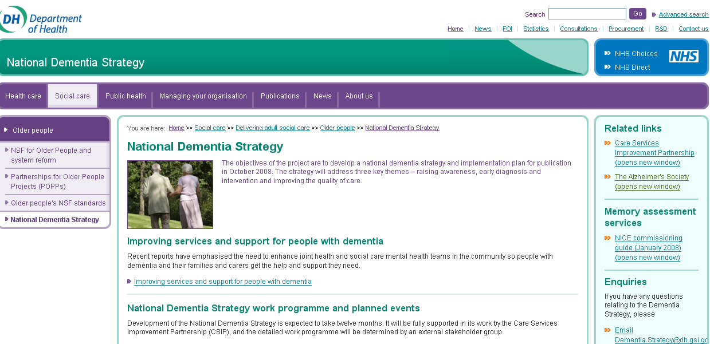

http://www.dh.gov.uk/en/SocialCare/Deliveringadultsocialcare/Olderpeople/NationalDementiaStrategy/index.htm

- DH Guide – service areas covered by Department of Health

http://www.dh.gov.uk/en/Aboutus/HowDHworks/DH_083465

- Action and Learning Sites (Improving the Life Chances of Disabled People)
Improving the Life Chances of Disabled People report recommended that by 2010, each local authority area should have a user-led organisation modelled on existing Centres for Independent Living. User-led organisations are organisations led and controlled by disabled people.
http://www.dh.gov.uk/en/SocialCare/Socialcarereform/Userledorganisations/DH_083152

- The Coronary Heart Disease National Service Framework: Building for the future - progress report for 2007

http://www.dh.gov.uk/en/Publicationsandstatistics/Publications/PublicationsPolicyAndGuidance/DH_083060

- National Stroke Strategy easy access version

http://www.dh.gov.uk/en/Publicationsandstatistics/Publications/PublicationsPolicyAndGuidance/DH_083506

- Information resources for patients with diabetes and other long term conditions.

http://www.dh.gov.uk/en/Publicationsandstatistics/Publications/DH_074283

- Raising the profile of long term conditions care: A compendium of information

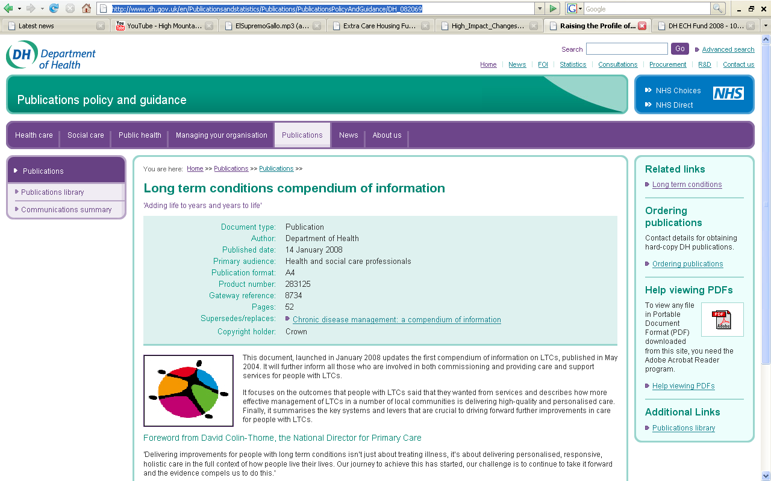

http://www.dh.gov.uk/en/Publicationsandstatistics/Publications/PublicationsPolicyAndGuidance/DH_082069

- Research evidence on the effectiveness of self care support

http://www.dh.gov.uk/en/Publicationsandstatistics/Publications/PublicationsPolicyAndGuidance/DH_080689

- Lifetime Homes, Lifetime Neighbourhoods; A National Strategy for Housing in an Ageing Society

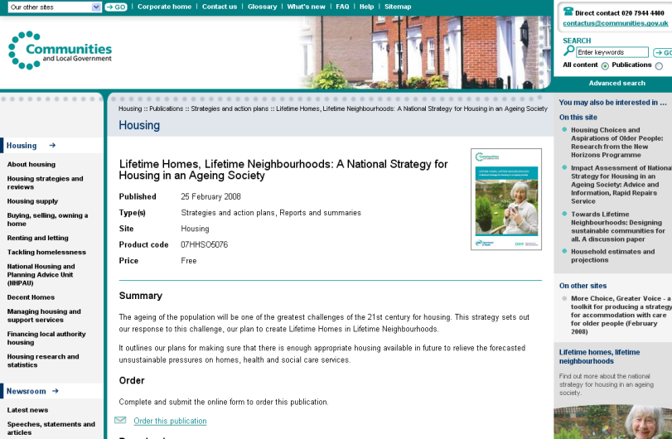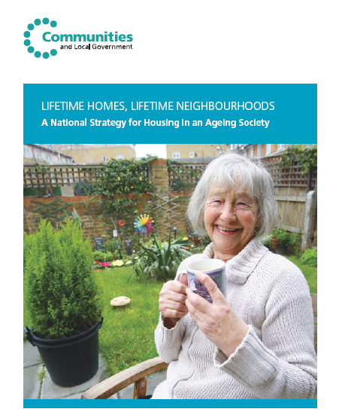

http://www.communities.gov.uk/publications/housing/lifetimehomesneighbourhoods

5 New CSIP Publications

Telecare LIN

See also announcements for extra care fund
a) High Impact Changes for Health and Social Care (March 2008)
A new CSIP publication has been launched today featuring an inspirational collection of organisational initiatives which are changing health and social care services and the lives of people who use them.
These initiatives are organised around the seven positive outcomes for people using health and social care services identified in the Government Green Paper Independence wellbeing and choice and the White Paper Our health our care our say. These were identified following a major consultation exercise informed by the expressed views of service users and carers across the country.They have been further reinforced by Putting people first (2007) and the 2008 Local Government Circular Transforming Social Care.
  http://www.icn.csip.org.uk/index.cfm?pid=486&catalogueContentID=2907 | The seven outcomes are:  - improved health and emotional wellbeing  - improved quality of life  - making a positive contribution  - choice and control  - freedom from discrimination  - economic wellbeing, and  - personal dignity

b) Housing LIN – Housing with Care Matters (March 2008)

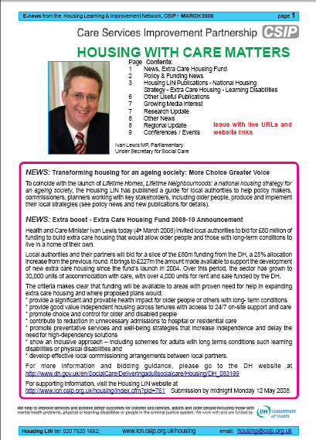

http://www.icn.csip.org.uk/_library/Resources/Housing/Support_materials/Newsletter/Newsletter27.pdf
c) Medication in Extra Care Housing
This factsheet was prepared for the Housing LIN by Opus Pharmacy Services. For the first time, it takes
a detailed look at the management of medication on schemes, staffing issues and self-care. The
factsheet is aimed at practitioners, commissioners, care service managers and housing managers in
extra care housing, an environment not specifically referred to in any guidance on the handling of
medicines. It covers areas such as safe storage, administration of medicines, monitoring and record
keeping and staff training.

http://www.icn.csip.org.uk/housing/index.cfm?pid=521&catalogueContentID=2544

d) Social Well-Being in Extra Care Housing
This factsheet explores social well-being and how it can be promoted in extra care housing, whether for
rent, shared ownership or for sale. It is aimed at those involved in commissioning, planning,
designing, providing and managing extra care housing. It has been developed alongside a directory
of social well-being, which can be seen at

http://www.icn.csip.org.uk/housing/index.cfm?pid=521&catalogueContentID=2780
6 Recent web links

Telecare LIN

Mike Clark provides an update on telecare/telehealth and related links form recent weeks.

CSIP is not responsible for the content of external links.

Tameside Carers Newsletter – reference to telecare:
http://www.tameside.gov.uk/carers/newsletters/feb08#3

ChesterCare launch new Choice Service:
http://www.individual.com/story.php?story=79188918
http://www.midlands-housing.co.uk/nnews/chestercare-launches-new-choice-service-1763-1.html

North Wales Telecare Project:
http://ssia.wlga.gov.uk/index.cfm?articleid=2911

Coventry Telecare:
http://www.coventry.gov.uk/ccm/content/social-services-%26-housing-directorate/older-peoples-services/telecare-pilot-project.en

TelehealthWorld – The Magazine of Telehealth, Telemedicine and Connected Healthcare
http://www.telehealthworld.com/

EU cash to turn baby boomers into silver surfers - the European Parliament voted to devote 150 million euros ($234 million) from the EU's budget over the next five years to a new research program known as ambient-assisted living.
http://www.reuters.com/article/internetNews/idUSL1390595120080313

Nottingham City PCT Launches Mainstream Telehealth Deployment
http://www.24dash.com/news/Local_Government/2008-03-13-Nottingham-City-PCT-Launches-Mainstream-Telehealth-Deployment
http://www.computerweekly.com/Articles/2008/03/14/229857/nottingham-primary-care-trust-rolls-out-telecare-system-to-reduce-hospital.htm
http://www.wirelesshealthcare.co.uk/wh/news/wk12-08-0006.htm

Patients get home health machines
http://news.bbc.co.uk/1/hi/england/nottinghamshire/7285032.stm

Hampshire Telecare

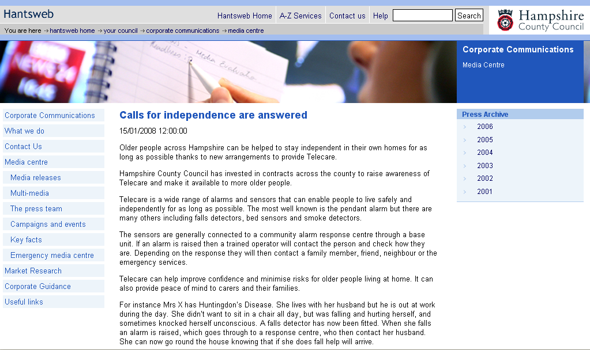
http://www3.hants.gov.uk/communications/mediacentre/mediareleases.htm?newsid=203844

Diabetes telemedicine system tested – Bournemouth Hospital
http://www.hospitalhealthcare.com/default.asp?title=Diabetestelemedicinesystemtested&page=article.display&article.id=9301

Cardiac telemedicine service proven to prevent hospital admissions in year-long study
http://www.publictechnology.net/modules.php?op=modload&name=News&file=article&sid=14514

Mobile working in social care ? transforming service delivery in the London Boroughs of Barking & Dagenham and Havering
http://www.publictechnology.net/modules.php?op=modload&name=News&file=article&sid=14509

Videoconferencing helps lead way to better rural services says Defra
http://www.publictechnology.net/modules.php?op=modload&name=News&file=article&sid=14482

More technology to assist care
http://www.eurekamagazine.co.uk/article/13384/More-technology-to-assist-care.aspx

SENIOR project initiates ethical debate on ICT for the elderly
http://cordis.europa.eu/fetch?CALLER=EN_NEWS&ACTION=D&SESSION=&RCN=29203
http://www.seniorproject.eu/public/

Telecare is Key to Supporting the Provision of Personalised Care, Choice and Control
http://www.itbinnovation.com/pr/19033

Journal of Telemedicine and Telecare – January/March 2008 – recent references
http://www.ingentaconnect.com/content/rsm/jtt -

An evaluation of second and third generation telecare services in older people's housing
Journal of Telemedicine and Telecare, Vol. 14, No. 1. (January 2008), pp. 8-12.
by Brownsell, Simon, Blackburn, Steven, Hawley, S Mark

Automated telephone reminder messages can assist electronic diabetes care
Journal of Telemedicine and Telecare, Vol. 14, No. 1. (January 2008), pp. 32-36.
by Mollon, Brent, Holbrook, M Anne, Keshavjee, Karim, Troyan, Sue, Gaebel, Kathryn, Thabane, Lehana, Perera, Gihan

Mental health profile of callers to a telephone counselling service
Journal of Telemedicine and Telecare, Vol. 14, No. 1. (January 2008), pp. 42-47.
by Burgess, Nicole, Christensen, Helen, Leach, S Liana, Farrer, Louise, Griffiths, M Kathleen

Home-based telehealth: a review and meta-analysis
pp. 62-66(5)
Authors: DelliFraine, Jami L.; Dansky, Kathryn H.

Human factors in the development and implementation of telerehabilitation systems
pp. 55-58(4)
Authors: Brennan, David M.; Barker, Linsey M.

An Internet-based videoconferencing system for supporting frail elderly people and their carers
pp. 79-82(4)
Authors: Savolainen, Liina; Hanson, Elizabeth; Magnusson, Lennart; Gustavsson, Tomas

Video: Free technology to help the elderly - Essex
http://www.harlowherald.co.uk/content/hlwherald/news/story.aspx?brand=EHHOnline&category=NewsHarlow&tBrand=herts24&tCategory=newshlhnew&itemid=WEED11%20Mar%202008%2014%3A51%3A35%3A440

TV keeps eye on OAP safety – Dewentside
http://www.chroniclelive.co.uk/north-east-news/todays-evening-chronicle/2008/03/08/tv-keeps-eye-on-oap-safety-72703-20582797/

Spirometry ruled out for blanket COPD screening in USA
http://www.healthcarerepublic.com/news/GP/788378/Spirometry-ruled-blanket-COPD-screening/
http://www.annals.org/cgi/content/full/0000605-200804010-00212v1

Birmingham men at greater risk of diabetes
http://www.onmedica.com/NewsArticle.aspx?id=71ee9be0-1f64-4081-8666-24eac2f38c2a

New diabetes tsar appointed
http://www.onmedica.com/NewsArticle.aspx?id=e5652919-b4c6-4952-8499-0792d3e1cdf5

Diabetes care poor in many areas
http://www.onmedica.com/NewsArticle.aspx?id=5a1639bf-464d-4f7c-8e3b-17a405cc0078

Humana issue pedometers in Stoke
http://www.ehiprimarycare.com/news/humana_issue_pedometers_in_stoke

Scottish NHS to receive £201m including some e-health
http://www.e-health-insider.com/news/3550/scottish_nhs_to_receive_%C2%A3201m_for_e-health_projects

EHTEL offers guidance on telemedicine strategies
http://www.ehealtheurope.net/news/3539/ehtel_offers_guidance_on_telemedicine_strategies

Funds for public to buy own care
http://www.guardian.co.uk/society/2008/mar/06/health.publicservices

Govt announces £80m for older people's care at home – extra care
http://www.inthenews.co.uk/news/health/govt-announces-80m-older-peoples-care-at-home-$1209428.htm
http://www.24dash.com/news/Housing/2008-03-04-Local-authorities-invited-to-bid-for-share-of-80m-extra-care-housing-funding

Google/Micrsoft and health records
http://www.technewsworld.com/story/61968.html?welcome=1205606027
http://washington.bizjournals.com/washington/stories/2008/03/10/story2.html?b=1205121600%5E1601826

Myhome247 devices
http://www.myhome247.co.uk/myhome247_kits.html

Diabetes monitoring in Bournemouth
http://www.broadband-finder.co.uk/news/broadband/internet-diabetes-monitoring_18507957.html

Cardiocom patient monitoring
http://www.newswiretoday.com/news/31283/

Toumaz remote monitoring
http://www.newelectronics.co.uk/article/13396/Getting-plastered.aspx

Charterhouse/Tunstall
http://www.newswiretoday.com/news/31283/
http://www.tunstall.co.uk/news.aspx?PageID=14&NewsID=115

Sunderland bucks the eligibility trend
http://www.communitycare.co.uk/Articles/2008/03/05/107491/sunderland-bucks-the-eligibility-trend.html

Telepresence
http://www.telepresenceoptions.com/2008/03/the_problem_with_the_teleprese/

Stockton extra care with telecare
http://www.northumberlandgazette.co.uk/latest-north-east-news/Tenants-move-in-to-apartment.3836584.jp

Sensor beds that check heart health
http://news.bbc.co.uk/1/hi/health/7259098.stm
http://worldbignews.com/science/soon-sensor-beds-that-check-heart-health.html

Remote diabetes monitoring
http://www.streetinsider.com/Press+Releases/XTend+Medical+(XMDC)+Begins+Remote+Diabetic+Telehealth+Program/3359367.html
http://www.wirelesshealthcare.co.uk/wh/news/wk12-08-0001.htm
Telemedicine in Tasmania
http://www.media.tas.gov.au/release.php?id=23309
A modular microscope attachment for cell phones could improve the quality of telemedicine.
http://www.technologyreview.com/Infotech/20433/?a=f

European Commission releases TeleHealth2007 conference report
http://www.hospitalhealthcare.com/default.asp?title=EuropeanCommissionreleasesTeleHealth2007conferencereport&page=article.display&article.id=9371
http://www.healthtechwire.com/Pressrelease.146+M5ed7299155b.0.html

Schools and colleges in USA offering telemedicine initiatives
http://iptv.tmcnet.com/topics/iptv-programming-news/articles/23274-23-schools-us-offer-telemedicine-initiatives.htm

Bell Canada healthcare initiative
http://www.canhealth.com/News776.html

Vodafone mobile based telemedicine
http://www.wirelesshealthcare.co.uk/wh/news/wk10-08-0002a.htm

Greater Manchester extends telemedicine pilot
http://www.ehiprimarycare.com/news/3532/greater_manchester_extends_telemedicine_pilot

Interreg IIIC Telemedicine Project Concluded
http://www.leonardo-energy.org/drupal/node/2680
t+ provides LifeScan patients remote access to data
http://www.ehiprimarycare.com/news/3494/t+_provides_lifescan_patients_remote_access_to_data

Wales increases telemedicine spend
http://www.e-health-insider.com/news/3486/wales_to_up_investment_in_telemedicine

e health at CEBIT
http://www.wirelesshealthcare.co.uk/wh/news/wk10-08-0008a.htm

Alarm 'bell' calls to aid pensioners – Worcestershire
http://www.birminghammail.net/news/top-stories/2008/02/27/alarm-bell-calls-to-aid-pensioners-97319-20529586/

Securing Good Care for Older People: Taking a Long-term View – Oxford Institute of Ageing
http://www.ageing.ox.ac.uk/ageinghorizonsnew/ltc/davies_ltc.pdf

Lifetime Homes, Lifetime Neighbourhoods: A National Strategy for Housing in an Ageing Society – DCLG
http://www.communities.gov.uk/documents/housing/pdf/lifetimehomes

Podcast on chronic heart failure
http://www.cochrane.org/podcasts/review_summaries/mp3/Hawthorn.mp3

Age Concern – The Age Agenda 2008
http://www.ageconcern.org.uk/AgeConcern/Documents/Age_Agenda_2008.pdf

Ivan Lewis announces £27m extra for Social Enterprise
http://www.gnn.gov.uk/environment/fullDetail.asp?ReleaseID=355787&NewsAreaID=2&NavigatedFromDepartment=True
RTX Telehealth monitor
http://www.wirelesshealthcare.co.uk/wh/news/wk08-08-0001.htm

Senior Care Centre Will Use Real Time Tracking
http://www.wirelesshealthcare.co.uk/wh/news/wk08-08-0006.htm

Philips Heartcycle
http://www.wirelesshealthcare.co.uk/wh/news/wk10-08-0003.htm

Nintendo and healthcare
http://www.wirelesshealthcare.co.uk/wh/news/wk10-08-0004.htm

WaveSense blood glucose monitoring
http://www.wirelesshealthcare.co.uk/wh/news/wk10-08-0006.htm

PDAs may keep elderly people active
http://www.wirelesshealthcare.co.uk/wh/news/wk06-08-0004.htm

More elderly Americans suffering from diabetes
http://www.wirelesshealthcare.co.uk/wh/news/wk05-08-0004.htm

Switching on to Telehealth: Revolutionising Care for People With COPD
http://www.publictechnology.net/modules.php?op=modload&name=News&file=article&sid=13880&mode=thread&order=0&thold=0

Telehealth in Northern Ireland
http://www.belfasttelegraph.co.uk/health/article3390276.ece

Transcript from telecare item on BBC ‘You and Yours’
http://www.bbc.co.uk/radio4/youandyours/transcripts_2008_05_wed_02.shtml

Woman escapes after microwave ignites
http://www.dailypost.co.uk/news/breaking-news/2008/02/11/woman-escapes-after-microwave-ignites-55578-20462802/

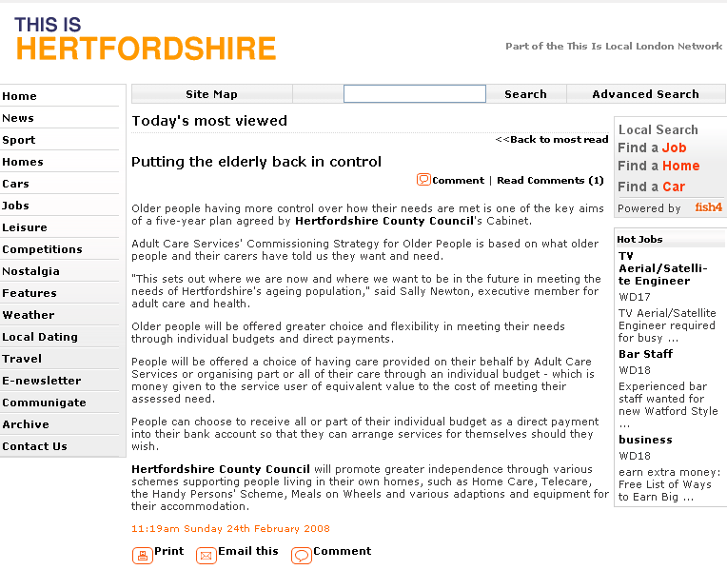
http://www.thisishertfordshire.co.uk/mostpopular.var.2065944.mostviewed.putting_the_elderly_back_in_control.php

Discarded cigarette caused house fire
http://www.dailypost.co.uk/news/north-wales-news/2008/01/21/discarded-cigarette-caused-house-fire-55578-20373128/

Diabetes UK Scotland launched
http://www.diabetesdaily.com/forum/news-interesting-links/11289-diabetes-uk-careline-scotland-launched

Cheshire and telecare progress
http://www.publictechnology.net/modules.php?op=modload&name=News&file=article&sid=14373

Use of Blackberrys for healthcare report in Canada
http://dailygleaner.canadaeast.com/rss/article/173301

Dementia is a living death for 700,000 Britons. That figure is rising sharply. Can we cope?
http://www.guardian.co.uk/society/2008/feb/17/mentalhealth.health

Project Lifesaver
http://www.baldwincountynow.com/articles/2008/02/01/local_news/doc479f906e32bee949270568.txt
http://www.firerescue1.com/rescue/articles/348377/

Technology in nursing homes
http://www.eagletimes.com/main.asp?SectionID=1&SubSectionID=4&ArticleID=6184&TM=578.225

Frisco firm creating system to find wandering Alzheimer's patients
http://www.dallasnews.com/sharedcontent/dws/bus/stories/DN-EmFinders_30bus.ART.State.Edition1.38aaeda.html

CSCI Report
http://www.csci.org.uk/about_us/news/state_of_social_care_2007_ne-1.aspx
http://news.bbc.co.uk/1/hi/health/7214709.stm

Dementia services in England
http://www.medicalnewstoday.com/articles/95103.php
http://www.onmedica.com/NewsArticle.aspx?id=c4ca013a-7909-43ab-9601-48031ecde5e6
http://commentisfree.guardian.co.uk/yvonne_roberts/2008/01/death_rehearsal.html
http://www.guardian.co.uk/society/2008/jan/24/longtermcare.socialcare
http://news.bbc.co.uk/1/hi/health/7204545.stm

Electronic care monitoring
http://www.communitycare.co.uk/Articles/2008/01/30/107105/councils-use-of-electronic-timesheets-under-fire.html

Keeping Dementia Sufferers In Their Own Homes For As Long As Possible
http://www.medicalnewstoday.com/articles/100812.php

RFID Homecare monitoring
http://www.hospitaliteurope.com/default.asp?title=RFIDsystemforhomecaremonitoringlaunched&page=article.display&article.id=7664

Cornwall smart house
http://www.24dash.com/news/Housing/2008-02-05-New-SMART-house-demonstrates-latest-technology

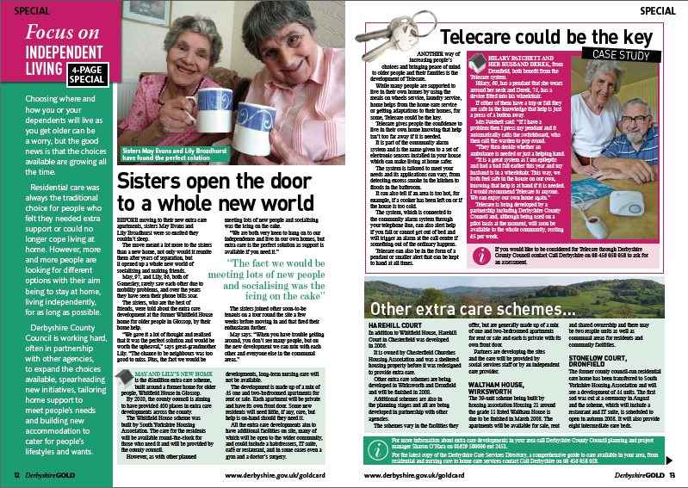

Derbyshire
http://www.derbyshire.gov.uk/Images/12-13_tcm2-211581.pdf

Falls in USA
http://www.intelihealth.com/IH/ihtIH/WSAUS000/333/8896/652368.html

When patients are partners
http://www.guardian.co.uk/society/2008/jan/21/nhspolicy.comment

Nottinghamshire telecare
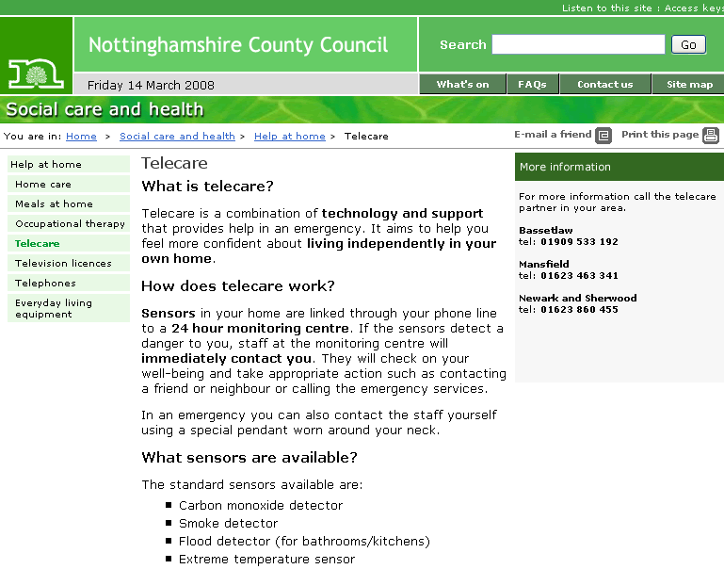

http://chrisbaron.nottinghamshire.gov.uk/home/social_care/helpathome/telecare.htm

Recognition for Plymouth Call Centre
http://www.thisisplymouth.co.uk/displayNode.jsp?nodeId=133717&command=displayContent&sourceNode=133310&contentPK=19723318&folderPk=78032&pNodeId=241848

Pre-natal help by smartphone
http://www.australianit.news.com.au/story/0,24897,23273847-15306,00.html

Tech that keeps an eye on your home
http://tech.yahoo.com/blogs/raskin/17990

California doctors participate in remote monitoring program for diabetics
http://www.healthcareitnews.com/story.cms?id=8638&fromRSS=true

Remote Implantable ECG Monitoring System For Patients In Ohio
http://www.wirelesshealthcare.co.uk/wh/news/wk04-08-0001.htm

4HomeMedia (4HM) Launches Broadband Home Health Service
http://www.4homemedia.com/4homemedia-4hm-launches-broadband-home-health-service

Machine helps monitor patients' health from comfort of home
http://www.missoulian.com/articles/2008/01/03/news/top/news01.txt

Caerphilly Council completes upgrade to 21CN
http://www.ukprwire.com/Detailed/Health_Wellbeing/Caerphilly_County_Borough_Council_Completes_Telecare_Upgrade_to_Guarantee_21CN_Compatibility_15184.shtml
http://www.tunstall.co.uk/news.aspx?PageID=14&NewsID=111

Aerotel Medical Systems Reveals New Innovative Personal Safety Solution at Mobile World Congress
http://www.ehealthnews.eu/content/view/979/26/

Hull Council launches on-demand broadband TV service (to include telecare/telehealth)
http://www.telappliant.com/news/18454731/Council+launches+on-demand+broadband+TV+service/0/
http://www.iptv-watch.co.uk/04022008-innovative-iptv-service-for-elderly-people-in-hull.html
http://www.publictechnology.net/modules.php?op=modload&name=News&file=article&sid=13929&mode=thread&order=0&thold=0

Increase in IT Skills Amongst the Elderly Will Boost Telecare Market
http://www.publictechnology.net/modules.php?op=modload&name=News&file=article&sid=13929&mode=thread&order=0&thold=0

Three Valleys Carelink recognised for quality service
http://www.24dash.com/news/Housing/2008-01-31-Three-Valleys-Carelink-recognised-for-quality-service

Is technology the answer to social care?
http://news.bbc.co.uk/1/hi/health/7213684.stm

Denbighshire's first Joint Health and Social Care Commissioning strategy for Older People's Service
http://www.egovmonitor.com/node/16799

Extra care and older people
http://www.communitycare.co.uk/Articles/2008/01/09/106907/extra-care-and-older-people-jill-manthorpe-reviews-two-pieces-of-research.html

Private GP service provider pilots telehealth
http://www.ehiprimarycare.com/news/3465/private_gp_service_provider_pilots_telehealth

Belfast to get European Centre for Connected Health
http://www.ehiprimarycare.com/news/3418/belfast_to_get_european_centre_for_connected_health

New PDSI Guide from Tunstall
http://www.tunstall.co.uk/assets/literature/Physical%20Disabilities%20Guide.pdf

Tele rehab in Australia
http://www.uq.edu.au/news/?article=13993

Telehealth technology helps senior citizens (Video)
http://new.khastv.com/modules/news/article.php?storyid=12505&storytopic=4

Healthcare IT: driving US presidential campaigns
http://www.cbronline.com/article_feature.asp?guid=C58BD48F-E718-4BC2-BA24-D1277AA65524

Scotland trials HealthPresence advanced telemedicine system
http://www.computerweekly.com/Articles/2008/02/13/229377/scotland-trials-healthpresence-advanced-telemedicine.htm
http://www.silicon.com/publicsector/0,3800010403,39169965,00.htm
http://healthcareitnews.eu/content/view/875/41/
http://thescotsman.scotsman.com/scotland/The-doccom-revolution.3728862.jp

Evidence gap on telehealth needs to be filled
http://www.ehiprimarycare.com/news/evidence_gap_on_telehealth_needs_to_be_filled

Fabric based sensing
http://www.idtechex.com/printedelectronicsworld/articles/fabric_based_sensing_a_challenge_in_physiological_monitoring_devices_00000807.asp

Docobo unveils multi-user telemonitoring system
http://www.bjhcim.co.uk/news/2008/n801022.htm

Surgery pod receives industry support
http://www.hesmagazine.com/story.asp?sectioncode=196&storyCode=2047805

Using Telehealth to Avoid Urgent Care and Hospitalization
http://hhc.sagepub.com/cgi/content/abstract/20/2/154

System helps lung patients – Sheffield
http://www.thestar.co.uk/news/System-helps-lung-patients.3630363.jp

Telemedicine Holds Promise for Health Care
http://www.hcnhealthcare.com/2008/02/28/telemedicine-holds-promise-for-health-care/

Broomwell's Cardiac Telemedicine Service Proven To Prevent Hospital Admissions In Year-Long Study
http://www.medicalnewstoday.com/articles/98924.php

Clothing that tracks vital signs
http://www.wired.com/techbiz/startups/magazine/16-02/ps_smartclothes

Mobile health and EPR feature at CeBIT
http://ehealtheurope.net/news/3520/mobile_health_and_epr_feature_at_cebit

The Effects of TeleWound Management on Use of Service and Financial Outcomes
http://www.mdlinx.com/NurseLinx/xml-article.cfm/2100839

Consumer Medical Devices Market to be Worth $5 billion by 2011, says InMedica
http://industry.tekrati.com/research/10003/
http://news.bbc.co.uk/1/hi/scotland/north_east/7219547.stm

Reimbursement and integration challenges will be solved as telehealth grows in importance
http://www.healthcare-informatics.com/ME2/dirmod.asp?sid=E3EC2A8000454A258DF3AA343FDBDA9E&nm=&type=Publishing&mod=Publications%3A%3AArticle&mid=8F3A7027421841978F18BE895F87F791&tier=4&id=E7705C911060469FBCC9F26CAF3875A5

First Responders Testing Cutting-Edge Technology on Heart Attack Victims
http://www.medicalnewsblog.info/2008/02/12/first-responders-testing-cutting-edge-technology-on-heart-attack-victims.html

Key Aspects of Technology, Products and Service for Helping those with Dementia EHSSB Case Study
http://ecompost.wordpress.com/2008/03/10/key-aspects-of-technology-products-and-service-for-helping-those-with-dementia-ehssb-case-study/

£80 million to keep older people together in a home of their own
http://www.gnn.gov.uk/environment/fullDetail.asp?ReleaseID=357387&NewsAreaID=2

Centre for Connected Health - report
http://www.connected-health.org/about-us/progress-report.aspx

Assistive technology at B&Q
http://www.diy.com/diy/jsp/bq/templates/content_lookup.jsp?content=/content/can_do/search_cando.jsp&noleftnav=true&menu=cando

Emergency care services in Wales
http://icwales.icnetwork.co.uk/news/health-news/2008/02/11/revolutionary-vision-but-will-it-work-91466-20459500/

New Class 1 standard for Telecare Alarms comes into force
http://www.publictechnology.net/modules.php?op=modload&name=News&file=article&sid=13974

The Alzheimer’s Store – USA
http://www.alzstore.com/

Technology to Support the Ageing Global Population 2007 to 2027 (Registration)
http://www.s2satwork.com/download_login.php

Frost & Sullivan Honors Cardiocom with its 2008 Patient Monitoring Product Innovation of the Year Award
http://www.frost.com/prod/servlet/press-release.pag?docid=124068821

CSIP JSNA podcast
http://www.cat.csip.org.uk/index.cfm?pid=507

CSIP Dignity podcast
http://www.changeagentteam.org.uk/index.cfm?pid=218&catalogueContentID=3151

DATAMONITOR: Doctor + iPhone = Better Healthcare
http://australia.tmcnet.com/news/2008/03/14/3327592.htm

New Healthcare Study Outlines Strategies to Increase Adoption of Home Health Monitoring Technologies
http://sev.prnewswire.com/health-care-hospitals/20080318/LATU06318032008-1.html

CSED Newsletter – includes transforming community equipment
http://www.csed.csip.org.uk/silo/files/csed-newsletter-edition-11--feb--march-2008.pdf

For people with Alzheimer’s, a wristband that gets attention
http://www.sanluisobispo.com/news/local/story/306839.html

New Report Identifies the Two Key Factors Driving the Market for Wireless ehealth Platforms
http://www.tmcnet.com/usubmit/2008/03/14/3328299.htm

Wristband with sensor technology
http://www.exmocare.com/bt2/

Plan for the Implementation of Telecare In Bolton 2007-2009
http://democracy.bolton.gov.uk/CMISWebPublic/Binary.ashx?Document=5748

18% of all boomers expected to develop Alzheimer's - USA
http://www.usatoday.com/news/health/2008-03-17-alzheimers-stats_N.htm
http://www.allheadlinenews.com/articles/7010381664
http://www.medicalnewstoday.com/articles/101030.php
http://www.canada.com/topics/bodyandhealth/story.html?id=86a88167-cf93-46c0-abf1-85fa6eff2b22&k=94911

£8m pledge to help elderly at home – telecare in Scotland
http://www.publictechnology.net/modules.php?op=modload&name=News&file=article&sid=14801
http://www.ehiprimarycare.com/news/3572/scotland_devotes_an_extra_%C2%A38m_to_telecare
http://www.buteman.co.uk/latest-scottish-news/8m-pledge-to-help-elderly.3887197.jp
http://ukpress.google.com/article/ALeqM5hzJBHO0Roi77rAT_VCCQLm2JN_rQ
http://news.scotsman.com/health/8m-boost-for-elderly-care.3887975.jp
http://www.dailyrecord.co.uk/news/newsfeed/2008/03/18/8m-for-oap-lifeline-86908-20354709/
http://www.kablenet.com/kd.nsf/Frontpage/AA213CB3E4374B11802574100051CAB5?OpenDocument
http://www.egovmonitor.com/node/17794
http://www.wirelesshealthcare.co.uk/wh/news/wk12-08-0003.htm
http://www.midlothianadvertiser.co.uk/latest-scottish-news/8m-pledge-to-help-elderly.3887197.jp
http://www.hesmagazine.com/story.asp?sectioncode=196&storyCode=2047966
http://www.itpro.co.uk/news/180039/public-sector-roundup-8-million-for-scot-telecare.html
http://www.ehiprimarycare.com/news/3572/%C2%A38m_to_be_spent_on_telehealth_in_scotland
http://www.telecareaware.com/2008/18/03/scotland-extra-%c2%a38m-for-telecare/

Telemedicine – Scotland
http://news.scotsman.com/health/Another-health-board-to-run.3887041.jp

Is the Future of Senior Housing @ Home?
http://futureofseniorhousing.blogspot.com/2008/03/is-future-of-senior-housing-home.html

Helping the elderly remain in their homes – Dane housing
http://www.thisischeshire.co.uk/display.var.2128576.0.helping_the_elderly_remain_in_their_homes.php

Wireless healthcare reports (charge for reports)
http://www.wirelesshealthcare.co.uk/wh/report_telecare_2.htm
http://www.wirelesshealthcare.co.uk/wh/report_consumer.htm

ePractice launches eHealth Procurers Forum
http://ehealtheurope.net/news/3575/epractice_launches_ehealth_procurers_forum

Using the Nintendo Wii for therapy/obesity management
http://www.wirelesshealthcare.co.uk/wh/news/wk12-08-0007.htm
http://www.nintendolife.com/articles/2007/07/11/e3_2007_wii_fitness
http://en.wikipedia.org/wiki/Wii_Sports

Managing blood sugar – glucose meters
http://www.diabeteshealth.com/read/2008/03/09/5445.html

Replacing Paper Based Training With Hi-Tech Help, UK Nursing
http://03530.com/2008/03/20/replacing-paper-based-training-with-hi-tech-help-uk-nursing.html

Smart grid cities – Boulder, Colorado
http://www.xcelenergy.com/XLWEB/CDA/0%2c3080%2c1-1-1_15531_43141_46932-39884-0_0_0-0%2c00.html

AAAI: Asthma Academy Unveils Web Tool for Asthma Care
http://www.medpagetoday.com/MeetingCoverage/AAAAIMeeting/tb/8778

Remote heart monitoring device to help cut health costs
http://www.gulfnews.com/nation/Health/10198397.html

Deloitte’s ‘Connected Care’ Model Promotes Technologically Enabled In-Home Health Care, Projects Future Health Care Savings in the Billions
http://www.deloitte.com/dtt/press_release/0,1014,cid%253D196091,00.html
http://www.bio-medicine.org/medicine-news-1/Deloittes-Connected-Care-Model-Promotes-Technologically-Enabled-In-Home-Health-Care--Projects-Future-Health-Care-Savings-in-the-Billions-14224-1/
http://www.hospitalbuyer.com/industry-market/trends/coordination-of-in-home-treatment-reduces-cost-improves-care-2201/

Online weight management
http://www.wirelesshealthcare.co.uk/wh/news/wk12-08-0008.htm

BT 21CN Broadband services commence in April 2008 (note this is broadband and not the telephone system used for most telecare operations where new roll out dates for England have not yet been announced):
http://www.vnunet.com/computing/news/2212373/21cn-services-rolled-april-3900810
http://www.computing.co.uk/computing/news/2212373/21cn-services-rolled-april-3900810
http://www.btplc.com/21CN/Thetechnologyofthenetwork/Thetechnologyofthenetwork.htm
http://www.switchedonuk.org/

Home monitoring of implantable cardiac devices
http://www.verivox.de/News/ArticleDetails.asp?aid=77394&pm=1
7 Events

Telecare LIN

- CSIP Housing LIN Meetings

South West Region LIN - 2 April 2008, Bristol
West Midlands LIN - 10 April 2008, Dudley
Yorkshire and Humber LIN – 17 April 2008

Full list of Housing LIN events:

http://www.icn.csip.org.uk/housing/index.cfm?pid=167

Latest Housing LIN Newsletter:
http://www.icn.csip.org.uk/_library/Resources/Housing/Support_materials/Newsletter/Newsletter26.pdf

- Community Care Live – London 14 and 15 May 2008

CSIP Network’s Clare Skidmore will be presenting a workshop covering telecare and extra care on 15 May
http://www.communitycarelive08.co.uk/workshops

- The National Sheltered and Supported Housing Congress and Exhibition 2008 – 5/6 June 2008

CSIP Network’s Mike Clark will be presenting on telecare at the conference

http://www.cornwall.ac.uk/cshs/index.php?dlrid=1109

- Managing Long Term Conditions – Harrogate – 1 May 2008

CSIP Network’s Jeremy Porteus will be chairing: Integrating services for long term conditions

http://www.managinglongtermconditions.com/conference/integrating_services.html

The Foundation for Assistive Technology (FAST) provides a full listing of forthcoming telecare events – see http://www.fastuk.org/services/events.php?pg=2. Suppliers also run telecare and telehealth events – check their web sites regularly for dates.

All previous telecare eNewsletters are available at: www.icn.csip.org.uk/telecarenewsletters

CSIP Telecare Services

You can send comments and questions about the CSIP Implementation Guide, factsheets or other resources or contact us via telecare@csip.org.uk. Also, use this mailbox to send in good practice examples.

If you or a colleague would like to receive future copies of the newsletter then all you need to do is register at http://www.icn.csip.org.uk/index.cfm?pid=12

