

CSIP Telecare eNewsletter

February 2008 (1)

Contents
1 CSIP telecare events – Final places and programmes 2
2 New CSIP Telehealth briefing from CSIP’s Dr Simon Brownsell 8
3 Transforming Social Care – Local Authority Circular published 9
4 Events 10

Item 1 provides a summary of the recent London Telecare event

Item 2 introduces a new telehealth briefing from Dr Simon Brownsell

Item 3 references the important recent local authority circular on transforming social care. This will have a major impact on how future services are commissioned and provided.

Item 4 lists current CSIP events.

Appendix 1 – Supplier’s supplement for March 2008

The Care Services Improvement Partnership (CSIP Networks) is responsible for providing general implementation support to organisations building their telecare and telehealth programmes.

If you are an organisation implementing telecare and have an interesting local telecare story for inclusion in a future newsletter then e-mail Mike Clark (newsletter editor, CSIP Networks) at telecare@csip.org.uk

If you or a colleague would like to receive future copies of the newsletter then all you need to do is register at http://www.icn.csip.org.uk/index.cfm?pid=12

Update from Mike Clark, CSIP Networks
1 CSIP telecare events – Final places and programmes

Telecare LIN

The scheduled CSIP events are as follows and booking will shortly reach the maximum numbers for the sites:

Venue | Date | Places Remaining at 27 January 2007
Manchester | 4 February 2008 | 5
Taunton | 7 February 2008 | 12
Birmingham | 12 February 2008 | 1

Link:
http://www.icn.csip.org.uk/index.cfm?pid=476&sectorID=170

115 people attended the first of the Telecare events in London on 24 January 2008 to hear a range of speakers covering their own local outcomes and achievements as well as more information about the national picture and developments in telehealth and the Department of Health Long Term Conditions Whole System Demonstrator Programme. Here is a quick glimpse of the London presentations together with links to the PowerPoint presentations on the CSIP web site.

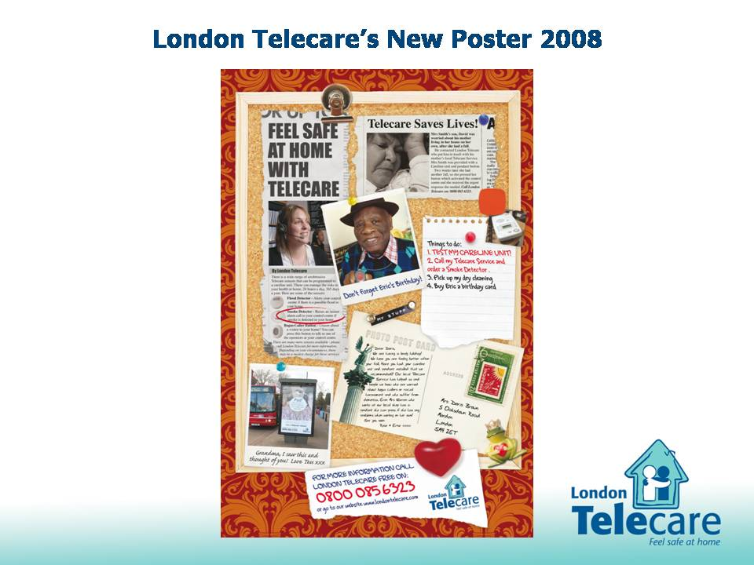

Marketing telecare will be vital to ensuring that people with personal budgets will be able to make appropriate choices. London Telecare (Doug Miles, June Curran, John Chambers) showed how their ideas were being taken forwards at low cost. They also covered their continuing programme to support the capital’s services through regular meetings, workshops and other events as part of a coordinated programme.

Link: http://www.icn.csip.org.uk/_library/Resources/Telecare/Telecare_Outcomes/Telecare_London_-_London_Telecare_-_Doug_Miles_June_Curran_John_Chambers.ppt

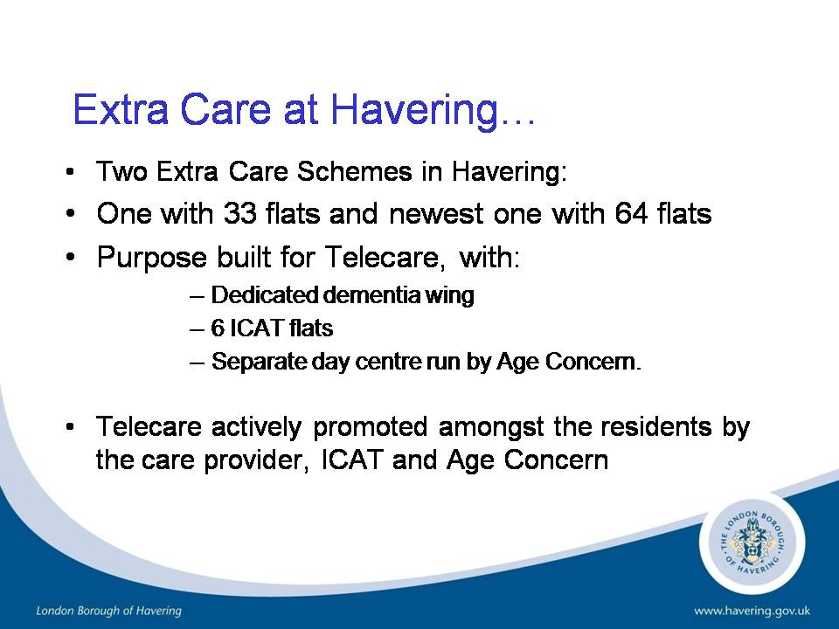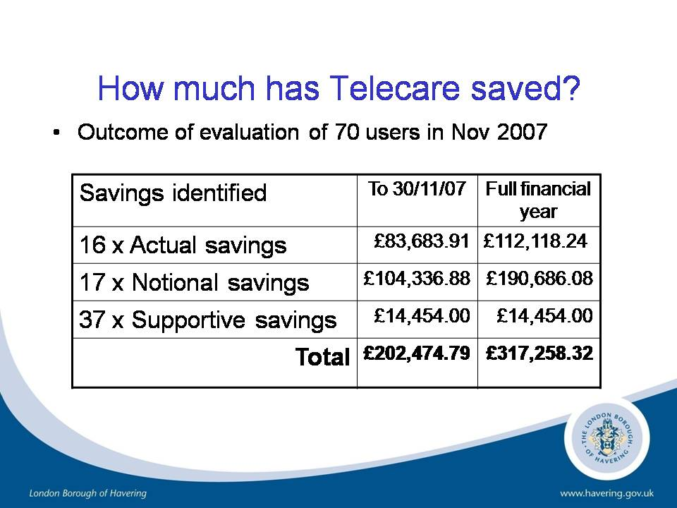

Havering’s Sue Blakeley covered a wide rage of telecare innovation from extra care to working with the Metropolitan Police on bogus callers where recordings can be used as evidence. Sue also explained how Havering were calculating costs and savings for their services.

Link: http://www.icn.csip.org.uk/_library/Resources/Telecare/Telecare_Outcomes/Telecare_London_Havering_-_Sue_Blakeley.ppt

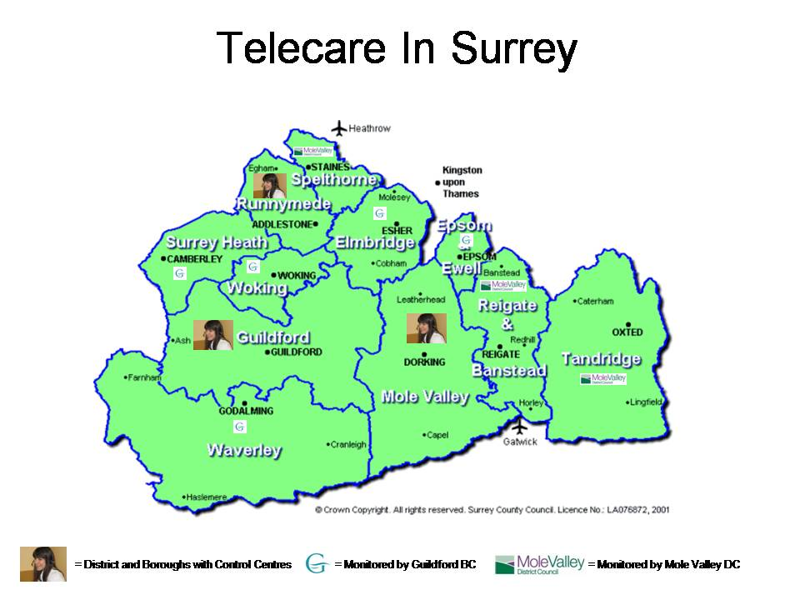

Guildford’s Gerry Allmark reviewed progress across Surrey county with a population of one million. Surrey now has one PCT as well as 11 district councils involved via three control centres. A Partnership Board oversees the programme and links with strategic initiatives such as the Local Area Agreement. Gerry commented on the success of their programmes to support hospital discharges.

Link: http://www.icn.csip.org.uk/_library/Resources/Telecare/Telecare_Outcomes/Telecare_London_-_Guildford_-_Gerry_Allmark.ppt

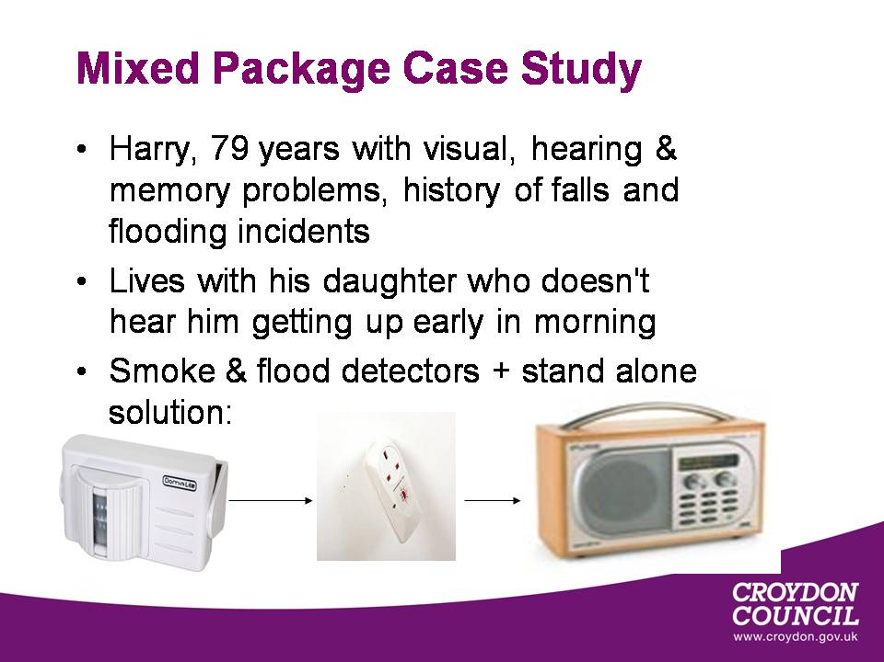

Kathy Grafham along with Barbara Dunk (South London and Maudsley NHS Foundation Trust ) have pioneered Croydon’s telecare support for people with dementia. A wide range of innovative solutions are used. People can also view and purchase their own devices from the local centre which will shortly be supplemented by a bus with telecare equipment which will tour the area to support older people as part of their POPPS programme.

Link: http://www.icn.csip.org.uk/_library/Resources/Telecare/Telecare_Outcomes/Telecare_London_-_Croydon_-_Kathy_Grafham.ppt

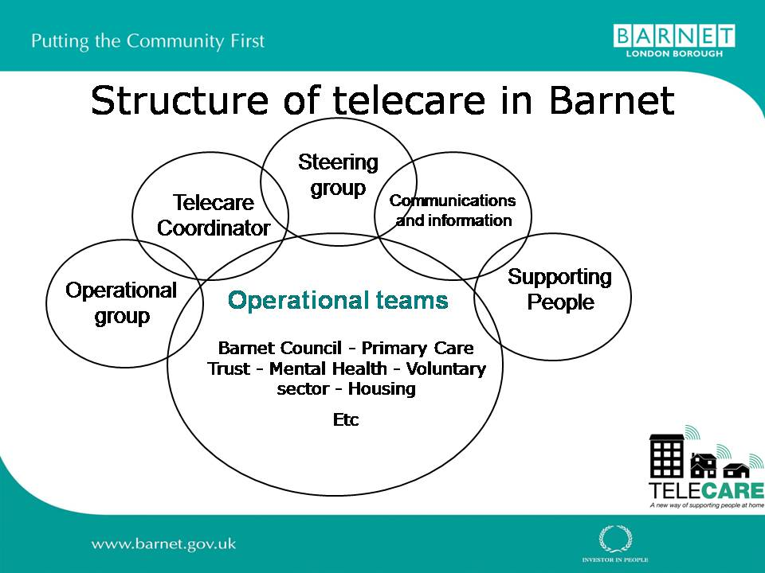

Barnet’s Guy Dewsbury explained how key partners and stakeholders were working steadily to build mainstream services in Barnet. Telecare was becoming embedded within the organisation as part of a care option available to users who would benefit.

Link: http://www.icn.csip.org.uk/_library/Resources/Telecare/Telecare_Outcomes/Telecare_London_-_Barnet_-_Guy_Dewsbury.ppt

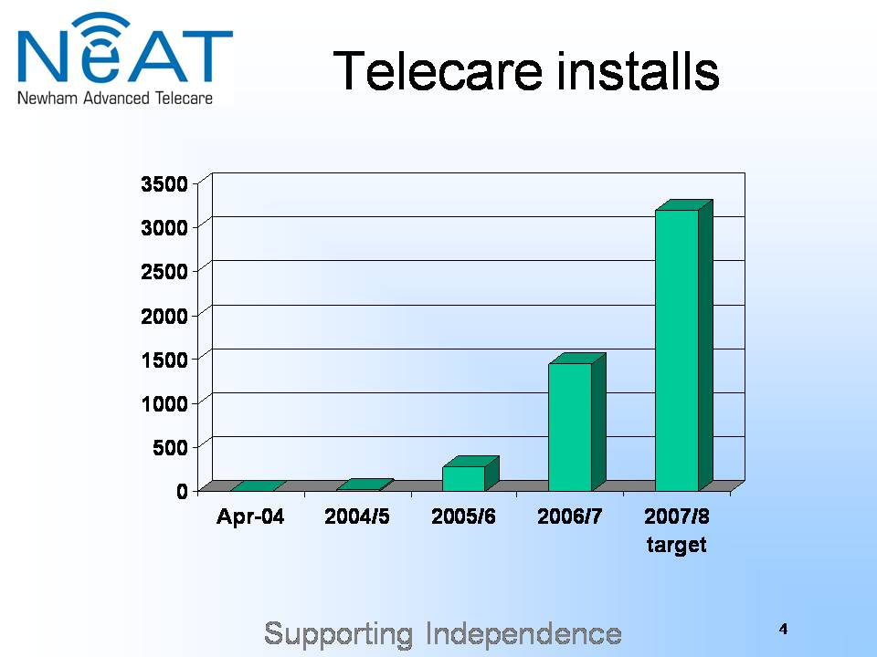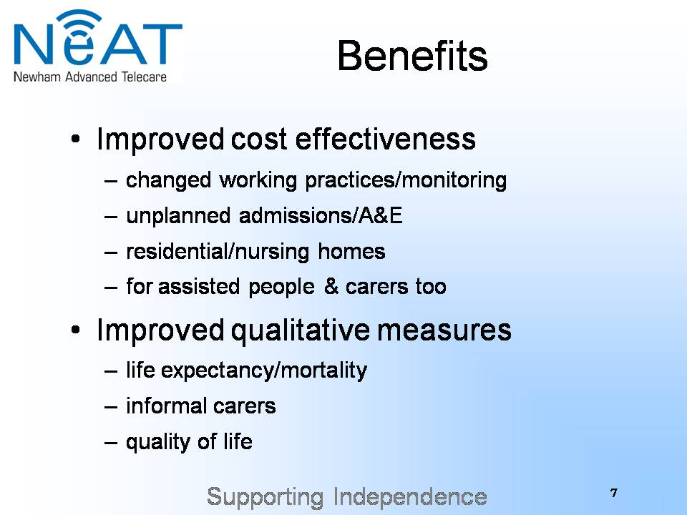

Charles Lowe provided information on the growth of telecare installations in Newham over the last two years. He focused particularly on the support for people with learning disabilities and their families and carers. Potential areas for demonstrating cost-effectiveness and improved quality of service using telecare alone together with other service changes were now being clearly identified. Newham is also one of the three Department of Health’s Long Term Conditions Whole Systems Demonstrators.

Link: http://www.icn.csip.org.uk/_library/Resources/Telecare/Telecare_Outcomes/Telecare_London_-_Newham_-_Charles_Lowe.ppt

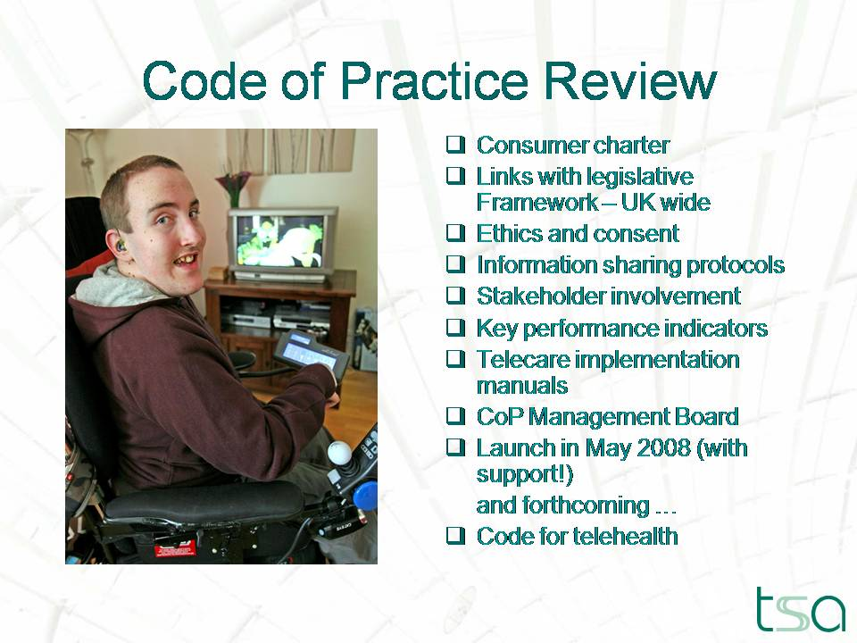

Marian Preece from Telecare Services Association covered the excellent progress being made to develop the existing successful codes of practice following the recent consultation period. Code compliant organisations had increased considerably over the last 2-3 years. The updated codes are likely to be launched in May 2008.

Link: http://www.icn.csip.org.uk/_library/Resources/Telecare/Telecare_Outcomes/Telecare_London_-_TSA_-_Marian_Preece.ppt

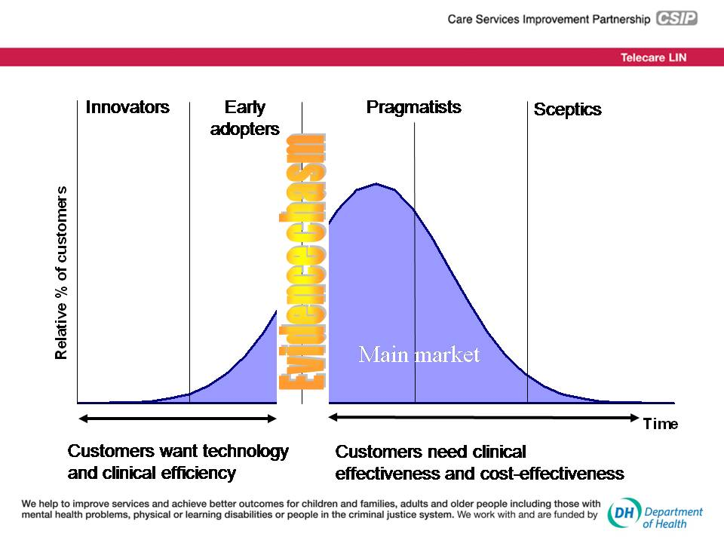

CSIP’s Dr Simon Brownsell reviewed some of the challenges for introducing telehealth. With a recent video clip (not currently available for download), it was possible to see how users and clinical staff could benefit from remote monitoring of long term conditions. Simon also looked at the major challenge we all face in overcoming the evidence chasm (see slide) as we move from the innovation and early adopter phases into telecare and telehealth mainstreaming.

Link: http://www.icn.csip.org.uk/_library/Resources/Telecare/Telecare_Outcomes/Telecare_London_-_CSIP_-_Simon_Brownsell.ppt

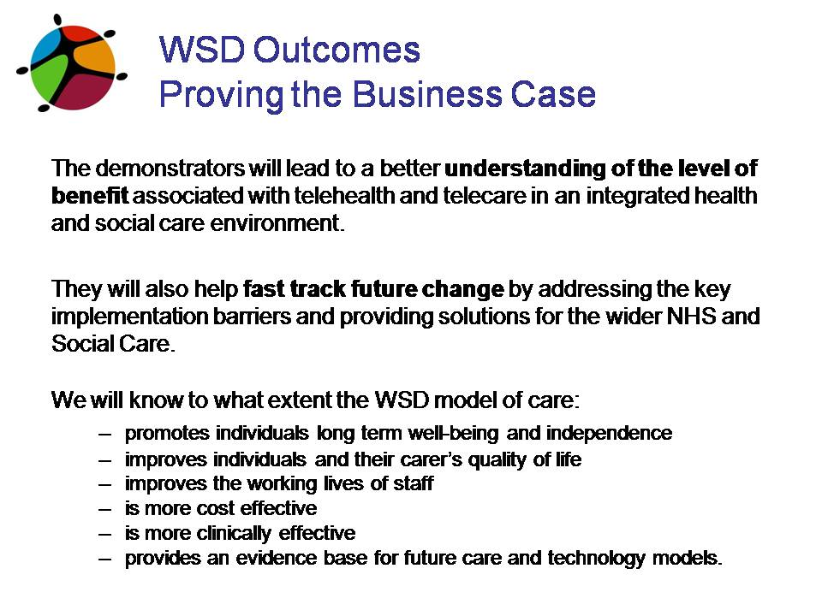

Michael Dillon (NHS Connecting for Health) covered for Tim Ellis and Claire Whittington from the Department of Health’s Long Term Conditions Whole System Demonstrator programme. Michael took the audience through some of the work being carried out to commence the programme in Spring 2008 in Cornwall, Kent and Newham. This included background information about the sites and the proposed evaluation arrangements. Some early lessons were summarised from this preparatory work. Tim Ellis or Claire Whittington will be at the remaining four events.

Link: http://www.icn.csip.org.uk/_library/Resources/Telecare/Telecare_Outcomes/Telecare_London_-_DH_-_Tim_Ellis.ppt

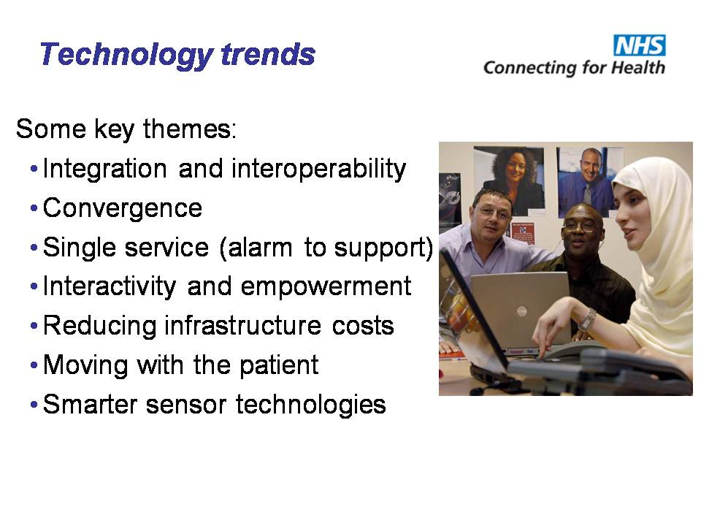

Michael Dillon from NHS Connecting for Health also took the audience through some of the key themes in respect of future technology and the important links to be made with record systems. These would be examined in the Demonstrator sites. Organisations implementing telehealth and advanced AT solutions linking to health and social care records can make contact at michaeldillon@nhs.net

Link: http://www.icn.csip.org.uk/_library/Resources/Telecare/Telecare_Outcomes/Telecare_London_-_NHS_CFH_-_Michael_Dillon.ppt

Programmes and venue information is still available for Manchester, Taunton and Birmingham at:
http://www.icn.csip.org.uk/index.cfm?pid=476&sectorID=170

*****As part of our programme, we are working on a supplier supplement for the March 2008 newsletter – if you are a supplier of telecare/telehealth products and services then see Appendix 1

2 New CSIP Telehealth briefing from CSIP’s Dr Simon Brownsell

Telecare LIN

Dr Simon Brownsell is currently working for CSIP on aspects of telecare and telehealth. In a new CSIP briefing, Simon looks at the growing interest in telehealth in the management of long term conditions and disease management approaches.

If you are trialling telehealth, could you let us know at telecare@csip.org.uk . Also, colleagues at NHS Connecting for Health are keeping track of these developments – they would be very interested in your progress (michaeldillon@nhs.net or george.macginnis@nhs.net).

Here is a summary of the briefing which is now available for download.

A 2006 European Commission report has suggested that ‘the way healthcare is presently delivered has to be deeply reformed… The situation is becoming unsustainable and will only worsen in the future as chronic diseases and the demographic change place additional strains on healthcare systems around Europe.’

They call for a ‘new healthcare delivery model based on preventative and person-centred health systems. This new model can only be achieved through proper use of ICT [Information and Communication Technologies], in combination with appropriate organisational changes and skills.’

Approximately 15m people in this country live with a long term condition and telecare/telehealth are possible approaches to assisting such people. A review of recent academic literature relating to the telehealth aspects of supporting people with long term conditions is presented. This demonstrates that while in some cases there are high levels of reliable evidence conversely other studies have reported mixed findings or that supportive and reliable evidence is not available. As telehealth is an emerging area this is perhaps to be expected but it does suggest that greater efforts are required to develop an evidence base and to share learning between initiatives.

Increasingly service commissioners and providers are trialling telehealth in their local environments. To aid these initiatives attention is given to current lessons of note with particular emphasis on implementation issues and translating a pilot project into a mainstream service. In so doing it is hoped that future initiatives can avoid known obstacles and that we can move more quickly to a shared position of best practice and a robust evidence base.

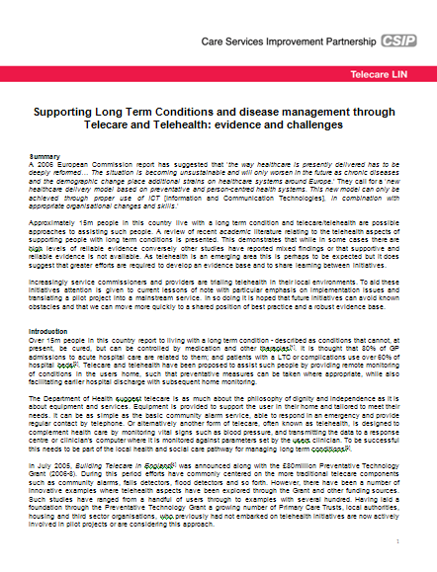

Link: http://www.icn.csip.org.uk/_library/Resources/Telecare/Support_Materials/Briefing_-_Telehealth_SB_Final2.doc

The Transforming Social Care Circular has now been published together with the grant funding over the next three years. This circular will have a major impact on how services are provided in the future and should be read carefully by commissioners and service providers involved in local telecare service provision along with ‘Putting People First’ (See newsletters for December 2007 and January 2008). Some of the relevant paragraphs from the Circular appear below.
3 Transforming Social Care – Local Authority Circular published

Telecare LIN

LAC (2008)1 – references to telecare
11…….Supported by the DH’s efficiency programme, councils have increasing shown how developing homecare re-ablement services can support independent living and deliver value for money. Assistive technology such as telecare and minor adaptations, like fitting a handrail, can also enable people with support needs to continue to live in their own homes……

17 ……To do this will require a common assessment of individual social care needs, emphasising the importance of self-assessment. The role of social workers will be focused on advocacy and brokerage, rather than assessment and gate keeping. This move is from the model of care, where an individual receives the care determined by a professional, to one that has person centred planning at its heart, with the individual firmly at the centre in identifying what is personally important to deliver his or her outcomes. With self-directed support, people are able to design the support or care arrangements that best suit their specific needs. It puts people in the centre of the planning process, and recognises that they are best placed to understand their own needs and how to meet them. They will be able to control or direct the flexible use of resources (where they wish to), building on the support of technology (eg telecare), family, friends and the wider community to enable them to enjoy their position as citizens within their communities……

10 …..Person centred planning and self-directed support to become mainstream, with individuals having choice and control over how best to meet their needs, including through routine access to telecare…..

See also:

19. In the future, all individuals eligible for publicly-funded adult social care will have a personal budget (other than in circumstances where people require emergency access to provision); a clear, upfront allocation of funding to enable them to make informed choices about how best to meet their needs, including their broader health and well-being. Having an understanding of what is available will enable people to use resources flexibly and innovatively, no longer simply choosing from an existing menu, but shaping their own menu of support. A person will be able to take all or part of their personal budget as a direct payment, to pay for their own support either by employing individuals themselves or for purchasing support through an agency. Others may wish, once they have decided on their preferred care package, to have the council continue to pay for this directly. The approach, which may be a combination of both, will depend on what works best for them. The term personal budget will describe this transparent allocation of resources.

Link: http://www.dh.gov.uk/en/Publicationsandstatistics/Lettersandcirculars/LocalAuthorityCirculars/DH_081934

4 Events

Telecare LIN

- CSIP Telecare events

Venue | Date
Manchester | 4 February 2008
Taunton | 7 February 2008
Birmingham | 12 February 2008

- Housing LIN events – booking now available:

21/02/08 London and South East Regional Housing LIN Meeting

28/02/08 North West Regional Housing LIN Meeting

13/03/08 West Midlands Regional Housing LIN Meeting

02/04/08 South West Regional Housing LIN Meeting

Full list of Housing LIN events:

http://www.icn.csip.org.uk/housing/index.cfm?pid=167

Latest Housing LIN Newsletter:
http://www.icn.csip.org.uk/_library/Resources/Housing/Support_materials/Newsletter/Newsletter26.pdf

The Foundation for Assistive Technology (FAST) provides a full listing of forthcoming telecare events – see http://www.fastuk.org/services/events.php?pg=2. Suppliers also run telecare and telehealth events – check their web sites regularly for dates.

All previous telecare eNewsletters are available at: www.icn.csip.org.uk/telecarenewsletters

CSIP Telecare Services

You can send comments and questions about the CSIP Implementation Guide, factsheets or other resources or contact us via telecare@csip.org.uk. Also, use this mailbox to send in good practice examples.

If you or a colleague would like to receive future copies of the newsletter then all you need to do is register at http://www.icn.csip.org.uk/index.cfm?pid=12

Glossary:

ALIP – Assisted Living Innovation Platform
AT – Assistive Technology
BERR – Business Enterprise and Regulatory Reform
CSCI – Commission for Social Care Inspection
DCLG – Department for Communities and Local Government
FACS – Fair Access to Care Services
NHS CfH – NHS Connecting for Health
NHS PASA – NHS Purchasing and Supply Agency
PT Grant or PTG – Preventative Technology Grant
TSA – Telecare Services Association

Appendix 1 – Supplier’s supplement for March 2008

As you know, from time to time we offer some space on an equitable basis to suppliers in the CSIP Telecare eNewsletter newsletter. Later in the year we will again cover the April 2008 NHS PASA updates.

There has been a very considerable amount of interest from suppliers in the five CSIP events in January and February 2008

These events do not include exhibition space.

We would wish to recognise the important work that suppliers have done in responding to their customers and working in partnership to implement telecare and telehealth programmes since 2005/6.

Here are some ways in which suppliers can be involved currently:

- They can attend an event and contribute from the floor – many suppliers have booked spaces (http://www.icn.csip.org.uk/index.cfm?pid=476&sectorID=170).
- They can join in the collection of 200 telecare and telehealth outcomes since 2005/6. These will go onto the CSIP web site along with responses from local authorities, health trusts, housing associations etc – send 250 to 500 words to telecare@csip.org.uk if you are not attending any of the CSIP events
- They can contribute to a supplement in the March 2008 telecare newsletter which draws together content from suppliers on telehealth and advanced assistive technology (AAT)

For suppliers that wish to contribute to the newsletter supplement here are the details:

- Up to 2 pages of A4 (12 point Arial) per supplier in Microsoft Word (we can include a jpeg image/logo but keep the layout and margins simple for copy/pasting)
- Please use the general definition of telecare from Building Telecare in England to include some form of monitoring/response. The definition is broad to include telehealth, community safety etc.
http://www.dh.gov.uk/en/Publicationsandstatistics/Publications/PublicationsPolicyAndGuidance/Browsable/DH_4122310
- Please include case studies, evaluation findings, innovations. ( CSIP are covering a lot of telehealth and disease management for the next few months, so we are looking for telehealth, telephone support, weather forecast examples and some of the more complex assessment and support systems eg for dementia or extra care rather than simpler solutions)
- We are not looking for advertisements as suppliers can include links to their web sites in the article, it is more about cases studies (anonymised), evaluations, device/monitoring options, solutions, examples of products and services in use, achievements. Embedded web links are OK but CSIP will not have time to check them all
- If you are referencing local authorities, health trusts, housing associations by name please confirm that they are happy for you to use their names
- The supplement is open to all suppliers as long as they meet a 5pm, 3 March 2008 deadline. Suppliers involved outside of the National Framework Agreement are eligible for inclusion. This would ensure that all suppliers are treated equitably
- Where there are sub-contractors and affiliates in the National Framework Agreement, we will link to the NHS PASA current position from the supplement and cross references can be included in the submission. We will limit each company name to one full 2 pages of A4 entry in the supplement although there may be additional linkages through the framework agreement
- Inclusion in the supplement does not imply any endorsement of the products/services by DH, CSIP etc and there will be a reminder in the supplement to telecare organisations about the importance of making appropriate checks and following procurement and purchasing requirements
- Word documents can be sent to Mike Clark (CSIP Networks) at telecare@csip.org.uk by the 3 March deadline
- CSIP reserves the right not to include duplicated company/supplier examples and speculative advertisements without information about case studies, evaluations, achievements.

