

CSIP Telecare eNewsletter

August 2008

Welcome to the August 2008 newsletter. The Care Services Improvement Partnership (CSIP Networks) is responsible for providing general implementation support to organisations building their telecare and telehealth programmes.

If you are an organisation implementing telecare and have an interesting local telecare or telehealth story for inclusion in a future newsletter then e-mail Mike Clark (newsletter editor, CSIP Networks) at telecare@csip.org.uk

Please note, some adjustments have been made to the CSIP Networks web site – the main URL is now www.networks.csip.org.uk

Telecare shortcuts:

www.networks.csip.org.uk/telecarefactsheets
www.networks.csip.org.uk/telecarenewsletters
www.networks.csip.org.uk/telecareservices
www.networks.csip.org.uk/telecareoutcomes

WSD Action Network:
http://www.wsdactionnetwork.org.uk/

Notes:

1 CSIP Networks is not responsible for the content of external links and does not endorse any suppliers or their products.

2 CSIP Networks will be making some further adjustments to its web site pages and links in the next few weeks as telecare is re-positioned to operate alongside WSDAN. Some older factsheets will be updated or removed where they are no longer relevant. All current URLs will map across to the new arrangements so bookmarked pages will still work OK

Contents
Item | Page
1 WSD Action Network – Latest | 3
2 CSCI performance and other information | 3
3 NHS PASA framework agreements | 4
4 Supplier supplement for September 2008 – contributions welcome | 6
5 Health on the move – mobile technology and eHealth | 6
6 Updates to the CSIP Networks web site | 8
7 I4i update | 9
8 Carers strategy events | 11
9 Upcoming EOI and other deadlines | 12
10 News | 14
11 Events | 21
Appendix 1 | 23

Item 1 covers the WSD Action Network – the first newsletter will be available in September.

Item 2 covers the publication of CSCI and other performance data over the coming months.

Item 3 covers NHS framework agreements in addition to telecare that may be of interest to health and social care commissioners and providers.

Item 4 Invites contributions for the September supplier supplement.

Item 5 looks at some of the features of mobile technology that may be of interest.

Item 6 covers the recent updates to the CSIP Networks site.

Item 7 updates the July references to i4i (Invention for Innovation).

Item 8 provides information about the carers strategy events.

Item 9 Lists some upcoming deadlines for expressions of interest.

Item 10 provides a news listing including, DH, CSIP Networks and other links.

Item 11 identifies some upcoming events.

Glossary:

ALIP – Assisted Living Innovation Platform
AT – Assistive Technology
BERR – Business Enterprise and Regulatory Reform
CSCI – Commission for Social Care Inspection
DCLG – Department for Communities and Local Government
FACS – Fair Access to Care Services
i4i – Invention for Innovation
NHS CfH – NHS Connecting for Health
NHS PASA – NHS Purchasing and Supply Agency
PT Grant or PTG – Preventative Technology Grant
TSA – Telecare Services Association
TSB – Technology Strategy Board
WSDAN – Whole System Demonstrator (Long Term Conditions) Action Network
1 WSD Action Network – Latest

Telecare LIN

Registrations continue to come in for the new WSDAN web site. You will need to register to receive the monthly newsletter and any other updates. This will include future information about events.

The web site for the network is:
www.wsdactionnetwork.org.uk

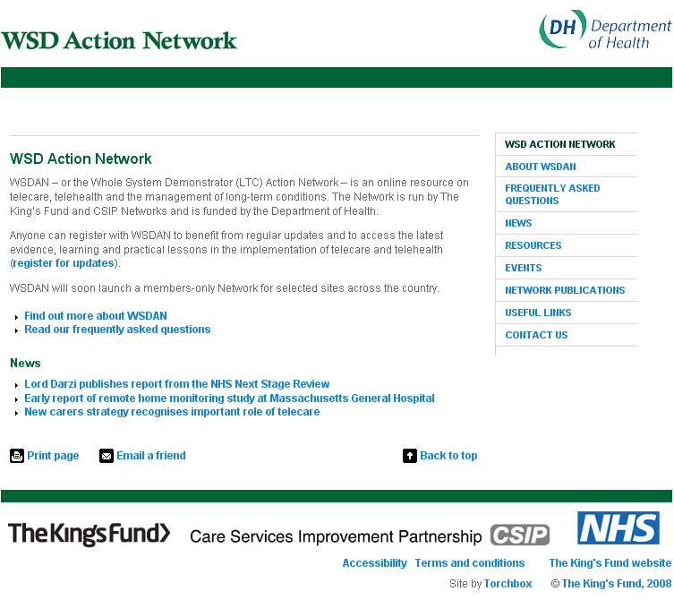

The first newsletter will appear in September 2008 so make sure that you are registered to receive it.

It is also important to maintain your CSIP registration as the telecare newsletter will continue to provide important information for commissioners and service providers as the evidence continues to build up for telecare and telehealth.

For WSDAN registration go to http://www.wsdactionnetwork.org.uk/about_wsdan/register_for_updates.html

2 CSCI performance and other information

Telecare LIN

Starting in September 2008, we will be providing information about telecare performance as collected by CSCI over the period of the Preventative Technology Grant.

We will be starting with the headline information – was the overall target of an additional 160,000 users met between 2006-2008?

As we progress through the Autumn, CSCI will have a process to follow in respect of the performance information and the final letters to social care authorities. During this time, there is still the possibility of adjustments to the figures.

As we progress through the next few weeks, we will be looking at the regional picture and finally individual local authority information will be available at the end of November 2008 when the social care star ratings are published. At that stage we will be updating all of the telecare profiles (www.networks.csip.org.uk/telecareprofiles).

3 NHS PASA framework agreements

Telecare LIN

From Paddy Howlin at NHS PASA


Advance notification of a new National Agency Nursing and Care Framework Agreement by the NHS Purchasing and Supply Agency

Introduction

It is the intention of the NHS Purchasing and Supply Agency (NHS PASA) to develop a National Framework Agreement covering the requirements for Agency Nursing and Care workers, which will replace the existing NHS PASA agency nursing framework agreements for the London Agency Project (LAP3) and Multi Regional Framework Agreement when they expire on 30th September 2009.

Due to changes in the size and structure of the agency nursing and care market in the UK, it has become more appropriate to consider the supply requirements of the NHS. These will be included in the proposed new agreement.

The intention is to award a new National Framework Agreement for Agency Nursing and Care by April 2009 to ensure the NHS, Local Authorities, suppliers and workers are provided with an adequate implementation and migration period prior to commencement on 1st October 2009

NHS PASA is utilising the CSIP e-newsletter to provide organisations currently utilising agency nursing and domiciliary care agencies with prior notice of the proposed new National Framework Agreement for Agency Nursing and Care.

Background

Expenditure on agency nursing by the NHS in England alone for the period 2007/8 is estimated at £250million

There is evidence to suggest that this trend may be affected by increasing requirements in specific areas, including:-

- government 18 week waiting list reduction programmes
- care in the home requirements (often jointly funded with local authorities)
- management of temporary staffing needs across social care
The objectives of the new agreement include:-

- minimising patient risk through compliance with quality standards monitored through the NHS PASA resourced national audit programme
- providing value for money through effective national management of supply costs including pay rates and agency margins with appropriate opportunities for increased financial benefits for users through encouraging for longer term and advanced notice bookings
- enabling both local and national agencies to provide the full range of temporary staffing requirements for nursing and care to meet NHS geographical needs across the various specialties.
- facilitating the opportunity for the NHS and agencies to work together to provide a committed programme of service underwritten by the framework terms and conditions.
- developing the requirements for care in the home requirements
- developing the requirements for social care
- developing the requirements for learning disabilities
- providing the opportunity for local authorities to utilise the framework agreement in order to achieve continuity of care for patients.

The following is a list of the Agenda for Change pay bands and specialties including the following job families that will be included in the new agreement:

- Nursing services
- Midwifery
- Home Care
- Theatre
- Residential and Day Care
- Social Work
- Dental Nurses
- Health Visitors
- Community Services
- NHS Direct

NHS PASA and are keen for both the NHS and Local Authorities to participate and influence the development of the new National Framework Agreement. If you are keen to find out more about the agreement or would like to provide stakeholder comments relating to the development of this contract, please contact NHS PASA (details can be found below).

Current status

NHS PASA has sought expressions of interest (EOI) from nursing and domiciliary care agencies to participate in the procurement process earlier this year, and the EOI stage has now been completed.

Nearly 300 EOI responses have been received from agencies offering nursing, social care and domiciliary care, and each of these was required to complete a Pre-Qualification Questionnaire (PQQ) as part of the tendering process.
.
NHS PASA is currently evaluating the responses to the PQQ with an emphasis on commercial status, risk, service and compliance. The evaluation includes obtaining references from bankers and users of the agency.

NHS PASA is also undertaking a physical inspection of all the agencies to ascertain their procedure and practices meet the minimum standards required. The inspection includes a sample selection of agency worker files.

Following the completion of the above, NHS PASA will short list appropriate agencies to invite to tender. All bids will be in accordance with the NHS PASA Conditions of Contract relating to this agreement.

Final bids received will be analysed and negotiated prior to the award of the agreement planned for Spring 2009.

The New National Framework Agreement for the supply of agency nursing and care workers will commence 1st October 2009.

Further information:

If you seek to find out further information relating to the new National Framework Agreement for the supply of agency nursing and care workers, please contact Brenda Hibell, Category Manager via brenda.hibell@pasa.nhs.uk. Alternatively contact the Agency Nursing team via NursingAndCare@pasa.nhs.uk or visit the NHS PASA Agency Nursing website at: www.pasa.nhs.uk/agency.
4 Supplier supplement for September 2008 – contributions welcome

Telecare LIN

5 Health on the move – mobile technology and eHealth

Telecare LIN

If you are a manufacturer or supplier of telecare and telehealth equipment, we have another supplement coming up in September this year. We are particularly interested to hear about case studies and evaluations.

For this edition, we are also interested to hear from other organisations outside of local authorities or PCTs who are implementing, researching or evaluating telecare and telehealth in England.

Appendix 1 has the simple rules to follow if you are interested in contributing.

e-mail contributions to telecare@csip.org.uk by 8 September 2008.
6 Health information on the move

Telecare LIN

The proportion of homes in the UK using mobile telephones has increased to 84%, and fixed line coverage is down from 90% to 87%. A growing number (12%) of adults in the UK live in a home with a mobile phone but with no fixed-line (Ofcom, 2008)

Mobile phones have become an accepted technology for voice, text and more recently, internet browsing and e-mail.

Could they become an essential part of supporting people with long term conditions in the community? Also, do they have a role in health promotion and prevention (eg smoking cessation, obesity management) to the extent that some long term conditions such as diabetes and COPD are more likely to be controlled in the longer term?

With improved specifications and increased functionality, mobile devices could not only provide GPS coordinates to assist with locating a person, but could provide a decent quality video connection when someone with COPD is feeling unwell.

Mobile phones are able to transmit data from linked medical devices as well as provide medication prompts and reminders. They provide a means of communications between individual clinicians and control centres with patients for health promotion and timely advice.

A recent article in the British Journal of Community Nursing (Br J Community Nurs. 2008 Apr;13(4):160, 162-5) looks at mobile phone technology in patient care.
Link: http://www.energeticsecrets.com/energy-medicine---solid-solutions-for-vibrant-health/271

Some London pharmacies are planning to launch a text message service to invite potential smoking quitters for local services and arrange follow-ups.

Link: http://www.publictechnology.net/modules.php?op=modload&name=News&file=article&sid=16873

With the development of advanced mobile phones, it is now becoming possible to run ‘You Tube’ videos, link with health records, search 17 million journal articles using ‘Unbound Medicine’ (http://www.unboundmedicine.com/iphone.htm), manage health records (including digital images), maintain an emergency card, provide information about symptoms and conditions, count calories or administer a simple eye examination.
Link: http://www.chicagotribune.com/features/lifestyle/chi-0727-health-cell-phone-sidejul27,0,3379444.column
http://www.icmcc.org/pdf/ICMCCSWWS08.pdf

Jonathan Linkous of the American Telemedicine Association recently suggested that “Health care applications for the iPhone, text messages from physicians and even Nintendo's Wii Fit video game are versions of telemedicine”. according to Jonathan Linkous, chief executive officer of the American Telemedicine Association”.
As with all aspects of telecare and telehealth, it will be important to consider a range of issues including device interoperability, confidentiality of health records, accessibility and design of devices.
Further links:
http://www.smstextnews.com/2007/08/sms_alerts_reduce_missed_doctors_appointments_by_27.html
http://www.iplato.net/news-appointment-reminders-and-mobile-health-promotion/press-releases/remember-ur-gp-appt-gp-text-messaging-service.html
http://www.computerweekly.com/Articles/2006/11/24/220177/ealing-rolls-out-text-alerts-to-cut-missed-gp-appointments.htm
http://www.tplusmedical.co.uk/?lang=EN
http://www.wherify.com/wherifone/seniors.html
CSIP Networks is not responsible for the content of external links and does not endorse any suppliers or their products.
6 Updates to the CSIP Networks web site

Telecare LIN

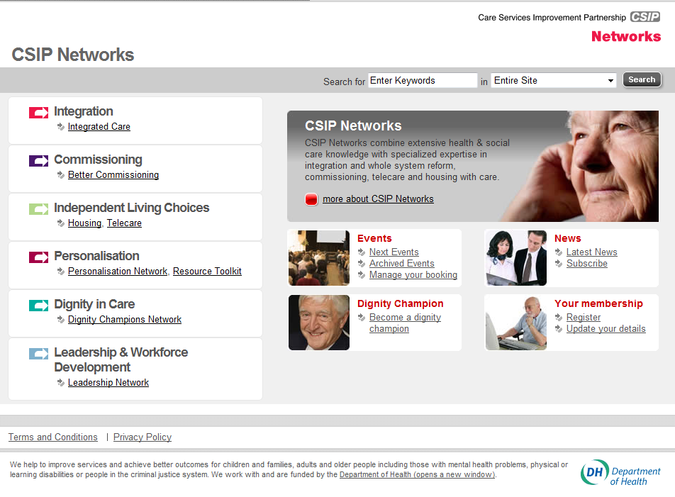

Adjustments have now been made to the CSIP Networks web site – the main URL is now www.networks.csip.org.uk

Telecare shortcuts can still be used:

www.networks.csip.org.uk/telecarefactsheets
www.networks.csip.org.uk/telecarenewsletters
www.networks.csip.org.uk/telecareservices
www.networks.csip.org.uk/telecareoutcomes

The mailbox remains the same – telecare@csip.org.uk

If you still have older URLs bookmarked for newsletters, factsheets etc, don’t worry as you will be redirected to the revised page.

Many older items have been removed (see table below) – you can still get copies of these items by sending an e-mail to the telecare mailbox. As the next set of CSCI figures are published in the coming months, we will be removing older spreadsheets as their contents will be consolidated in the most recent versions.

Commissioning telecare - Powerpoint slides - September 2007
CSIP Telecare slides - September 2007 (pdf format)
Telecare Ready Reckoner - checklist
CSIP Slides covering DH document 'Building Telecare in England'
CSIP Telecare - Masterclass Slides
Telecare Reducing the Lead Time - Slides
Telecare Report to Board, Cabinet, Committee - Factsheet
Telecare Report to Board, Cabinet, Committee - Template
Telecare Ready Reckoner - Factsheet
Telecare Ready Reckoner - Spreadsheet
Telecare Reducing the Lead Time - Factsheet
Telecare User Information for Local Consultations
Procuring Telecare
Telecare and Telehealth Systems - Slides
Priorities from Launch Conference on 19 July 2005 - Factsheet
Telecare on the Net - factsheet
Telecare on the Net - web links
Telecare case studies and examples
Telecare and the Independent Sector
Commissioning Telecare Services - CSIP and Telecare
Commissioning Telecare Services - CSIP and Telecare
Care With Chips: How Technology is Supporting Delivery of Care in West Lothian
Designing a Prospective Memory Aid for Cognitively Impaired Elderly Individuals
Terms of Reference for the Telecare Advisory Network (TAN)
eNews January to March 2007
eNews 24th October 2006
eNews 30th September 2006
eNews 28th August 2006
eNews 17th July 2006
NHS PASA Update on Telecare National Framework Agreement - June 2006
PASA Telecare National Framework Agreement - December 2005
Telecare Sourcing Workshop Notes - December 2005
Appraisal of the Scope of Assistive Technologies - December 2005
Assistive Technology Sourcing Workshop - December 2005
Assistive Technology: an Education, a Career, a Partnership - November 2005
Guidelines to develop Local Telecare Strategies - Wales, October 2005
The Government Assistive Technology & Telecare Initiative - May 2005
Taking Telecare forward - Moyra Riseborough Presentation - January 2005
Innovation in Electronic Technology - March 2005
Hanover Smart Choice - January 2005
Telecare Getting Started
Some updated information is now available for the i4i (Invention for Innovation) Programme that supersedes the coverage in the July newsletter.
7 i4i - update

Telecare LIN

Information about the recent programme call is available at:
http://www.nihr-ccf.org.uk/site/callsproposals/i4i/default.cfm;jsessionid=f030a9ef667298cc1a577b7b7a3f5f6e4b1a

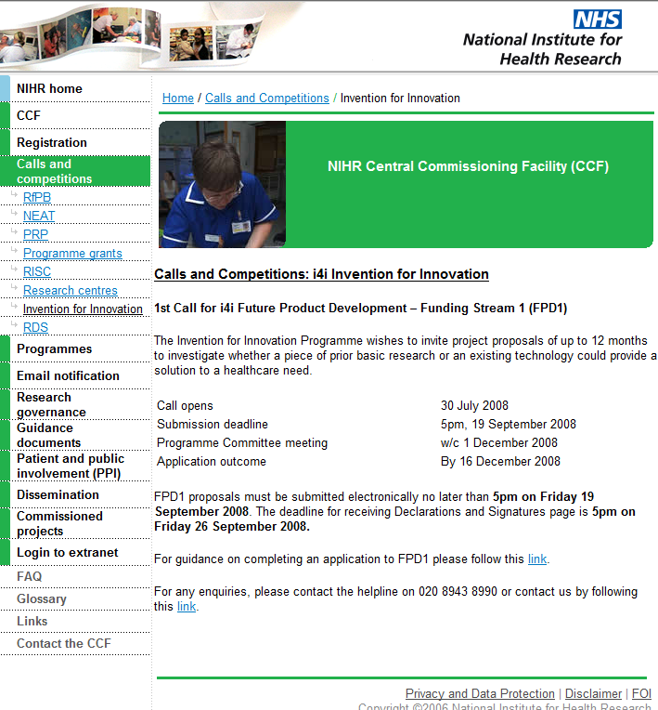

Programmes under The umbrella of i4i includes:
- i4i Future Product Development funding streams
- Pilot Healthcare Technology Co-operatives (HTCs)
- Challenge Fund for Innovation supporting
- NIHR involvement in Assisted Living Innovation Platform
- NIHR involvement in Knowledge Transfer Partnership programme
- NIHR involvement with Medical Futures
- NIHR involvement in MATCH PLUS project
- The migration of the New and Emerging Applications of Technology (NEAT)
- Health Technology Devices (HTD)
Additional information about i4i including background, presentations etc is available at:
http://www.nihr-ccf.org.uk/site/programmes/i4i/default.cfm
The purpose of these events (there are nine being held across the country) is to help create a common sense of purpose and foster collective responsibility to ensure that carers have the services they need in their caring role whilst being enabled to have a life outside caring. The events will do this through:
8 Carers strategy events

Telecare LIN

- Engaging with local partners in early thinking on the development of pilots to be initiated in 2009/10;
- Encouraging partnership working across the board, from health to housing, for carers;
- Sharing learning from models of good practice within regions.
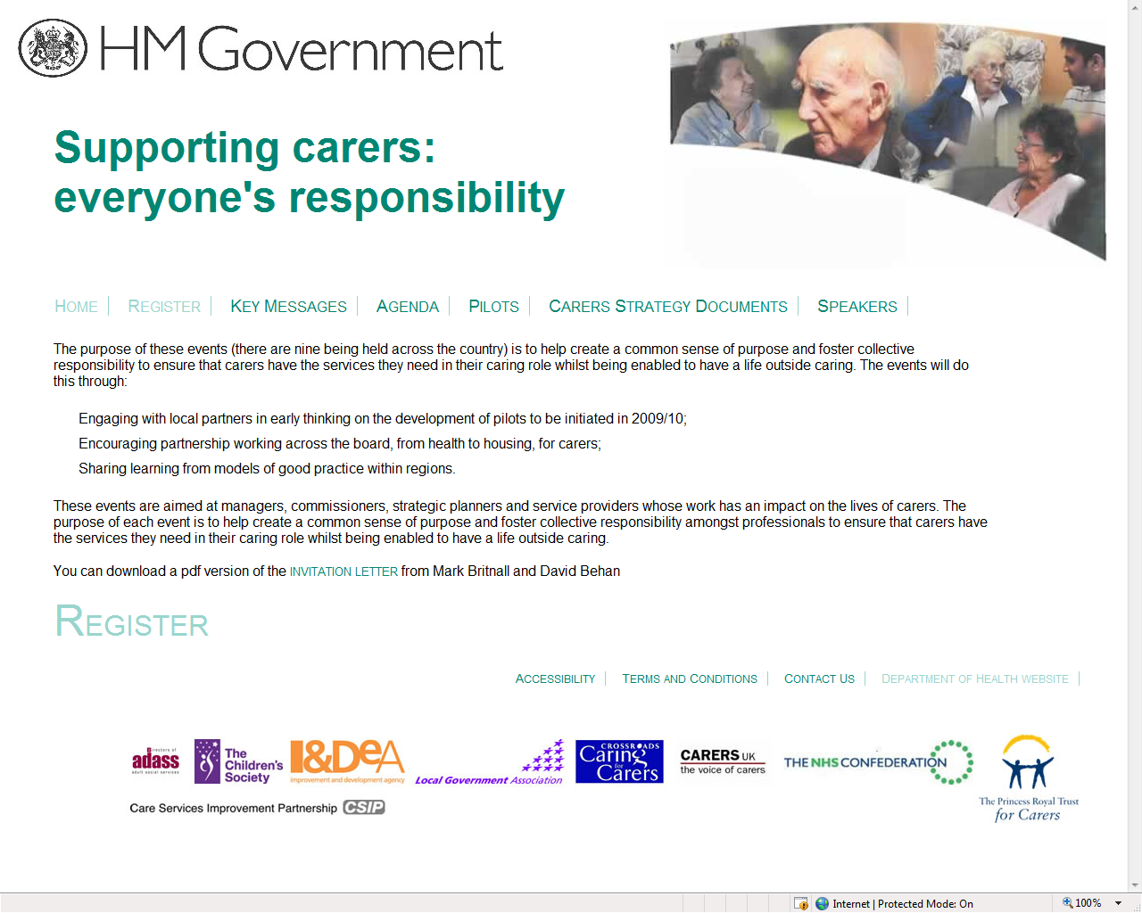
These events are aimed at managers, commissioners, strategic planners and service providers whose work has an impact on the lives of carers. The purpose of each event is to help create a common sense of purpose and foster collective responsibility amongst professionals to ensure that carers have the services they need in their caring role whilst being enabled to have a life outside caring.
- Peterborough, Monday 8 September 2008
- Nottingham, Monday 15 September 2008
- York, Wednesday 17 September 2008
- Newcastle, Monday 22 September 2008
- Liverpool, Wednesday 24 September 2008
- Birmingham, Friday 26 September 2008
- Gatwick, Thursday 2 October 2008
- Central London, Tuesday 14 October 2008
- Plymouth, Friday 17 October 2008
Some events are currently holding waiting lists.
Registration for the events: http://www.coievents.co.uk/carersstrategy/register.asp

There are a number of Expression of Interest and other deadlines approaching for those involved in telecare and telehealth.
9 Upcoming EOI and other deadlines

Telecare LIN

- A Smart Care Distributed Environment - July 2008 competition for funding

Key Dates:
Competition Launch 27 June 2008
Deadline for submission of Compulsory Expression of Interest Form - 4 September 2008
Successful Expression of Applicants Informed Interest 6 October 2008
Compulsory Consortia Building Workshop 30 October and 31 October 2008
Registration of Intent to Submit 28 November 2008
Compulsory Project Application Briefing 11 December 2008
Deadline for submission of Project Application Form 29 January 2009
Successful Project Applicants Informed 13 March 2009

https://www.technologyprogramme.org.uk/extranet/competitions/InnovationPlatforms/ALIP2/Documents/TSBSmartCareEnvironment2.0.pdf

- Ageing well with cognitive impairment

Closure date: 9 September 2008

http://ec.europa.eu/information_society/activities/ict_psp/documents/4_ICTPSP_Info%20Day.pdf

- Third sector investment programme

The third sector investment programme replaces the S64 grant.

First stage applications must be submitted by Monday 8 September 2008.

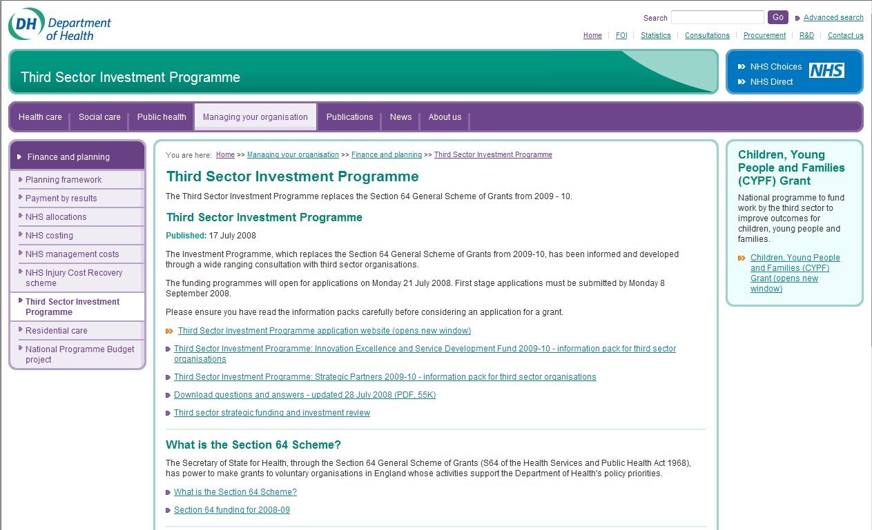

http://www.dh.gov.uk/en/Managingyourorganisation/Financeandplanning/Section64grants/index.htm

- i4i Invention for Innovation
1st Call for i4i Future Product Development – Funding Stream 1 (FPD1)
The Invention for Innovation Programme wishes to invite project proposals of up to 12 months to investigate whether a piece of prior basic research or an existing technology could provide a solution to a healthcare need.
Call opens | 30 July 2008
Submission deadline | 5pm, 19 September 2008
Programme Committee meeting | w/c 1 December 2008
Application outcome | By 16 December 2008
FPD1 proposals must be submitted electronically no later than 5pm on Friday 19 September 2008. The deadline for receiving Declarations and Signatures page is 5pm on Friday 26 September 2008.
http://www.nihr-ccf.org.uk/site/callsproposals/i4i/default.cfm;jsessionid=f030a9ef667298cc1a577b7b7a3f5f6e4b1a
10 News

Telecare LIN

Department of Health

- Call for expressions of interest in piloting the Common Assessment Framework for Adults - Phase 1

http://www.dh.gov.uk/en/Publicationsandstatistics/Lettersandcirculars/Dearcolleagueletters/DH_087164

- Five years on: delivering the diabetes national service framework

http://www.dh.gov.uk/en/Publicationsandstatistics/Publications/PublicationsPolicyAndGuidance/DH_087123

- Consultation on direct payments regulations

http://www.dh.gov.uk/en/Consultations/Liveconsultations/DH_087108

- Evaluation of Information prescriptions

http://www.dh.gov.uk/en/Publicationsandstatistics/Publications/PublicationsPolicyAndGuidance/DH_086889

- The Joint Strategic Needs Assessment (JSNA) core dataset

http://www.dh.gov.uk/en/Publicationsandstatistics/Publications/PublicationsPolicyAndGuidance/DH_086676

CSIP publications

- A summary of Lord Darzi’s Review of the NHS

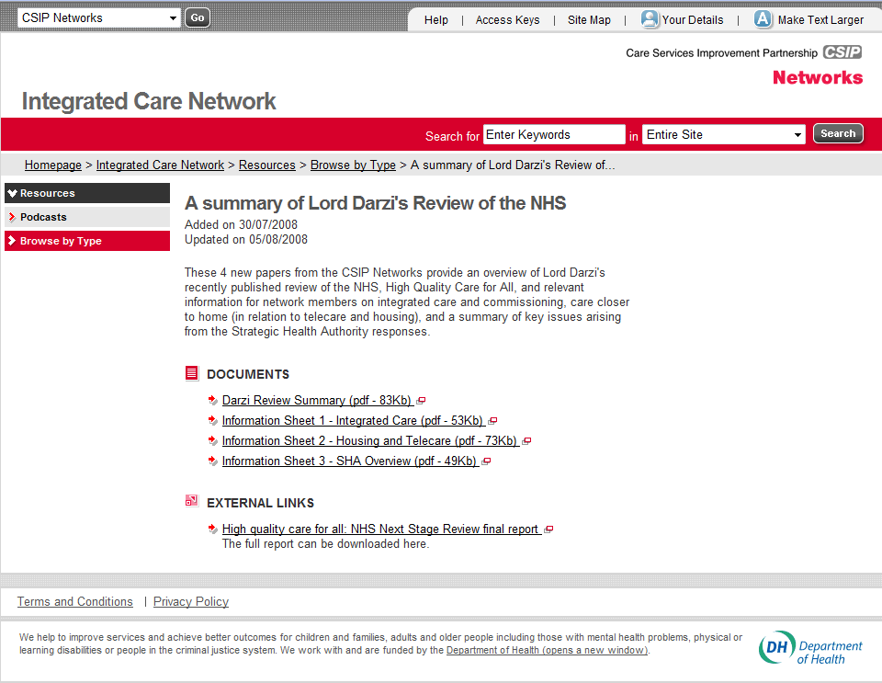

A range of documents are available which look at particular aspects of the recent review of the NHS.

http://www.networks.csip.org.uk/icn/Resources/Type/ICNResource/

- Recent publication - Commissioning housing support for health and well-being
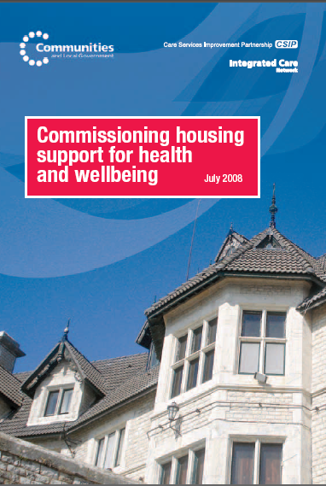
http://www.integratedcarenetwork.gov.uk/housing/index.cfm?pid=528&catalogueContentID=3529
- CSIP Networks better commissioning newsletter for August 2008
http://networks.csip.org.uk/_library/Resources/BetterCommissioning/08.08_Better_Commissioning_-_Whats_New.pdf

- CSIP Networks Housing LIN – latest newsletter

http://www.networks.csip.org.uk/IndependentLivingChoices/Housing/Topics/type/resource/?cid=3767

You can register for CSIP newsletters and other materials at http://www.networks.csip.org.uk/useraccount/register/

Other news

Age Concern
On the right track? A progress review of the human rights of older people in health and social care
http://www.ageconcern.org.uk/AgeConcern/Documents/On_the_right_track_FINAL.pdf
Asthma advice with storms
http://www.scarborougheveningnews.co.uk/news/Asthma-advice-with-storms-on.4374285.jp
Weather watch boosts lung health
http://news.bbc.co.uk/1/hi/health/7523336.stm
Long-term programs needed to change activity patterns of COPD patients
http://www.medwire-news.md/48/76892/Respiratory/Long-term_programs_needed_to_change_activity_patterns_of_COPD_patients_.html
Project Lifesaver Program
http://www.medicalnewstoday.com/articles/118474.php
http://www.app.com/apps/pbcs.dll/article?AID=/20080814/NEWS02/808140576/1070
http://www.lompocrecord.com/articles/2008/08/01/news/centralcoast/news03.txt
Bill Would Create Silver Alerts For Lost Seniors
http://www.app.com/apps/pbcs.dll/article?AID=/20080814/NEWS02/808140576/1070
Charity funds web-based service for deaf
http://www.ehiprimarycare.com/news/charity_funds_web-based_service_for_deaf
California Company Sees Return on E-Health Tools for Employees
http://www.ihealthbeat.org/articles/2008/8/11/California-Company-Sees-Return-on-EHealth-Tools-for-Employees.aspx?topicID=52
E-mail used to help Iraq doctors treat patients
http://www.iht.com/articles/ap/2008/08/14/europe/EU-MED-Iraq-E-mail-Doctors.php
RCN documents on e-health
http://newdocumentsbulletin.blogspot.com/2008/08/nursing.html
E-health programs result in lower premiums for companies, better care for employees
http://sanjose.bizjournals.com/sanjose/stories/2008/08/11/story3.html?b=1218427200%5E1681407
Few US doctors answer e-mails from patients
http://www.gmanews.tv/story/91036/Few-US-doctors-answer-e-mails-from-patients
Massachusetts requires EHRs in hospitals by 2015
http://www.fcw.com/online/news/153468-1.html
EHTEL and EuroRec announce e-health symposium
http://ehealtheurope.net/news/4033/ehtel_and_eurorec_announce_e-health_symposium
Telemedicine Leads to Better Stroke Treatment Decisions
http://www.newswise.com/articles/view/543158/
mHealth & Mobile Telemedicine Convention
http://www.ehealth-connection.org/
Gentag and MacroArray Develop Prostate Cancer Wireless Diagnostic
http://www.medicaldevicestoday.com/2008/07/gentag-and-macr.html
Home monitors expected to play bigger role in health care
http://www.medicaldevicestoday.com/2008/07/gentag-and-macr.html
New Technology Helps Residents with Chronic Diseases Monitor their ...
http://www.prweb.com/releases/2008/8/prweb1199714.htm
Stick-on patch for rescue teams
http://news.bbc.co.uk/1/hi/scotland/highlands_and_islands/7543557.stm
VNA finds home-monitoring system keeps elderly out of hospital
http://www.wickedlocal.com/melrose/news/x469168400/Telemonitors-free-local-seniors-from-hospital-visits
Progress made in NHS Diabetes care
http://www.egovmonitor.com/node/20548
http://news.bbc.co.uk/1/hi/health/7570470.stm
Firms may issue Smartcards to access patient records
http://www.healthcarerepublic.com/news/GP/839986/Firms-may-issue-Smartcards-access-patient-records/
Estonia takes steps to e-health
http://ehealtheurope.net/news/4080/estonia_takes_steps_to_e-health
Who's Keeping an Eye on Your Online Health Records?
http://www.sciam.com/article.cfm?id=whos-keeping-an-eye
HEART SCANS FOR PATIENTS AT THEIR GP SURGERY - Nottingham
http://www.thisisnottingham.co.uk/news/Heart-scans-patients-GP-surgery/article-265739-detail/article.html
Sheltered warden service changes – Bute
http://www.buteman.co.uk/news/Sheltered-housing-warden-cuts-confirmed.4407086.jp
Officials discuss expanding telemed options - Wyoming
http://www.jacksonholestartrib.com/articles/2008/08/23/news/casper/3596ddb88f4eb637872574ad007ee973.txt
Telehealth: A policy analysis for quality, impact on patient outcomes, and political feasibility – USA article
http://www.sciencedirect.com/science?_ob=ArticleURL&_udi=B6WNY-4T40TW7-C&_user=10&_coverDate=08%2F31%2F2008&_rdoc=11&_fmt=high&_orig=browse&_srch=doc-info(%23toc%236975%232008%23999439995%23695167%23FLA%23display%23Volume)&_cdi=6975&_sort=d&_docanchor=&_ct=18&_version=1&_urlVersion=0&_userid=10&md5=ab9e532bb8ff808dc457a3ca1c0f3d2f
Also: Sarah Palin and Technology - http://www.govtech.com/gt/402325?topic=117677
Colorado telehealth network set to be largest in the US
http://www.govtech.com/gt/391133?topic=117677
Cambridge Consultants Brings Its Vena Platform to the Continua Alliance
http://www.businesswire.com/portal/site/google/?ndmViewId=news_view&newsId=20080811005633&newsLang=en
Telemedicine leads to better stroke treatment decisions
http://esciencenews.com/articles/2008/08/03/telemedicine.leads.better.stroke.treatment.decisions
UC doctors treat inmates through video program
http://www.sacbee.com/101/story/1128846.html
Rising fuel costs threaten home health care – USA
http://www.timesunion.com/AspStories/story.asp?storyID=708560&category=OPINION
Telemedicine allows better stroke treatment decisions
http://story.100.com/?sid=389924
Telemedicine Improves Rural Stroke Care
http://www.medpagetoday.com/Cardiology/Strokes/tb/10393

Norwegian Centre for Telemedicine
http://www.telemed.no/index.php?cat=43160&language=en
AMD reports growing demand for telemedicine
http://www.hospitaliteurope.com/default.asp?title=AMDreportsgrowingdemandfortelemedicine&page=article.display&article.id=12724
Telehealth—Opportunities and Pitfalls
http://www.adajournal.org/article/PIIS0002822308006536/abstract?rss=yes
Online Doctor Visits
http://www.ihealthbeat.org/articles/2008/8/22/Report-Online-Doctor-Visits-Can-Boost-Access-Concerns-Remain.aspx?topicID=57
What’s Holding Telemedicine Back?
http://www.healthleadersmedia.com/content/216817/topic/WS_HLM2_TEC/Whats-Holding-Telemedicine-Back.html
Online doctors make house calls again
http://www.connpost.com/ci_10270663
Physician Care and Telemedicine
http://www.ncpa.org/pub/ba/ba624/
My Healthy Access and NuPhysicia Sign Joint Operating Agreement for Wal-Mart Based Telemedicine Clinics
http://www.smartbrief.com/news/aaaa/industryBW-detail.jsp?id=F2F20772-3B92-4FA8-A538-22B6DB3693C1
http://www.businesswire.com/portal/site/google/?ndmViewId=news_view&newsId=20080820005304&newsLang=en
http://retailnu.wordpress.com/2008/08/21/telemedicine-clinic-to-open-at-wal-mart-in-pearland/
From San Diego to Timbuktu, Long-Distance Surgery
http://www.voiceofsandiego.org/articles/2008/08/18/news/02telemed081808.txt
XCAST Labs - Hosted Digital Voice and Video Applications (video)
http://www.brightcove.tv/title.jsp?title=1736991119
Rural areas reap benefits of telemedicine in India
http://timesofindia.indiatimes.com/Bangalore/Rural_areas_reap_benefits_of_telemedicine_/articleshow/3369847.cms
'Robodoc' coming to a hospital near you
http://www.signonsandiego.com/news/northcounty/20080814-1829-bn14robodoc.html
Web Site Lets Patients See Doctor Online (video)
http://www.nbc6.net/news/17159165/detail.html
Telemedicine helps prevent blindness in diabetes patients
http://www.insidebayarea.com/ci_10151791
http://www.californiahealthline.org/articles/2008/8/11/Telemedicine-Initiative-Boosts-Eye-Screenings-for-Diabetes-Patients.aspx?topicID=43
Study: telemedicine beats telephone consults
http://arstechnica.com/news.ars/post/20080811-telemedicine-better-than-telephone-consults-study-says.html
Frost & Sullivan Recognizes Noninvasive Medical Technologies for its Sustained Pioneering Efforts in Patient-centric Remote Monitoring Solutions
http://www.newswiretoday.com/news/38642/
Mobile Phones To Support Healthcare In Rural India
http://vaziran.wordpress.com/2008/08/09/mobile-phones-to-support-healthcare-in-rural-india/
Indian Government Invests In Telemedicine
http://www.geekhealth.net/indian-government-invests-in-telemedicine/
Technology benefits stroke patients
http://www.hospitalhealthcare.com/default.asp?title=Technologybenefitsstrokepatients&page=article.display&article.id=12831
A change in thinking: how do you make telemedicine work (Tanzania)?
http://www.iicd.org/articles/telemedicine-ipath-tanzania
California Study Builds Case for Telemedicine Use in Stroke Treatment
http://www.californiahealthline.org/articles/2008/8/5/California-Study-Builds-Case-for-Telemedicine-Use-in-Stroke-Treatment.aspx?topicID=43
ICW selected for US telehealth programmeselected for US telehealth programme
http://ehealtheurope.net/news/4092/icw_selected_for_us_telehealth_programme
Officials discuss expanding telemed options
http://www.jacksonholestartrib.com/articles/2008/08/23/news/casper/3596ddb88f4eb637872574ad007ee973.txt
Telehealth – the answer to diabetes care?
http://intellect.computing.co.uk/2008/08/telehealth-the.html
Sensors and sensitivity keep the vulnerable safe at home
http://www.walesonline.co.uk/news/health-news/2008/08/18/sensors-and-sensitivity-keep-the-vulnerable-safe-at-home-91466-21550978/
Does Telemedicine Have a Role in Technology-Enabled Health Care Reform?
http://www.ihealthbeat.org/articles/2008/7/22/Does-Telemedicine-Have-a-Role-in-TechnologyEnabled-Health-Care-Reform.aspx?ps=1&authorid=1614
Telemedicine and heart monitoring
http://www.publicnet.co.uk/news/2008/08/05/telemedicine-trials-deliver-faster-cheaper-heart-monitoring/
Telemedicine With Video Proves Superior To Telephone Consultation
http://www.medicalnewstoday.com/articles/117155.php
Telemedicine is more accurate than telephone for stroke
http://www.onmedica.com/NewsArticle.aspx?id=c98b5f99-3a7a-49f9-9fc7-358b91e8f11a
XTend Medical (XMDC) Begins Remote Patient Monitoring Program in U.K.
http://www.marketwatch.com/news/story/xtend-medical-xmdc-begins-remote/story.aspx?guid={D3916075-0A9D-447F-ABE1-F86CA99D4A22}&dist=hppr
Montefiore's CMO and Health Hero Network Create Partnership to Move Health Care Into the Home in the Bronx
http://www.marketwatch.com/news/story/montefiores-cmo-health-hero-network/story.aspx?guid={3CAA4668-0BAA-47EB-A4EB-71AA7A9F213D}
Telehealth World Ezine
http://www.telehealthworld.com/images/TeleHealthSummerEzine.pdf
JHU/APL Developing Medical Devices
http://telemedicinenews.blogspot.com/2008/08/jhuapl-developing-medical-devices.html
Applying telecare in dementia: what psychiatrists need to know
http://apt.rcpsych.org/cgi/content/short/14/5/382
Officials discuss expanding telemed options
http://bulletin.aarp.org/states/wy/articles/officials_discuss_expanding_telemed_options.html
NHS trust launches telehealth monitoring service
http://healthcareitnews.eu/content/view/1179/41/
Swindon PCT Launches Mainstream Telehealth Monitoring Service for COPD Patients
http://www.24dash.com/news/Health/2008-08-29-Swindon-PCT-Launches-Mainstream-Telehealth-Monitoring-Service-for-COPD-Patients
VA centers to coordinate rural veterans telehealth services
http://www.govhealthit.com/online/news/350542-1.html
ICW selected for US telehealth programme
http://ehealtheurope.net/news/4092/icw_selected_for_us_telehealth_programme
E-learning and Telehealth: Measuring Your Success
http://www.liebertonline.com/doi/abs/10.1089/tmj.2007.0103
Telecare system comes to island
http://news.bbc.co.uk/1/hi/world/europe/isle_of_man/7590578.stm
CSIP Networks is not responsible for the content of external links and does not endorse any suppliers or their products.
11 Events

Telecare LIN

- CSIP Housing LIN Meetings

For details about Housing LIN and other CSIP Networks events:
http://www.networks.csip.org.uk/Events/

- CSIP Network’s Mike Clark will be speaking at Enabling People with Long Term Conditions – how telecare, electronic and computer-based technologies can help – London - 16 September 2008

Link and flyer: http://www.p-cns.org.uk/longterm_Conditions_conf.pdf

- CSIP Network’s Mike Clark will be speaking at the Technology in Dementia Care Conference in Birmingham on 2 october 2008

Link and flyer: http://www.careinfo.org/conferences/Tech08_form_A4_web.pdf

- Mike Clark will be speaking at Transforming health and social care services using ehealth and assistive technologies on 16 October 2008 in London

http://www.insidegovernment.co.uk/health/ehealth/index.php

- Tim Ellis (Department of Health) will be covering the Whole system Demonstrators and Ed Harding from CSIP Networks will be speaking at the TSA Conference (3-5 November) Brighton

http://www.telecare.org.uk/information/42301/46531/national_telecare_and_telehealth_conference/

The Foundation for Assistive Technology (FAST) provides a full listing of forthcoming telecare events – see http://www.fastuk.org/services/events.php?pg=2. Suppliers also run telecare and telehealth events – check their web sites regularly for dates.

All previous telecare eNewsletters are available at: www.networks.csip.org.uk/telecarenewsletters

CSIP Telecare Services

You can send comments and questions about the CSIP Implementation Guide, factsheets or other resources or contact us via telecare@csip.org.uk. Also, use this mailbox to send in good practice examples. If you or a colleague would like to receive future copies of the newsletter then all you need to do is register at http://www.icn.csip.org.uk/index.cfm?pid=12

Appendix 1 – Supplier supplement for September 2008

As you know, from time to time we offer some space on an equitable basis to suppliers in the CSIP Telecare eNewsletter newsletter.

We wish to continue to recognise the important work that suppliers have done in responding to their customers and working in partnership to implement telecare and telehealth programmes since 2005/6. For this addition, we are broadening the scope to other agencies and organisations involved in telecare and telehealth implementation.

For organisations that wish to contribute to the newsletter supplement here are the details:

- Up to 3 pages of A4 (12 point Arial) per supplier in Microsoft Word (we can include a jpeg image/logo but keep the layout and margins simple for copy/pasting)
- Please use the general definition of telecare from Building Telecare in England to include some form of monitoring/response. The definition is broad to include telehealth, community safety etc.
http://www.dh.gov.uk/en/Publicationsandstatistics/Publications/PublicationsPolicyAndGuidance/Browsable/DH_4122310
- Please include case studies, evaluation findings, innovations. (we are looking for telehealth, telephone support, weather forecast examples and some of the more complex assessment and integrated systems eg for dementia or extra care rather than simpler solutions)
- We are not looking for advertisements as suppliers can include links to their web sites in the article, it is more about case studies (anonymised), evaluations, device/monitoring options, solutions, examples of products and services in use, achievements. Embedded web links are OK but CSIP will not have time to check them all
- If you are referencing local authorities, health trusts, housing associations by name please confirm that they are happy for you to use their names
- The supplement is open to all suppliers/organisations as long as they meet a 5pm, 8 September 2008 deadline. Suppliers involved outside of the National Framework Agreement are eligible for inclusion. This would ensure that all suppliers are treated equitably
- Where there are sub-contractors and affiliates in the National Framework Agreement, we will link to the NHS PASA current position from the supplement and cross references can be included in the submission. We will limit each company name to one full 2 pages of A4 entry in the supplement although there may be additional linkages through the framework agreement
- Inclusion in the supplement does not imply any endorsement of the products/services by DH, CSIP etc and there will be a reminder in the supplement to telecare organisations about the importance of making appropriate checks and following procurement and purchasing requirements
- Word documents can be sent to Mike Clark (CSIP Networks) at telecare@csip.org.uk by the 8 September deadline
- CSIP reserves the right not to include duplicated company/supplier examples and speculative advertisements without information about case studies, evaluations, achievements.

