 | News Headlines: 16 April 2015

March 2015 was the last Telecare LIN newsletter supported by Innovate UK, KTN Ltd and the Assisted Living Innovation Platform and we would like to thank them for their support in recent years.
Going forward we need your support. To maintain a comprehensive monthly news summary going out to over 48,000 people, we are looking to crowdsource funding to support the website, content and hundreds of links and journal article references each month. We are currently looking for a number of organisations to support continuing production (including supplements, Twitter stream, archive) at around the £5k level per year. The news service, currently in its tenth year is recognised as an authoritative source and valuable resource in the UK and in other parts of the world working on digital health, telehealth, mHealth, telemedicine and telecare.
Many people also value the extensive coverage of UK health and care policy as well as regular site listings and supplements (eg telehealth, dementia, long term conditions). This is, therefore, an opportunity not to be missed if your organisation would like to be associated with the sector-leading newsletter and our successful brand. You can email j.porteus@telecarelin.org.uk for details.
In the meantime, we will be providing a limited ‘headline only’ service for registered members of the website whilst we establish whether or not the crowdfunding approach is successful over the next three months. You can still follow Mike Clark on Twitter (@clarkmike - together with summaries on Storify and Rebelmouse) or Jeremy at @HousingLIN or on the Housing LIN homepage.
_________________________________________________________________________________
General Election 2015 – what is being promised for health and care?

Its purdah time, so there is very little news from Government Departments, NHS and local authorities until after the UK elections. With a May election looming, the main parties have been launching their manifestos. Clearly, the NHS is high on the priority list with pledges made about funding the Five Year Forward View in England which envisages a financial gap of £30bn by 2020. Social care is much lower down the priority list in terms of concrete commitments. Here are the main links (Conservative, Green, Labour/Labour Health, Liberal Democrat, UKIP – SNP not yet available). You can find out more at the King’s Fund Health and social care election tracker.
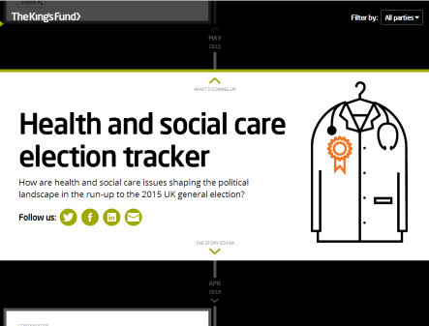
Also, the King’s Fund has an upcoming live stream Health and Care Debate covering the main parties at 11am on 21 April 2015.
Other UK News

In his blog, Roy Lilley says that 'One area of NHS efficiency that needs a real kick is the delivery of healthcare by the use of technology'. A head to head in the BMJ discusses Can healthy people benefit from health apps? In the Guardian, David Brindle says 'Politicians scramble to make NHS promises, but forget social care at their peril’. eHealth Insider looks at the Labour manifesto and says it fails to focus on IT, meanwhile The Conservative Party has promised to continue the NHS transparency agenda and to give people full access to their electronic health records. The Royal College of Nursing is worried about nursing numbers particularly in the community – crucial to new models of healthcare. The Long Term Care Revolution national challenge has now commenced - Innovate UK has announced dates, total fund and application arrangements. NHS hospital waiting time figures are the worst in seven years reports the Guardian. In a BBC report, David Nicholson, former health service boss says ‘NHS finance problem are being ignored’.
Global news
From the U.S.: IBM has teamed up with Apple and wants to launch new employee health and wellness management solutions. Watson Health will analyse app and activity tracking data obtained via the Apple watch. IBM has acquired two firms to assist - Explorys (one of the largest healthcare databases in the world) and Phytel (digital medical record systems to reduce hospital readmissions and automate communications). The system could provide diagnoses or health alerts which could also be sent to doctors, carers, or insurers with the user's consent. IBM has said that information will be anonymised and must have an ‘opt-in’ function.
Also:
IBM Creates Watson Health to Analyze Medical Data
Apple Watch hands over digital health data for IBM’s Watson to crunch
IBM Announces Deals With Apple, Johnson And Johnson, And Medtronic In Bid To Transform Health Care
Apple have been taking pre-orders for the Apple Watch from 10 April ready for the 24 April launch – will this new wearable support health and care services and enable people to self-manage? What apps will be available? Will the watch have sensors? Will wrist worn wearables replace older generations of telecare? Find out more in next week’s news update.
Upcoming Telecare/Telehealth UK events for April 2015:
Socitm Spring Conference – 23 April 2015, London http://www.socitmspringconference.com/
DHACA Day, 27 April Bradford - http://dhaca.org.uk/events/dhaca-day-iv/
Holyrood Telehealth and Telecare 2015 Glasgow, 28-29 April 2015 http://telehealthcare.holyrood.com/
Med-Tech Innovation Expo 29-30 April 2015, Coventry http://www.mtiexpo-uk.com/

Note: Telecare LIN is not responsible for the content and accuracy of external links

