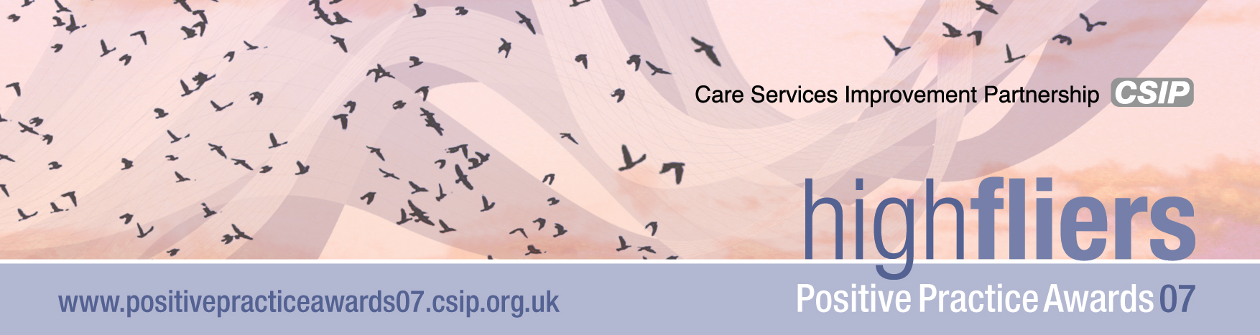
High Flying Positive Practice – you decide

The fourth Care Services Improvement Partnership (CSIP) Positive Practice Awards (PPA) are launched today in a new online version designed to give everyone interested in health and social care the chance to take part in these unique awards. Go to www.positivepracticeawards07.csip.org.uk

For the first time, all applications will not only be submitted on line but they can also be viewed and rated by the public, giving everyone the chance to participate in the judging process. Our panel of expert judges will take all views and ratings into consideration when looking at individual applications. No other public service awards have tried this approach.

Closing date for applications is 1st October 2007 and short-listed entries will be announced on the 15th October 2007. The award ceremony will take place on 17th December 2007 at the Royal Lancaster Hotel, Lancaster Gate, Hyde Park Corner, London.

Award categories:

The award for an individual is:
- Making a difference

The awards for teams are:
- Innovative partnerships
- High impact changes in mental health
- Specialist services
- Recognising diversity
- Personalisation – improving choice and control
- Information sharing joining health and social care
- Children and families and young people
- Health and social care in criminal justice
- New ways of working
- Using football to improve outcomes in health and well-being (sponsored by the Football Association)
- Innovative commissioning
Winners receive:

- £2,000 and a trophy
in addition to all short-listed receiving
- two highly commended in each category
- two places for the awards dinner in London in December for each short-listed entry and accommodation
- a logo stating you were a winner or highly commended
- inclusion in our 2007 positive practice publication
- promotion of your practice on our website, and
- support from CSIP to profile your work.
For more information:

Contact Cassandra McHugh on 0113 2545127 or email cassandra.mchugh@csip.org.uk

