

CSIP Telecare eNewsletter

***Season’s Greetings and a Happy New Year to CSIP eNewsletter readers***

December 2007

Welcome to the December 2007 CSIP telecare eNewsletter. The Care Services Improvement Partnership (CSIP) is responsible for providing general implementation support to organisations building their telecare and telehealth programmes.

If you are an organisation implementing telecare and have an interesting local telecare story for inclusion in a future newsletter then e-mail Mike Clark (newsletter editor, CSIP Networks) at telecare@csip.org.uk

If you or a colleague would like to receive future copies of the newsletter then all you need to do is register at http://www.icn.csip.org.uk/index.cfm?pid=12

CSIP telecare services have now moved to: www.icn.csip.org.uk/telecare

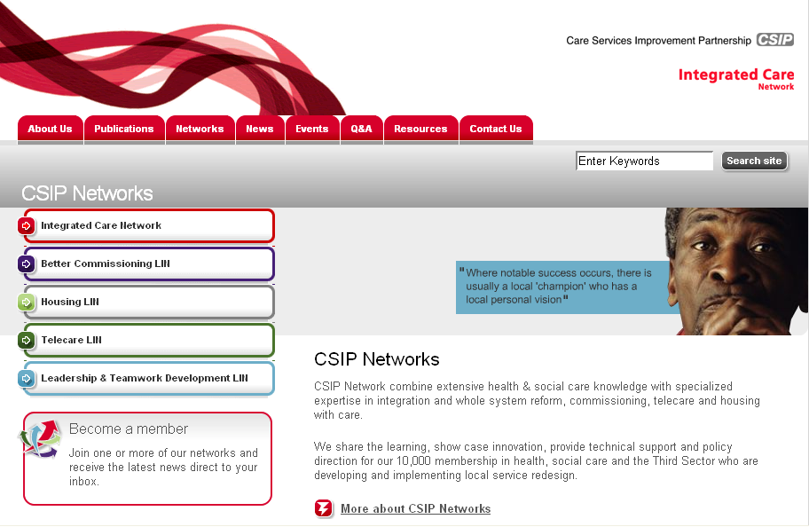

Here are some short cuts to get you to the new locations quickly:

www.icn.csip.org.uk/telecareguide
www.icn.csip.org.uk/telecarenewsletters
www.icn.csip.org.uk/telecarefactsheets
www.icn.csip.org.uk/telecareprofiles

***Forthcoming CSIP 2008 telecare events – London (24 Jan), Leeds (29 Jan), Manchester (4 Feb), Taunton (7 Feb) and Birmingham (12 Feb) – Booking now available***

Contents
1 Putting People First – what does it mean for telecare/telehealth? 3
2 Announcements and other publications 16
3 CSIP telecare and telehealth events for 2008 18
4 Events 20

Item 1 looks at the recent Putting People First Concordat and looks at the implications for telecare and health

Item 2 provides an update of recent announcements and publications

Item 3 provides update information on the recently announced telecare and telehealth events

Item 4 lists other upcoming events of interest

Glossary:

ALIP – Assistive Living Innovation Platform
AT – Assistive Technology
BERR – Business Enterprise and Regulatory Reform
CSCI – Commission for Social Care Inspection
FACS – Fair Access to Care Services
NHS CfH – NHS Connecting for Health
NHS PASA – NHS Purchasing and Supply Agency
PT Grant or PTG – Preventative Technology Grant
TSA – Telecare Services Association

Prepared by Mike Clark for CSIP Networks
1 Putting People First – what does it mean for telecare/telehealth?

Telecare LIN

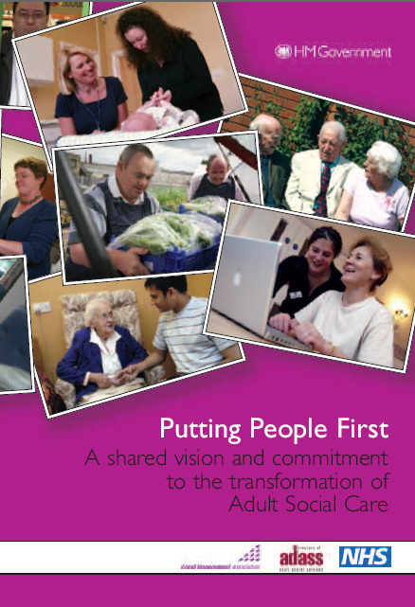 | Section 3.3 “…… Person centred planning and self directed support to become mainstream and define individually tailored support packages. Telecare to be viewed as integral not marginal……”

Speech by the Rt Hon Alan Johnson MP, Secretary of State for Health, 10 December 2007: ‘Putting People First’ - Launch of new social care reform concordat (10 December 2007)

“There are five elements of our shared vision for transformation:
1) A new relationship between Government, Local Authorities, the NHS, Independent Sector Providers and the Regulator.
2) A major shift of resources and practice to prevention, early intervention and re-enablement.
3)High quality accessible information and advice available to all irrespective of financial means,
4) a commitment to treating Carers as partners and
5) maximum power, control and choice in the hands of the people who use these services and their Carers”.

Link:
http://www.dh.gov.uk/en/News/Speeches/DH_081194

In this newsletter we take a more detailed look at ‘Putting People First’ and start to consider the impact of this very important announcement for telecare stakeholders. The text in the following boxes is directly taken from the Concordat document. Links are made to other key policies and documents that commissioners and service providers in health, housing and social care need to be aware of.

Link to Putting People First:
http://www.dh.gov.uk/en/Publicationsandstatistics/Publications/PublicationsPolicyAndGuidance/DH_081118
Listen to Alan Johnson’s Speech plus speeches from two beneficiaries of individual budgets at:
http://www.kingsfund.org.uk/events/past_events/social_care.html

Section 1 of the Concordat

…. access to high quality support should be universal and available in every community.

….Ultimately, every locality should seek to have a single community based support system focussed on the health and wellbeing of the local population. Binding together local Government, primary care, community based health provision, public health, social care and the wider issues of housing, employment, benefits advice and education/training….

…The new local performance framework, which covers the delivery of all services by local government working alone or in partnership, will help to create an improved approach to local partnership, enabling local authorities and partners to work together to lead their area and better meet the public’s needs. The transformation of adult social care will be delivered through the new performance framework, and will draw on new mechanisms within the framework, such as the new statutory requirement on local authorities and PCTs to undertake a Joint Strategic Needs Assessment, to ensure that the transformation process really delivers on the challenges for each local area….

….In future organisations will be expected to put citizens at the heart of a reformed system.

Local authorities and their partners implementing telecare and telehealth are working hard to put citizens at the heart of their service arrangements. Much work has been done across the country to tailor care packages for individuals, however, it will be important to work in a more coordinated and integrated manner across agencies.

This includes bringing together health, housing, social care, third sector and other providers to support innovative care packages and provide information and advice for people that will have personal budgets. Commissioners and service providers will need to ensure that telecare is picked up at all appropriate steps in particular commissioning intentions and local area agreements.

Listed below are links for other important publications in understanding this section of the Concordat.

Links:
Commissioning framework for health and well-being:
http://www.dh.gov.uk/en/Publicationsandstatistics/Publications/PublicationsPolicyAndGuidance/DH_072604

World Class Commissioning:
http://www.dh.gov.uk/en/Policyandguidance/Organisationpolicy/Commissioning/Worldclasscommissioning/index.htm

CSIP Networks – Better Commissioning:
http://www.icn.csip.org.uk/betterCommissioning/

Local Area Agreements:
http://www.communities.gov.uk/localgovernment/performanceframeworkpartnerships/localareaagreements/

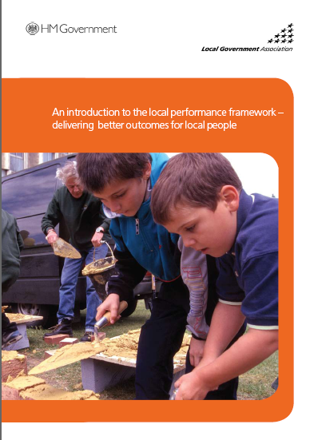 | 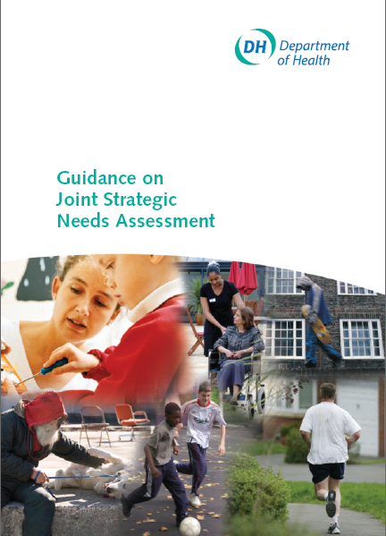

Local Performance Framework:
http://www.communities.gov.uk/publications/localgovernment/localperformanceframework

Joint Strategic Needs Assessment – includes guidance published on 13 December 2007:
http://www.dh.gov.uk/en/Publicationsandstatistics/Publications/PublicationsPolicyAndGuidance/DH_081097

Section 2 of the Concordat

….The time has now come to build on best practice and replace paternalistic, reactive care of variable quality with a mainstream system focussed on prevention, early intervention, enablement, and high quality personally tailored services. In the future, we want people to have maximum choice, control and power over the support services they receive…..

…..Over time, people who use social care services and their families will increasingly shape and commission their own services. Personal Budgets will ensure people receiving public funding use available resources to choose their own support services – a right previously available only to self-funders. The state and statutory agencies will have a different not lesser role – more active and enabling, less controlling….

Since Building Telecare in England in 2005, local authorities and their partners have been building up best practice in telecare and telehealth provision. However, service options have mainly been limited to existing community alarm and telecare providers, often provided by local authorities themselves. This will need to move forwards so that individual users and carers can make an informed choice.

Tailoring of services for assessed FACS-eligible users has been very good and telecare is increasingly being used as part of the assessment process (eg for people with dementia) and re-ablement programmes. Although sensor-based approaches for FACS-eligible users has also been good, preventative services for people not eligible (eg previously low/moderate under FACS) has not gone much beyond pendant alarms and smoke detectors primarily backed through Supporting People programmes. Early intervention means having a wide range of existing and potential service users on your local ‘radar’ with direct provision of preventative services and information/advice for self-funders and those using personal budgets. This will support individual choice enabling people to have control and power over the services they receive. The choice will extend to equipment ownership, wider choice of devices available on the high street to support care plans (eg mobile phones with video facilities or linked to home sensors).

Section 3

The key elements of a personalised adult social care system will be:

3.1 Local authority leadership accompanied by authentic partnership working with the local NHS, other statutory agencies, third and private sector providers, users and carers and the wider local community to create a new, high quality care system which is fair, accessible and responsive to the individual needs of those who use services and their carers.
The current Darzi review of the NHS has recognised the relationship between health, social care and wider community services will be integral to the creation of a truly personalised care system.

The Darzi Review, Our NHS, our future: NHS next stage review (Department of Health, October 2007) takes stock of progress made in recent years towards the vision of a patient-centred NHS set out in the NHS Plan (Department of Health, 2000). It challenges us to look ahead for the next decade and consider what more we could and should be doing to respond to people’s rising aspirations.

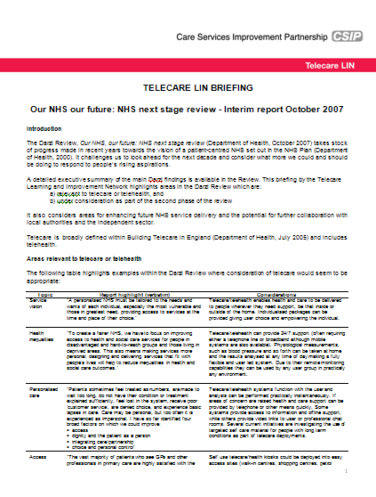 | Dr Simon Brownsell has prepared a special briefing on the Darzi Review for CSIP Networks.

Telecare Briefing Link:
http://www.icn.csip.org.uk/telecare/index.cfm?pid=353&catalogueContentID=2457

Our NHS Our future: NHS next stage review - interim report (Department of Health, October 2007)
http://www.dh.gov.uk/en/Publicationsandstatistics/Publications/PublicationsPolicyAndGuidance/dh_079077

Our NHS, Our future – web site:
http://www.ournhs.nhs.uk/

3.2 Agreed and shared outcomes which should ensure people, irrespective of illness or disability, are supported to:
- live independently;
- stay healthy and recover quickly from illness;
- exercise maximum control over their own life and where appropriate the lives of their family members;
- sustain a family unit which avoids children being required to take on inappropriate caring roles;
- participate as active and equal citizens, both economically and socially;
- have the best possible quality of life, irrespective of illness or disability;
- retain maximum dignity and respect.

This section stresses the importance of agreed and shared outcomes. It will be important to identify best outcomes from telecare and telehealth services. This means understanding the pathways where remote monitoring can be supported and looking at how device packages and monitoring/response services can be tailored. In future, individuals will have a personal budget to directly purchase services – it will be important to ensure that appropriate accurate and independent advice and guidance is available to identify options that will meet user needs.
3.3 System-wide transformation, developed and owned by local partners covering the following objectives:
- A joint strategic needs assessment undertaken by local authorities, relevant PCT and NHS providers. This should be undertaken in conjunction with other local needs assessments and plans (for example, local housing strategies). The joint strategic needs assessment and these other plans will inform the Sustainable Community Strategy. It will also be accompanied by an integrated approach with local NHS commissioners and providers to achieve specific outcomes on issues including:
- relevant preventative public health policies, e.g. infection control and fall reduction strategies;
- hospital discharge arrangements;
- the provision of adequate intermediate care;
- the management of long term conditions;
- packages of support with a health and/or nursing care element;
- co-located services, bringing together social care;
primary care and other relevant professionals;
- community equipment services;
- universal information, advice and advocacy;
- carer support and public/patient involvement;
- complaints systems.

Joint Strategic Needs Assessment – includes guidance published on 13 December 2007:
http://www.dh.gov.uk/en/Publicationsandstatistics/Publications/PublicationsPolicyAndGuidance/DH_081097

Local Housing Strategy:
http://www.communities.gov.uk/housing/strategiesandreviews/localauthorityhousing/

CSIP Networks – Housing:
http://www.icn.csip.org.uk/housing/

Sustainable Community Strategy:
http://www.sustainable-development.gov.uk/advice/local/localleadership.htm
http://www.sustainable-development.gov.uk/publications/documents/sustainable-communities-guide.pdf

Falls prevention (NSF for Older People – Standard 6):
http://www.dh.gov.uk/en/Policyandguidance/Healthandsocialcaretopics/Olderpeoplesservices/DH_4002294

Hospital discharge:
http://www.dh.gov.uk/en/Publicationsandstatistics/Publications/PublicationsPolicyAndGuidance/DH_4088366
http://www.dh.gov.uk/en/Publicationsandstatistics/Publications/PublicationsPolicyAndGuidance/DH_4003252
http://www.dh.gov.uk/en/Publicationsandstatistics/Publications/PublicationsPolicyAndGuidance/DH_4050931
http://www.dh.gov.uk/en/Publicationsandstatistics/Publications/PublicationsPolicyAndGuidance/Browsable/DH_4097757
http://www.dh.gov.uk/en/Publicationsandstatistics/Publications/PublicationsPolicyAndGuidance/DH_4007881

Intermediate care (NSF for Older People – Standard 3):
http://www.dh.gov.uk/en/Policyandguidance/Healthandsocialcaretopics/Olderpeoplesservices/DH_4002288

Long term conditions:
http://www.dh.gov.uk/en/Policyandguidance/Healthandsocialcaretopics/Longtermconditions/index.htm
http://www.dh.gov.uk/en/Policyandguidance/Healthandsocialcaretopics/Longtermconditions/DH_4140328

Continuing care:
http://www.dh.gov.uk/en/Policyandguidance/SocialCare/Socialcarereform/Continuingcare/index.htm

Guidance on NHS funded nursing care:
http://www.dh.gov.uk/en/Publicationsandstatistics/Lettersandcirculars/LocalAuthorityCirculars/AllLocalAuthority/DH_4003962

Transforming community equipment:
http://www.csip.org.uk/~csed/workstreams/transforming-community-equipment--wheelchair-services.html

Carer Support:
http://www.dh.gov.uk/en/Publicationsandstatistics/Publications/PublicationsPolicyAndGuidance/DH_078093

New deal for carers:
http://www.dh.gov.uk/en/Policyandguidance/SocialCare/Deliveringadultsocialcare/Carers/NewDealforCarers/index.htm

Our health, our care, our say:
http://www.dh.gov.uk/en/Policyandguidance/Organisationpolicy/Modernisation/Ourhealthourcareoursay/index.htm

Patient and public involvement:
http://www.dh.gov.uk/en/Policyandguidance/Organisationpolicy/PatientAndPublicinvolvement/index.htm

Independent Complaints Advocacy Service:
http://www.dh.gov.uk/en/Policyandguidance/Organisationpolicy/Complaintspolicy/NHScomplaintsprocedure/DH_4087428

The full range of relevant local statutory, voluntary and private sector organisations need to be fully engaged. Where appropriate, Local Area Agreements will be the vehicle to bring together national policy with local priorities, informed by the vision developed by local partners. This will mean organisations being willing to allocate funding to others, if this will have greater impact on shared outcomes. The NHS Operating Framework will reflect a new shared responsibility for the health and wellbeing of citizens, families and communities.

This will mean involvement of a wide range of stakeholders involved in telecare and telehealth provision. It will also start to address the issue of benefits accruing to organisations which are not actually providing inputs (a frequently mentioned barrier to telecare implementation). Local area agreements will need to include stretch targets for preventative services such as telecare and telehealth. Pooled funds and joint/strategic commissioning should also be considered to make the best use of resources available across organisations.

CSIP Networks - Integrated care and partnership working:
http://www.icn.csip.org.uk/icn/
Local Area Agreements:
http://www.communities.gov.uk/localgovernment/performanceframeworkpartnerships/localareaagreements/

NHS Operating Framework for 2008/9:
http://www.dh.gov.uk/en/Publicationsandstatistics/Publications/PublicationsPolicyAndGuidance/DH_081094

Commissioning which incentivises and stimulates quality provision offering high standards of care, dignity and maximum choice and control for service users. Supports third/private sector innovation, including social enterprise and where appropriate is undertaken jointly with the NHS and other statutory agencies eg Learning and Skills Council, employment services, and Housing Authorities. This must be shaped by the Joint Strategic Needs Assessment.

Telecare and telehealth will need to be commissioned as part of integrated health, housing and social care services using identifiable technical and service standards. A choice of services will need to be provided in each area with appropriate independent advice and guidance.
Commissioning framework for health and well-being:
http://www.dh.gov.uk/en/Publicationsandstatistics/Publications/PublicationsPolicyAndGuidance/DH_072604
Dignity in care:
http://www.dh.gov.uk/en/Policyandguidance/SocialCare/Socialcarereform/Dignityincare/DH_4134922
National minimum standards:
http://www.csci.org.uk/professional/care_providers/all_services/national_minimum_standards.aspx

The NHS PASA National Framework Agreement and the Assisted Living Innovation Platform are supporting third/private sector innovation. Several telecare providers are operating in the third sector and other social enterprise organisations are under consideration.

Social enterprises in health and social care:
http://www.dh.gov.uk/en/Policyandguidance/Organisationpolicy/Commissioning/Socialenterprise/index.htm
http://www.dh.gov.uk/en/Publicationsandstatistics/Publications/PublicationsPolicyAndGuidance/DH_072928

Joint Strategic Needs Assessment – includes guidance published on 13 December 2007:
http://www.dh.gov.uk/en/Publicationsandstatistics/Publications/PublicationsPolicyAndGuidance/DH_081097

NHS PASA – Telecare national framework agreement:
http://www.pasa.nhs.uk/PASAWeb/Productsandservices/Telecare/

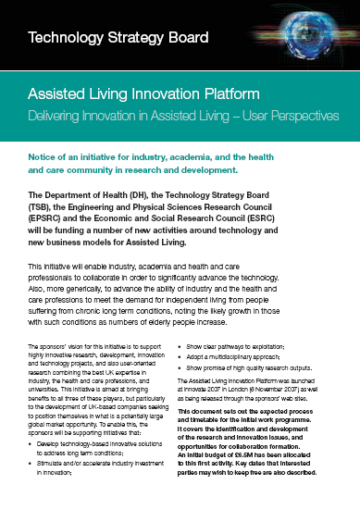

BERR – Technology Strategy Board
http://www.berr.gov.uk/innovation/technologystrategyboard/index.html

BERR Press Release on Assisted Living Innovation Platform:
http://www.berr.gov.uk/innovation/technologystrategyboard/page42353.html
http://www.technologyprogramme.org.uk/site/IP/ALIP/default.cfm
Learning and Skills Council:
http://www.lsc.gov.uk/

- A locally agreed approach, which informs the Sustainable Community Strategy, utilising all relevant community resources especially the voluntary sector so that prevention, early intervention and enablement become the norm. Supporting people to remain in their own homes for as long as possible. The alleviation of loneliness and isolation to be a major priority. Citizens live independently but are not independent; they are interdependent on family members, work colleagues, friends and social networks.

Telecare service providers will need to address the issues around supporting people in their own homes where this can lead to loneliness and depression simply because they are not prepared to go outside of the sensor zone. In future, portable and wearable devices that enable people to remain mobile will help support physical activity as well as reduce isolation and exclusion.

Sustainable Community Strategy:
http://www.sustainable-development.gov.uk/advice/local/localleadership.htm
http://www.sustainable-development.gov.uk/publications/documents/sustainable-communities-guide.pdf

- A universal information, advice and advocacy service for people needing services and their carers irrespective of their eligibility for public funding. A ‘first shop stop’, which could be accessed by phone, letter, e-mail, internet or at accessible community locations. Key strategic partners to be the Pensions Agency and relevant voluntary organisations. The LinkAge Plus pilots are providing strong evidence of the benefits for older people of this approach. Personal advocates to be available in the absence of a carer or in circumstances where people require support to articulate their needs and/or utilise the personal budget.

Local authorities and their partners will need to consider the provision of telecare and telehealth information through accessible locations. These locations will provide a range of services across Government Departments. Ethnical and consent issues for telecare provision will become increasingly important. This includes the involvement of advocates.

Ashford Gateway (Kent) – example of services with key partners:
http://www.ashfordgateway.co.uk/
Pensions Agency:
http://www.dwp.gov.uk/
LinkAge Plus:
http://www.dwp.gov.uk/opportunity_age/linkage/

Independent Mental Capacity Advocate Service:
http://www.dh.gov.uk/en/Policyandguidance/SocialCare/Deliveringadultsocialcare/MentalCapacity/IMCA/index.htm

- A common assessment process of individual social care needs with a greater emphasis on self-assessment. Social workers spending less time on assessment and more on support, brokerage and advocacy.

This recognises the importance of single/common assessment processes with a recognition of the importance of self-assessment that would include information about telecare options in the area. This should enable skilled social workers, care and case managers to provide support, information, guidance and in some cases individual representation with service providers. Assessors will need access to independent information from a wide range of sources to provide assistive technology solutions.
Single assessment process:
http://www.dh.gov.uk/en/Policyandguidance/SocialCare/Chargingandassessment/SingleAssessmentProcess/index.htm
Common assessment framework:
http://www.socialcare.csip.org.uk/index.cfm?pid=7
Self-assessment:
http://www.socialcare.csip.org.uk/index.cfm?pid=81

- Person centred planning and self directed support to become mainstream and define individually tailored support packages. Telecare to be viewed as integral not marginal.

These specific comments on telecare as ‘integral not marginal’ helps us take services forwards into the future as an important part of care packages and person centred approaches. This reflects the importance with which remote monitoring support for people to remain in their own homes is now taken and is recognition of the work carried out by local authorities and their partners across the country to build telecare services for their local populations.

This means considering telecare as a serious option for every care package and asking the question “is there any reason why telecare would not be suitable for this individual?” Social Care panels will need to address telecare and telehealth options in their discussions as part of an holistic, whole system approach. The balance between human contact and remote monitoring support should provide extra re-assurance for all stakeholders.

Services should now be fully costed and telecare/telehealth options should be embedded in care pathways based on work carried out by local authorities and their partners over the last couple of years.

Charging (for social care, where applicable) needs to be locally agreed and transparent (see Building Telecare in England). Failure to have service costs and charging options in place could lead to problems with personal budget administration. Although a care package may include telecare, users with personal budgets will need to have sufficient resources available to maintain their current and future care packages. With the majority of these packages having significant domiciliary care hours included (often ten hours or more per week), it is vital that there is sufficient money within the personal budget to fund existing and future telecare provision.

As people start to take on their personal budgets, there is also the possibility that domiciliary care providers who often act as a responder and meet the CSCI minimum standards, will start to add telecare into their service offerings to provide added value. Local commissioners will need to look at how capacity is built and maintained in the sector to provide choice for users, carers and other stakeholders from a range of providers.

Building Telecare in England:
http://www.dh.gov.uk/en/PolicyAndGuidance/HealthAndSocialCareTopics/OlderPeoplesServices/DH_4116208

CSIP Networks – telecare:
www.icn.csip.org.uk/telecare

Person centred approaches:
http://www.scie.org.uk/publications/practiceguides/adultplacement/planning.asp
http://www.valuingpeople.gov.uk/dynamic/valuingpeople135.jsp

- Personal budgets for everyone eligible for publicly funded adult social care support other than in circumstances where people require emergency access to provision. Lord Darzi’s recent NHS next stage review interim report suggested that in the future personal budgets for people with long term conditions could include NHS resources.

Further information is expected later on the administration of personal budgets. Although there has been some media speculation on possible coverage of long term conditions, no decisions have been made at this time to do so.

Our NHS Our future: NHS next stage review - interim report (Department of Health, October 2007)
http://www.dh.gov.uk/en/Publicationsandstatistics/Publications/PublicationsPolicyAndGuidance/dh_079077

Telecare briefing link on Darzi Report:
http://www.icn.csip.org.uk/telecare/index.cfm?pid=353&catalogueContentID=2457

- Direct payments utilised by increasing numbers of people, as defined by locally set targets in LAAs.

Direct payments that include telecare hardly exist. There are thought to be just a handful of examples.
This may be partly because telecare has been provided at no charge in many programmes whilst there is grant funding and also because commissioners and locally social workers and care managers have not looked beyond their own existing services as an option so there is no true appreciation of the costs and charging arrangements yet.
As we move from the current adult social care performance framework into the next round of local area agreements across local authority/health services, it will be important to ensure that drivers are in place to maintain take-up of telecare services. Only a handful of current LAA’s make reference to telecare.
Local Area Agreements:
http://www.communities.gov.uk/localgovernment/performanceframeworkpartnerships/localareaagreements/
Direct payments:
http://www.dh.gov.uk/en/Policyandguidance/SocialCare/Socialcarereform/Personalisation/Directpayments/index.htm
Individual budgets including evaluation:
http://www.dh.gov.uk/en/Policyandguidance/SocialCare/Socialcarereform/Personalisation/Individualbudgets/index.htm
http://individualbudgets.csip.org.uk/index.jsp
http://www.ibsen.org.uk/metadot/index.pl?id=2191&isa=Category&op=show

- Family members and carers to be treated as experts and care partners other than in circumstances where their views and aspirations are at odds with the person using the service or they are seeking to deny a family member the chance to experience maximum choice and control over their own life. Programmes to be supported which enable carers to develop their skills and confidence.

Family members and carers have been crucial to the success of telecare as a service. As well as providing a responder service, they will need to be involved in appropriate parts of care planning (with the consent of the service user) together with choices around the telecare services that are available in the local community.
Our Health our care our say – Chapter 5 (New deal for carers – expert carers programmes)
http://www.dh.gov.uk/en/Policyandguidance/Organisationpolicy/Modernisation/Ourhealthourcareoursay/index.htm

Carer Support:
http://www.dh.gov.uk/en/Publicationsandstatistics/Publications/PublicationsPolicyAndGuidance/DH_078093

- A transformed community equipment service, consistent with the retail market model.

Although telecare was not included within the scope of the transforming community equipment initiative because of the commencement of the PT Grant, there is no reason why the strengths of the retail model should not be considered by local authorities in service commissioning and building local capacity for telecare provision. This will support choice and convenience for users, carers and other stakeholders. Independent information and service provider comparisons will become more important.
Transforming community equipment:
http://www.csip.org.uk/~csed/workstreams/transforming-community-equipment--wheelchair-services.html

- Systems which support integrated working with children’s services, including transition planning and parent carers, and identifying and addressing concerns about children’s welfare.

- Support for at least one local user led organisation and mainstream mechanisms to develop networks which ensure people using services and their families have a collective voice, influencing policy and provision.

Telecare service providers can play an important role in identifying issues and concerns and ensuring that they are brought to the attention of commissioners in conjunction with other networks. User feedback can be used effectively to improve service standards in a number of areas.
- Systems which act on and minimise the risk of abuse and neglect of vulnerable adults, supported by a network of “champions”, including volunteers and professionals, promoting dignity in local care services.

Telecare provides opportunities for proactive as well as reactive monitoring. This provides re-assurance to people in their own homes. Complementary call monitoring arrangements ensure that domiciliary care is provided to meet agreed care plans. These are rapid and effective ways of ensuring that problems are picked up early.
- Local workforce development strategies focussed on raising skill levels and providing career development opportunities across all sectors. Strategies to be co-produced, co-developed and co-evaluated with the private and voluntary sectors.

In the light of ‘Putting People First’ and the progress made on telecare implementation, it will be important to further consider the skills that key stakeholders need in providing telecare and telehealth services in the future. Some work has been carried out by FAST, Skills for Care, Skills for Health and CSIP to look at workforce development in telecare and the broader assistive technology areas.

FAST – AT Workforce Development:
http://www.fastuk.org/atforumactivities/workforcedevelopment.php

Adult social care will also take responsibility for championing the rights and needs of older people, disabled people, people with mental health needs and carers within the local authority, across public services and in the wider community. Early priorities will be intergenerational programmes involving older people as active citizens, integrated policy development which supports independent living (housing, access to work, education/training and leisure) including transition planning for young disabled people and local action to tackle the stigma faced by people with mental health problems.

Putting People First:
http://www.dh.gov.uk/en/Publicationsandstatistics/Publications/PublicationsPolicyAndGuidance/DH_081118
Letter to Directors of Adult Social care - LASSL(DH) (2007)2:
http://www.dh.gov.uk/en/Publicationsandstatistics/Lettersandcirculars/Localauthoritysocialservicesletters/DH_081123
2 Announcements and other publications

Telecare LIN

- Social Care Reform Grant - On 10 December 2007, the Department of Health announced a £520 million Social Care Reform Grant over the next three years to transform care and independent living for older and disabled people through the introduction of personal care budgets and a concordat between central and local government, NHS and Social care. This was in the form of a letter to local authorities (LASSL(DH) (2007)2).

Link:
http://www.dh.gov.uk/en/Publicationsandstatistics/Publications/PublicationsPolicyAndGuidance/DH_081118
LASSL(DH) (2007)2:
http://www.dh.gov.uk/en/Publicationsandstatistics/Lettersandcirculars/Localauthoritysocialservicesletters/DH_081123
LASSL(DH) (2007)3 – single capital pot:
http://www.dh.gov.uk/en/Publicationsandstatistics/Lettersandcirculars/Localauthoritysocialservicesletters/DH_081126

- More Extra Care Housing funding forthcoming - The Local Authority circular LASSL(DH)(2007)2 accompanying the Social Care Reform Grant also highlights a number of specific revenue and capital programmes that the Department of Health will be taking forward to enhance independent living opportunities for older people. This includes a further £80m grant programme for extra care housing over the next two years, approximately £40m per annum. Further details of the bidding arrangements are expected in early 2008.

Link:
http://www.dh.gov.uk/en/Publicationsandstatistics/Lettersandcirculars/Localauthoritysocialservicesletters/DH_081123

- Supporting People funding news - The Department for Communities and Local Government has announced £4.9bn funding for the Supporting People programme over the next three years. The funding will help over a million vulnerable people each year, including victims of domestic violence, teenage parents, older people and those with mental health problems – enabling them to live independently in their accommodation. Supporting People funding will total £1.686bn in 2008/ 2009, £1.666bn in 2009/2010 and £1.636bn in 2010/11.

Link:
http://www.spkweb.org.uk/Subjects/Finance/Grant+Allocations+2008-09/Grant+allocations+2008-09.htm
www.local.communities.gov.uk/finance/0809/specgrant/supporting people.xls

- Housing with Care Matters – news from CSIP Networks (December 2007)

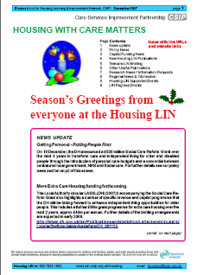 | The December 2007 newsletter (Housing and Care Matters) covers a wide range of housing, social care and health news including recent important announcements about Supporting People and Extra Care.  Contents:  1 News update  2 Policy News  3 Capital Funding News  4 New Housing LIN Publications  5 Telecare LIN Briefing  5 Other Useful Publications  7 Research News / Information Requests  8 Regional News & Information  8 Housing LIN Supported Events  9 LIN Regional Events

Link:
http://www.icn.csip.org.uk/_library/Resources/Housing/Support_materials/Newsletter/Newsletter26.pdf

- The NHS in England: The operating framework for 2008/9 – Department of Health, December 2007

The operating framework is an annual document that gives direction to health trusts.

Link:
http://www.dh.gov.uk/en/Publicationsandstatistics/Publications/PublicationsPolicyAndGuidance/DH_081094

- National stroke strategy (Department of Health, December 2007)

Organisations looking at commissioning telecare in their areas will need to be aware of the stroke strategy.

Link:
http://www.dh.gov.uk/en/Publicationsandstatistics/Publications/PublicationsPolicyAndGuidance/DH_081062

- Confirmation of Payment by Results arrangements for 2008/09 (Department of Health, December 2007)

The Payment by Results arrangements sets out the national tariff for 2008/9. This is of importance when looking at telecare/telehealth and any potential savings in hospital admissions.

Link:
http://www.dh.gov.uk/en/Policyandguidance/Organisationpolicy/Financeandplanning/NHSFinancialReforms/DH_081238

- Guidance on Joint Strategic Needs Assessment (Department of Health, December 2007)

Link:
http://www.dh.gov.uk/en/Publicationsandstatistics/Publications/PublicationsPolicyAndGuidance/DH_081097

- Consultation on pandemic influenza (Department of Health, November 2007)

Local commissioners and telecare providers will need to have plans in place to respond to a pandemic flu outbreak.

Link:
http://www.dh.gov.uk/en/Consultations/Liveconsultations/DH_080737

- Consultation - Possible amendments to medicines and associated legislation during an influenza pandemic (Department of Health, November 2007)

During a flu pandemic, there could be issues with the availability of medicines. This consultation document considers the relevant areas.

Link:
http://www.dh.gov.uk/en/Consultations/Liveconsultations/DH_080768

- Medical device alert - MDA/2007/077 - Home use blood glucose meters: Boots brand blood glucose monitoring system

http://www.mhra.gov.uk/home/idcplg?IdcService=SS_GET_PAGE&useSecondary=true&ssDocName=CON2032712&ssTargetNodeId=365

- Improving Chronic Disease Management - An Anglo–American exchange (Kings Fund, November 2007)

http://www.kingsfund.org.uk/publications/kings_fund_publications/improving_1.html

3 CSIP telecare and telehealth events for 2008

Telecare LIN

Update from Mike Clark, CSIP Networks

The scheduled CSIP events are as follows and registration is now open:

Venue | Date
London | 24 January 2008
Leeds | 29 January 2008
Manchester | 4 February 2008
Taunton | 7 February 2008
Birmingham | 12 February 2008

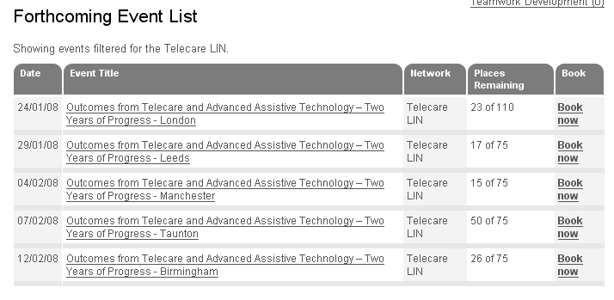

Position at 18 December 2007

Link:
http://www.icn.csip.org.uk/index.cfm?pid=476&sectorID=170

Some of the events are proving popular and we may have to restrict some requests where a number of people are registering from the same organisation. Around 270 people have booked in the first ten days so it is important to make your arrangements as soon as possible. We are monitoring the lower take-up for the Taunton event with 25 booked at this time, but places at the other sites are moving quickly.

The main aim of these five events is for organisations to share the impact of their services on stakeholders and hear what others are doing from neighbouring areas since the publication of Building Telecare in England in 2005. In addition, attendees will hear more about telehealth and the best practice approaches that will take local authorities, health trusts, third sector and partner organisations into the future as telecare and telehealth move towards mainstream services.

The outcomes events are about:

- Redesigning and restructuring services to include telecare and telehealth options
- Developing new ways of partnership and integrated working through telecare and telehealth
- Promoting care closer to home, dignity and choice using telecare and telehealth
- Adjusting care pathways to include cost-effective AT solutions
- Identifying implementation barriers and how they have been overcome
- Progress made with learning disability and other service users who are now benefiting from telecare solutions
- Balancing FACS-eligible, preventative, targeted and self care approaches
- Working with suppliers to develop innovative solutions to local problems
- Introducing self-assessment and supported self directed care, direct payments, personal budgets
- Identifying sensor configurations that are effective for dementia assessment and support
- Obtaining initial evaluations on vital signs and long term condition monitoring
- Reviewing AT arrangements for preventative services to include telecare and telehealth
- Extending housing schemes with telecare support
- Identifying and overcoming barriers to user acceptance of technology
- Examining impact on carers
- Establishing locally whether telecare has an impact on care home and hospital admissions
- Providing training and awareness to a wide range of stakeholders as well as longer term workforce issues
- Identifying individual outcomes and service cost-effectiveness

We are not expecting full-blown evaluations but sometimes these can help in providing an external review and objective assessment of your work. We would like to see ‘outcomes’ for the investment you have made locally. Service redesign examples are as important as numbers of new users.

Local authorities and their partners will remember that the 2006 CSCI performance assessment covered ‘description of the service’. The descriptions are included in each local authority’s telecare profile included at www.icn.csip.org.uk/telecareprofiles and were listed in the November newsletter.

During December 2007, CSIP’s Mike Clark will be e-mailing contacts from our extensive membership database to look at how progress is being made against initial plans. CSIP will be collecting outcomes and learning points for the five events. These will link up in April 2008 with the CSCI performance assessment information.

4 Events

Telecare LIN

- CSIP Telecare events

Venue | Date
London | 24 January 2008
Leeds | 29 January 2008
Manchester | 4 February 2008
Taunton | 7 February 2008
Birmingham | 12 February 2008

- Housing LIN events – booking now available:

16/01/08 South West Regional Housing LIN Meeting

31/01/08 West Midlands Regional Housing LIN Meeting

28/02/08 North West Regional Housing LIN Meeting

10/04/08 West Midlands Regional Housing LIN Meeting

Full list of Housing LIN events:

http://www.icn.csip.org.uk/housing/index.cfm?pid=167

Latest Housing LIN Newsletter:
http://www.icn.csip.org.uk/_library/Resources/Housing/Support_materials/Newsletter/Newsletter26.pdf

The Foundation for Assistive Technology (FAST) provides a full listing of forthcoming telecare events – see http://www.fastuk.org/services/events.php?pg=2. Suppliers also run telecare and telehealth events – check their web sites regularly for dates.

All previous telecare eNewsletters are available at: www.icn.csip.org.uk/telecarenewsletters

CSIP Telecare Services

You can send comments and questions about the CSIP Implementation Guide, factsheets or other resources or contact us via telecare@csip.org.uk. Also, use this mailbox to send in good practice examples.

If you or a colleague would like to receive future copies of the newsletter then all you need to do is register at http://www.icn.csip.org.uk/index.cfm?pid=12

