

CSIP Telecare eNewsletter

July 2007

Welcome to the July 2007 CSIP telecare eNewsletter. The Care Services Improvement Partnership (CSIP) is responsible for providing general implementation support to organisations building their telecare and telehealth programmes.

If you are an organisation implementing telecare and have an interesting local telecare story for inclusion in a future newsletter then e-mail Mike Clark (newsletter editor) at telecare@csip.org.uk

If you or a colleague would like to receive future copies of the newsletter then all you need to do is register at http://www.icn.csip.org.uk/index.cfm?pid=12

CSIP telecare services have now moved to: www.icn.csip.org.uk/telecare

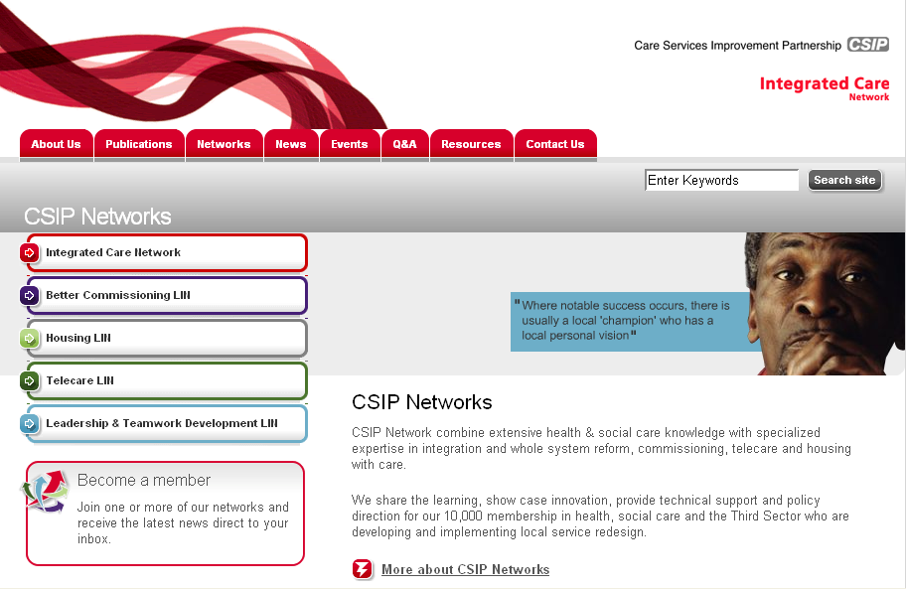

Here are some short cuts to get you to the new locations quickly:

www.icn.csip.org.uk/telecareguide
www.icn.csip.org.uk/telecarenewsletters
www.icn.csip.org.uk/telecarefactsheets
www.icn.csip.org.uk/telecareprofiles

Contents
1 Preventative Technology Grant carry over 3
2 CSCI report on 2006/7 telecare outturn due soon 3
3 Preparing for mainstreaming – overcoming implementation barriers 4
4 Recent publications and press releases 12
5 Telecare events 13

Item 1 covers the recent update which permits PT Grant carry over. This item will be of relevance to service commissioners as well as providers in health, housing and social care.

Item 2 provides information about the upcoming CSCI report on take-up of telecare in 2006/7. This item previews the CSCI data that will appear in the August 2007 newsletter.

Item 3 Sets out issues, risks and good practice for mainstreaming telecare. This item will be of interest to organisations looking at commissioning and integrating telecare into health, housing and social care services.

Item 4 Lists recent publications of relevance to telecare commissioners and leads.

Item 5 Lists upcoming telecare events.

1 Preventative Technology Grant carry over

An announcement was made at the end of June to permit carry over of 2007/8 PT Grant allocations.

2. Extending the effectiveness of the Preventative Technology Grant (Gateway reference number: 8488)

Any unspent allocation from this year’s Preventative Technology Grant (LAC (2006)5) can be carried forward into 2008/9 (and must be spent within that year). The grant is provided to enable councils to invest in telecare and help an additional 160,000 older people to remain independent at home.

Action: Read the circular, understand the grant arrangements and help to benefit patients and older people.

The week – Issue 2 (29 June to 5 July 2007), item 2:
http://www.dh.gov.uk/en/Publicationsandstatistics/Bulletins/theweek/DH_076551

LAC (2006)5 Preventative technology grant 2006-07 to 2007-08: http://www.dh.gov.uk/en/Publicationsandstatistics/Lettersandcirculars/LocalAuthorityCirculars/AllLocalAuthority/DH_4131935

The carry over will support:
- Phased mainstreaming during 2007 and 2008
- Implementation of advanced telecare and telehealth configurations
- Evaluation of cost-effectiveness over a longer period
- Organisations that need more time to set up and build infrastructure
- Improvements in telecare and telehealth commissioning as part of an integrated service
- Late starters and situations where momentum needs to be restored
- Establishment of charging and other local arrangements

2 CSCI report on 2006/7 telecare outturn due soon

In August 2007, CSIP will be publishing the CSCI returns. The returns will provide the 2006/7 outturn figures for additional users benefiting from telecare together with projections for the coming year and a breakdown of equipment and infrastructure spend.

Early indications suggest that targets set by individual local authorities in April 2006 were probably too high for the first year. However, sound overall progress is expected to be demonstrable within the first year’s returns particularly as many organisations have been setting up infrastructure prior to launching their services.

When the CSCI reports arrive, CSIP will publish an alphabetical listing of the 2006/7 outturns against the initial targets. Organisations are encouraged to contact CSIP for support where they are continuing to have set up problems.

To assist with implementation and mainstreaming programmes, CSIP is able to help with:

- establishing links to other organisations in your area
- providing networking support
- providing tele-mentoring support for commissioners, telecare project managers and coordinators
- trouble-shooting and problem solving – eg equipment, charging, FACS versus preventative approaches
- advanced telecare and telehealth programmes

These facilities are in addition to the wide range of resources available. Many other organisations (eg Northern Housing Consortium) as well as NHS PASA framework suppliers are supporting implementation programmes.

Obviously, with carry over now permitted for PT Grant from 2007/8 into 2008/9, some local targets for Year 2 may now spread across the two years.

For assistance or support with local programmes as well as query handling, contact Mike Clark at telecare@csip.org.uk.

3 Preparing for mainstreaming – overcoming implementation barriers
(Prepared by Mike Clark for CSIP)

This section of the newsletter provides an alphabetical list of some of the current issues being raised by local telecare services around the country as picked up through telecare mailbox queries and network meetings. Each topic area identifies some of the issues and then summarises risks and good practice. If you have other areas you wish to see covered please let Mike Clark know at telecare@csip.org.uk.

Assessment and FACS

Issues: Fair Access to Care Services (FACS) in many parts of the country is now operating at critical and substantial levels only. This is having an impact on the numbers and types users who may benefit from telecare services. Assessments are often being carried out in isolation by different health, housing and social care organisations. There is confusion over assessing for user needs versus assessing for services.

Risks: There may be poor take-up from higher FACS levels as user needs may be too complex to be supported by telecare sensor solutions – this could affect telecare referral rates and mainstreaming. There is the possibility of duplication of assessments and poor care planning where organisations are not communicating with each other.

Good practice: A spread of service approaches including ‘FACS eligible’, ‘preventative’ and ‘targeted’ may yield better results compared with just one approach. Assessment should follow single/common assessment frameworks using agreed data sharing protocols with shared records that comply with data protection requirements. Assessments should be of ‘user needs - organisations should avoid ‘assessing for a telecare service’ particularly with social care assessments as it could be challenged.

Business case

Issues: Telecare project managers and coordinators are regularly asked to present a local business case for including telecare or telehealth within mainstream services. There is not yet long term statistically valid evidence over a large enough group of people over a long enough period to show absolute cost-effectiveness of telecare and telehealth in England.

Risks: Telecare and telehealth may not be accepted as part of an integrated solution at a time when there is considerable pressure on community services. Local organisations may need to make their decisions about mainstreaming ahead of significant early feedback from the demonstrator sites and other evidence becoming available.

Good practice: The level of evidence being looked for in respect of telecare and telehealth is often far higher than for any other related service. The CSIP Evidence factsheet provides the current position on evidence available. Local organisations have to be realistic in their consideration of potential long term savings at this time. It is possible to build up a picture of where the greatest impact is likely to be based on work completed using PT Grant money.

Care pathways

Issues: Relatively few care pathways are in place generally in health and social care. It is unlikely that existing pathways include telecare and telehealth.

Risks: Users and carers are not benefiting from well-tested, evidence-based approaches. Services may not be as effective as they could be in supporting people at home.

Good practice: Care pathways help ensure consistency and provide a solid foundation for commissioning and service provision. Start with simple pathways particularly for targeted services (eg falls prevention, medication etc) and ensure that telecare and telehealth options are included based on local evidence of successful care planning as well as preventative and targeted approaches.

Charging

Issues: Charging can be complex and very few authorities have addressed all of the issues yet. In the May newsletter, CSIP covered charging in some detail. If you have not already reviewed your local charging arrangements as part of ‘Fairer Charging for Non-Residential Services’ you may be too late for April 2008. This is because local charging policies would require consultation and need to go through administrative and various legal checks prior to implementation.

Risks: A delay in setting charges will impact on presenting a telecare business case, the outcomes of evaluations and the balance of user assessed versus preventative and targeted services. Incomplete charging tariffs will mislead and confuse users, carers and other stakeholders. High charges could affect uptake and drop out rates. Because of the complexity, there is always a possibility of a legal challenge against local charges.

Good practice: Ensure all aspects of charging for telecare have been considered. Follow local procedures for consultation and legal requirements. Provide clear and accurate information for all stakeholders. See CSIP Telecare eNewsletter for May 2007.

Champions for telecare

Issues: It is difficult to get high level champions for telecare.

Risks: Implementation remains patchy with few additional users benefiting. There is no long term funding and mainstreaming of telecare and telehealth services.

Good practice: Telecare and telehealth should be part of a wide range of locally commissioned services. Senior managers, cabinet lead members, board members will need to be aware of the range of services provided to meet individual needs and support people to remain independent. Visits to users and carers with telecare and telehealth will provide useful feedback to decision makers about how services can help to support people at home.

Commissioning

Issues: Joint and strategic commissioning is not well developed in many areas. Commissioning plans and local area agreements do not yet include telecare and telehealth to any extent. Telecare strategies may exist but are not linked to other commissioning documents.

Risks: Telecare and telehealth will not be included in local health, housing and social care services where they do not appear in commissioning plans or are not related to a local performance target.

Good practice: Ensure that telecare and telehealth are linked to the joint strategic needs assessment and the development of commissioning plans and local area agreement updates. Input from health, housing, social care and other community services are vital.

Cost - benefit and cost-effectiveness

Issues: It is difficult to establish the long term cost-effectiveness of telecare and telehealth services. The financial and statistical information on savings remains limited for telecare. There are questions about the size and nature of previous evaluations as well as the difficulties in setting up trials over the long term.

Risks: Telecare and telehealth will not be included in local health, housing and social care services where they do not appear in commissioning plans or are not related to a local performance or savings target. Mainstreaming and sustainability are affected.

Good practice: Review the many examples of evaluations which help build the evidence base to support telecare and telehealth together with local evaluations (See Evidence Factsheet and Telecare eNewsletter for May 2007) together with recent reports from Kent and West Lothian. Recognise that there are no definitive long term figures yet for savings as you need extensive baseline data and a lengthy implementation over several years with significant numbers of people to get statistical validity.

All preventative services (eg from respite care to community matron work with long term conditions) are faced with a similar situation in establishing long term savings. Also, it may not be possible to release any savings identified eg stopping a fall may prevent a hospital admission for a fracture and potentially save a tariff charge, but could you ever be sure that the telecare prevented the fall and can you release the tariff amount for further investment or as a saving?

It will be sometime yet before the three demonstrator sites report back - each site has a target of 1500 telecare and 1000 telehealth users to ensure there is statistical significance.

If you are looking at the overall cost, you also need to factor in charges for telecare and the extent to which users will make their own decision with their own money or via a direct payment/individualised budget. Users could effectively choose to have telecare services regardless of the local authority decision on mainstreaming.

Ensure that support is provided for self care, self-management of long term conditions etc where people may choose to make their own purchasing decisions.

Given that in excess of 1.4 million people have telecare of some type (reported in Building Telecare in England), local authorities probably need to think carefully why they would not include telecare and telehealth within their future commissioning arrangements. Given the growing numbers of older people, local authorities and their partners are faced with very limited options in supporting people at home. Without telecare and telehealth even in the form of basic reassurance and carer support, pressures will continue to mount.

Culture change

Issues: Although provided with training, staff have not made the cultural change within local organisations and have not fully adopted telecare as a care option.

Risks: Referrals for telecare services are low or inappropriate. Staff lose confidence in telecare. Telecare fails to become part of mainstream services.

Good practice: Ensure that care pathways are in place that include telecare and telehealth services. Provide appropriate training to key staff so that they can customise individual care plans and packages. Ensure that alert monitoring is effectively reviewed by staff responsible for the care plan. Update staff as services are developed.

Data sharing

Issues: There are no agreed protocols in place for data sharing with appropriate user consent.

Risks: Health, housing and social care staff provide parallel telecare and telehealth services. Users are supported by multiple and separate response arrangements. Incidents and alerts are not shared with the responsible services eg falls history maintained by a control centre is not available to social care managers or health staff.

Good practice: Protocols are in place between all relevant partner organisations. Assessments use a single process/common assessment framework. Services are delivered through common standards with interoperability wherever possible.

Evaluation

Issues: No local evaluation is available. Is there any point in carrying out further evaluations if the quality threshold is set high and it is very difficult to do a randomised control trial?

Risks: Reports from other areas do not go far enough to persuade local commissioners to mainstream telecare and telehealth. Individual case studies demonstrating local telecare effectiveness are insufficient to attract long term investment to mainstream services and make them sustainable.

Good practice: (See also Cost Benefit) The recent CSIP evidence factsheet and May 2007 newsletter provide some useful pointers to evidence accumulated for telecare and telehealth. Organisations commissioning future evaluations need to be clear about their specifications and may wish to concentrate more on new areas of activity rather than those where evidence for individual benefits have been established.

Telecare and telehealth should be integrated with other local health, housing and social care services that are commissioned and evaluated against existing and new care pathways.

Simple evaluations with some degree of independence can be set up quickly using peer review between neighbouring areas ie the telecare lead from Area A visits area B for 1-2 days and gathers information using a simple framework. The lead from Area B visits area A and carries out a similar activity. A joint workshop and report will identify a wide range of good practice issues and improved approaches for inclusion in future plans.

In addition, peer review across neighbouring areas could lead to longer term benchmarking and provide the framework for a fuller independently commissioned evaluation.

Funding

Issues: There is insufficient funding to mainstream telecare and telehealth for the longer term.

Risks: With an ageing population, local providers will not be able to provide a cost-effective range of services for users and carers to meet their needs. Telecare and telehealth will not be provided as care options with potentially increasing numbers of care home and hospital admissions.

Good practice: Carry over of PT Grant into 2008/9 is permitted (subject to any local requirements) – this may provide some additional flexibility. A whole system approach needs to be taken so that organisations do not question benefits accruing in other areas. Telecare and telehealth should be part of an overall commissioning approach to meet the needs of the local population. Links should be made with Supporting People arrangements.

Health involvement

Issues: Health trusts have other priorities and are slow to engage with telecare. Clinicians look for a higher level of evidence compared to social care practitioners.

Risks: Users and carers are unable to receive the advantages of telecare and telehealth support. There are no whole system/integrated approaches to looking at inputs, outputs and outcomes. There is duplication as housing and social care services also pick up users where there is a health input.

Good practice: There is much more evidence of health involvement compared with a year ago. There is also increasing awareness and appreciation that other organisations including housing, social care and third sector organisations can provide services that benefit the health and well-being of the local community. Project groups and steering groups have health representatives and there are increasing numbers of telehealth projects underway.

Installation and maintenance

Issues: Installation and maintenance are not matching referral rates leading to delays.

Risks: At risk users may need rapid installation eg intermediate care, hospital discharge, palliative care arrangements. Local authorities may not reach their D54 targets.

Good practice: Installation and maintenance procedures and protocols need to be commissioned to ensure that all relevant standards and specifications are met. This includes installations into housing schemes.

Mainstreaming and sustainability

Issues: Services are not ready to mainstream. A business case is not available for sustainability.

Risks: Users, carers and other stakeholders could be excluded from a range of service options that could support them at home.

Good practice: Set out a business case covering national and local successes and identify continuing challenges and how they can be overcome. Be realistic in how telecare and telehealth is effective in individual cases and ensure that care options and pathways are in place. All future plans should be fully costed. Services should be commissioned to meet needs. Ensure there is an appropriate balance between FACS-assessed, preventative and targeted services.

Monitoring and response

Issues: Standards and arrangements are different across service providers. Procedures and algorithms are not well developed to respond to triggers and alerts.

Risks: There is inconsistency where there are multiple service providers in a given area. Monitoring and response arrangements are not linked to care plans.

Good practice: Involve stakeholders in developing care pathways and service response protocols. Make references to these in specifications, service level agreements and contracts as part of commissioning telecare and telehealth within an integrated service. Ensure that care/case managers maintain responsibilities for supporting individual care plans particularly with complex cases.

Performance indicators and targets

Issues: Telecare performance is measured only in additional numbers of older people benefiting from services.

Risks: Local authorities become target driven rather than commissioning and providing integrated services using telecare and telehealth for a wide range of users. External commentators view telecare outturn figures as a league table to see who has the most users.

Good practice: The CSCI performance indicator for telecare is a high level outcome indicator to demonstrate the overall use of the grant and its impact on the whole population. The PT Grant is not ring-fenced. This means that local authorities and their partners have flexibility in its use. Telecare and telehealth implementation is not a competition between local authorities. There will be different priorities and the pace of implementation will vary across authorities. Although identified for older people, there are examples of other user groups benefiting from telecare. Local authorities and their partners should identify other linked indicators (eg home care, direct payments, extra care) and add in other quality and outcome indicators which help to establish the care pathways where telecare and telehealth are most effective.

Preventative approaches

Issues: There is often a focus on services for FACS eligible users without a broader view of the preventative role of telecare and telehealth.

Risks: The needs of users in critical and substantial categories may be so complex as not to benefit from telecare.

Good practice: The key to good telecare and telehealth implementation is in finding the balance of user-assessed, preventative and targeted approaches and developing care pathways that demonstrate effective outcomes for users and build up a wider case for cost-effective commissioning and provision. Links need to be made to Supporting People and other local programmes.

Projects and pilot

Issues: Many organisations have not yet moved out of the projects and pilots phase.

Risks: With added eligibility requirements, charging exemptions and other artificial arrangements used in pilot programmes, local authorities and their partners will not have a good picture of how telecare and telehealth could be commissioned as part of future integrated services eg referral rates and user satisfaction could be affected by charging arrangements. Evaluations can be skewed by artificial criteria and may not reflect how a mainstream service would operate.

Good practice: Services should move into phased mainstreaming using real criteria eg FACS, falls programmes eligibility as soon as possible. Evaluation should not take place within an artificial environment.

Protocols

Issues: Care pathways and protocols are not in place. There is no real data sharing across health, housing and social care.

Risks: It will not be easy to show service effectiveness without care pathways. Users may be put at risk without agreed data sharing arrangements.

Good practice: Care pathways, protocols and robust operating procedures should be in place and regularly checked to ensure they remain effective. Local authorities, health trusts and other partners need to be working to agreed data sharing arrangements with appropriate user consent to ensure that all relevant information is captured and acted on.

Referrals

Issues: Poorly planned and rapidly implemented services often lead to poor forecast of demand.

Risks: Low referral numbers may indicate poor staff training amongst other things – unit costs may be high and there is no accumulation of data to support mainstreaming. High referral numbers may lead to long delays in installing equipment for users and carers who may benefit the most.

Good practice: Referrals should be within clearly identified care pathways. Forecasts should be made across a balance of user-assessed, preventative and targeted services. Plans should be in place to provide appropriate training as well as management of demand and interest particularly where there is a public launch and aggressive marketing of services.

Workforce

Issues: Awareness training is in place but plans have not been developed to look at workforce issues for full implementation and mainstreaming.

Risks: Staff as key stakeholders will not be able to respond to commissioned service specifications. There will be delays and/or poor practice in providing services.

Good practice: Identify the skills and competences for the types of staff that support the provision of telecare and telehealth in your local organisation and take appropriate steps to support staff development and training.

4 Recent publications and press releases
- On the state of public health: Annual report of the Chief Medical Officer 2006 DH, July 2007)

Web link:
http://www.dh.gov.uk/en/Publicationsandstatistics/Publications/AnnualReports/DH_076817

- The National Framework for NHS Continuing Healthcare and NHS-funded Nursing Care (DH, June 2007)

Web link:

http://www.dh.gov.uk/en/Publicationsandstatistics/Publications/PublicationsPolicyAndGuidance/DH_076288

- Modernising adult social care – what’s working (DH June 2007)

Web link:

http://www.dh.gov.uk/en/Publicationsandstatistics/Publications/PublicationsPolicyAndGuidance/DH_076203

- Beyond procurement: Connecting procurement practice to patients - Good practice guidance on integrating equalities into healthcare(DH June 2007)

Web link:

http://www.dh.gov.uk/en/Publicationsandstatistics/Publications/PublicationsPolicyAndGuidance/DH_075724

- Our health, our care, our say - one year on: making it happen - the third sector event report, actions and next steps (DH June 2007)

Web link:

http://www.dh.gov.uk/en/Publicationsandstatistics/Publications/PublicationsPolicyAndGuidance/DH_075491

- Health and Social Care Outcomes and Accountability Framework (2008-09 to 2010-11) (DH 2007)

Web link:

http://www.dh.gov.uk/en/Consultations/Liveconsultations/DH_075267

- Independence and Opportunity: Our Strategy for Supporting People (Communities and Local Government, June 2007)
Web link:

http://www.spkweb.org.uk/NR/rdonlyres/4E92E1E2-B5EF-42B4-AD0C-FE5B68C4330B/12855/bm07024supportingpeoplestrategy.pdf

- Social Care Bulletin No 3 (DH, 23 July 2007)

Web link:

http://www.dh.gov.uk/en/Publicationsandstatistics/Bulletins/Socialcarebulletin/Browsable/DH_076936

- A new ambition for stroke - a consultation on a national strategy 9 July 2007 (DH 2007)

Web link:

http://www.dh.gov.uk/en/Consultations/Liveconsultations/DH_076575

- Improving services and support for people with dementia (NAO, July 2007)

Includes references to telecare

Web link:

http://www.nao.org.uk/publications/nao_reports/06-07/0607604.pdf

- Homes for the future – Green Paper (Communities and Local Government, July 2007)

Includes national housing strategy for an ageing population.

Web link:

http://www.communities.gov.uk/index.asp?id=1511923

5 Telecare events

- Regional Housing LIN dates for 2007:

Here is the list of the upcoming Housing LIN regional meeting

- 30/08/07 - Eastern Regional Housing LIN - Norwich
- 13/09/07 - South West Regional Housing LIN - Bristol
- 01/11/07 - West Midlands Regional Housing LIN - Walsall

Web link:

http://www.icn.csip.org.uk/housing/index.cfm?pid=167&eventID=67

- West Midlands Telecare Network:

- Wolverhampton – 11 September 2007

For more information contact Sue Williams (sue.williams@csip.org.uk)

- Telecare 2007 – 27 September 2007

Title: Telecare 2007
Date: 27 September 2007
Venue: Lakeside Conference Centre, Aston University, Birmingham, UK
Entry: Free for participants from the NHS, Social Services, healthcare and third sector organisations
Web site: www.telecare-events.co.uk
Organiser: BJHC Events Ltd

CSIP’s Mike Clark will be joining other colleagues from UK telecare programmes at Telecare 2007.

This one-day event, centred on case-history presentations with a supporting exhibition, will primarily focus on disseminating the capabilities of telecare technologies and advancing the knowledge of people commissioning telecare services in the UK and Europe about what products and systems are available and how best to deploy them.

- Telecare Services Association (TSA) Conference – Cardiff, 6-8 November 2007

CSIP’s Nigel Walker and Judith Whittam will be speaking at the TSA Conference along with Claire Whittington (White Paper Long Term Conditions Demonstrator Programme).

The National Telecare & Telehealth Conference will take place in Cardiff, November 6th – 8th. The event which attracted almost 400 delegates last year will bring together the single largest gathering of Telecare & Telehealth professionals in the UK this year. With the interest generated by the Whole System Demonstrator Sites there will be significant focus on Telehealth with added international perspective.

Web link:

http://www.telecare.org.uk/event/42301/46596/tsa_annual_conference_2007.htm

The Foundation for Assistive Technology (FAST) provides a full listing of forthcoming telecare events – see http://www.fastuk.org/services/events.php?pg=2. Suppliers also run telecare and telehealth events – check their web sites regularly for dates.

All previous telecare eNewsletters are available at: www.icn.csip.org.uk/telecarenewsletters

CSIP Telecare Services

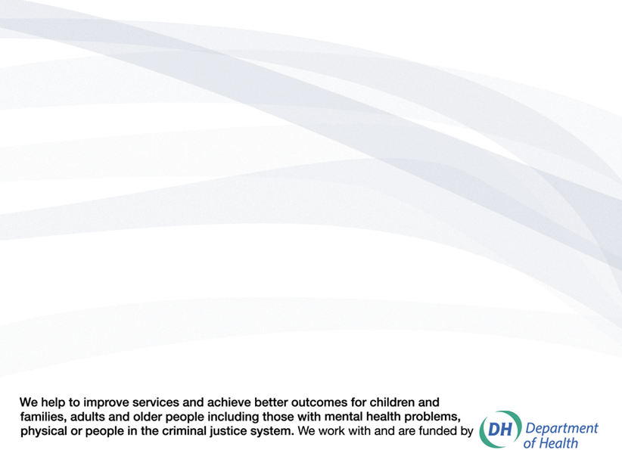
You can send comments and questions about the CSIP Implementation Guide, factsheets or other resources or contact us via telecare@csip.org.uk. Also, use this mailbox to send in good practice examples.

If you or a colleague would like to receive future copies of the newsletter then all you need to do is register at http://www.icn.csip.org.uk/index.cfm?pid=12

