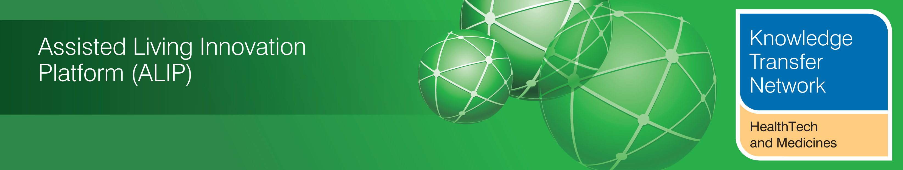
SUPPLEMENT ON INTEGRATED CARE
November 2013

Welcome to an additional supplement from the Technology Strategy Board (TSB) Knowledge Transfer Network and the Telecare Learning and Improvement Network. This supplement looks at progress and plans around integrated care in England. In other parts of the UK there is already much closer working between primary/secondary care and social care.

Integration

1 Background

It was the enforced pause in the passage through Parliament of the 2012 NHS and Social Care Act which led to a renewed focus on integration across health and care services in England. The Government started to realised that the NHS would not be able to deliver improved services with flatlining budgets without closer working of primary/secondary care and greater links with social care, housing, third sector and other services that could impact on health and wellbeing.

“The Government’s proposals for the NHS have attracted many claims that they will create fragmentation and undermine integration of services around the needs of

patients and individuals. What is also clear is that services under the existing system

are currently highly fragmented across the NHS, public health and social care; and

within the NHS, between primary, secondary and tertiary care. Regardless of

whether our discussions were focussed on the issue of public accountability and

patient involvement, competition and choice or clinical advice and leadership,

concerns around integration came up time and time again. The importance of

collaboration and integration between different care sectors and care settings are,

therefore, strong themes in each of the separate workstream reports and important

recommendations for strengthening collaboration and integration are put forward”.

NHS Future Forum - Summary report on proposed changes to the NHS – Professor Steve Field -13 June 2011

2 Integrated Care Pilots

Prior to the Future Forum recommendation, work had commenced on a number of integrated care pilots. The 16 pilots (see Table 1) were evaluated over two years and a report published in March 2012.

Some of the conclusions from the evaluation include:

- The pilots developed and implemented a loose collection of ‘integrating activities’ based on local circumstances

- a number of aims were shared eg bringing care closer to the service user; providing service users with a greater sense of continuity of care; identifying and supporting those with greatest needs; providing more preventive care; and reducing the amount of care provided unnecessarily in hospital settings

- Most pilots concentrated on horizontal integration rather than vertical integration

- Integrated care led to process improvements such as an increase in the use of care plans and the development of new roles for care staff. Patients did not, in general, share the sense of improvement

- A key aim of many pilots was to reduce hospital utilisation. There was no evidence of a general reduction in emergency admissions, but there were reductions in planned admissions and in outpatient attendance

- There was no overall significant changes in the costs of secondary care utilisation, but for case management sites there was a net reduction in combined inpatient and outpatient costs

- Could the approach to integrated care found in these pilots improve quality of care? The evaluators concluded that it can if well led and managed, and tailored to local circumstances and patient needs. Improvements are not likely to be evident in the short term

- Could the approaches to integrated care found in the pilots save money? – not in the short term and certainly not inevitably, say the evaluators. The case management approaches used in the pilots could lead to an overall reduction in secondary care costs

- The most likely improvements following integrated care activities are in healthcare processes. They are less likely to be apparent in patient experience or in reduced costs.

- The scale and complexity of delivering integrated care activities can easily overwhelm even strong leadership and competent project management

- Enthusiastic local leadership could produce expectations that were difficult to realise in practice. Changes to practice often took much longer to achieve than anticipated.

- The focus on the needs and preferences of end users can easily be lost in the challenging task of building the organisational platform for integration and in organising new methods of delivering professional care

- When developing integrating activities there is no one approach that suits all occasions

- Of the approaches used, case management looked to be the most promising in terms of reducing secondary care costs. However, the reductions in costs were in elective admissions and outpatient attendance, rather than in emergency admissions as had been anticipated

Table 1: The 16 initiatives in the integrated care pilot programme.

Integrated Care Pilot | Main integration focus/client group | Integration Pioneer? (From 1 November 2013)
Bournemouth & Poole | Structured care for dementia | No
Cambridge Assura | End of life care | No
Church View, Sunderland | Older people at risk of admission | No
North Cornwall | Mental healthcare | Yes – Cornwall & Isles of Scilly
Cumbria | People at risk of admission (self-management) | No
Durham Dales | a) Rapid access medical assessment clinic with reclassification of acute  hospital as community hospital  b) Moving services closer to home  c) Fuel poverty intervention  d) Improved transport to services  e) Older people’s mental health | No
Nene (Northamptonshire  Integrated Care Partnership) | People at risk of admission to hospital (long-term conditions) | No
Newquay | Structured care for dementia | Yes – Cornwall & Isles of Scilly
Norfolk | Long-term conditions | No
North Tyneside | Falls in over-60s | No
Northumbria | Chronic obstructive pulmonary disease (COPD) | No
Principia, Nottinghamshire | a) People at risk of admission  b) COPD | No
Tameside & Glossop | a) People at risk of cardiovascular disease (CVD)  b) People with CVD | No
Torbay | a) Prevention of admission of older people to hospital  b) Enhanced discharge planning  c) People in nursing homes with COPD/ congestive cardiac failure (CCF)  d) Services for low-level dementia | South Devon and Torbay
Tower Hamlets | Structured care for diabetes | Yes - Waltham Forest and East London and City
Wakefield | Substance misuse | No

3 Integrated care pioneers announced
In May 2013, the integration pioneers’ programme was launched, inviting local areas to demonstrate the use of ambitious and innovative approaches to deliver person-centred, co-ordinated care and support. Over 100 initial expressions of interest were received.
The pioneers announced on 1 November 2013 are:

Barnsley
The aim of the Stronger Barnsley Together initiative is to make sure that the health and care needs of local people are met in the face of an increasingly difficult climate. Population changes, public sector cuts and welfare reforms, have the had an impact on how Barnsley delivers these services, and they cannot afford to continue with the existing system as it is. A new centralised monitoring centre has been set up. When the centre is alerted about an emergency case, it is assessed within one of three categories (individual, families, and communities) and the right kind of help is delivered. This will help ensure that the right help is dispatched quickly to the relevant patient.
Patients will receive tailored care to suit their requirements, whether this is day to day support to enable people to stay safe, secure and independent, or the dispatch of a mobile response unit for further investigation. This is vitally important to ensure that patients are seen swiftly and receive the care and information they need – whether this is avoiding a return to A&E, getting extra care support for a child’s care needs, or even work to improve the information available explaining how to access to council services.

Cheshire
Connecting Care across Cheshire will join up local health and social care services around the needs of local people and take away the organisational boundaries that can get in the way of good care.
Local people will only have to tell their story once – rather than facing repetition, duplication and confusion. Also the programme will tackle issues at an earlier stage before they escalate to more costly crisis services.
There will be a particular focus on older people with long-term conditions and families with complex needs.

Cornwall and Isles of Scilly
Fifteen organisations from across health and social care, including local councils, charities, GPs, social workers and community service will come together to transform the way health, social care and the voluntary and community sector work together. This is about relieving pressures on the system and making sure patients are treated in the right place. Teams will come together to prevent people from falling through the gaps between organisations.
Instead of waiting for people to fall into ill-health and a cycle of dependency, the pioneer team will work proactively to support people to improve their health and wellbeing. The pioneer will measure success by asking patients about their experiences of care and measuring falls and injuries in the over 65s.

Greenwich
Teams of nurses, social workers, occupational therapists and physiotherapists work together to provide a multidisciplinary response to emergencies arising within the community which require a response within 24 hours. The team responds to emergencies they are alerted to within the community at care homes, A&E and through GP surgeries, and handle those of which could be dealt with through treatment at home or through short term residential care.
Over 2,000 patient admissions were avoided due to immediate intervention from the Joint Emergency Team (JET). There were no delayed discharges for patients over 65 and over £1m has been saved from the social care budget.

Islington
Islington Clinical Commissioning Group and Islington Council are working together to ensure local patients benefit from better health outcomes. They are working with people to develop individual care plans, looking at their goals and wishes around care and incorporating this into how they receive care. They have already established an integrated care organisation at Whittingdon Health better aligning acute and community provision.
Patients will benefit from having a single point of contact rather than dealing with different contacts, providing different services. Patients will feel better supported and listened to.

Leeds
Leeds is all about aiming to go ‘further and faster’ to ensure that adults and children in Leeds experience high quality and seamless care.
Twelve health and social care teams now work in Leeds to coordinate the care for older people and those with long-term conditions.
The NHS and local authority have opened a new joint recovery centre offering rehabilitative care – to prevent hospital admission, facilitate earlier discharge and promote independence. In its first month of operation, it saw a 50% reduction in length of stay at hospital.
Leeds has set up a programme to integrate health visiting and children’s centres into a new Early Start Service across 25 local teams in the city. Children and families now experience one service, supporting their health, social care and early educational needs, championing the importance of early intervention. Since the service has been in operation, the increase in face-to-face antenatal contacts has risen from 46% to 94% and the number of looked after children has dropped from 443 to 414.
Patients will also benefit from an innovative approach which will enable people to access their information online.

Kent
In Kent, the focus will be around creating an integrated health and social care system which aims to help people live as independent a life as possible, based on their needs and circumstances. By bringing together CCGs, Kent County Council, District Councils, acute services and the voluntary sector, the aim will be to move to care provision that will promote greater independence for patients, whilst reducing care home admissions. In addition, a new workforce with the skills to deliver integrated care will be recruited.
Patients will have access to 24/7 community based care, ensuring they are looked after well but do not need to go to hospital. A patient held care record will ensure the patient is in control of the information they have to manage their condition in the best way possible. Patients will also have greater flexibility and freedom to source the services they need through a fully integrated personal budget covering health and social care services.

North West London
The care of North West London’s 2 million residents is set to improve with a new drive to integrate health and social care across the eight London boroughs.
Local people will be supported by GPs who will work with community practitioners, to help residents remain independent. People will be given a single point of contact who will work with them to plan all aspects of their care taking into account all physical, mental and social care needs.
Prevention and early intervention will be central – by bringing together health and social care far more residents will be cared for at or closer to home reducing the number of unplanned emergency admissions to hospitals. The outcomes for patients and their experiences of care are also expected to increase. Financial savings are also expected with the money saved from keeping people out of hospital unnecessarily being ploughed back into community and social care services.

North Staffordshire
Five of Staffordshire’s Clinical Commissioning Groups (CCGs) are teaming up with Macmillan Cancer Support to transform the way people with cancer or those at the end of their lives are cared for and supported.
The project will look at commissioning services in a new way – so that there would be one principal organisation responsible for the overall provision of cancer care and one for end of life care.

South Devon and Torbay
South Devon and Torbay already has well-co-ordinated or integrated health and social care but as a Pioneer site now plans to offer people joined up care across the whole spectrum of services, by including mental health and GP services. They are looking at ways to move towards seven day services so that care on a Sunday is as good as care on a Monday – and patients are always in the place that’s best for them. The teams want to ensure that mental health services are every bit as good and easy to get as other health services and coordinate care so that people only have to tell their story once, whether they need health, social care, GP or mental health services.
Having integrated health and social care teams has meant patients having faster access to services; previously, getting in touch with a social worker, district nurse, physiotherapist and occupational therapist required multiple phone calls, but now all of these services can be accessed through a single call. In addition, patients needing physiotherapy only need to wait 48 hours for an appointment – an improvement from an 8 week waiting time.
A joint engagement on mental health is bringing changes and improvements even as the engagement continues – for instance, people wanted an alternative to inpatient admissions so we are piloting a crisis house, where they can get intensive support
An integrated service for people with severe alcohol problems frequently attending A&E, is offering holistic support. The service might help sort out housing problems rather merely offer detox. 84% report improvements. “The people helping me have been my lifesavers. I shall never, ever forget them.” – Patient, alcohol service.

Southend
Southend’s health and social care partners will be making practical, ground level changes that will have a real impact on the lives of local people.
They will improve the way that services are commissioned and contracted to achieve better value for money for local people with a specific focus on support for the frail elderly and those with long term conditions. They will also look to reduce the demand for urgent care at hospitals so that resources can be used much more effectively. Wherever possible they will reduce reliance on institutional care by helping people maintain their much-valued independence.
By 2016 they will have better integrated services which local people will find simpler to access and systems that share information and knowledge between partners far more effectively. There will be a renewed focus on preventing conditions before they become more acute and fostering a local atmosphere of individual responsibility, where people are able to take more control of their health and wellbeing.

South Tyneside
People in South Tyneside are going to have the opportunity to benefit from a range of support to help them look after themselves more effectively, live more independently and make changes in their lives earlier.
In future GPs and care staff, for example, will have different conversations with their patients and clients , starting with how they can help the person to help themselves and then providing a different range of options including increased family and carer support, voluntary sector support and technical support to help that person self-manage their care
In order to do this there will be changes in the way partners organise, develop and support their own workforces to deliver this and a greater role for voluntary sector networks.

Waltham Forest and East London and City
The Waltham Forest, East London and City (WELC) Integrated Care Programme is about putting the patient in control of their health and wellbeing. The vision is for people to live well for longer leading more socially active independent lives, reducing admissions to hospital, and enabling access to treatment more quickly.
Older people across Newham, Tower Hamlets and Waltham Forest will be given a single point of contact that will be responsible for co-ordinating their entire healthcare needs. This will mean residents will no longer face the frustration and difficulty of having to explain their health issues repeatedly to different services.

Worcestershire
The Well Connected programme brings together all the local NHS organisations (Worcestershire Acute NHS Trust, Worcestershire Health and Care NHS Trust and the Clinical Commissioning Groups), Worcestershire County Council and key representatives from the voluntary sector. The aim is to better join up and co-ordinate health and care for people and support them to stay healthy, recover quickly from an illness and ensure that care and treatment is received in the most appropriate place. It is hoped this will lead to a reduction in avoidable hospital admissions and the length of time people who are admitted to hospital need to stay there.
A more connected and joined up approach has reduced unnecessary hospital admissions for patients.
The pioneers will be meeting together for the first time in December 2013. Some of the bid information is becoming available. The pioneers will be evaluated as they progress and information shared widely.
Additional links:
http://www.england.nhs.uk/2013/11/01/interg-care-pioneers/
http://www.england.nhs.uk/2013/10/31/nao-em-ad/

4 Integration Transformation Fund
The June 2013 Spending Review (Guardian) announced the creation of a £3.8bn Integration Transformation Fund (ITF).

The latest information about the Fund is covered in a joint letter from the Local Government Association and NHS England.

Health and Wellbeing Boards are encouraged to extend the scope of their integration plans including pooled budgets. Planning for 2015-16 commences in early 2014 and form part of a five year strategy for health and care. The NHS planning framework will invite clinical commissioning groups to agree five year strategies, including a two year operational plan that covers the ITF through Health and Wellbeing Boards.

The £3.8bn pool brings together NHS and Local Government resources that are already committed to existing core activity. Councils and CCGs will, therefore, have to redirect funds from these activities to shared programmes that deliver better outcomes for individuals. The Government has made clear that part of the fund will be linked to performance.

Table 2 covers the sources of the Integration Transformation Fund (ITF).

Table 2: Where does the ITF come from (June 2013 SR)

2014/2015
An additional £200m transfer from the NHS to social care, in addition to the £900m transfer already planned.

2015/2016
£3.8bn pooled budget to be deployed locally on health and social care through pooled budget arrangements.
The ITF is created from –
£1.9bn NHS funding
£1.9bn based on existing funding in 2014/15 that is allocated across the health and wider social care system composed of:
£130m Carers breaks funding
£300m reablement funding
£354m capital funding (incl £220m DFG)
£1.1bn existing transfer from health to social care

The role of Health and Wellbeing Boards is emphasised in the planning arrangements for the ITF.

In 2015/16 The fund will be allocated to local areas, where it will be put into pooled budgets under joint governance between 211 CCGs and 152 local authorities. A condition on accessing the money in the fund is that CCGs and local authorities must jointly agree plans for how the money will be spent, and these plans must meet certain requirements.

The formula for distribution of the full £3.8bn fund in 2015/16 will be subject to ministerial decisions in the coming weeks. The Spending Review agreed that £1bn of the £3.8bn would be linked to achieving outcomes. 50% of the pay-for-performance element will be paid at the beginning
of 2015/16, contingent on the Health and Wellbeing Board adopting a plan that meets the national conditions by April 2014, and on the basis of 2014/15 performance. The remaining 50% will be paid in the second half of the year and could be based on in-year performance.

Areas for consideration for measurement include:

- Delayed transfers of care
- Emergency admissions
- Effectiveness of re-ablement
- Admissions to residential and nursing care
- Patient and service user experience

Each upper tier Health and Wellbeing Board will sign off the plan for its constituent local authorities and CCGs. Health and Wellbeing Boards are required to return the completed planning template by 15 February 2014.

The Spending Review established six national conditions:

- Plans to be jointly agreed
- Protection for social care services
- As part of agreed local plans, 7-day services in health and social care to support patients being discharged and prevent unnecessary admissions at weekends
- Better data sharing between health and social care, based on the NHS number
- Ensure a joint approach to assessments and care planning and ensure that, where funding is used for integrated packages of care, there will be an accountable professional
- Agreement on the consequential impact of changes in the acute sector

5 Impact of the ITF on the telecare, telehealth and digital technology sector

There is widespread support for the ITF as a significant re-investment of existing NHS and care funds into integrated care even though it is only around 3% of the combined health and care annual spend in England.

Each CCG will need to release at least £10m of their existing funding to contribute towards the overall pooled fund when it is set up – in many cases, this will lead to some current services being decommissioned (this may have consequences where, for instance, telehealth has not been successfully deployed). Also, there is increasing evidence that as many as 10% of CCGs could have a year end deficit in 2013/14 – a further funding pressure from the ITF could leave some CCGs with continuing deficits in future years. Some of the funding is currently earmarked for existing service areas eg disabled facilities grants so there may not be much flexibility. As many hospital services are stretched and face potential deficits, it is expected that they will place considerable pressures on the planning process and allocation of the funds.

There is no doubt that use of the ITF will be closely monitored particularly if there is a performance element. Where performance funding is not available, locally, a programme may have to be abandoned. It is also unclear how the pooling arrangement will work beyond 2015/16.

Where solutions involving technology have been proven to be cost-effective locally, they could play an important part in contributing to the measurables mentioned ie reducing delayed transfers of care, reducing emergency admissions, improving the effectiveness of re-ablement, reducing admissions to residential and nursing care. Commissioners and service providers will need to examine their local performance and outcome data and put forward the appropriate business cases for investment as part of the overall plan by 15 February 2014. In addition, work done in the telecare, telehealth, medical records, informatics and interoperability areas could contribute to the data sharing requirements using the NHS number. Telecare is already a well established 24/7 service and control centres could have a wider support role in conjunction with 111 service, out of hours, housing, social care and hospitals to coordinate services around users/patients especially at critical times (eg hospital discharges).

As these plans could cover up to five years, failure to put forward successful business and development plans could reduce the likelihood of technology-supported services being adopted at scale for the foreseeable future.

6 Other resources

The Kings Fund
Integrated care
http://www.kingsfund.org.uk/topics/integrated-care
Making integrated care a reality
http://www.kingsfund.org.uk/projects/making-integrated-care-reality
Joined-up care in action: our integrated care map
http://www.kingsfund.org.uk/projects/integrated-care-making-it-happen/integrated-care-map

Nuffield Trust
Integrated Care
http://www.nuffieldtrust.org.uk/our-work/integrated-care
Evaluating integrated and community-based care: how do we know what works?
http://www.nuffieldtrust.org.uk/publications/evaluating-integrated-and-community-based-care-how-do-we-know-what-works
Evaluation of the first year of the Inner North West London Integrated Care Pilot
http://www.nuffieldtrust.org.uk/publications/evaluation-first-year-inner-north-west-london-integrated-care-pilot

Health Foundation
Pioneering Integrated Care
http://www.health.org.uk/blog/pioneering-integrated-care/

International Foundation for Integrated Care
http://www.integratedcarefoundation.org/

International Journal of Integrated Care
http://www.ijic.org/index.php/ijic
Statement on the health and social care Integration Transformation Fund -NHS England/LGA
http://www.england.nhs.uk/wp-content/uploads/2013/08/itf-aug13.pdf
Integrated Care: Our Shared Commitment
https://www.gov.uk/government/publications/integrated-care

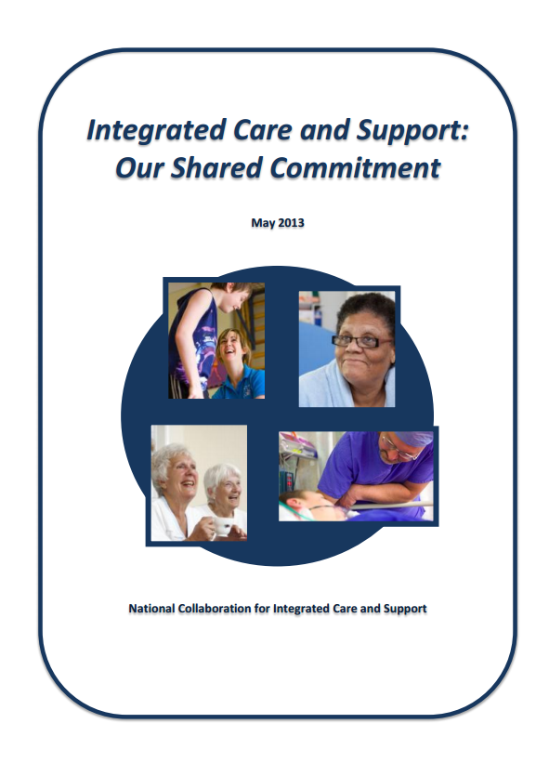
https://www.gov.uk/government/uploads/system/uploads/attachment_data/file/198748/DEFINITIVE_FINAL_VERSION_Integrated_Care_and_Support_-_Our_Shared_Commitment_2013-05-13.pdf

National Voices – Principles for Integrated Care

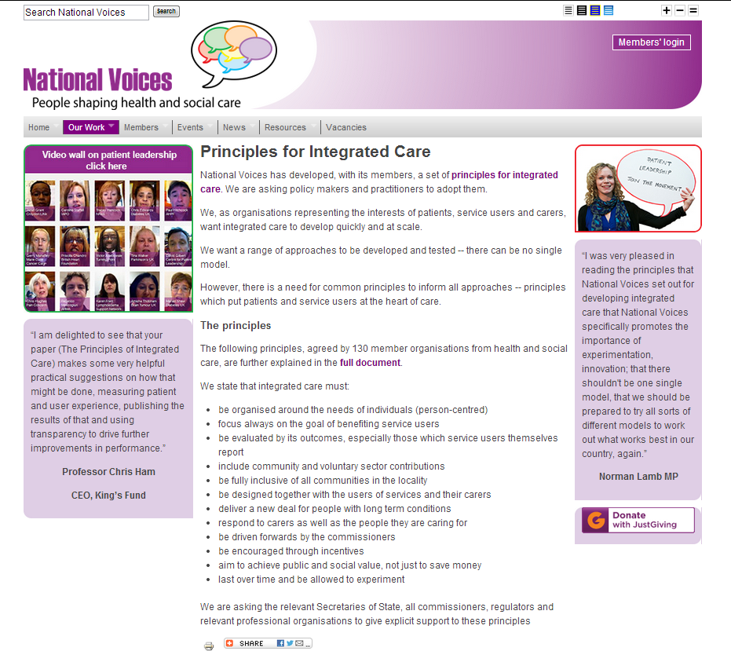
http://www.nationalvoices.org.uk/principles-integrated-care
http://www.nationalvoices.org.uk/sites/www.nationalvoices.org.uk/files/principles_for_integrated_care_20111021.pdf

Housing LIN – Integration: Healthy Partnerships ( a range of important documents is covered)

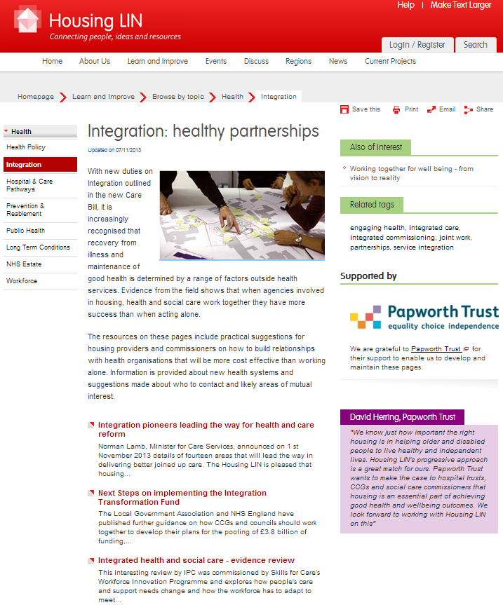

http://www.housinglin.org.uk/Topics/browse/HealthandHousing/Integration/
Build housing into integrated care – Jeremy Porteus, Housing LIN (HSJ – subscription required)
http://www.hsj.co.uk/home/commissioning/opinion/build-housing-into-integrated-care/5065336.article#.UpXHqdLhzWQ

Newsletter supplement prepared by Mike Clark (@clarkmike) and brought to you by the Telecare LIN on behalf of the Technology Strategy Board. Newsletters and supplements are archived at www.telecarelin.org.uk

Disclaimer: “We provide this newsletter supplement for information purposes only and neither the Technology Strategy Board nor the authors accept any liability whatsoever for inaccuracies, errors or omissions therein or for any consequences arising therefrom.”



